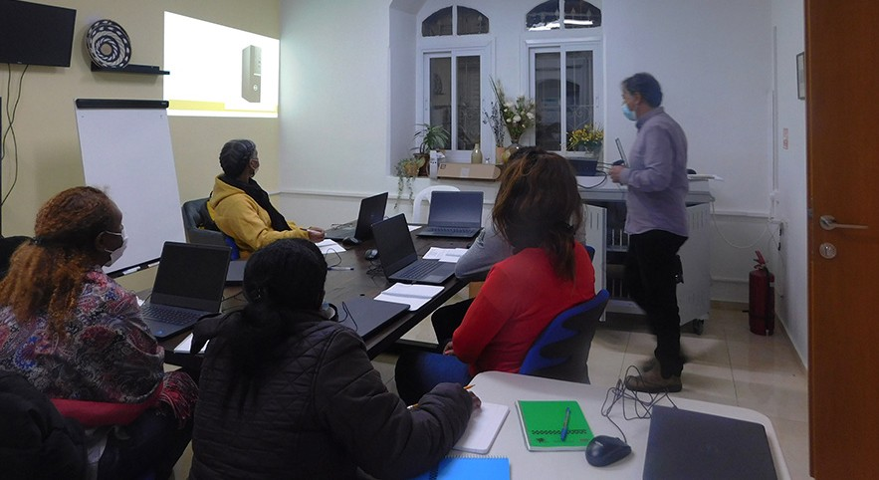
in

Prayer Letter
Watchman’s

Christian Friends of Israel prayer@cfijerusalem.org www.cfijerusalem.org
March 2022 /Jewish Year 5782
Making Aliyah
“Don’t fear, I am with you. From the east, I’ll bring your children; from the west, I’ll gather you. I’ll say to the north, ‘Give them back!’ and to the south, ‘Don’t detain them.’ Bring my sons from far away and my daughters from the end of the earth” (Isaiah 43:5-6, CEB).

Ethiopian Jewish students in the Hope Resource Center

The word Aliyah means “the act of going up,” which refers to the immigration of Jews from the nations to the Land of Israel (going up towards Jerusalem). “Making Aliyah” is part of a national Zionist ideology of the return of the Jewish people to their homeland. Israel’s Law of Return allows Jews, namely those deemed Jewish by Talmudic law or Israeli secular law, and eligible non-Jews the legal right to assisted immigration, settlement in Israel, and Israeli citizenship. They consider an eligible non-Jew to be: a child and a grandchild of a Jew, the spouse of a Jew, the spouse of a child of a Jew, and the spouse of a grandchild of a Jew (Jewish Virtual Library).

The Aliyah concept is rooted in scripture with its recurrent theme of Israel returning home after being taken captive by other nations. Ezekiel 28:25, ISV, states, “This is what the Lord God says: ‘When I gather the house of Israel from the nations to which I’ve scattered them, I will show them my holiness before the watching world, and they will live on the land that I gave to my servant Jacob.’” God said to the patriarch Abraham, “For all the land which you see, I will give it to you and to your descendants forever (Genesis 13:15, AMP, emphasis mine).”

As Christians, we want to have the heart of God by loving what He loves and seeing things from His eternal perspective. Since the Lord says He loves Israel with an everlasting love (Jeremiah 31:3), we should also love Israel. One day I was reading Isaiah 49:22, AMP, which says, “This is what the Lord God says, ‘Listen carefully, I will lift up My hand to the [Gentile] nations and set up My banner to the peoples, and they will bring your sons in the fold of their garments, and your daughters will be carried on their shoulders” (Emphasis mine).

The words seemed to leap off the page! I saw God’s plan that Gentiles would assist the Jews as they return home. As a Gentile believer in the God of Israel, I am one of those people from the nations that God has sig- naled to assist Abraham’s descendants in their return home. I don’t believe I am alone. I think God’s banner is yet raised to call more Christians to understand the times and come alongside Israel in the making of aliyah.

Jewish olim (immigrants) come from many countries to flee anti-Semitism, escape war and poverty, or fulfill their dream of returning to the Holy Land. Interacting with these dear people and hearing their stories has been eye-opening for me. Their faces and countries of origin may be different, but their goals are the same: to learn a new language, find a job, and assimilate into the Israeli culture. Reaching those goals can prove to be an arduous and often lengthy process. It takes endurance to overcome the obstacles when moving to the Holy Land.

For over 35 years, CFI has come alongside thousands of Jewish immigrants in supplying food, clothing, finances, comfort, prayer, music, and friendship. We also offer small appliances in the Operation Start-up Store and computer literacy training in our new Hope Resource Center. As you pray for the immigrants, would you ask the Lord how you might contribute to the much-needed assistance of those descendants of Abraham who are returning to their homeland?

Please join us in praying for Jews making Aliyah
- Praise God for His eternal promises to Israel. He made this promise to King David, “And I will provide a place for my people Israel and will plant them so that they can have a home of their own. Your house and your kingdom will endure forever before me; your throne will be established forever” (2 Samuel 7:10a, 16, NIV).

- Thank the Lord that Israel is preparing a contingency plan to receive thousands of Ukrainian Jews who may flee amid growing tensions and speculation over an imminent Russian invasion of Ukraine. “See, I will bring them from the land of the north and gather them from the ends of the earth. Among them will be the blind and the lame, expectant mothers and women in labor; a great throng will return” (Jeremiah 31:8, NIV).

- Intercede for the Middle East. We want to preempt any war that does not align with God’s timetable. Ecclesiastes 3:8 says; There is “…a time for war and a time for peace.” In a statement by Rick Ridings for Israel prayer coverage, he said, “I felt the Lord say that now our prayers and intercessions could inter- cept Satan’s plans for a World War III to cut short a Great Harvest. I also felt that Satan would attempt to start World War III in order to block the soon coming wave of Aliyah, the movement of Jewish people from the West coming home to Israel. The times and seasons are in His hands, and not in Satan’s, who often tries to cause certain end-times events to occur ahead of the Lord’s timing” (Rick Ridings, Succat Hallel).

- Pray for the olim struggling to learn Hebrew and gain job skills to succeed in Israel. Please pray that the Spirit of God will give them understanding, confidence, and courage. “‘I know the plans I have in mind for you, declares the Lord; ‘they are plans for peace, not disaster, to give you a future filled with hope’” (Jeremiah 29:11, CEB).

- Ask the Lord to show the Body of Messiah how important Aliyah is to God’s heart and His plans for these last days. “The Lord rebuilds Jerusalem; He gathers Israel’s exiled people” (Psalm 147:2, HCSB). (Chuck Cohen, Intercessors for Israel).

Our Dear Prayer Warriors,
It is a pleasure to greet you once again. What a joy it has been to pray with some of you in person in my travels back to the United States! Modern technology allowed us to continue our monthly prayer meetings and join many others. I sensed a spiritual acceleration in our times of intercession together. Have you noticed it? Let’s continue waiting and listening before the Lord as He directs our steps, opens our eyes, and takes us to new levels.

To join our online prayer meetings, please contact us. May the strength of the Lord be upon you.

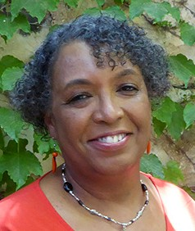
By His power,

Linda D. McMurray
Wall of Prayer Coordinator

