CFI Projects Monthly Reports for
International
Representatives

Dear CFI International Representative Family,

Thank you for your continued support of the Outreach efforts of Christian Friends of Israel. We continue to strive to encourage those in need and to offer practical assistance during times of struggle. It’s during these times when relationships can be formed which please God and allow us to show Compassion to those who need it the most and have possibly never experienced it before.

During this time of global pandemic, we continue to offer assistance as we are able, and we know each passing day may allow for additional hardships, but we also know the God whom we serve. He is more than able to protect, and provide and heal. We are willing to represent Him to the people of Israel.

Please receive the CFI Outreach electronic updates as a reminder
of the impact each of you have in the lives of so many. We are grateful to represent those of you in the Nations - to those in the Land of Israel.

A friend loves at all times, And a brother is born for adversity.

Proverbs 17:17 (NKJV)

Project Forsake Them Not

“I will remember the works of the Lord; surely I will remember Your wonders of old. I will also meditate on all Your work, and talk of Your deeds” Psalm 77:11-12.

To remember is a decision, an actual action that takes time, and often effort. We have a tendency to have short memories, as often it is a painful decision to remember the wonders of old. However, by remembering, the events and peoples long gone, are preserved. It is because someone in the past remembered to remember that we have history today.
Our precious Holocaust Survivors – they all are the history writers as they share their experience during the Holocaust, telling their stories to future generations. We also can choose to be the part of that history as we continue to remember, to meditate and to talk about it.

In January, as Israel was in the third lockdown, and we were not able to visit people, we chose to remember. We called our precious friends, we wrote their stories and we cried finding out some of our dear ones had passed away. We also participated in the International Holocaust Remembrance Day event, organised by the Association of the Concentration Camps and Ghetto Survivors, on Zoom. One of the main themes of the event was the importance of preserving the memories of those who lived through the horrors of the Holocaust. We heard many personal testimonies and historical facts. Once again, we were reminded to remember and to speak out for those who will never again be able to speak for themselves.

News of Motl’s passing away was heartbreaking, but not surprising. He was a very special person, and we shared a deep bond. I would like to honour Motl’s memory by sharing a small part of his story.
Motl’s childhood was not much different from other children born in Poland in 1926. His parents lived in Vladimir-Volynsky, where, before WWII began, more than half of the population were Jews. After the Red Army invaded Vladimir-Volynsky in 1939, it became part of the Soviet Union. Motl had three sisters, and his mother was busy with their education and looking after the house.
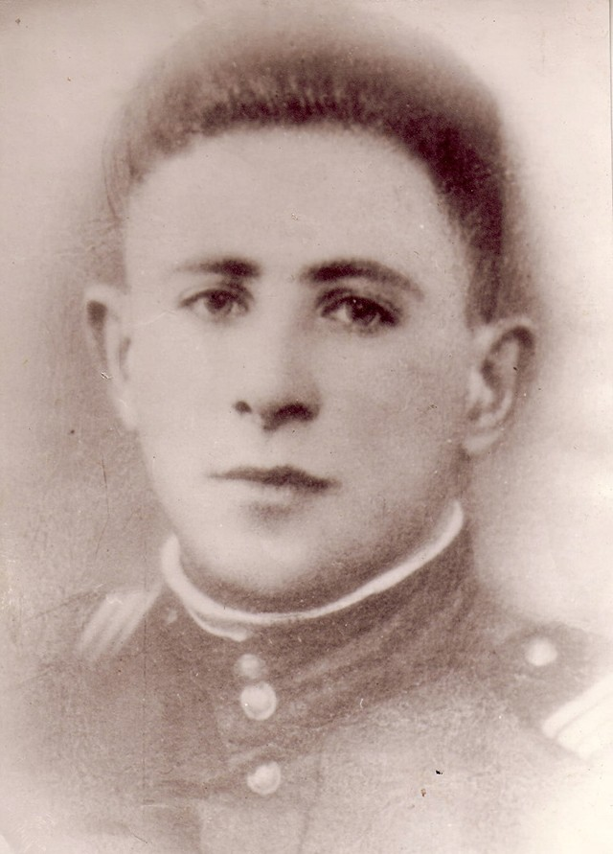
The start of the war was horrific. The border was only five kilometres away. Jewish homes were burnt, and the town was constantly under threat of shootings and bombings.
By the 23rd of June 1941, just a day after the war began, the Germans were already in the town. Motl remembers the “new order” that forced all the Jews to wear yellow stars of David. They were also put into ghettos where they were constantly robbed of their belongings and mocked, not only by the Germans but also the Ukrainian police.
On the 12th of November 1942 a pogrom started in the ghetto. It was carried out by a group of the SS with the help of the local Ukrainian police. Motl’s mother and father, sister Sura and grandfather tried to hide, but they did not succeed. They were all shot, along with many other Jews. His two other sisters managed to escape and hide with a local peasant family whom they knew well.
Motl wanted to take revenge and joined the group of Polish partisans at the end of January 1943. While serving in the partisan Motl learned how to use different weapons. He was brave and gifted and very soon the commanders started to

involve him in the serious resistance operations. In April 1944 the Germans attacked their partisan base. Many died, but they continued to resist the attack. Over 20 Germans were taken captive, and Motl was recognised for his bravery again.
After the war, Motl studied and later worked as a director of a big shopping center. He had two daughters, grandchildren and many great grandchildren. Motl also loved singing songs in Yiddish and was part of local choir.
We do remember and appreciate Motl’s life and impact it made in our lives. Today we are saying for Motl, “Never Again!”
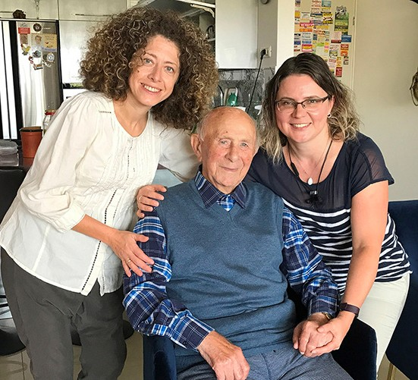
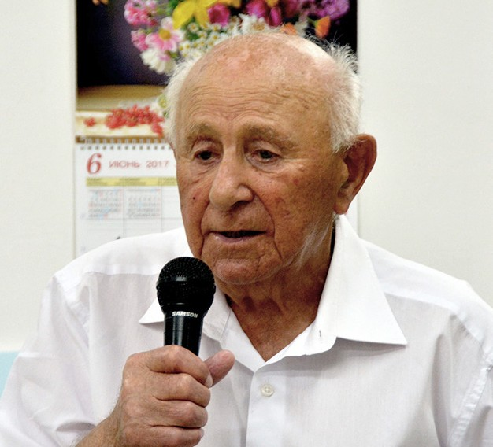

Thank you so very much for your love and support shown through action. Thank you for helping us to remember and to speak out, preserving the memories, and writing the history. Let us remember to remember. As we run this race against time to reach out to as many Holocaust Survivors as possible, we highly appreciate your prayers and stand with us.
We do remember those who died. We do remember those who are living.

“Sing praises to the Lord, who dwells in Zion! Declare His deeds among the people. When He avenges blood, He remembers them; He does not forget the cry of the humble” Psalm 9:11-12.

Olga Kopilova Project Supervisor

Project Open Gates

Greetings from the CFI distribution center!

I am excited to tell you that the lockdown is over and we are able to receive people again here in our place. The restrictions allow only one person to be served at a time. So the amount of the clients is not a lot for one day. But I am happy that we are open, as well as for the different individuals that came in this week. Everybody has found something good for himself or herself. We had a family who made Aliyah from Colombia – religious Jews. It was a pleasure to give them both clothes and bedding; especially the 5 and 6 year-old daughters got a lot of warm and beautiful things for themselves. Another family was from Peru. They live in Beersheva at the moment. The little twin boys did not come in, but both of the parents took care of them very well. The mother found clothes for the boys and the father took a huge rabbit to make his sons happy. This family doesn’t speaks any Hebrew yet, only Spanish. I managed to communicate with the mother without a common language, and one of our Spanish speaking volunteers came just in time to the DC and helped the father with shopping. God is good! Today it was snowing in Jerusalem. One Russian speaking family was not afraid of the difficulties on the road. They came in the morning and found a lot of good quality items for themselves. You could see that they didn’t have too many clothes although they have been already two years in the Land.

I can feel the gratefulness of these people when they leave our building. Thank God that we as Christians have this opportunity to bless new immigrants in Jerusalem. Next week’s calendar is already full of appointments. Some of the clients who come have just arrived to Israel. Isn’t it exciting! God is on the move!
”…Thus says the Lord God: I will gather you from the peoples, and assemble you out of the countries where you have been scattered, and I will give you the land of Israel” Ezekiel 11:17.

Let’s keep going in this good work!
Tiina Danilevski Project Supervisor
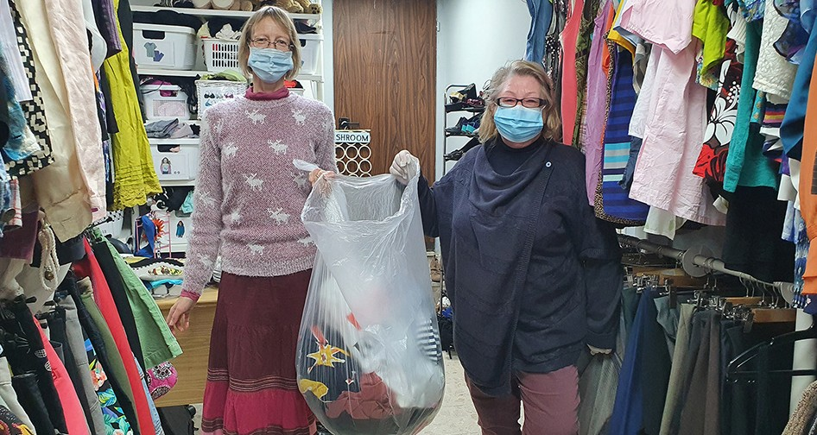

Project Bridal Salon

Shalom haverim (friends in Hebrew) from snowy Jerusalem!
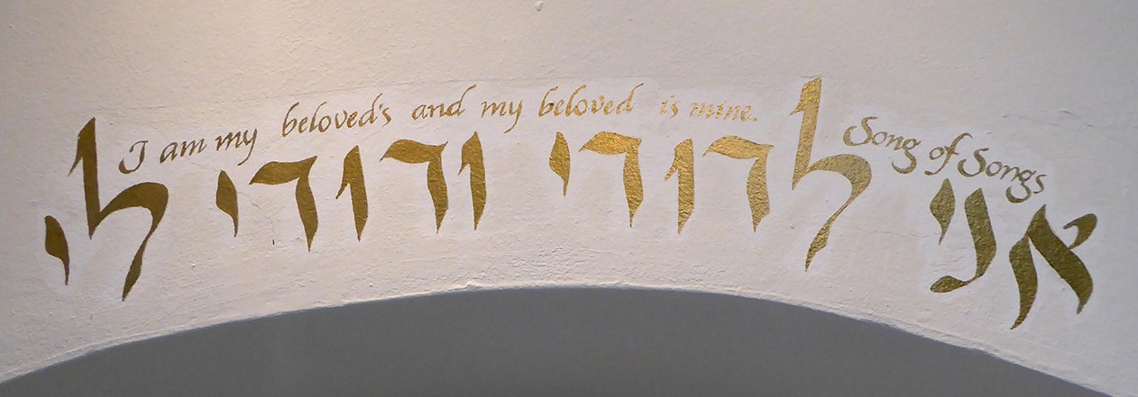

The weather turned cold about two days ago. People are enjoying this “white moment” in Jerusalem. We are already open for clients in our Bridal Salon. One person can come in at a time and choose items for themselves.

The first client after the lockdown was a bride to be, Ruth. She moved to Israel from France when she was seven. She looks so Israeli that you really think she was born in the land. Despite the fact that Ruth is serving in the IDF she is going to get married in April this year. Her future husband David visited our distribution center as a new immigrant not long ago. He told Ruth about the Bridal Salon. We managed to make an appointment with her, when she had a holiday from the army. So she came in and started to look at different options.
“I really hope that I will find something for myself,” she said. “I am quite picky.” I understood what she meant. Every girl wants to find a dress that is ‘The One.’ For a soldier it would be a big blessing to get a wedding dress without any cost. In Ruth’s case the schedule for searching for a good gown was very limited too.
She wanted something very light and simple, fitting and beautiful. Both of us were happy when she found a dress that was exactly what she wanted. Beside the dress she also got a pair of shoes, a veil and a necklace. Now she doesn’t have to worry about finding a wedding gown anymore. Ruth gave thanks to the Lord for His care and also for us Christian friends, who are serving the people of Israel.

David came to our place a couple of days later. He did not want a regular suit for himself. He was looking for something that was more his style. The first thing that we found was a beautiful champagne color vest. David liked it a lot. Then we found a burgundy shirt and beige trousers that suited him and the vest very well. Our groom did not want any ties or bow ties. He was already content and thankful for the good-looking outfit for their Special Day.

There have already been phone calls and messages from different people who want to be served by the CFI Bridal Salon in Jerusalem. I am happy that we are able to welcome them to our wonderful place.
Thank you for your support and prayers for this ministry!

Tiina Danilevski Project Supervisor

Project Under His Wings

Shalom Dear Friends of Israel,

“Yet this I call to mind and therefore I have hope:…great is Your faithfulness” Lamentations 3:21-23.

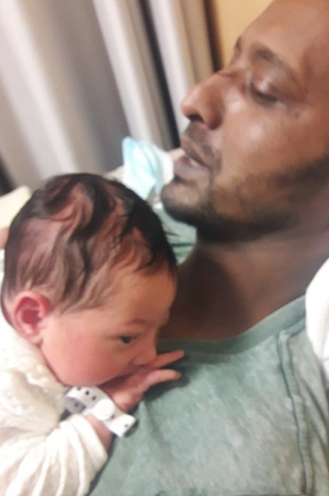
Out of dry bones the Israel Defense Forces (IDF) stood up upon their feet and has grown into an exceeding great army
in fulfillment of Ezekiel 37:10. Today, as with then in May 1948, the enemies of Israel continue to seek annilnation of the Jewish nation, but thanks be to God for the brave men and women of the IDF who have paid an inestimable price, which has cost many young men and women serving in IDF to defend this country, their lives or being traumatized; therefore the nation
of Israel not only has survived but continues to grow stronger.

Like Ezekiel and Jeremiah whose hopes were restored by God when they thought all hope was gone... (Ezekiel 37 & Lamen- tations 3:21-23), so it was with Shmuel, a severely traumatized former warrior, who while doing his compulsory military service in the anti-terrorism unit (the Duvdevan unit), thought all his hope was gone. Yet God restored his hope and has given him not only a wife but also a baby girl last week. It was a miracle, as the doctors told him that he would not be able to have chil- dren due to his post trauma. I went to their home to celebrate this great joy and miracle with him and his family, after receiving a phone call from him to tell me about this exciting news.

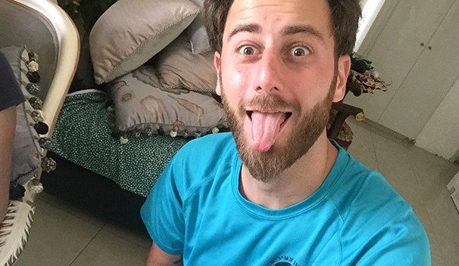
Henry is another victim of terror, who is quite a character, and acts like he is fine and does not care. He lost one of his legs in a terror attack in which the terrorist hit him from behind with a
high-speed car when he was riding a motorcycle. He has been trying to be strong and tough in the presence of others, to conceal his brokenness, sadness and struggle with joking and sarcasm.
I felt God’s love and compassion for Henry. During the visit, prompted by the Holy Spirit I said to him that I felt that God said he needs a little more encouragement. Then he broke into tears
and started to tell me some of his stories, which he did not share with others. Please pray that the Lord Himself will continue to minister to Henry and open his eyes regarding who He truly is.

A heartfelt “Thank you,” for your being a co-labor of Project UHW, through your prayer and financial support. Like Shmuel May your hope be renewed as you recall the faithfulness of God. Bless you from Zion.
Maggie Huang Project Supervisor

Project Communities Under Attack

Dear Friends of Israel,

“We have this hope as an anchor for the soul… “ Hebrews 6:19a.

Shalom. I remember during one period of my life when I felt hopeless and depressed, all I wanted to do was to sleep as if all the worries and sorrow would go away, but they did not. That was the same approach Israel Ifrah takes. When I went to Israel’s home for the scheduled visit, he was sleeping and did not want to get up. So his parents, Ester and Danny, received me instead as he was traumatized by the rocket attacks and severely depressed. It did not offend me, as sometimes I do receive phone calls from victims of terror to cancel the scheduled visit due to trauma.

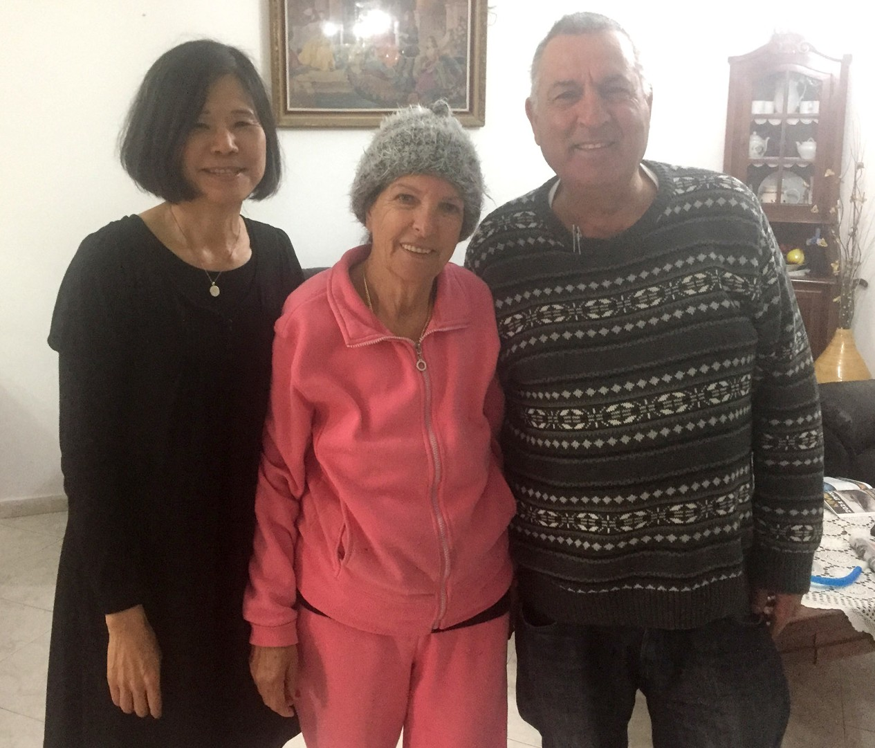
Their home was hit two times by rockets fired from Gaza, the second time in
the year 2009, the room where Israel was in was hit directly, causing serious damage to the house and further trauma to him.

Like many Israeli families, Israel’s family are culturally and traditionally observing Israeli Jews who observe Shabbat and Jewish Holidays and practice Judaism loosely. They believe in God but do not have any personal relationships with Him.

A warm relation was formed during the visit, and Ester and Danny were very appreciative for the love and support Project CUA of CFI – your outreach ministry to victims of rocket attack in Is-
rael – extended to them. And like many others whom Project CUA visited, they said to me, “Please come back to visit. You are always welcome in this home.”

I am forever grateful to God for bringing me out of the pit, of the sense of hopelessness, through knowing what He has done for us and that I have this hope as an anchor for my soul. (Hebrews 6:19a)
Please lift up Israel’s situation in prayer and that the Spirit of God moves and works in his heart to receive my visit next time.

Thank you – our supporters for enabling Project CUA to reach out on your behalf to these precious Israe- li citizens who have suffered ongoing rocket attacks from Gaza for around 15 years. In this turmoil and uncertain time, may you and your loved ones have this hope as a ‘soul anchor’, firm and secure in Him, who is our Great High priest who enters the inner sanctuary behind the curtain for us and intercedes for us in Heaven.

Maggie Huang Project Supervisor

Project Wall of Prayer

Building momentum

“We kept at it, repairing and rebuilding the wall...the people had a heart for the work” Nehemiah 4:6 MSG.

What a joy it is to see Wall of Prayer laborers from the nations arising to surround Israel with their prayers! This month we heard from several long-term prayer warriors who have been interceding for Israel for decades. Some have targeted their intercession for specific Holy Land cities and have gladly sent their photos to be added to the Israel Watch prayer map. Others, like a young man from an Asian country, are new and want to learn how to pray. A great way to learn to pray is by being aligned with seasoned prayer warriors. Messages from people who are joining our prayer teams and sending their photographs are beginning to flow in. The Wall of Prayer is being fortified.
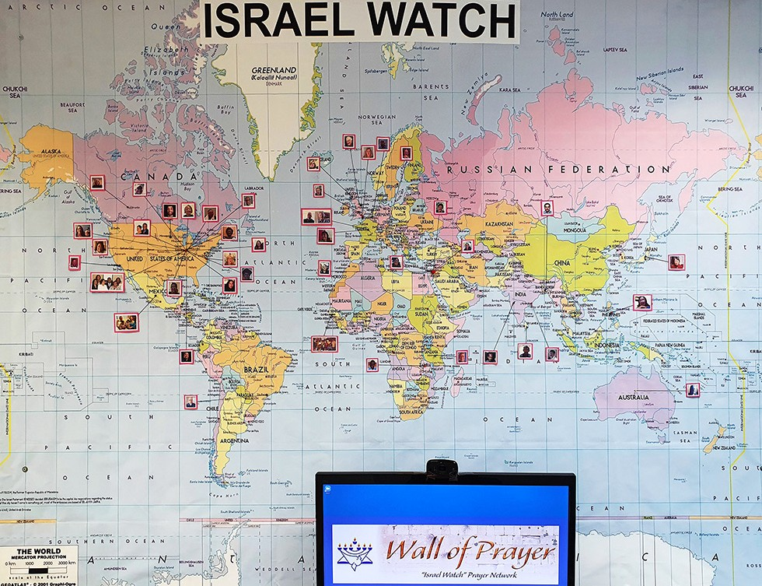
World Map in the Prayer Department

The Jerusalem office sponsors three prayer groups who regularly petition God on behalf of Israel: A staff team, CFI Representatives, and our team from the nations.
In the last month, we have experienced an overall acceleration by the Holy Spirit in the power and strategic

direction of our prayers in all three groups. Many of the international representatives also have prayer teams in their countries. Praise God for this impetus of more prayer in these difficult times!
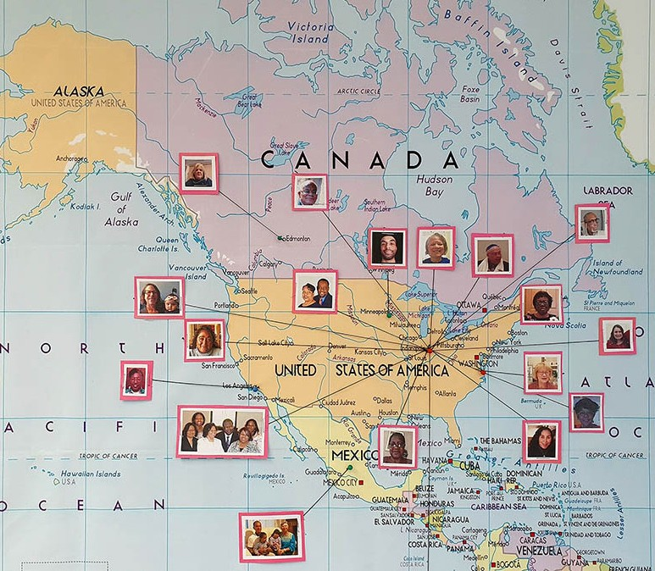
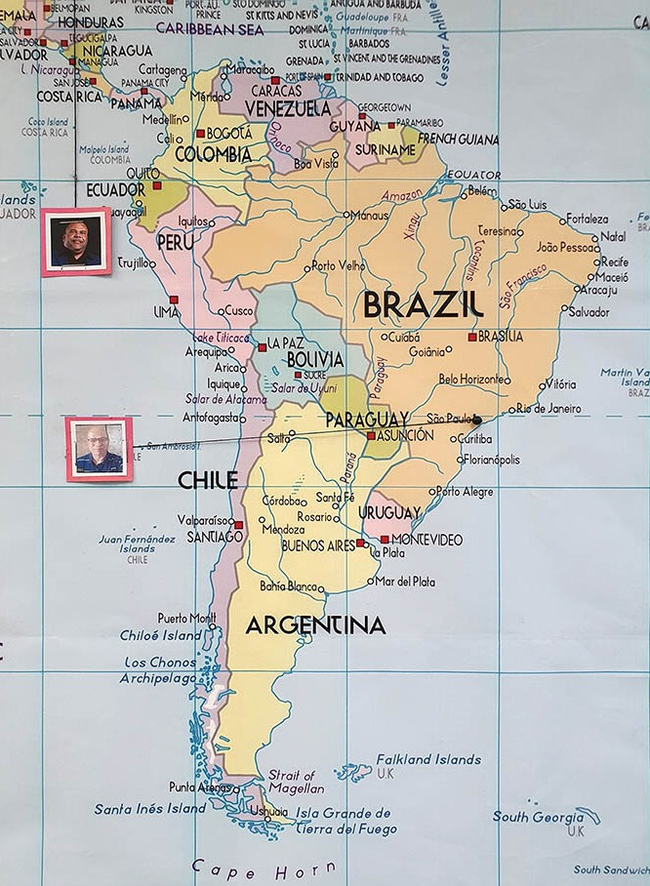
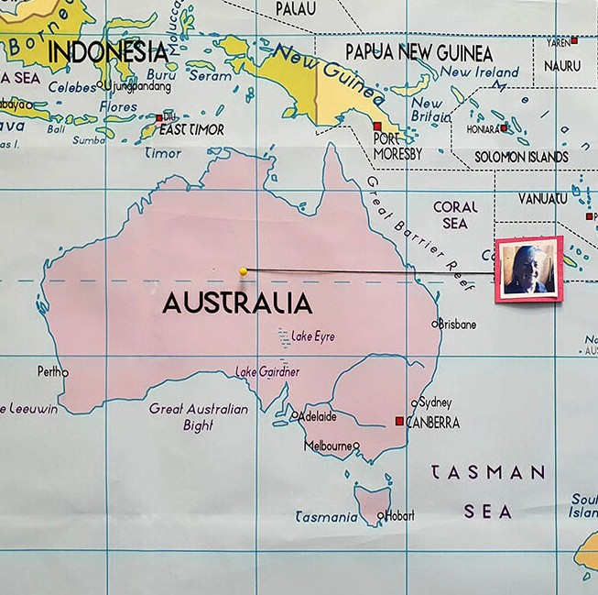
North America South America Australia
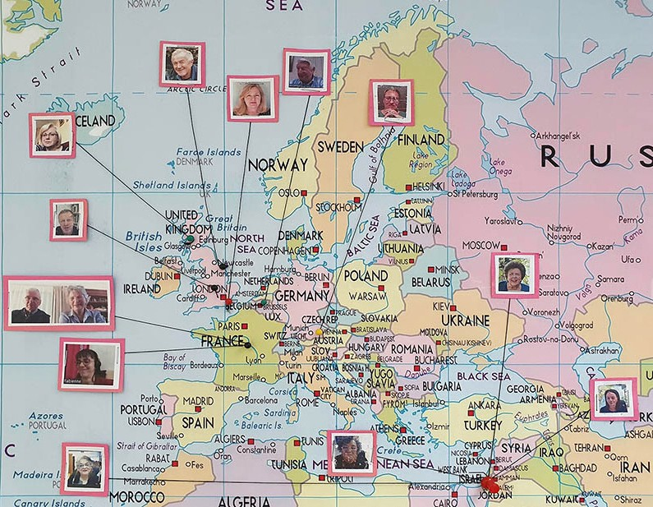
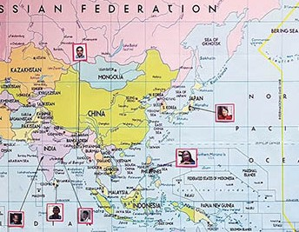
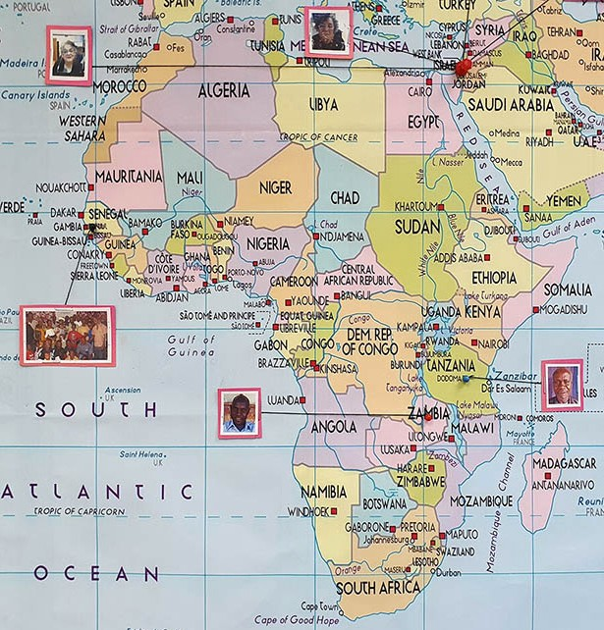
Europe Asia Africa

We have found that as we pray together on behalf of Israel, God is strengthening us. This month our team from the nations began praying not only for Israel, but also for the CFI Representatives who are promoting and supporting Israel in their various countries, especially where they face strong anti- Semitism. We
are watching God move as the spiritual momentum builds. To God be the glory for the things He is doing through prayer.

Thank you for your committed stance on the side of Israel and actually on the side of the God of Israel. We appreciate your sacrifices, love, prayers, and support. May the Lord bless you in every aspect of your lives.
Linda McMurray Project Supervisor

