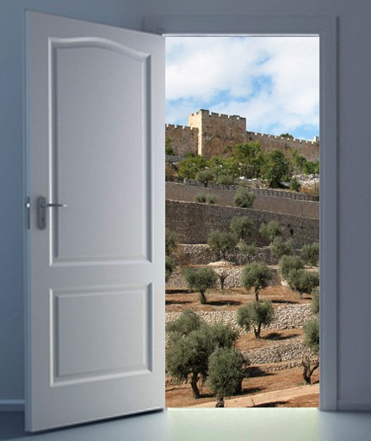
in

Prayer Letter
Watchman’s

Christian Friends of Israel prayer@cfijerusalem.org www.cfijerusalem.org
June 2022 /Jewish Year 5782
Doors of Opportunity
“Therefore, pay careful attention to how you conduct your life – live wisely, not unwisely. Use your time well, for these are evil days. So don’t be foolish but try to understand what the will of the Lord is” (Ephesians 5:15-17, CJB).

March 1, 2022, marked a momen- tous day. It was the day that Israel announced the reopening of its doors to tourism after two years of rigid covid travel restrictions. Tourists of all ages may now enter Israel, vaccinated or unvaccinat- ed, with only a few requirements. Many people have prayed for this time of open travel. We praise God for answering our prayers! In Ephesians 5:15-17, Paul instruct- ed the believers to live wisely and ‘redeem the time,’ which meant to take advantage of the opportuni- ties God had given them to further His Kingdom. This is the season of the “open door.” As we move clos- er to the end times, I believe God wants us listen to His directions and do all we can while we can.

The CFI Jerusalem staff are excit- ed because the ‘open doors’ have allowed new volunteers from vari- ous countries to join our team and others to return from abroad. Some staff had to wait several months, facing last-minute setbacks, but they finally arrived. We expect the Lord to send more workers be- cause there is much to do for the Kingdom of God in Israel.

Has God placed assignments on your heart that you have postponed until a more convenient time? Perhaps you need to revisit such assignments. Is the door of opportunity now open? Apostle Paul recognized open- ings for him to do Kingdom work, so he arranged his schedule to accommodate God’s agenda. He wrote to the believers in Corinth, saying, “I will stay on at Ephesus until Shavuot for a great door has opened wide for me, though many are in opposition” (1 Corinthians 16:8-9, TLV). Please notice that although the door of great opportunity was open for Paul, he still faced opposing spiritual forces, which is to say that although God may direct our steps through the doorway, we may confront challenges. Always remember, the Greater One who lives within us gives us the power to overcome obstacles and push past resistance. John encouraged the believers when he said to them, “You belong to God, children, and you have conquered them, for the one who is in you is greater than the one who is in the world” (1 John 4:4, NABRE).

I remember well the time when God was calling me to serve in Jerusalem. I resisted His voice, wrestling with the decision for several months, telling Him that I could not go because I was a grandmother. God was merciful and loving as He allowed me the time to draw closer to Him and submit to His will. Are you struggling with obeying God’s call on your life? The word of the Lord to Israel in Psalm 95:7-8 says, “Today if only you would hear his voice, do not harden your hearts.” I believe this verse also applies to Believers who have been spirit- ually grafted into Israel through the blood of Yeshua. Obeying God’s voice and coming to serve in Israel has brought me more fulfillment than I could have ever imagined. The words of 1 Corinthians 2:9, CJB, describe my experience, and I quote, “But, as the Tanakh says, ‘No eye has seen, no ear has heard, and no one’s heart has imagined all the things that God has prepared for those who love him.’ ”

In Psalm 90:12, NIV, Moses wrote, “So teach us to number our days that we may gain a heart of wisdom.” As we realize the brevity of life and the continual change of seasons, it is wise for us to hear God and follow His instructions. Yeshua spoke to His disciples about the value of time in John 9:4, when He said, “As long as it is day, we must keep doing the work of the One who sent me; the night is coming when no one can work.” There is coming a time when this age will end, and the doors of opportunity will close. Please do not let time run out on what God has given you to fulfill in the Kingdom. This is not the time to procrastinate. Many people say that coming to Israel is on their “to-do” list. Is God nudging you to journey to the Holy Land? Perhaps now is the time to get your passport and save your ‘shekels’ for the trip. The door is open. We at CFI welcome you to join us for a prayer walk in the land of Israel! Together we can pray onsite with insight.

Let us pray for doors of opportunity!
- Praise God for His omniscience! He knows everything and has a divine strategy and timetable for every event. “For My thoughts are not your thoughts, nor are your ways My ways. It is a declaration of Adonai. For as the heavens are higher than earth, so are My ways higher than your ways, and My thoughts than your thoughts” (Isaiah 55:8-9, TLV).

- Pray that Yeshua would cause divine discontentment among Believers who are not fulfilling His purposes in their lives. Please pray that they will awaken to see the opportunities He has opened for them. “I know what you are doing. Look, I have put in front of you an open door, and no one can shut it” (Revelation 3:8, CJB).

- Ask the Lord to send more volunteers to CFI and other ministries that need workers. The new immigrants are calling and arriving at our Operation Start-up store to receive household items – especially the Ukrainians, and we need more volunteers to assist them. In Luke 10:2, Yeshua told His disciples, “The harvest is plentiful, but the workers are few. Therefore, beg the Lord of the harvest to send out workers into His harvest” (TLV).

- Thank God for Israel’s “open door” to olim (immigrants) from the nations. Please continue to intercede as He calls His people to come home to Israel from the corners of the earth. Like a strong magnet, may the Spirit of God supernaturally draw those of Jewish heritage back to Israel despite obstacles or resistance. “Fear not, for I am with you; I will bring your descendants from the east and gather you from the west; I will say to the north, ‘Give them up! ’And to the south, ‘Do not keep them back!’ Bring My sons from afar, and My daughters from the ends of the earth” (Isaiah 43:5-6, NKJV).

Dear Prayer Warriors,
In the northern hemisphere, the summer is here – a time of sunshine and activity. Watching more tour buses driving through the streets of Jerusalem brings me great joy! CFI is happy to be a part of what God is doing in this season. As you continue in intercession for Israel and the nations, I pray that you hear God’s voice clearly about how you should use the time He has given you.

Shalom,

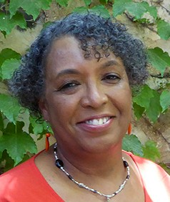
Linda D. McMurray
Wall of Prayer Coordinator

