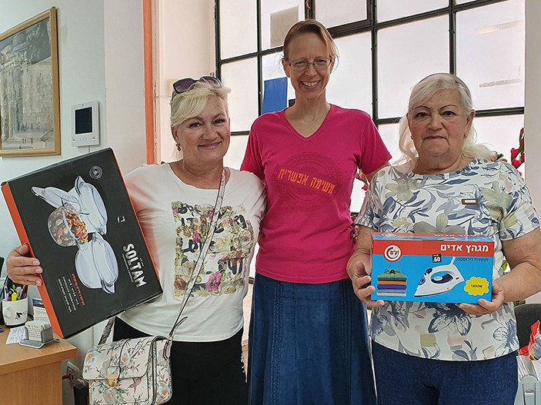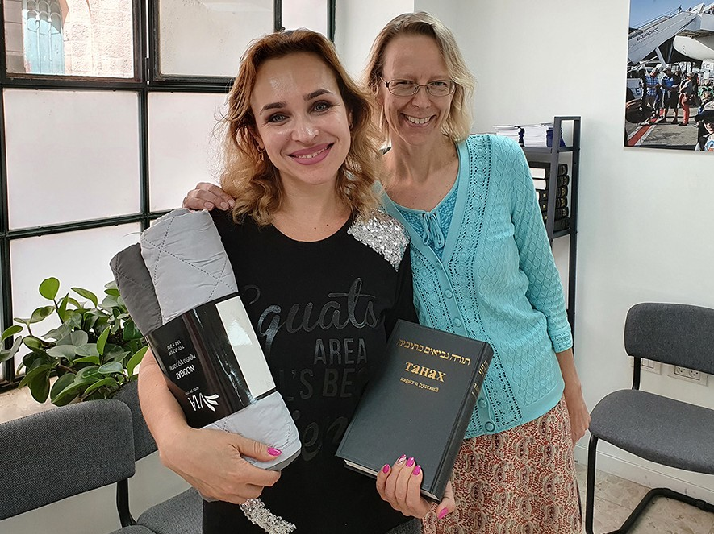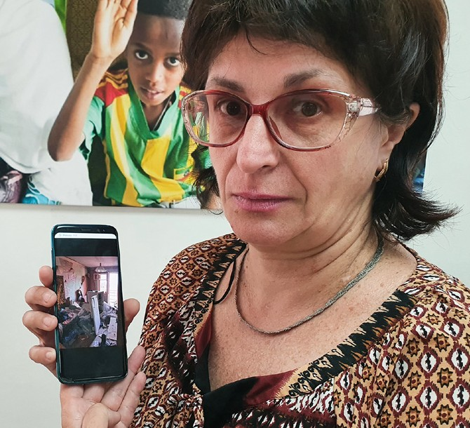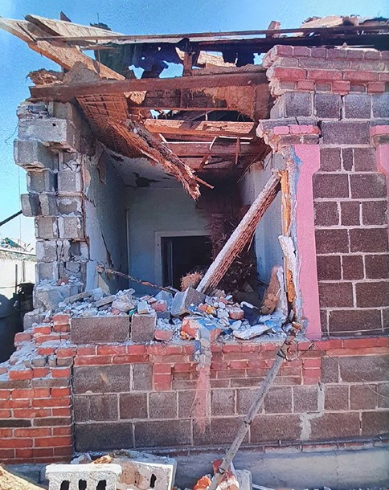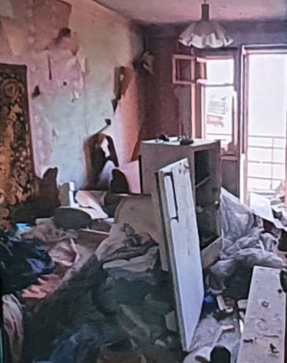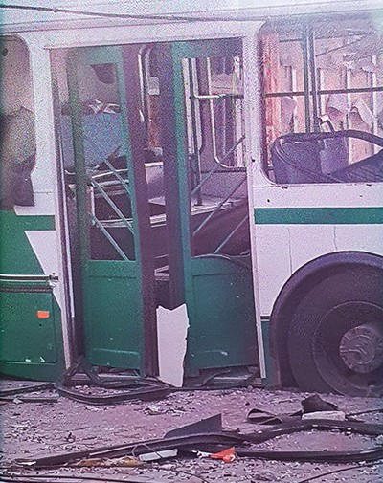
in

Prayer Letter
Watchman’s

Christian Friends of Israel prayer@cfijerusalem.org www.cfijerusalem.org
July 2022 /Jewish Year 5782
HELPING THOSE IN CRISIS
“Which of these three seems to you a neighbor to the one attacked by robbers? And he said, ‘The one who showed mercy to him.’ Then Yeshua said to him, ‘Go, and you do the same’” (Luke 10:36-37, TLV).

February 24, 2022, was the day that Russia invaded Ukraine. Since then, the war has continued to rage. Over 30 nations have responded to this crisis by sending financial aid, emergency supplies or military equipment to enable Ukraine to defend itself. Numerous countries, including Israel, have welcomed Ukrainians fleeing death and destruction. “From the start of the war in Ukraine, the State of Israel has received more than 15,000 new immigrants, and this is a source of great national pride,” stated Israel’s Immigration and Absorption Minister Pnina Tamano-Shata. The most popular Israeli cities for these olim (immigrants) to settle in are Netanya, Je- rusalem, Tel Aviv, and Haifa. In Isaiah 25:4, TLV, the prophet exalted the Lord for rescuing them in their time of trouble, it says, “For You have been a stronghold for the poor, a stronghold for the needy in distress, a refuge from the rainstorm, a shade from the heat. For the breath of the ruthless is like a storm against the wall.” God has demonstrated His role as a rescuer through the lives of these immigrants from Ukraine.

Israel offers temporary housing to these new citizens who must settle and find an apartment within a month. This task can be daunting for people who may be traumatized from seeing death and destruction and possibly leaving male family members behind to help defend their homeland. They desperately need our prayers! CFI has come alongside over 500 new citizens from Ukraine to help them start a new life in Israel through the Open Gates outreach. Project supervisor Tiina Danilevski and her team offer compassion and comfort to the newcomers as they are provided with personal items, household articles, and the Tanak (Jewish scriptures).

A few weeks ago, a young Ukrainian woman told me her story of escape during this war. She visited Jerusa- lem several years ago, and once, during her worship time in the Holy City, she experienced an immersion in the Ruach HaKodesh (Holy Spirit.) She returned to Ukraine a new person, painting pictures of visions that God gave her. When the Russian attack began, she and her family had to flee from their home in Kharkiv with only 20 minutes to grab clothing. Some people in her community hid in bomb shelters or the kehila (congrega- tions) for protection, safety, and companionship. There were major traffic jams as people scrambled to leave the area. She said it was frightening to see once-beautiful places in total ruin. At one point, her family stayed in a big house near an airport where 16 people shared living quarters. During days of very little sleep, she continually prayed Psalms 91, “He who dwells in the secret place of the Most High shall abide under the shadow of the Almighty. I will say of the Lord, ‘He is my refuge and my fortress; My God, in Him I will trust’” (Psalm 91:1-2, NKJV). Eventually, her parents felt it was time to move out of that house and make room for others who were arriving. Shortly after her family left, Russia attacked the airport, and that area was bombed. Once again, Psalm 91 was proven true, “A thousand may fall at your side and ten thousand at your right hand, but danger will not come near you” (Psalm 91:7, AMP).

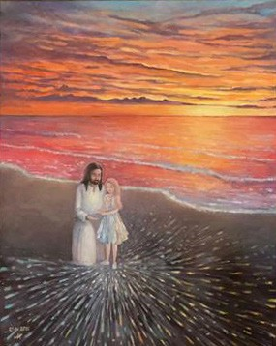When Ukraine pushed back the Russian army from Kharkiv, the young woman and her family were able to return to their home to gather some belongings. She said the Lord instructed her to take a painting that He had inspired her to create, and she obeyed. Because her family had dual citizenship in another country, the females and grandparents were allowed to leave Ukraine and immigrate to that country. Her father drove for 36 hours without sleep to get his family to safety although he and his son have remained in Ukraine to help defend the nation.

The young woman was very grateful for God’s provision and protec- tion. She felt she should return to Jerusalem to give her original paint- ing to those who had blessed her spiritually. Therefore, she chartered a weekend flight to Israel to deliver her gift and immediately returned to her family. This gift represented her thanksgiving offering to God. “What shall I repay to the LORD For all His benefits to me? I will lift up the cup of salvation, and call upon the name of the LORD” (Psalm 116:12-13, NASB).

Please join us in prayer for people in crisis
- Praise God for being our shelter. The young woman from Ukraine said that during this war, there have been many miracles of protection among the members of her kehila (congregation). “I will praise You, LORD, among the peoples; I will sing praises to You among the nations” (Psalm 108:3, HCSB). “He performs wonders that cannot be fathomed, miracles that cannot be counted” (Job 9:10, NIV).

- Intercede for people coming from traumatic situations and trying to start a new life in a different place. Although they may be bitter like Naomi in the Book of Ruth, ask God to send them someone like Ruth to walk with them through a difficult transition. “Ruth replied, ‘Do not plead with me to abandon you, to turn back from following you. For where you go, I will go’” (Ruth 1:16, TLV). Has God summoned you to be like Ruth? It may be hard work, but the outcome will glorify God! .

- Pray that the hearts of the new immigrants will be soft, fertile ground for the Spirit of God to blossom forth among them. “For I will pour water on the thirsty land and streams on the dry ground; I will pour my Spirit on your descendants, my blessing on your offspring” (Isaiah 44:3, CJB).

To our Dear Prayer Warriors
In His Sermon on the Mount, Yeshua (Jesus) taught His followers, “You are light for the world. Let your light shine before people, so that they may see the good things you do and praise your Father in heav- en” (Matthew 5:14, 16, CJB). In these times of spiritual darkness, when we come alongside people in crisis with Yeshua’s attitude and heart, let our prayers and actions turn their focus toward God. As we serve in this manner, our lives will bring Him glory.

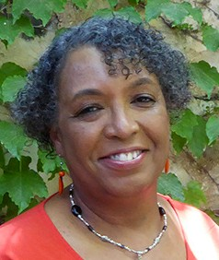
In His Love,

Linda D. McMurray
Wall of Prayer Coordinator

