CFI Projects Monthly Reports for
International
Representatives

Dear CFI International Representative Family,

Thank you for your continued support of the Outreach efforts of Christian Friends of Israel. We continue to strive to encourage those in need and to offer practical assistance during times of struggle. It’s during these times when relationships can be formed which please God and allow us to show Compassion to those who need it the most and have possibly never experienced it before.

During this time of global pandemic, we continue to offer assistance as we are able, and we know each passing day may allow for additional hardships, but we also know the God whom we serve. He is more than able to protect, and provide and heal. We are willing to represent Him to the people of Israel.

Please receive the CFI Outreach electronic updates as a reminder
of the impact each of you have in the lives of so many. We are grateful to represent those of you in the Nations - to those in the Land of Israel.

A friend loves at all times, And a brother is born for adversity.

Proverbs 17:17 (NKJV)

Project Forsake Them Not

When reading a letter, or even a book, written by someone I know well I can often hear the voice of
the one who wrote it. It’s comforting, really, don’t you think? We heard many such voices, my colleague and I, during the lockdown in May as we worked in the office writing and reading through the stories of our precious survivors. Every story would bring back many memories of the wonderful times we spent at their homes. Every story was like a revisit, as if we just stopped and took time to look back into their eyes; eyes so often full of pain and hope as they recounted the events of their past.
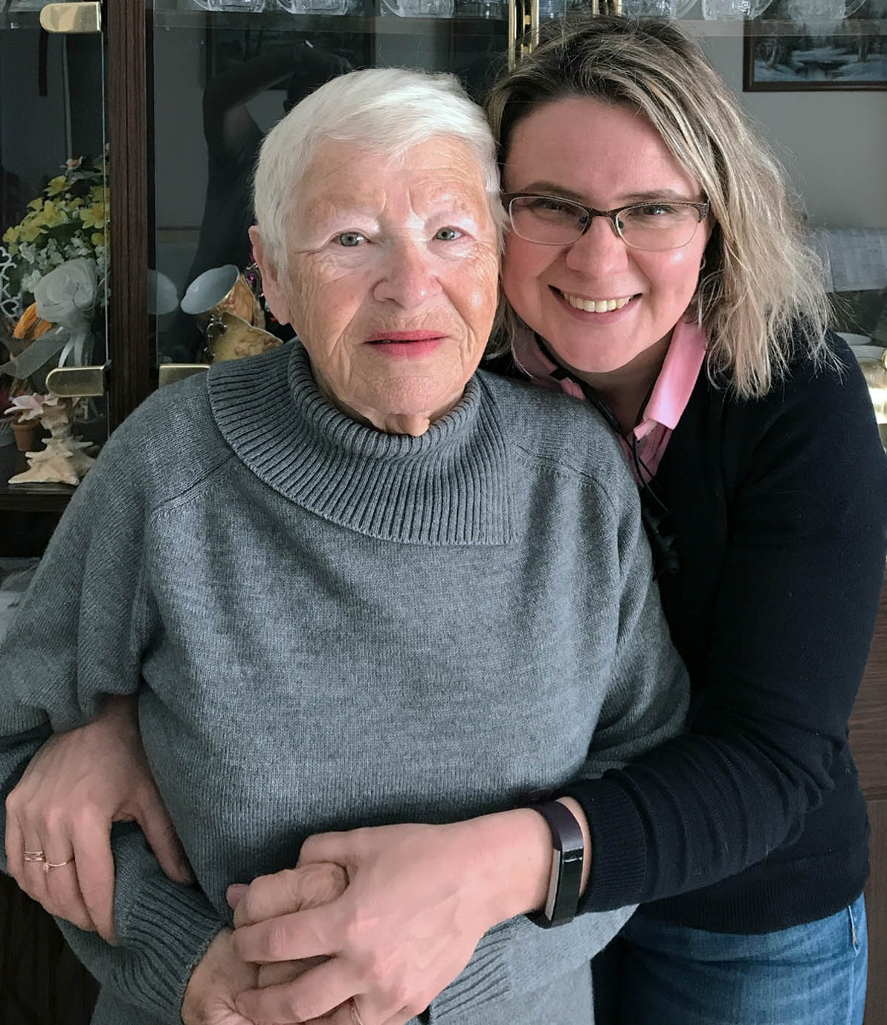
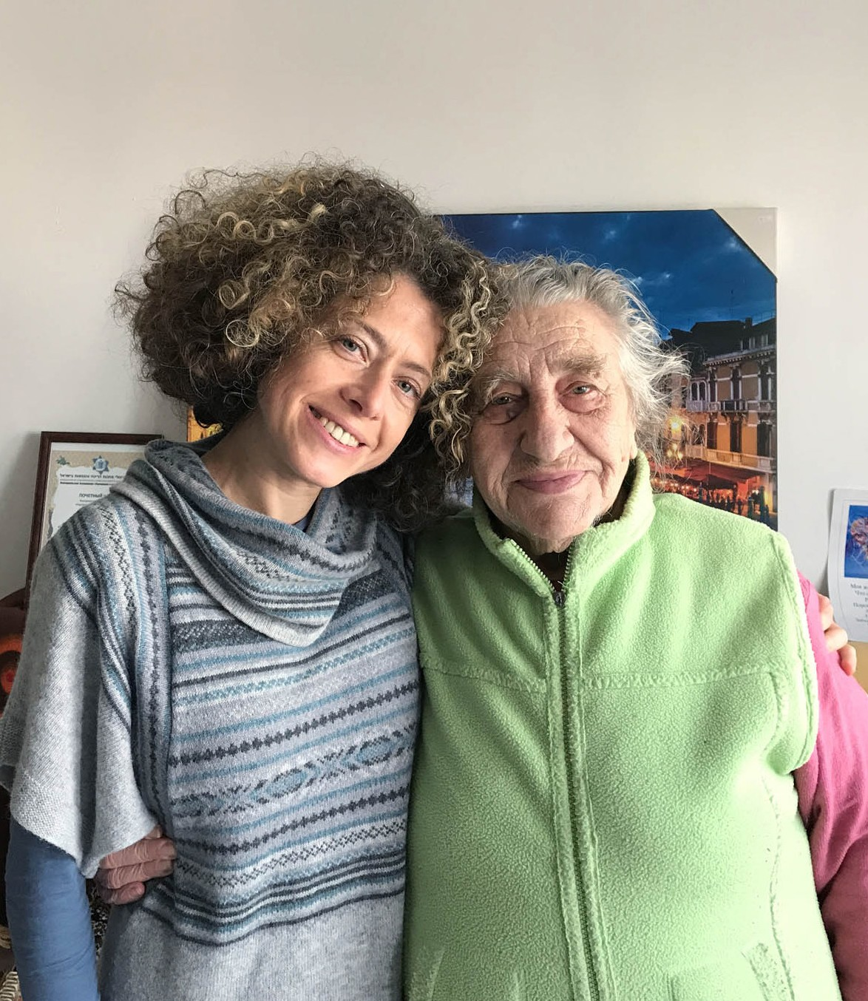
Klara from Haifa has no family in Israel. When we visited her for the first time her husband had just passed away. We didn’t say much that day; we just simply listened to her broken heart, and wept with the one who wept. We left, feeling that the Lord really bound our hearts; Klara was smiling by then and we felt the sense of release for her. Klara, in her younger days, was a teacher, she was always helping people in need. Our visit that day was at a time when Klara needed help herself, and we were glad for the privilege of being there for her. All the following visits were filled with many stories, but never about the Holocaust until, one day, she finally opened up to share a few details of her story that she learned from her parents; Details that saved her life.

Klara’s family lived in a town called Balta. She was only 18 months old when the war started. A ghetto was formed, where there were very strict rules. From time to time the Germans would conduct killing raids, and they also used some of the children from the ghetto to draw b lood, for use in medical experiments. Because Klara was so little her parents were afraid she would not survive, so they hid her in a wooden box. Klara spent most of her time in this box, and thankfully she was a quiet child. The box was either hidden under a sofa or under the stove. Sometimes her parents thought she had died as she was so quiet. There was often a lot of shooting in the ghetto, and it was not possible for anyone to escape. Klara’s father was then chosen to work in the kitchen of the police, and he was able to bring food back to the family. It really was a miracle that the whole family survived, even little Klara, in her small dark box.

Manya and Luba are two sisters who share a rented apartment. Their lives are modest, hearts simple, smiles wide. They shared their stories with us too.

“Manya and Luba were born in Bratslav in Ukraine, which was a centre of Jewish culture and tradition. Their father was handicapped, deaf and mute. He was an undertaker, responsible for burying the dead in their town. Their mother was an orphan from a poor background, and was uneducated. She stayed home taking care of their three children and the home. They had an older brother.

When the war started all the Jews in the town were sent to the death camp Pechora. They were housed in a three story building surrounded by a brick wall and no-one was allowed out of the area. It was extremely overcrowded. Everyday people died of hunger and sickness, but also every day more Jews arrived. Their father always had work taking the dead bodies out of the camp to bury them, and some- times others helped him. Because of their father’s job the whole family was able to survive as he was always able to return to the camp with some food. However, sometimes when he returned he had been beaten and once he had been beaten so badly all his teeth had been knocked out.

Towards the end of the war Manya was born. Her father smuggled her out of the camp with some of the dead bodies and gave her to a local Christian woman to care for. The woman had 5 children of her own but was still willing to take Manya and save her life. 35,000 prisoners were killed at the camp. By the time the camp was liberated by the Red Army on March 17, 1944, no more than 300-400 people were left alive. After the war Manya was able to be reunited with her family.”
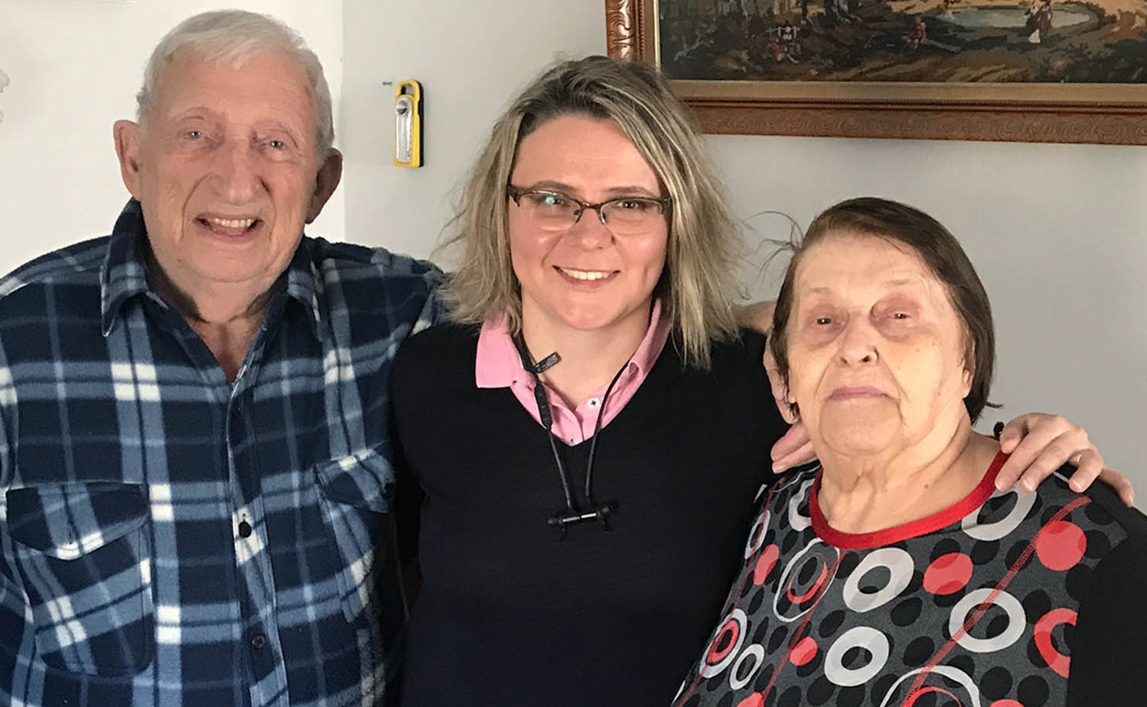
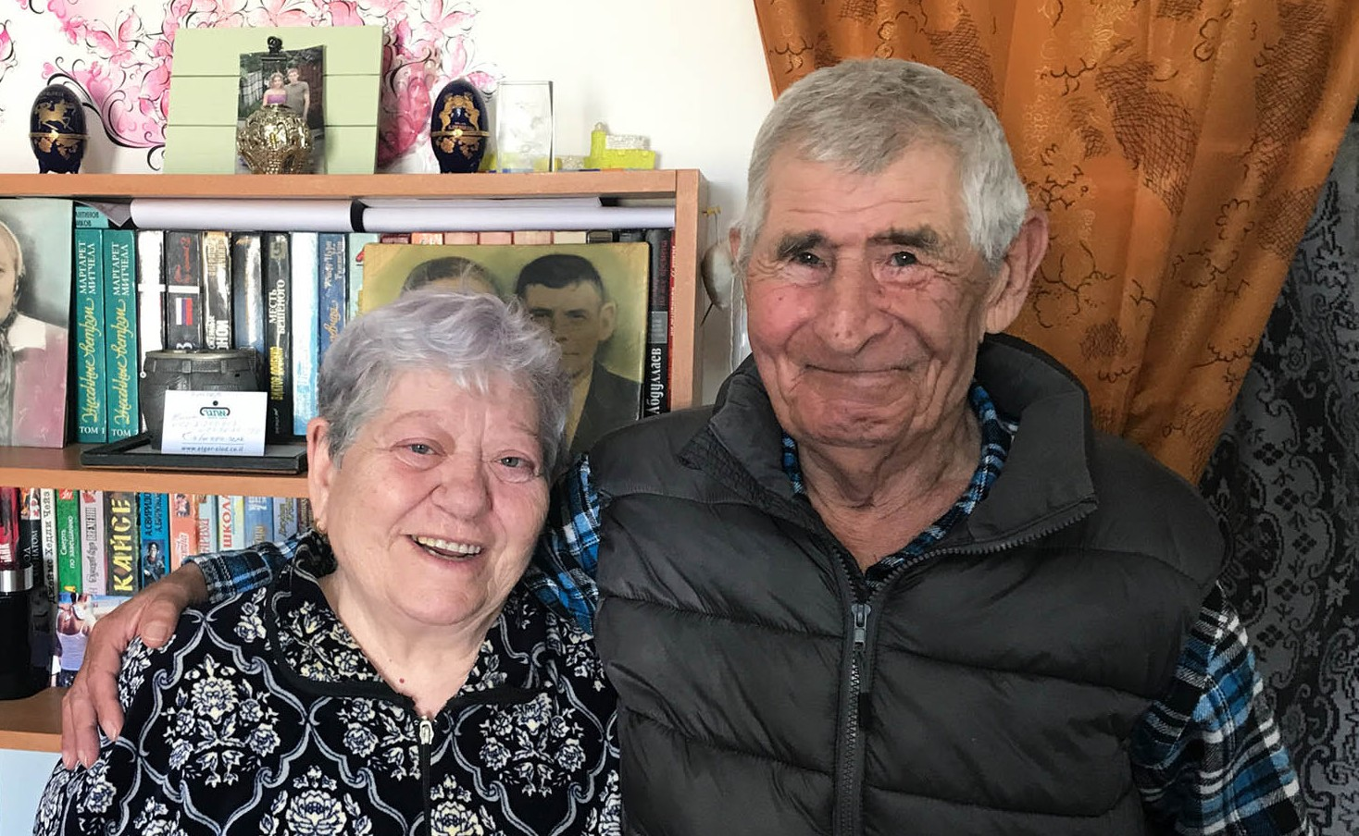
Often, to put these words on paper can feel like a journey, enough for an entire day. We listen, we pray, we look into their eyes again, we weep, and we praise; praise the One, who was, and is still able to preserve lives. He is Our God of Miracles.
We miss them. They miss us. We hope to be visiting them soon again.

In the meantime, we are ever grateful for your continued support. THANK YOU! May God continue to bless you all and keep you in His perfect peace.

“Let all those who seek You rejoice and be glad in You; Let such as love Your salvation say continually, “The Lord be magnified!”.” (Psalm 40:16)

Olga Kopilova Project Coordinator

Project David’s Shield

Dear Friends of Israel,

Oh, give thanks to the Lord, for He is good! For His mercy endures forever. Let the redeemed of the Lord say so, whom He has redeemed from the hand of the enemy, and gathered out of the lands, from the east and from the west, from the north and from the south. (Psalm 107:1-3 NKJV)

The duty of defending Israel never ceases. The intentions of her enemies – to destroy the state of Israel
– also never ceases. There continues to be an ever necessary defense force to counteract the many evolving tactics of the enemies of Israel.

We are always privileged to encourage the brave warriors of those who defend Israel, and recently we had the honor to visit a Magav (Border Police) Unit operating as internal border patrol outside of Jerusalem.

CFI and project David’s Shield has donated tactical radio equipment and clothing for special use. This highly trained counter terrorism unit and a division of the Israel Security Forces that shields those that need defense is an all-volunteer unit operating along with the Border Police.

We praise the Lord for continuing to be witnesses to the ways of God and encouraging those who even in times of war, terrorist activity and physical threat, promote the very basic message of love that God gave to the Jewish People – that being to choose Life…

Thank you for your support of prayers and resources as we continue to represent you as Christian Friends of Israel.

Shalom from Jerusalem,
Jim McKenzie Project Coordinator

Project Open Gates

Dear coworkers and friends from the nations,

I am happy to tell you that we have been a great blessing for many people of the Land in this month. Because of the situation with Covid-19 many families are in need. So are the new emigrants. I make appoint- ments with different individuals and they come in one by one. We still have quite a lot of clothing from the UK.

Our clients have been thankful to get good quality things for themselves and for their family members. I have been very busy every morning receiving and serving new emigrants, pensioners and some needy
families. People are calling us every day. They want to visit us from different cities, not only from Jerusalem.

One family with four children got lot of things from us. After finishing expensive courses the husband was working as a tour guide. It is a good job in the Land, especially, if you know languages. Now the situation changed radically. There is no work for tour guides because of the corona virus. The family is in need.
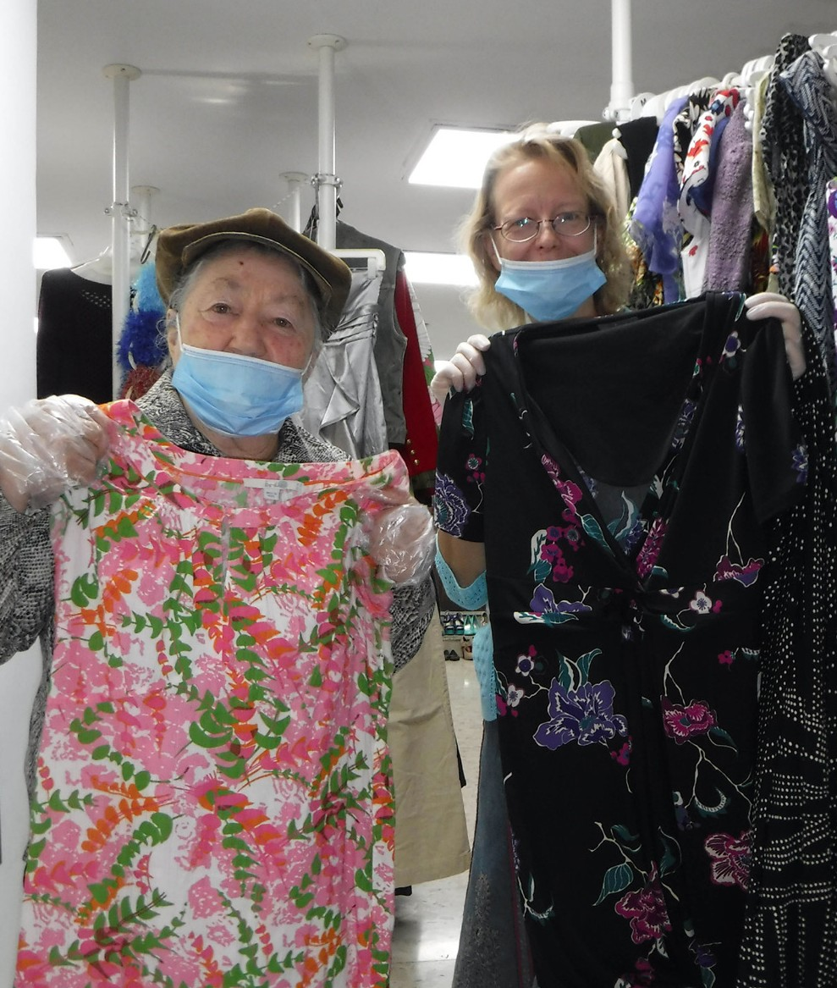
I am glad that we could give them something. Please, pray that the Lord’s hand will be over all the families in the Land.

There are people, who made Aliyah during this spring. It is great to see their motivation to have a new life in Israel. There are a lot of challenges in their lives, but I am sure that God will take care of those who made the choice to live in the promised Land. We as Christians from the nations can be involved in this.

God uses us to encourage His people in their first steps in the Land, and these new immigrants
remember it for the rest of their life. Many of them tell us stories of how Christians helped them to get to Israel. The goodness of the believers really touched the hearts of these people.

Let us continue in God’s business. Be blessed in the name of Yeshua.

Tiina Karkkainen Project Coordinator

Project Bridal Salon

Dear co-workers and friends,

After the corona lock-down season the work in our Bridal Salon is getting very busy. I have about 3 clients coming in every week. I serve them after lunch. The wedding plans of many future couples have been changed many times during this unusual time period. But what I see: People still want to get married in the Land! At the moment there is again a possibility to gather friends and relatives for the celebration in Israel. You need to keep rules given by the government, but you can have a bigger wedding, if you want. Many people are using this moment. Our help is welcome, because the financial situation of many families is difficult.

This week we had three ladies here that I was able to serve. Their friends and relatives stood outside, but we showed them the best options by opening the door once in a while. It was unusual, but fun. Every ‘bride to be’, found beautiful fitting dresses for themselves and for all three of them it was difficult to make the decision. Some girls needed days or even weeks to be sure about their choices. I kept the best dresses reserved for them.
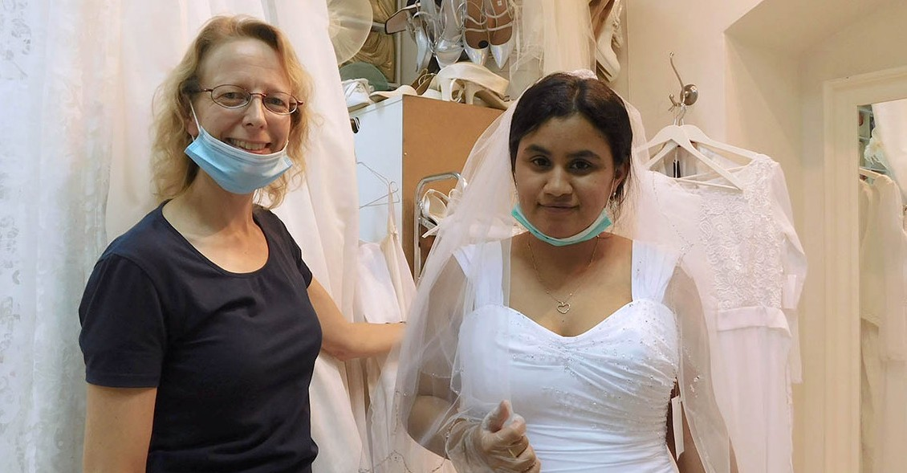

Some ‘brides to be’ have brought their dresses back without using them, because their weddings were canceled for an unknown period of time, but they know that they are welcome back, whenever they need a dress again. This time has sadness in it, but at the same time every wedding story is different and special this year. The Love and decisions of many future couples are tested during these months. It is good, even if it is not easy.

Thank you for your prayers! Greetings from the City of the great King! We are doing special work together!

Tiina Karkkainen Project Coordinator

Project Hope For The Future

We are more than courageous in Him who helps us to triumph!

“But thanks be to God, who always leads us as captives in Christ’s triumphal procession and uses us to spread the aroma of the knowledge of Him everywhere.”
2 Corinthians 2:14

We are presently moving forward in the community of Ethiopian Jews in the aftermath of the events of the past couple of months. It may have hit them hard, below the belt, financially and with added family stresses. I should mention that the death toll, concerning the corona, was zero but never the less the amount of domestic violence increased.

One mother of three living with her husband was slain for not fixing a cup of coffee and sitting with him. We are praying for the families to get the much-needed help during these days of stress.

Our purpose at Hope for the Future is to reach out and extend a hand to help eliminate the suffering, the pain, and stresses using the resources we have.

Hope for the Future was able to return to the Home Office a couple of weeks ago, giving us the ability to travel to meet many clients in public places, reaching out to help those in need, with food vouchers, student tuition, and financial resources.

Many clients could not have predicted nor prevented the outcome of being in quarantine and consequently unable to work. Hope for the Future responded to a request from a college student who she found that she could not pay her rent. It is sad to see those unable to pay for their rent, while pushing themselves to make a better life at school or interning. We felt compassion for this young woman and helped her pay her rent, therefore easing her situation, so she could continue her last year as a law student.

We hope to continue to see those working hard to help themselves receive a better life. In all this we fully appreciate the heart of those that join together to help CFI become the hands of help the Ethiopian community in Israel needs.

Marcia Brunson Project Coordinator

Project First Fruits

For when he sees his children, the work of My hands, in his midst, They will sanctify My Name; They will sanctify the Holy One of Jacob And will stand in awe and reverent fear of the God of Israel. Isaiah 29:23

We returned to a full schedule at CFI’s First Fruits with a new vigour and determination to undergird those that carry the banner of Yeshua/Jesus in the land. We have been able to renew long standing relationships in the faith community and initiate new alliances with ministries in the city and nation in
a short period of time. I am pleased to relate to those in the earth that are so consistent in their support for the projects at CFI and for this project specifically, that we remain impactful to as diverse an array of individuals and organizations as is represented in the Body of Christ in total.

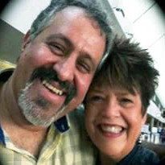
First, we stepped up to support another couple that was struggling with status issues via our good friends at Jerusalem Institute of Justice.
A believing Arab Citizen and minister is married to an American wife and she has finally obtained temporary resident status which allows her to be productive for her household and ministry within Jerusalem, due to the legal efforts of JIJ. We were especially happy to partner with this particular case at this time, as one of the prominent members of JIJ’s staff and vision, went home to be with the Lord after succumbing in a valiant battle against cancer recently. We honour her memory and servanthood in the community by defraying legal costs in this ministry couple’s dilemma.

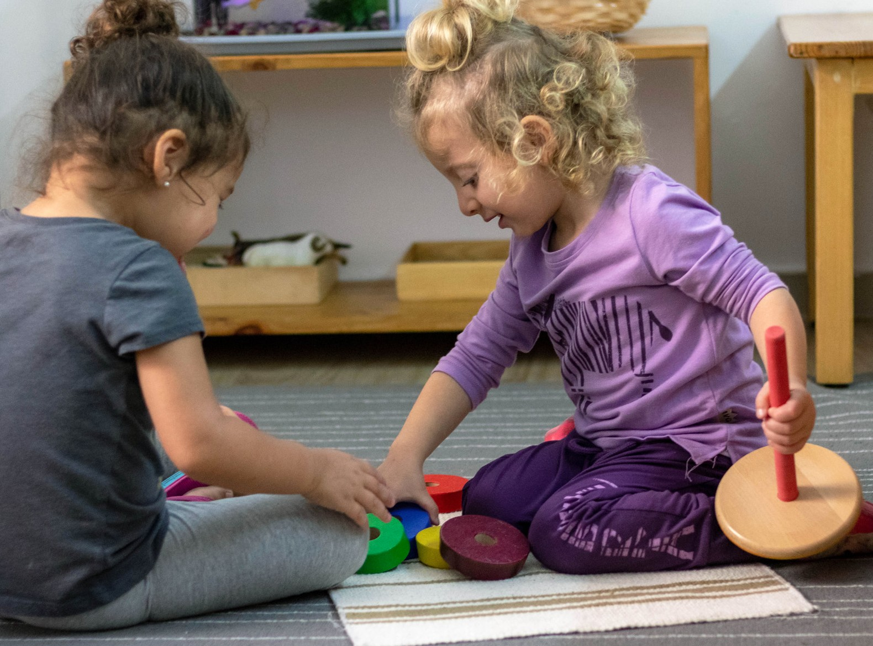
CFI has also resumed tangible support for Little Hearts Preschool, the only believing pre- school within Jerusalem with the added appeal of a Montessori learning model, after doing so years ago. Though there are only about
50-75 students at any one time participating, these little ones are already exposed to every tribe and every tongue of believer represented here in the fertile crescent region. The staff is comprised of Jewish and Arab believers which in it of
itself resonates beyond the walls of the facility where they give children much needed attention. Through your assistance and prayer, we hope to raise the public profile of this special operation in God’s Kingdom purpose for the city of the Great King!

I was also able to initial a new relationship with Shepherd of Israel Ministries, which initiates an outreach from a home, near the municipal offices of Jerusalem, that has included new believers from the Muslim and orthodox communities, in the face of an environment of persecution and some hostility. Their welcoming message of the love of Yeshua resonates with our founders’ visions here, that being, the principal thing reflected in our interaction in this city and land, so it was not difficult for us to bond quickly with the leader and staff there regarding the part of the Kingdom they are assigned to.

Being our first month back post-COVID (if there is such a thing), I believe you can be satisfied the First Fruits project remains vibrant thanks to your ongoing and unflinching advocacy and activity in the nations.

Be to me a rock of refuge and a sheltering stronghold to which I may continually come; You have given the commandment to save me, For You are my rock and my fortress. Psalm 71:3

Kim Brunson Project Coordinator

Project Streams Of Blessings

COMFORTING THEM AND DRYING THEIR TEARS
Blessed are those who mourn, for they shall be comforted (Matthew 5:4)

From centuries, we have witnessed the goodness of God delivering His people, His chosen ones and comforting them in the least expected moment, after experiencing moments of difficulty and battle. We can never assume that silence or quiet is weak, when we come to a moment of surrender before God, expecting His Will to be done in our lives.

God comforts with love but more over He comforts with His redeeming victory.
Egypt tried to prevent the people of Israel from having the victory of reaching a Promised Land. But to this day everyone remembers how God not only freed them, but also comforted them all the way. The world remembers to this day the miracle of seeing the Red Sea open, bread from heaven falling from the sky and eventually giving them an inheritance that to this day is a Land where milk and honey flow.

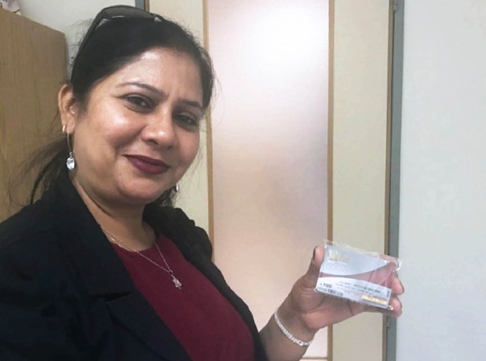
Silvia Kandlekar, born Jewish and living in India, worked in the Israeli embassy for several years in Delhi and apparently had a very settled life back there. A couple of years after, and due to domestic violence, she got divorced and decided to make the journey back home to Israel with her son Shai. Step by step she started her new life doing whatever possible, so that she could bring food to the table. She received help from the government for the first year and this gave her the opportunity to later on find proper employment according to her professional record.

The second time that she approached us for help, she remembered when she was assisted in 2015 at the Distribution Center with clothing, food and furniture to welcome her; she received very little emotional and financial help from her family during her crisis and her moving to Israel. When she contacted CFI
for this second time, we tried to convince her to let us help with her extra monthly payments, just to help her during this period during the virus. But she also wanted to walk the extra mile and keep knocking on doors until God provided a job, which is what she would need long term.

In every email that we sent out communicating with her, there was also lots of prayer for her to find a suitable opening. When we finally managed to meet her personally at our Head Quarters in Jerusalem we delivered an envelope with food vouchers for her to have food for at least the following month. She started crying with a smile of gratitude, as she expressed: “I have found along my life people closer than my own family. Thank you so much for helping me during this time of need.” As we continue sharing during her time in our offices, she was also heading to a job interview. After comforting her and praying over her, she left and promised to inform us about the outcome of her meeting. A couple of hours later she called and said, “You are the first to know; I have a job as an Assistant Manager”. We were more than happy to know and also reassure Sylvia on the phone that God honors her efforts, and that exactly at the end of our human’s effort, is where HE meets our needs.

We all want to witness miracles every single day and want to say to you all THANK YOU for being the miracle and for comforting the people of Israel even from a distance. Your monthly donations help us feed and support many of the needs, like heavenly manna, sent at the right place and time.

Karen Tohon Project Coordinator

Project Under His Wings

Dear Friend of Israel,

“…and circumcision is of the heart—by the Spirit, not the letter. ” Romans 2:29

There are two important prayer requests in this UHW update. It was reported that Palestinian intelligence offices in at least two cities in Judea and Samaria have been ordered to hide sensitive documents in preparation for possible violence. According to the report, a large number of physical files have been transferred to unspecified locations as the PA in Ramallah anticipates an uptick in tensions if Israel
goes ahead with applying sovereignty to 30% of Judea and Samaria and the Jordan Valley on July 1. Previously, such preparations were only made in the run-up to the Second Intifada, a violent uprising that lasted from 2000 until 2005 and which saw hundreds of terrorist attacks against Israeli citizens and IDF forces, claiming numerous lives. Please cover in prayer, Israel’s overall security as well as its preparedness to deal with this great potential challenge.

Another prayer point is to intercede for one particular group of Israeli Jews called the Breslov, that I came across with few days ago while heading home after work. Two of them were dancing on the
roof of a van with huge loudspeakers on their vehicle. Two more were dancing on the side of the street as bumper-to-bumper traffic passed by. A predominantly smiling crowd gathered around them on the sidewalk to watch. One passer-by joined in the dancing. “Na Nach Nachma Nachman Me’uman” is the Hebrew language painted on their vehicle meaning “Noah Nacham Nachman is trained”.

The name “Breslov” comes from the town of Breslov in the Ukraine where its founder Rabbi Nachman spent most of the last eight years of his life. The Breslov approach places great stress on serving God with joy and living life as intensely as possible. “It’s a great mitzvah always to be happy,” Nachman taught. The Message of Breslov is one of Simcha (Happiness), Simple prayer, Faith in God and finding the Tzaddik-Mashiach (Righteous Messiah). Some people also see the name as a play on words in Ash- kenazic Hebrew: “Bris lev” means “covenant (or circumcision) of the heart.

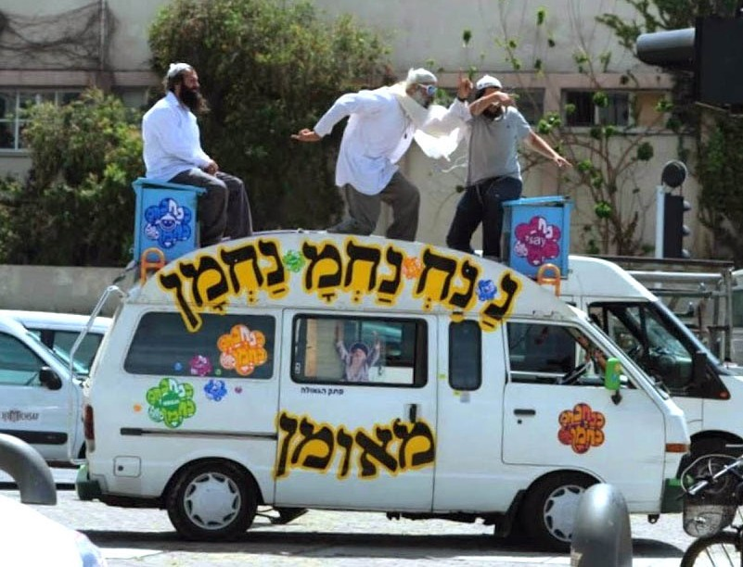
When I was reading these descriptions concerning the Breslov, the scripture in Romans 2:29 mentioned above came to mind. Let us intercede for the Breslov group that the Holy Spirit will do a deep work of ‘heart circumcision’ on many of them, prompting them to seek and find
the Righteous Messiah (Jeremiah 29:13).

May our Faithful God bless you and your family abundantly as you seek first His Kingdom so that you may continue to stand and prayerfully support Project UHW even in this challenging time.

Maggie Huang Project Coordinator

Project Communities Under Attack

Dear Friend of Israel,

“…Neither do I exercise myself in great matters, or in things too high for me.” (Psalm 131:1b)

Praise God that there has been a lull in violence in recent weeks in Southern Israel, adjacent to Gaza, with both Israel and the Palestinians focused on combating the outbreak of the coronavirus.

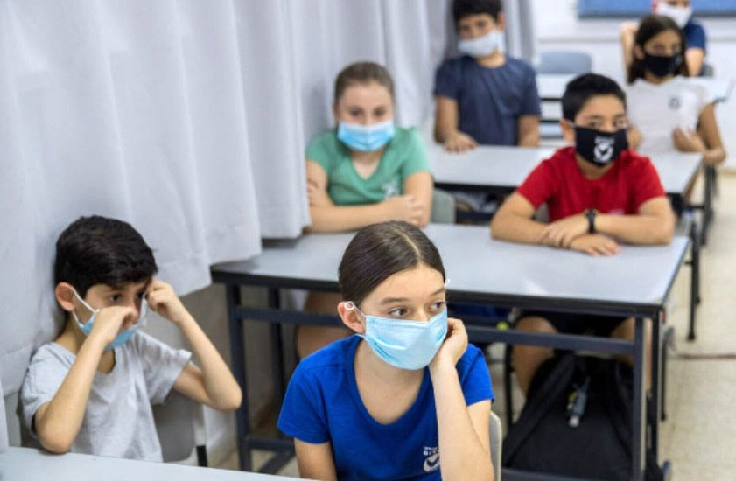
Israel has seen a spike in new coronavirus cases as schools, businesses, restaurants, bars, tourist attractions and other establish- ments reopen. As of early June nearly 24,000 students and staff were quarantined with 139 schools and daycares shut after reopening.
248 students, teachers and educational workers have now been diagnosed with coronavirus as cases in Israel are rising, including at one school in Sderot in the Gaza peripheral.

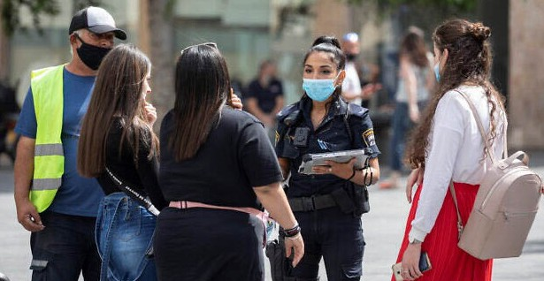
Sderot Municipality ordered that primary schools close after the Health Ministry report- ed that a student tested positive for coronavi- rus. Students in that school were ordered to quarantine themselves at home until June 17. The municipality was organizing tests for all students and staff at that school, a total of 350 people. The school is one of four in Sderot that have been forced to close due to corona- virus cases.

The reason for the new increase of Corona infections in Israel is that people have not
followed the government’s guidelines for reopening – wearing face masks, keeping social distancing
and hygiene. Health officials warned that some lockdown restrictions would be re-imposed if the infection continues to rise. Please pray that the Israelis will understand that this pandemic war is still not over that they will not be complacent but follow government’s guidelines (Psalm 131:1b).

On the 9th of June rocket sirens sounded in several communities near the Gaza border. An Israeli military spokesperson later said the sirens were a false alarm. This is the first time that rocket alert sirens have sounded during the Corona crisis as both Israel and Hamas have refrained from military activities while trying to counter the spread of the coronavirus.

Thank you for your ongoing support for Project CUA as CFI continues to reach out to communities under constant rocket attack from Gaza. May the Lord bless you and keep you and your loved ones and give you peace (Numbers 6:24-26).
Maggie Huang Project Coordinator

