CFI News Insights
Christian Friends of Israel
feedback@cfijerusalem.org
www.cfijerusalem.org

February 10, 2022 /Jewish Year 5782

Anti-Semitism and Aliyah:
“Incentive” for Jews to move to Israel from the nations on the rise

“She weeps bitterly in the night and her tears are [constantly] on her cheeks; Among all her lovers (political allies) She has no one to comfort her. All her friends have dealt treacherously with her; They have become her enemies Judah has gone into exile under affliction And under harsh servitude; She dwells among the [pagan] nations, But she has found no rest; All her pursuers have overtaken her in the midst of [her] distress” Lamentations 1:2-3 (AMP).

There has been a marked increase of random violence against Jews that reside beyond the borders of Israel in the last 2 years, both in Europe and in the Western Hemisphere. Recently these attacks, sometimes motivated by neo-fascist or extremist Islamic ideological mindsets regarding Jews, again took the spotlight in public awareness with a hostage crisis that took place at a synagogue in Texas, USA. A gunman intended to hold hostages until an infamous Pakistani Al-Queda terrorist might be freed from prison for her crimes against US military personnel in Afghanistan. Though this gunman’s specific priority may have been leveraging hostages for a prisoner release, there are many that know that it was not coincidental that he targeted Jews in their place of worship. As we mark International Holocaust Remembrance this week, it behooves us to recognize attitudes that remain in the earth that facilitated such a dark period previously, and to fashion an appropriate response from those of us who acknowledge Yeshua as Messiah and Lord, and can point to Israel and the Jews as the foundation of our faith.
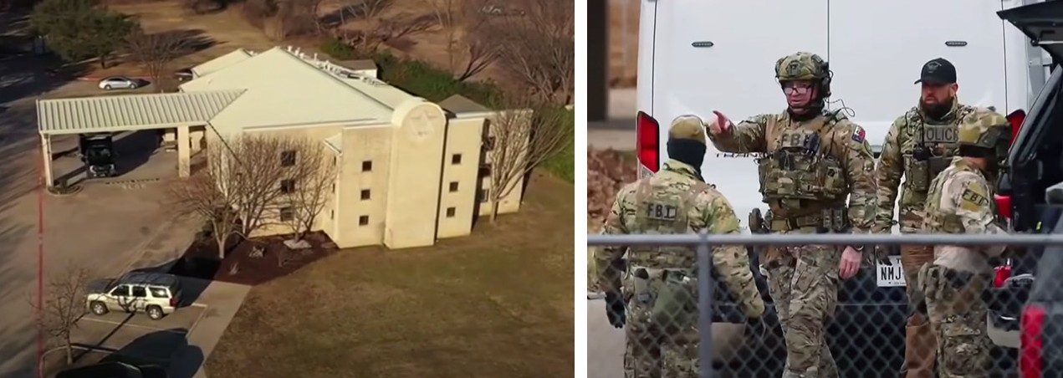
All hostages freed and hostage-taker dead after Texas synagogue standoff (YouTube)

These demonically-inspired attitudes and actions have risen in Europe dramatically. The Jewish Press reports that in France, a “high number of anti-Semitic acts (have been) committed in the private sphere (25 percent), acts committed near the victim’s home by a neighbor in a building or by people living in the neighborhood, and the proportion of use of weapons in physical attacks (20 percent) and anti-Semitic threats (10 percent). The weapons most used were knives (9 cases) and pistols (5 cases). “Other acts were committed using rifles, fireworks or mortars, hammer, machete, pellet gun and scissors.” Some of this activity has been directed as the repeated narrative of blood libel has been aimed against Jewish communities with reference to creating or spreading COVID or manipulating vaccine policies in the population as a tactic in positioning Jews for “world domination.” These are charges that have been aimed at Jews since the times of Ezra/Nehemiah and display the accuser’s strategy to use unrepentant Gentile nations and peoples to persecute or oppress God’s chosen. Fortunately, we make up a remnant in the earth of repentant Gentiles that pray with, stand beside and petition

for the plight of Jews, whether they are in the land or outside. We do this because we worship the same God, embrace the same Torah instructed codes of conduct and opinion of life value and enlightened self-interest, meaning that to agree with those in word or deed that who are vilifying Jewry in the earth, will not be a good path for us to take individually or corporately.

“Behold (listen carefully), I will send for many fishermen,” says the LORD, “and they will fish for them; and afterward I will send for many hunters, and they will hunt them from every mountain and from every hill and out of the clefts of the rocks” Jeremiah 16:16 (AMP).

I encourage and implore you all as a co-heir of Abraham’s covenant through Messiah Yeshua to pray that despite their current situation, that Jews around the world receive the message that it is time to return to the land of their forefathers to claim their inheritance physically and spiritually. We should continue to challenge world media regarding narratives that push half-truths to defame Israel or the Jewish community. Where we can, we ought to be intentional in bringing relief to families that have experienced anti-Semitic trauma in recent days. We should certainly be vocal when our governmental authorities are not attentive to enforce the law with respect to criminal activity committed at any level against Jewry and should make it clear that we do so from a biblical viewpoint. Those of you who support CFI in our activities in Israel know this is our viewpoint and we are filled with gratitude that you have been consistent as the days get darker, your lights shine brighter!

Reporting from Jerusalem,
Kim S. Brunson

