CFI Projects Monthly Reports for
International
Representatives

Dear CFI International Representative Family,

Thank you for your continued support of the Outreach efforts of Christian Friends of Israel. We continue to strive to encourage those in need and to offer practical assistance during times of struggle. It’s during these times when relationships can be formed which please God and allow us to show Compassion to those who need it the most and have possibly never experienced it before.

During this time of global pandemic, we continue to offer assistance as we are able, and we know each passing day may allow for additional hardships, but we also know the God whom we serve. He is more than able to protect, and provide and heal. We are willing to represent Him to the people of Israel.

Please receive the CFI Outreach electronic updates as a reminder
of the impact each of you have in the lives of so many. We are grateful to represent those of you in the Nations - to those in the Land of Israel.

A friend loves at all times, And a brother is born for adversity.

Proverbs 17:17 (NKJV)

Project Forsake Them Not

Perhaps no one likes waiting very much, especially when it is for something we long for most but don’t know when we will actually have that longing fulfilled. Expectation is a bit different. We have to wait, yes, but we know when that special something will be fulfilled, and the expectation fills us with excitement and joy. For instance, did you ever count down the days to see somebody you love so much, or for your upcoming holiday trip?

We often see the strong uplifting power of ‘Looking Forward To,’ in the lives of our dear Holocaust Survivors - the expectation of the birth of a new great grandchild, family visit or phone call, or a birthday celebration with friends. These all increase their motivation to live and to not give up.

In the past months, since COVID-19 invaded daily routines with restrictions, and often fear, our visits became more urgent than ever before. Many elderly people find themselves isolated and with no fellow- ship. Every phone call, every card and every visit is appreciated greatly.

Galina spends her days in her lounge, in front of the TV and a little table on which she has her most important documents, including a copy of the book of Psalms. The book, from the looks of it, was well read. It takes Galina a huge effort and a long time to get up from her soft big chair and start walking, so it took her five minutes to overcome three meters to open a door to us. The way back was also long, but she was happy and very excited! While we were talking, she reached out for the Psalms and pulled a stack of papers out of it – those were all the birthday cards and pictures we took together over the years, with scriptures included! “I read these daily! They mean so much to me!” said Galina with a big smile. We are so glad Galina finds encouragement in the precious Word of God.
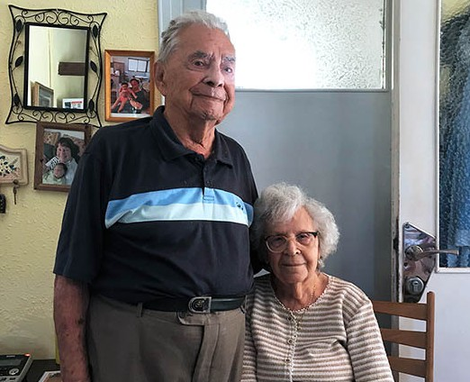
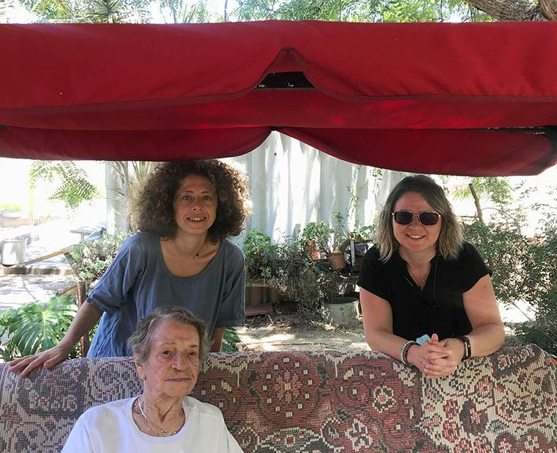

Maya and Pinchas hardly ever leave their apartment, and rely on their caregiver for all their necessities. Their children and grandchildren live all around Israel, and don’t have cars, and restrictions made it really hard for them to visit. Maya had some peaches to share with me, and while we were talking about fruits, she briefly mentioned that her favorite one is watermelon, but she only had it once this summer, and
that one was not good. About 20 minutes after the visit I rang the doorbell of their apartment again, this time with a huge watermelon in my hands. Maya’s reaction was priceless and the biggest gift for us. It definitely made her day, and we were happy to be a part of it. She called me the next day to say that that was one of the best watermelons she ever had.

We also were grateful for the opportunity to visit our friends in the kibbutz Mavkiim. On our first trip there we found out that Yaakov was just out of the hospital and his right leg was amputated, which made him even less mobile. There is only one air conditioner in his lounge, which was not enough in the heat of an Israeli summer. Again, the Lord so lead us, and we were in the right place and at the right time – to find the need and to meet it. A few days later we came back with a portable cooler, which would be sufficient to cool Yaakov’s room and to keep him comfortable.
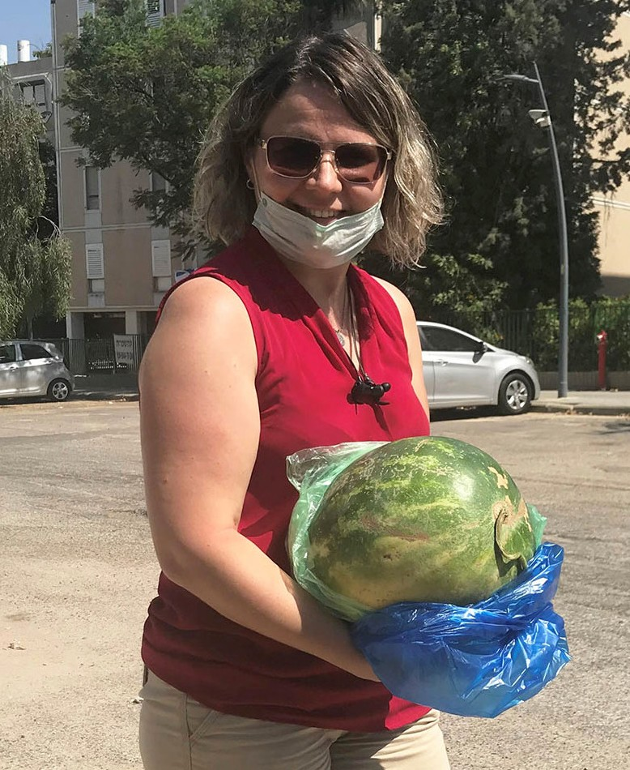
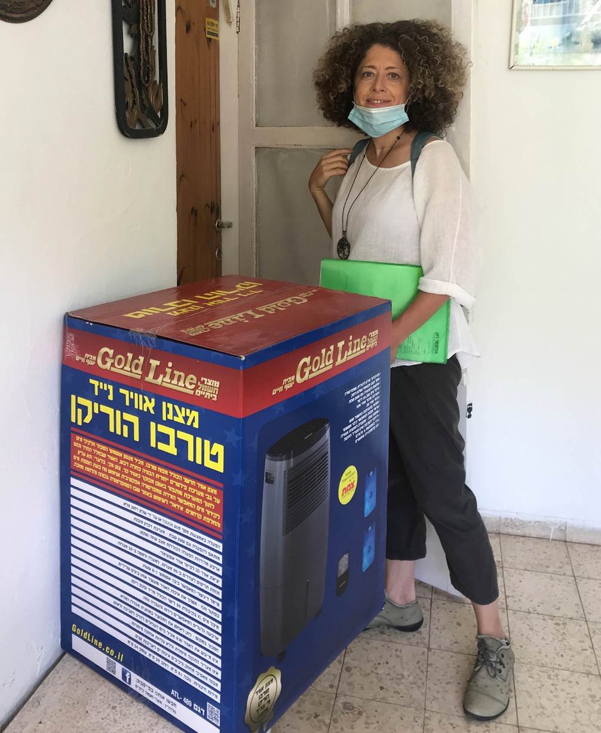

We are very grateful for all your prayers and financial support to Forsake Them Not project. Thank you so much for your obedience and faithfulness in giving, through which we are able to meet the needs of His special possessions, the Holocaust Survivors, who need love and attention as never before. Thank you for standing with us, standing with Israel, standing with His people in this time of such uncertainty.

“Truly my soul silently waits for God; from Him comes my salvation. He only is my rock and my salvation; He is my defense; I shall not be greatly moved” (Psalm 62:1-2).

Olga Kopilova Project Supervisor

Project Open Gates

Shalom from a hot Jerusalem, dear friends and supporters!

The last two weeks have been quieter at our distribution center. The situation with the corona virus is still a big factor here in Israel. Anyway there have been people making Aliyah continually during this summer. Today we had four visitors at our place. All of them moved to Israel on the same day 20.07.2020, but by different airlines.

Makar is a young man from St. Petersburg. It took about three years for him to make the decision and one year was needed to get all the documents ready and done for the Aliyah. He told us that 90 percent of the passengers in their flight to Tel Aviv were new immigrants. The state of Israel provided for two weeks stay in a hotel in Tel Aviv. “So, the quarantine was not so bad”, Makar explains. “We got good food. Everything was fine.”

For a young couple, Alex and Mariya, it was hard to stay in one room for two weeks. “We are used to moving and exploring different places all the time.” They come from the city of Kazan in Russia. Now they are living in an immigration center and studying Hebrew for free for the first half a year in the Land. The start with the new language has been difficult. Anyway they are motivated to learn as much as possible in this language school. After that they will look for a job. Alex and Mariya live in Jerusalem, but in the future they may move to Tel Aviv. “I visited the Land once before. I love Israel.” Mariya says.

Dmitry comes from Ukraine. He has problems with his hearing. For him, learning a new language with a class is much more difficult. His father is a Jew. The parents divorced a long time ago. Until now Dmitry was living with his mother. I asked about the reaction of his mother, when he started to plan to make Ali- yah. “My mother was happy to kick me out to the new life!” This nice young man explains. “She packed so many things into my suitcase that I don’t need anything at the moment.” Dmitry has already found a part time job. “I just heard from the news that there may be a lock down again. It is not good. I am just starting to work here in Jerusalem,” he said.
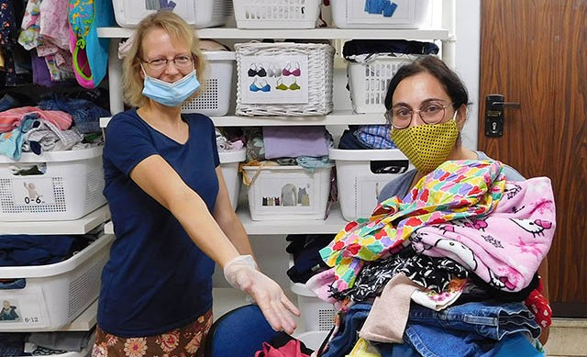
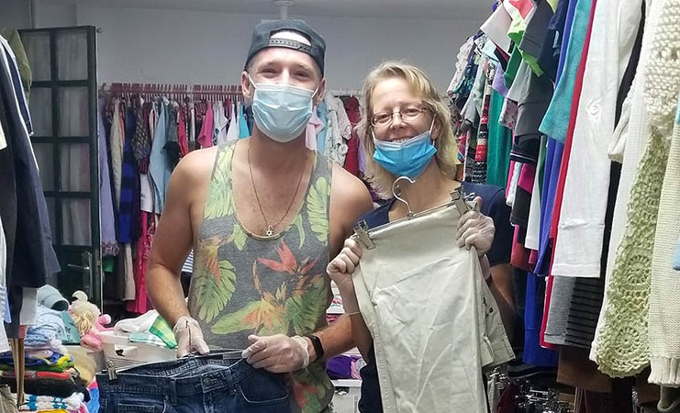
We also need to close our place here at the distribution center for couple of weeks. Israel is battling against Corona virus. Now there will be a lock down again during the period of the Feasts. Please, pray that the Lord will touch many hearts and open many eyes among His people in this special season. May He use us for His glory even during the time, when we won’t have any visitors at our distribution center.

Thank you for being with us!

Project Bridal Salon

Shalom from CFI Bridal Salon from Jerusalem!

This September is very unusual. We didn’t have any clients coming to our place, and from tomorrow we will be closed for three weeks because of the lock down. So, I don’t have any Bridal Salon news to share with you this month. Instead of the report here are some thoughts about two Bible verses today.

The month of Elul in the Jewish calendar is just ending and the new month of Tishrei is starting with the Jewish new-year 5781. The Hebrew word E-L-U-L points to the verse from the Song of Solomon 2:16 “My beloved is mine and I am his, he pastures his flock among the lilies.”

So, this month of the Jewish year is a special time when we are expected to check our relationship with our Beloved. We can ask ourselves a couple of questions. Am I really His? What is going on in my heart at the moment? Can I say that He is mine? Is He still the most beloved in my life, or are there other people or other things that are taking His throne in me? There are more questions that we can ask about this Bible verse. What does it mean that He pastures His flock among the lilies? For me it is a picture of peace, beauty and harmony.

Another verse is Revelation 22:17 “The Spirit and the Bride say, Come! And let him who hears say, Come! And let him who is thirsty come, let him who desires take the water of life without price.” The Holy Spirit in us is calling Yeshua to come back to this Earth. Am I myself calling Him to come back? Can I see myself as the Bride of the Lord? If we are born again, we belong to His church, to His Bride. It is a picture of a deep relationship and dedication between me and the Lord. But many times I don’t feel like it. Many times I even ignore Him in my life. Our flesh will never call Him to come back. Our flesh wants to do things by itself. Our flesh loves itself more than the Lord or anybody else. The flesh doesn’t have any need to get closer to the Lord. But our spirit is never satisfied without Him. If we are thirsty for God, we start to call upon Him.

There is a great promise for the thirsty ones in this Bible verse. They all can come and take the water of life without any cost. If we are hungry and thirsty for God, He will fill us with His Holy Spirit over and over again. When we are filled with the Spirit of Yeshua, with the water of life, we say to Him, “Come!” without any hindering elements. Our love relationship with the Lord becomes alive again. We start to wait for His returning with all of our hearts. We understand that there is no life without God. He is our all in all.

May our hearts be in the Messiah and with Him during the coming Feast season. Let us be in love with Him more and more every year.

Be blessed in Yeshua’s name.

Project Hope For The Future

Welcome September! This is a month of “teshuva”. “Tashan” meaning Return and “Hey” in the letter “JHVH represents Shekinah or presence of God. This return meaning Teshuvah is most associated with the High Holy Days – many people in Israel and all over follow this time in repentance prior to Yom Kippur the days of atonement.

Turning of the hearts of love toward man many times can be physical application instead of spoken. We are more isolated today in the times we live. The pandemic has not ceased yet and we can reach out and turn to those in need, who may not have the same means to raise their heads above the water of poverty, fear, isolation economic and social divides. This time of the year especially gives us the incentive to care about our neighbour or our fellow man on a daily bases.

“Finally, all of you have unity of mind, sympathy brotherly love, a tender heart, and a humble mind” (1 Peter 3:8).

Hope for the Future; consistently applies the foundations of looking to give hands up not just a hand out. Our project found this season to be more intense than the previous years due to our present situation here in the land of Israel. We experienced a race with time to ensure many families would have sufficient food during the High Holy Days. It is our normal posture, to give extra food vouchers, and reach out to help the larger families, single mothers and the sick and shut in. Our thoughts this year are to make sure families could shop before any restrictions prevented them from getting all the necessities they needed to enjoy their families in their homes.
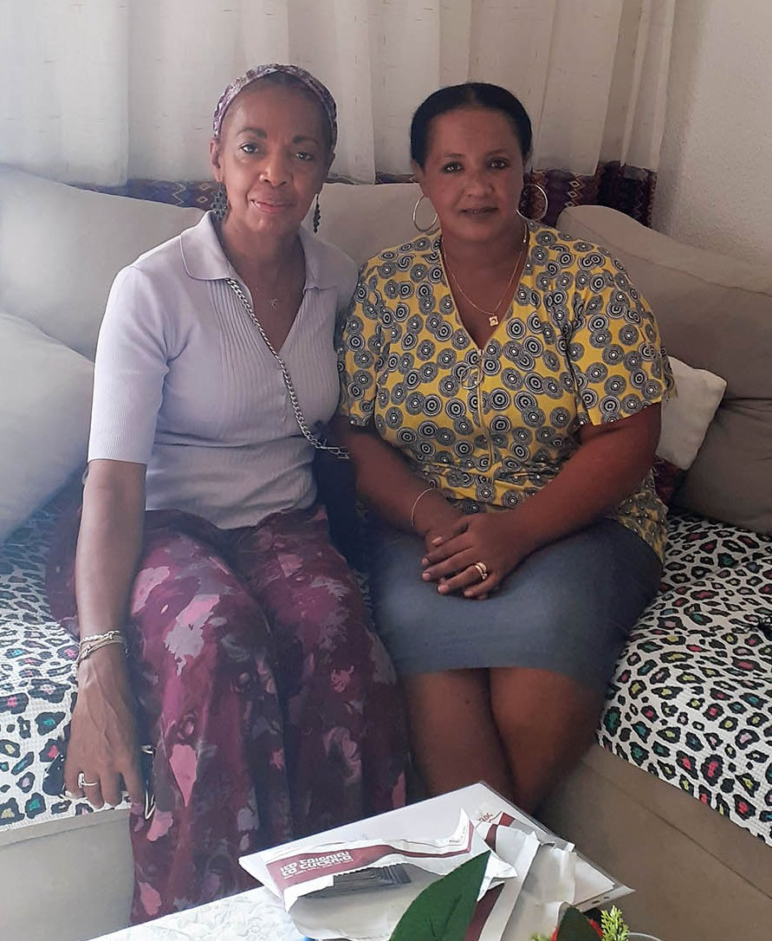
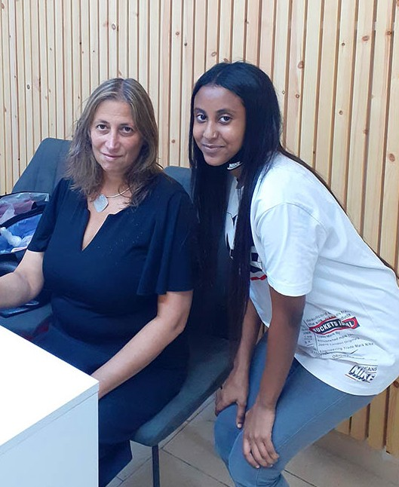

We found a few of our single Mothers in Jerusalem and Kiryat Gat, had extreme needs beyond food, Our first priority pertained to helping them to feed the children while out of school as well as during the

coming festival. Between the single mothers, we were able to give a monetary gift to two families. Times like this are giving opportunities, to embrace the situations and to do our best. I am always impressed by one of the Elders in the Kiryat Gat community, Mr. Avraham; whenever a family is in need he will get in contact with me to ensure the needy families are processed.

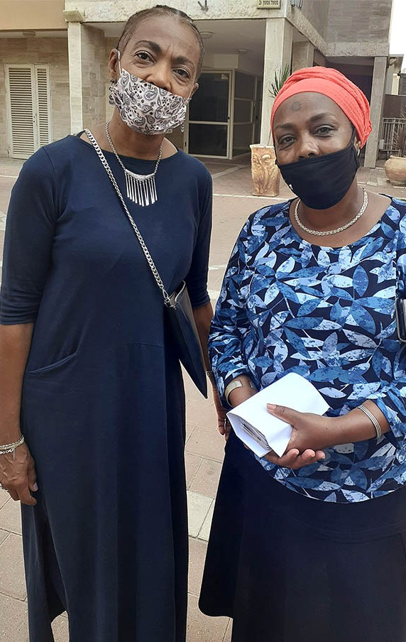
A religious Ethiopian family in Kiryat Gat, needed assistance, a large families with seven children, a Rabbi and his wife living off disabilities. I was able to deliver food vouchers to the family outside of the apartment building. Due to the corona,
I could not go in because of the Fathers health risk but the mother came out to greet me. She smiled behind her mask to show me her grateful heart.

Many families were touch in Beni Brak as the situation is more crucial with a larger elderly community, Hope for the Future wired funds to the WIZO director to purchase vouchers for thirteen families! We are thankful for such partnership to help us be the hands and face for our God. Finally, we had
a special request from a young college student preparing to serve in the IDF in Special Forces, struggling to study and get good grades, while not being able to work. Food is essential to us all; we supplied him with funds for his dorm apartment. From our efforts, we know that love has no limits nor bound- aries. It can bypass any situation when applied to fulfil the mandate of the Heart of Abba!

“Let Brotherly Love continue” (Hebrew 13:1).

Marcia Brunson Project Supervisor

Project First Fruits

“Solomon had twelve deputies over all Israel, who secured provisions for the king and his household; each man had to provide for a month in the year” (1 Kings 4:7, AMP).

“ADONAI will order a blessing to be with you in your barns and in everything you undertake; he will bless you in the land ADONAI your God is giving you” (Deuteronomy 28:8).

There continues to be challenges to Israelis as the nation tries to manage the COVID virus epidemic. These challenges have been hurdles to overcome for those of us in First Fruits and also within CFI in general. God has been faithful to provide His wisdom in navigating our assistance for those who are believing His promises concerning provision during these testing times. The nation prepares again for
a lockdown limiting the ability of citizens to move to and fro beyond acquiring basic needs and essential employment operations.

We have pinpointed the most urgent needs and streamlined our operation to continue to supplement a wide variety of people in Israel’s faith community with resources that will allow them to maintain their households.

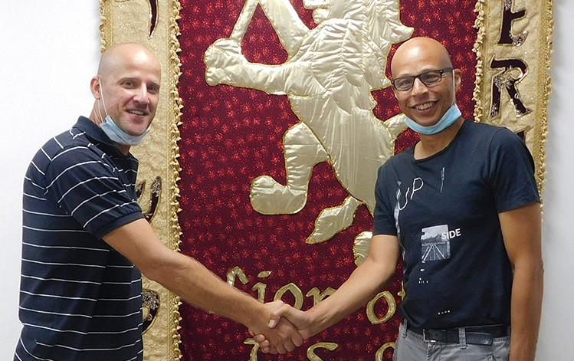
One family is headed up by a school teacher of Hungarian descent who had committed his family to relocation, to accommodate the pregnancy of his wife and enlarge the space available to them and all of the other children. We were able to help this man, heavily involved in ministry as well, with rent assistance and food vouchers to compensate for lost time in his capacity at his school.

We were also able to help another family of four that has been affected by the absence of tourist

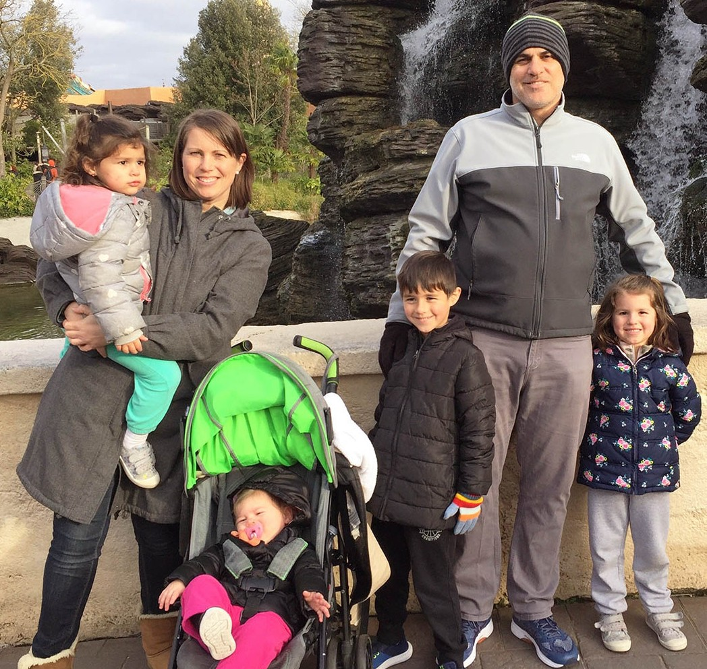
activity, as the husband and wife await word as to whether they will be able to assume roles as athletic coaches in basketball and soccer (foot- ball) respectively, once schools resume normal extracurricular activity.

In Netanya, we were pleased to lend food voucher and rent support to a Jewish believer of Moroccan ancestry by way of Belgium, who is caring for his mother who is suffering with a heart condition. He experienced a loss of employment due to a back injury in an auto accident. Before Aliyah, his mother ran two restaurants in Brussels that she closed one day a week for to feed the poor in her com- munity, so she should reap some of the Lord’s care, that she obviously expressed during her years as a business owner. The young man has

also pledged to contribute to CFI personally himself, as he will be able to return to work in coming weeks, as he is not accustomed to being a recipient of benevolent assistance and would like someone else in need to experience the generosity of our heavenly Father!

Beyond single family units, CFI was happy to partner with Streams in the Desert, a ministry based in the Beersheva region of Israel, who have really been meeting the needs of forgotten Russian speaking single mothers and “widows”. We supplemented their monthly food stipend to 7 families just in time for the High Holy Day season, where many of us will be shut-in and confined to our homes and towns.

We maintain momentum here because of your efforts in the nations and the generosity of donors who understand that others may actually have needs beyond theirs during these trying times in the earth. God is the provider of Israel. God is the great Husbandman that we can lean into as the Bride and as His partner in the earth.

“He who gives to the poor will lack nothing” (Proverbs 28:27a).

Kim Brunson Project Supervisor

Project Under His Wings

Shalom Dear Friend of Israel,

“Call upon me and I will answer you…” (Jeremiah 33:3).

I am in awe to see how God is moving in the lives of those who are seeking him. In September I felt led to visit Aviad and his young family again, to see how he was doing. Praise God that he started to work since March as a Building Engineer, building housing and projects in the wilderness of the Negev despite his post trauma. During the visit I saw that he felt frustrated over the constant demand of attention from him by his two young children, which was also a challenge for our conversations. After sometime we went to their back yard where Aviad has built slides, swings as well as a small playground for his two kids and we were uninterrupted there and started to talk about God and Scriptures from Bible.

We came across some Scriptures on Righteousness as well as what it means to us. Suddenly Aviad said to me, “wait, I need to show you something. You wouldn’t believe this.” Quickly he ran to his room and fetched something to show me. He said recently when he was working in the wilderness, he was pondering and asking what Righteousness is and talking to God about this. And when he turned around,
he couldn’t believe what he saw - a small Iron panel about the size of our palms, with the word “Righteous- ness” written in Hebrew (קדצ, Tsedek) on the panel. It was as if God dropped this panel in the vast wilder- ness to interact with him (Jeremiah 33:3). Aviad has a longing for God, but has been chided by people around him when he talked to them about God. When he told his coworkers about what he found, they told him if you still want this job, stop day dreaming. I encouraged him continue to talk to God no matter what others say.
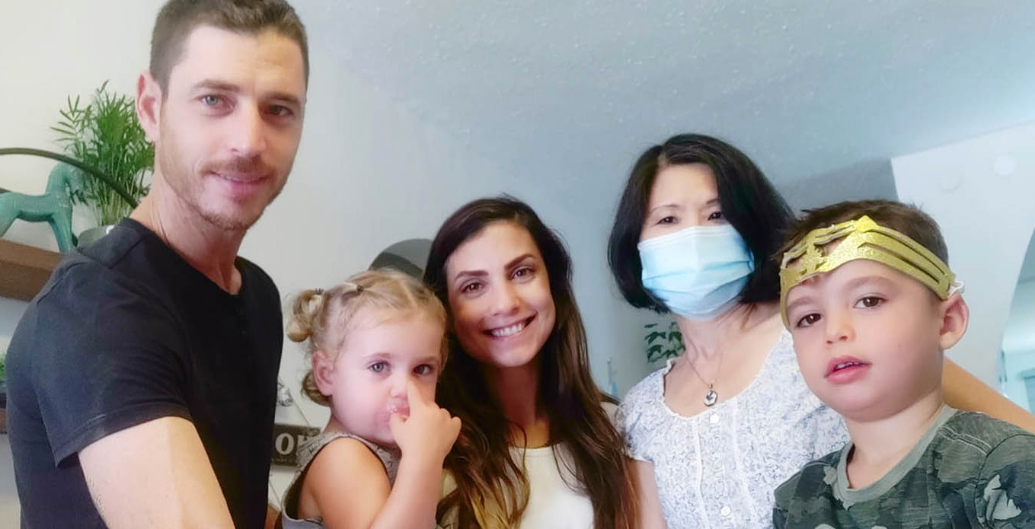
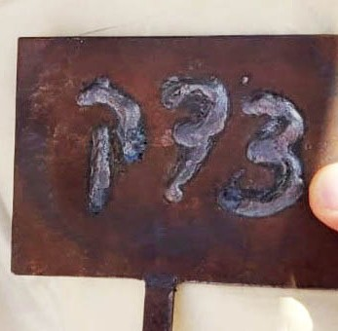

Oren is another young man whose heart is also seeking God. He was enlisted to the Anti-terrorism unit while serving in the IDF and was traumatized. But his symptoms manifested only after he was working and having his own business in the US. Despite great success in business Oren felt a deep emptiness in his heart and he was gradually overwhelmed by post trauma.

Two years ago he decided to move back to Israel, but sadly his parents as well as siblings deepened his trauma and sorrow by taking advantage of him and in cunning, seized all his money from him. Being
severely broken Oren locked himself in a room for 2 years. At the leading of the Holy Spirit, I was ministering deeply to Oren during the visit, and told him of the Father heart of our Heavenly Father. I encouraged him to read His Word and like David, to pour out his heart before God. Please lift up Aviad and Oren in prayer

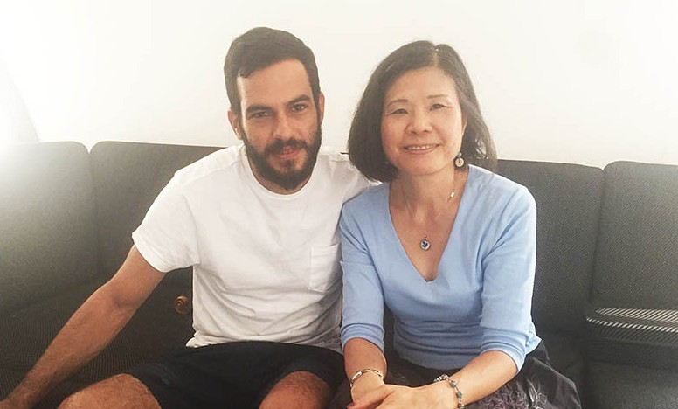
that the Lord will continue to draw them and reveal Himself to them and also deliver them out of trauma.

Thank you for being co-laborers of Project UHW – outreach to victims of terror attacks. God bless you and wish you and your family Happy Fall Feasts!
Maggie Huang Project Supervisor

Project Communities Under Attack

Dear Friend of Israel,

“Our soul has escaped like a bird out of the fowler’s snare….” (Psalm 124:7a)

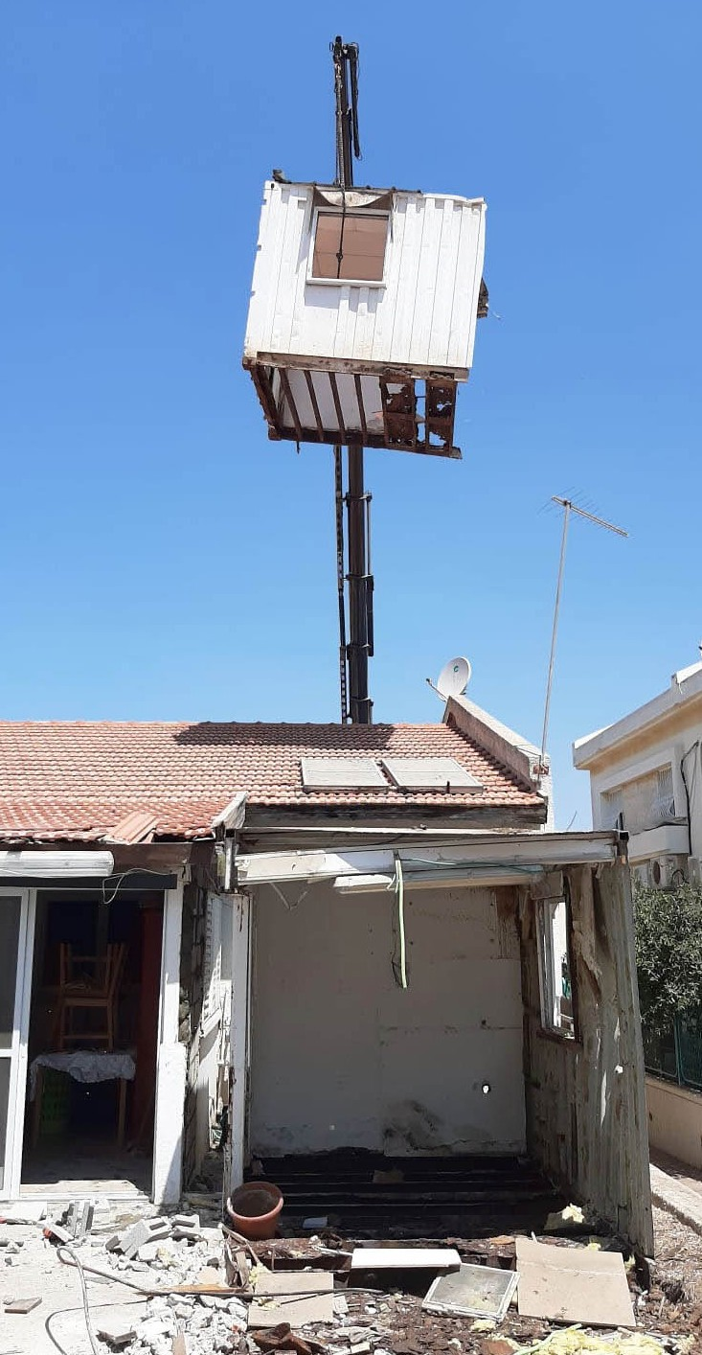
During our visit we ourselves were also greatly encouraged by one family in Sderot who witnessed God’s lovingkindness in protecting their entire household on 21 August at midnight during a recent rocket attack from Gaza.

Shlomo and Osnat’s house suffered serious damage, he said he believed they and their children miraculously escaped the destruction after warning sirens failed to wake them.

“It’s a miracle that we were unharmed,” said Shlomo. He said they did not hear the rocket alert at all, they were awoken by the explosions and smelled smoke. It was only after they left the house that they saw the destruction - the explosions cut the house in two and hit the roof of the secure room - the bomb shelter within the house. He said it was very scary but thankfully none of them was hurt (Psalm 124:7a).

Shlomo said our visit brought healing to him personally as he has been trying to be strong for his family in the midst of this traumatic event and had sup- pressed his emotions. He poured out his heart to us during the visit, saying he wept when he received a phone call from Project CUA shortly after rocket attack; he was touched by the love and care extended to him by us.

I received text messages from Shlomo after returning to Jerusalem, to thank us for the comfort, encour- agement and support. He said our visit touches his heart every time he looks at the pictures of our visit.
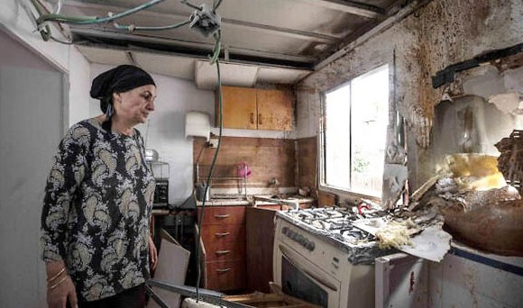
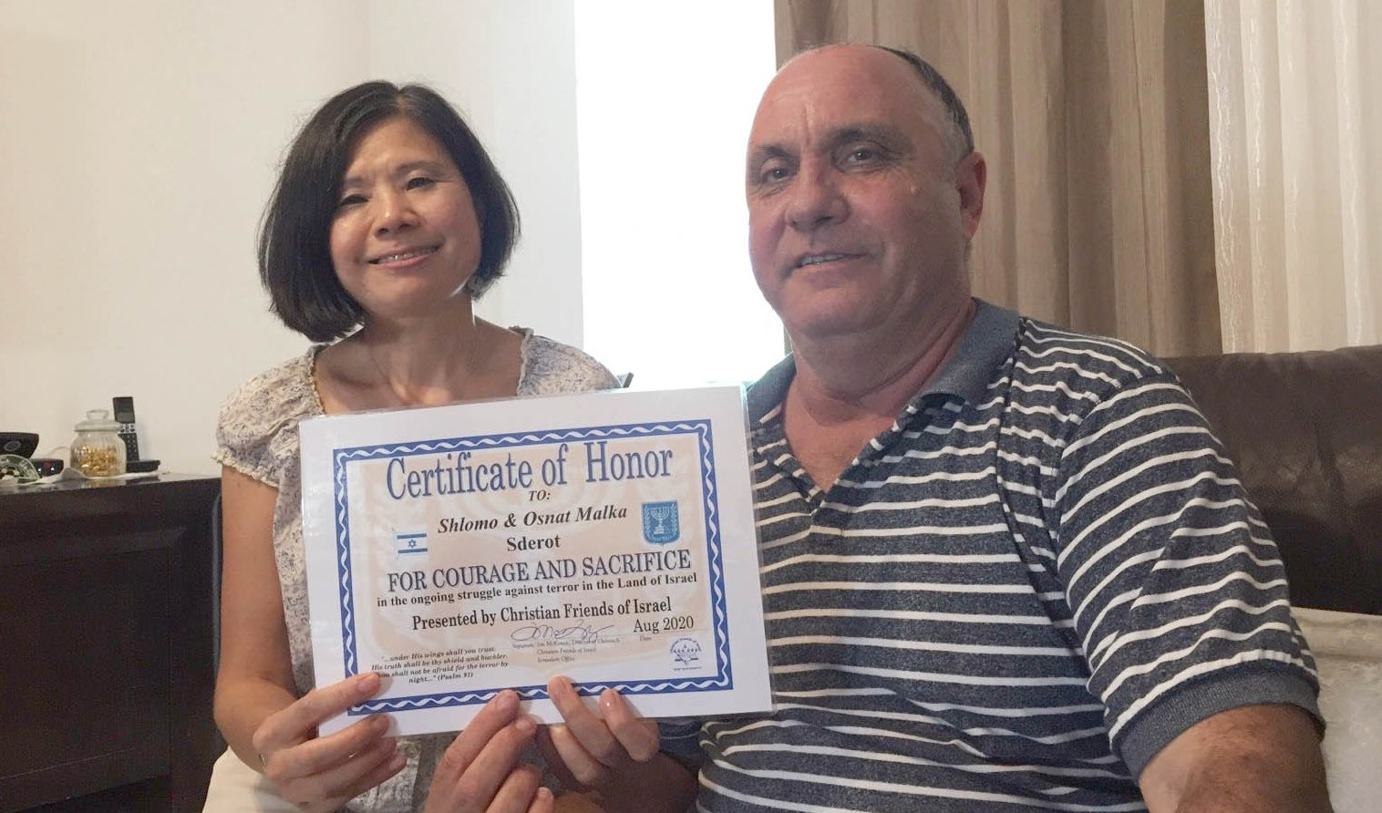
Thank you - our supporters, for allowing Project CUA to represent you in touching the hearts of the suffering rocket victims like Shlomo and others, which shows the love of our Lord, something which they never experienced.

Chagim Smechim (Happy Holidays – Jewish New Year, Day of Atonement and Feast of Tabernacle).

Maggie Huang Project Supervisor

Project Streams Of Blessings

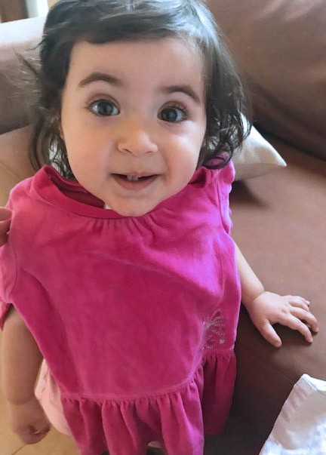
UNDERSTANDING THE TIMES
He who understands the times, knows how to behave.

“When it snows, she has no fear for her household; for all of them are clothed in scarlet” (Proverbs 31:21).

Through the scriptures we find teachings about the importance of clothing and the figure of authority that they represented, not only in moments that marked the destiny of humanity, but also determined and accomplished in the purposes of God. When Jacob placed the colored robe on Joseph, he was not only blessing him, he was also setting him apart for the assignment given by God that would require standards of Kingdom ethics. Joseph remembered and
adhered himself to these principles from his very present, until he reached the cathartic moment in the future, when his trust and testimony brought blessing and salvation to many nations, mainly for Israel.

Nowadays in togetherness with our Distribution Center in Jerusalem, your prayers and your kind donations from afar, the Streams of Blessing Project has paid sensitive care to the needs of the Jewish people during this season of scarcity and famine. We have helped parents to clothe newborn babies, children ready to attend Gan (kindergarten) and School, as some of them had decided not to enroll them for a new year of studies due to the lack of funds. We have been honored to understand their need, as we keep believing in God’s provision; and moreover we have had the privilege to clothe them properly for the occasion, as we also pray that God holds their future in His Hands. It is time for unity and care for one another regardless the religious creeds or cultural background.

In these moments of hardships, the way out for many is to take the easiest and fastest offers or alternatives because the pressure is strong. Christian Friends of Israel is not here to compromise or trade God’s blessing for a bowl of impermanent lentils and deprive our generations of experience and belief that there is an Almighty God who makes out of the impossible, all things possible. Hunger or distress will not dress our people’s clothing and future; nor will the Blessing be taken away this time.

“She is clothed with strength and dignity; she can laugh at the days to come” (Proverbs 31:25).

I used to read this chapter of Lemuel as a poem to his mother. Instead, I believe is a parameter of responsibilities that we, as the chosen bride of the coming King are required to exercise and practice regardless of the circumstances, as we prepare to daily abide in His Presence. Giants will always be there, but thus far the Lord has clothed and strengthened our spirits with His unfailing love, provision and cares to peacefully know within our hearts, that we can trust and rejoice in Him, no matter what lies ahead. Thank you for walking and standing with Israel at distance. We are grateful for you.

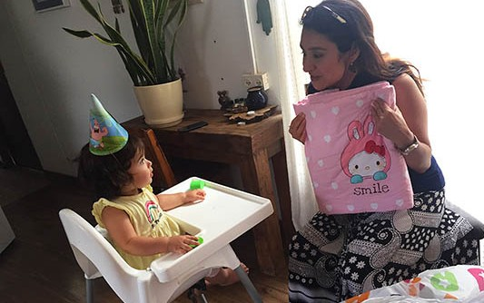
Karen Tohon
Project Supervisor

Project Wall of Prayer

“That is, that we may be mutually strengthened and encouraged and comforted by each other’s faith, both yours and mine” (Romans 1:12 AMPC).

How wonderful it is to discover the way God arranges circumstances to guide His children! The day before Rosh Hashanah, we visited the home of a family of Jewish Believers in Kiryat Tivon. They are among the ranks of those who have embraced the Light of the World and themselves shine as “lights in darkness.” Living in a highly secular area where people are indifferent to spiritual realities, this household finds themselves in the minority. Their family consists of four children, two of whom are currently serving in the IDF (Israeli Defense Force.) This mother is proud that her children are able to serve the country. One of her prayers is that they would remain strong in faith as they perform their duties as soldiers. She wants them to radiate the peace and hope that comes from the Prince of Peace. Amazingly enough, that was the one of the petitions that CFI staff had been praying on behalf of believing young people in the IDF just two days before our visit.

When Israelis reach age 18, both males and females are required to serve in the army, navy or air force. Life in the IDF is not always easy. Service men and women need our prayers for their physical, mental, emotional, and spiritual protection. Some youth suffer from PTSD (Post Traumatic Stress Disorder) as a result of situations they may experience or witness while carrying out their duties as soldiers. Standing at the base of Mount Carmel, we had the privilege and pleasure of praying with that mother for her children and others who are defending Israel. We rejoiced together as she shared that her child had connected with another young person of faith in the barracks. As mothers, we shared her relief and comfort.
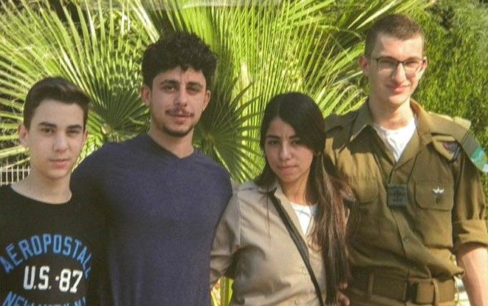
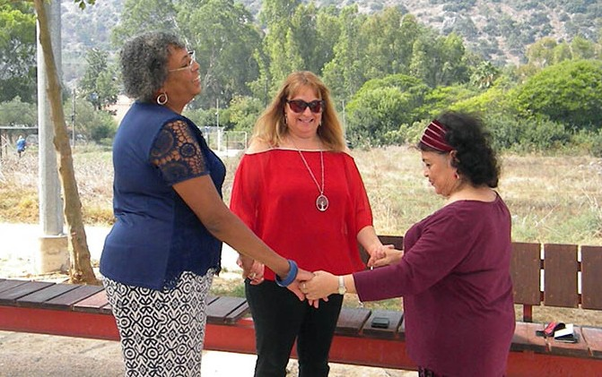

Seeing how God answers prayer increases our faith to continue coming to Him, not only with our requests, but with our praise. This family was excited to see how God had orchestrated our meeting and to know that He had sent us to encourage them. We were equally inspired to actually see and hear the stories of challenge and triumph from some of the people for whom we have been praying. Because of this visit, we will remain connected to them. What a wonderful way to usher in a sweet, new year, not just a time of pleasantness, but of richness and deep significance.

THANK YOU for your prayers and continued support. You make it possible for us to uplift Israeli families by traveling, bringing small gifts, praying and building relationships with them.

May the Lord, the Maker of Heaven and Earth, bless you from Zion.
Linda McMurray Project Supervisor

