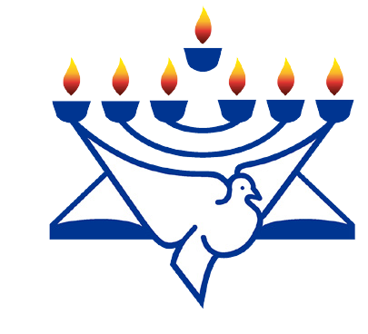February 2020 /Jewish Year 5780
Christian Friends of Israel prayer@cfijerusalem.org www.cfijerusalem.org
ORaniWsinagtcThhJeeruBsaalemr
Christian Friends of Israel prayer@cfijerusalem.org www.cfijerusalem.org
The Importance of Names
“…and thou shalt call his name JESUS: for he shall save his people from their sins”.
(Matthew 1:21). The name Yeshua literally means Salvation.
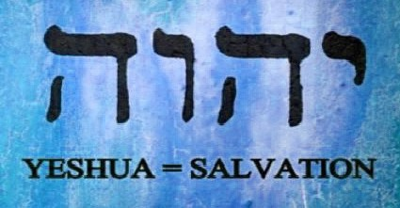
Jewish sources and scholars tell us that our name is the key to our souls. The Hebrew word for soul is neshamah. Central to that word, the middle two letters, shin and mem, make the word shem, Hebrew for “name”. They say here in Israel that your name is the key to your soul. Names are a book. They tell a story, often the story of our spiritual potential as well as our life’s mission. Some sources tell us that when we complete our years on this earth and face heavenly judgment, one of the most powerful questions we will be asked at the outset is, “What is your name and did you live up to it?”

For instance, my birth name is Sharon. It means a fertile and fruitful valley; a plain in Israel. Our commission is, “Go and bear fruit” (John 15:16). My grandmother told my mother, “This little girl will be a blessing”. I have “tried” to live up to my name but of course like so many of us, wish I could do so much more. Jewish sources tell us that God used names not for the sake of identification in the beginning but rather for creation. He spoke and the very words describing the object came into being. The Almighty merely gave it a name, and the very letters defined its atomic structure. Names came before the existence of those things with which they would subsequently be identified.

When Abram came to the realization of monotheism, his name had to be changed: See Genesis 17:5. The change of identity required a change of identification. When Jacob, whose name came from the root word meaning “heel” which so perfectly suited someone whose approach to the problems of life was always flight, suddenly realized he had to fight rather than flee, the angel informed him, “Your name shall be called no more Jacob, but Israel; for you have striven with God and with men, and have prevailed” (Genesis 32:28).

A traumatic lifestyle change brings with it a new personal descriptive. The children of Israel were redeemed from Egypt, God took note of their suffering and ensured their survival. They were imperfect in many ways, but they did not change their names, their language and their mode of dress. They remained true to themselves.

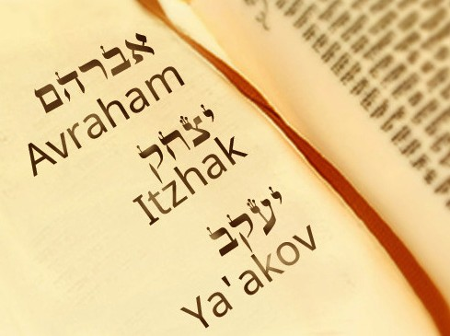
The Bible tells us “As his name is, so is he” (1 Samuel 25:25). We will forever leave behind our names as a final legacy. Does that mean we are predestined to live lives circumscribed by something beyond our control? Are we doomed to play out roles handed to us by our parents while we were infants? Is our free will limited by our names? Of course not. We emphasize the principle of freedom of choice. Our names do not force us to be what we are. It is what we are that transmits itself in a profoundly prophetic manner to those entrusted with the holy task of choosing our names. It is a message from God entrusted to our name-givers in order to help us define our mission on earth. Our names outlive us; let’s do everything in our power to make them be remembered for blessing.

Let Us Raise Our Voices Together in Prayer:
Pray fervently for the upcoming Israeli elections and that GOD will bring a unity here like never before. “Behold, how good and how pleasant it is for brethren to dwell together in unity! It is like the precious ointment upon the head, that ran down upon the beard, even Aaron’s beard: that went down to the skirts of his garments...” (Psalm 133:1-2).

- Thank the Lord for Prime Minister Netanyahu’s commitment to the settlements. Wisdom starts with a reverence for God. “To have knowledge, you must first have reverence for the Lord” (Proverbs 1:7).

- Call upon the Lord to be the One and Only True Guardian over His Chosen People, as He has so faithfully been. Indeed, the Guardian of Israel never rests or sleeps. “The LORD is your guardian. The LORD is the shade over your right hand. The sun will not beat down on you during the day, nor will the moon at night” (Psalm 121:4-6).

- Proclaim His Promises for an outpouring of the Holy Spirit. “And afterward, I will pour out my Spirit on all people. Your sons and daughters will prophesy, your old men will dream dreams, your young men will see visions” (Joel 2:28).

- Pray Fervently that the legal system of Israel be brought in line with the values of the Torah (God’s Word) which would encourage not only more acts of kindness, but values beyond consumer consumption, righteousness and justice and the building of prosperity without hurting the poor and weak. “But let justice roll on like a river, righteousness like a never-failing stream!” (Amos 5:24). Pray for a God selected government in which we can see the Hand of God move, as we have seen it before.

- Read Together in Jeremiah 31. “Thus says the LORD, who gives the sun for a light by day, and the ordinances of the moon and of the stars for a light by night, who divides the sea when the waves thereof roar; The LORD of hosts is his name. Only if these decrees vanish from my sight, declares the LORD, will Israel ever cease being a nation before me. declares the LORD” (Jeremiah 31:34-35).

Whatever our name, let us carry out whatever mission God has for us on this earth. To be an intercessor is a very high calling and no matter what age you are, you can be used by God to change circumstances, move mountains and prevent tragedies. God hears the voices of His beloved children on this earth as our voices are raised to Him in prayer, He knows our names!

In His Service Together,
Sharon Sanders
Christian Friends of Israel - Jerusalem

