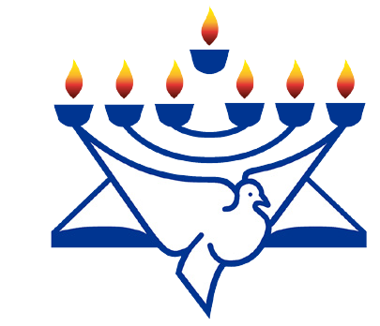
CFI News Insights
Christian Friends of Israel
feedback@cfijerusalem.org
www.cfijerusalem.org

June 25, 2021 /Jewish Year 5781
Old Embers Stoke a New Fire:
Convergence of Flashpoints between Ancient Adversaries
Part 2 of 2

“The blood avenger shall himself put the murderer to death; he shall put him to death when he meets him. But if he pushed his victim out of hatred or threw something at him with malicious intent, and he died, or if, in enmity, he struck the victim down with his hand, and he died, the one that struck the victim shall certainly be put to death; he is a murderer. The blood avenger shall put the murderer to death when he meets him” Numbers 35:19-22 (AMP).

This the second one of our Insights commentaries focusing on the most recent Arab-Israeli conflict that took place. There were some decidedly violent, domestic confrontations that occurred beyond the military one that happened between terrorist cells in Gaza and the IDF. There was a TikTok challenge issued amongst Arab youth to assault Haredi or Orthodox Jews by slapping them and running off. There were standoffs on the Temple Mount where Muslims gathered large rocks and Molotov cocktails, staged them within Al-Aqsa Mosque and would throw them at Temple Mount police and at persons praying at the Western Wall, then retreat quickly. When confronted by security personnel they would start to record video footage to distribute on the web to impugn reputations, by accusing them of accosting peaceful Muslim worshippers. There were also incidents of gangs of Arab and Jewish youth confronting one another in cities, to include instances of attempted lynching. These happened in some cities where previously there had been peaceful coexistence between communities, albeit with an undercurrent of suspicion in operation.

“The situation distressed Abraham greatly because of his son [Ishmael]” Genesis 21:11(AMP).
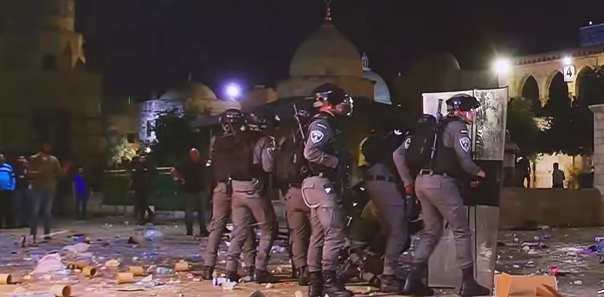
Clashes between Israeli police and Palestinian protesters outside the Al-Aqsa mosque (YouTube)

Whose Homes Are They?
There is an area in East Jerusalem referred to as Sheikh Jarrah where there have been Palestinian residents in place since Jordan had that part of the city from 1948-1967.

The Jordanians never transferred OWNERSHIP to these families. When the Israelis won subsequent wars, the ownership of the land reverted back to the Jewish landlords who possessed the property prior to the establishment of the Jewish state. Courts determined in the ‘80s that Jewish landlords were the rightful owners, but they continued to allow Arab tenants to remain. Now, there is new Jewish ownership who seek to reclaim, which though legal, would mean evicting generations of Arab families. The final appeal pending before the Supreme Court was delayed and Arab political leaders see this as a rallying point for the community to rage against the government. This also comes on the heels of P.A. elections where President Abbas claimed Israel would not allow East Jerusalem residents to participate.
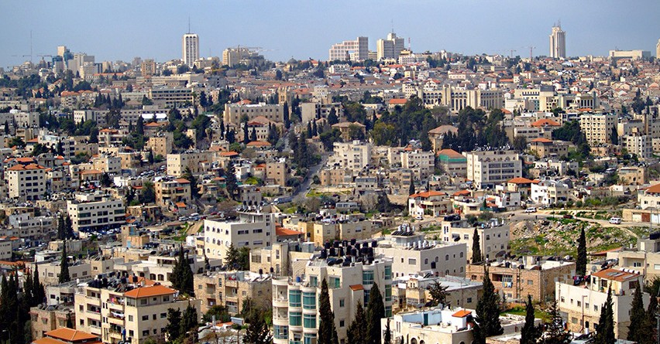
Sheikh Jarrah neighborhood. In the background, the city center of Jerusalem (by David Shankbone, CC BY 3.0, Wikipedia)

“So his sons Isaac and Ishmael buried him in the cave of Machpelah, in the field of Ephron the son of Zohar the Hittite, which is east of Mamre” Gen. 25:9.

Estranged brothers, Ishmael and Isaac came together in order to bury Abraham their Father at his passing. As believers, ultimately we are connected with a spiritual inheritance from Abraham through Yeshua, (Jesus). We should pray for the ultimate reconciliation between the descendants of Ishmael and Isaac, who are still contending for the physical inheritance that seems to be in dispute – the land. Once both of these groups receive a revelation of the “Who” of the inheritance, the “What” of the inheritance will be an issue that should take care of itself. We lament that biblically there may yet be more casualties in this conflict, militarily or domestically, before the love of the Father prevails upon the hearts of both groups. We can agree with God that the time would be shortened in His land between now and realization of promises as described in Isaiah’s 2nd and 11th chapters.

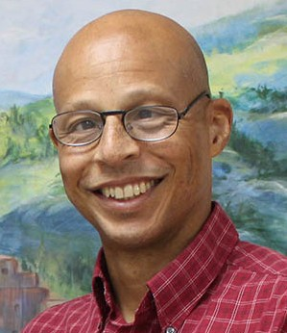
Reporting from Jerusalem,
Kim S. Brunson

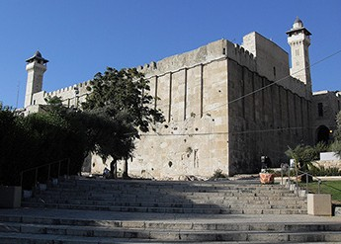
Cave of the Patriarchs (Hevron) where Abraham was buried by his sons Isaac and Ishmael
(by David Shankbone, CC BY-SA 4.0, Wikipedia)

