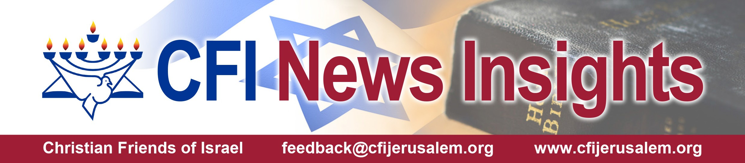

September 25th 2021 / Jewish Year 5782

Fall Feasts Observed in Israel - Part 1
Again the Lord spoke to Moses, saying, “Say to the children of Israel, ‘On the first day of the seventh month (almost October), you shall observe a day of solemn sabbatical rest, a memorial day announced by the blowing of trumpets, a holy convocation.
You shall not do any laborious work [on that day], but you shall present an offering by fire to the Lord.’” Leviticus 23:23-5 (AMP)

Blow the trumpet at the New Moon, At the full moon, on our feast day.
For this is a statute for Israel, An ordinance of the God of Jacob. Psalm 81:3-4 (AMP)

In 2021 the Fall Feast Holidays dominate the September calendar within Israeli society. That being the case, we will take the next 2 Insights to cover these observances, their significance to God with respect to the cyclical rhythm that he expects His covenant people (whether Jew or Gentile) to keep and how some in the land have acknowledged these dates this year. In the first part, we will review Rosh Hashanah (Yom Teruah) and Yom Kippur and in part 2, we will look at Sukkot and Simchat Torah which culminates the holiday period.
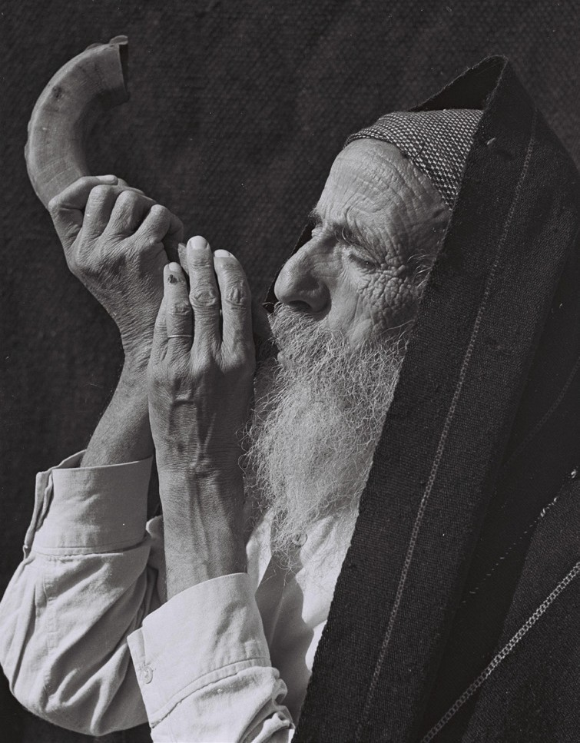
The first day of Tishri, the 7th month on the Hebrew calendar was set apart by blowing of trumpets, traditionally shofars or ram’s horns, as a way of awakening or summoning the people of Israel together. This day is supposed to be ‘Day One’ of
Creation, and point to the emergence of Adam and Eve in “Gan-Eden.” This year, the day in Israel was marked by the population hitting the 9.3 million mark in the land, the birth of 133 infants on September 6 and even a story of a paramedic saving a lady who had a severe allergic reaction to the traditional pomegranate and honey delicacies many enjoy for this celebratory day.
Zoltan Kluger, Public domain, via Wikimedia Commons

You shall do no work at all [on that day]. It is a permanent statute throughout your generations wherever you may be. It is to be to you a Sabbath of complete rest, and you shall humble your- selves. On the ninth day of the month at evening, from evening to evening you shall keep your Sabbath.” Leviticus 23:31-2 (AMP)

Next on the calendar, is Yom Kippur or the Day of Atonement. After introspec-
tion, the nation individually and corporately takes 25 hours to confesses sins in order to have YHVH God wipe them away and give everyone a clean slate for the next year. Fasting and repentance occurs and this day according to Jewish custom, God places the names of those absolved in the Book of Life until the following year. (As believers in Yeshua, we adhere to the belief that He completed the High priest and the animal sacrifice
function, once and for all time, sealing those in the Book of Life that are able to accept Him in those roles.)

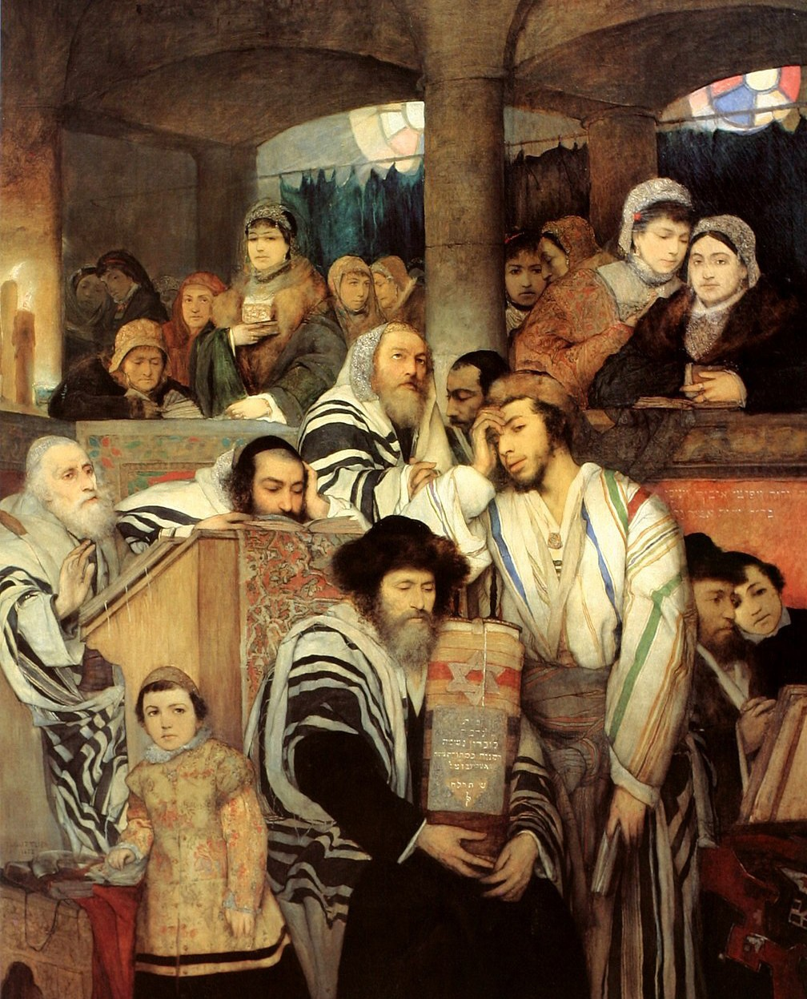
Maurycy Gottlieb, Public domain, via Wikimedia Commons

Modern observance annually calls for no use of any vehicles in the land on that day. Events that occurred this year connected with Yom Kippur included: the usual abundance of bikes, scooters, skates and skateboards that take advantage of naked roadways on this day. Unfortunately, a drunk driver ignored the sanctity of the day and ran over a teen- ager on a cycle, and killing him. Despite the holiday, the IDF and police in the land main- tained a level of due diligence with personnel deployed with the awareness that Israel can never be caught externally or internally off guard by any untoward happenstance.

Those of us from the nations should probably direct our faith via prayer to the Father at this time of year against anti-Semitic activity in the earth, that our nations begin to adjust their own annual and weekly habits to the one that God has put in place in Israel with reference to regular observance of Shabbat and the Spring and Fall Feast times. To do so might bring more understanding to Christians regarding the Jewish foundations of their own faith and a greater sensitivity to the culture and society of present day Israel as a nation-state.
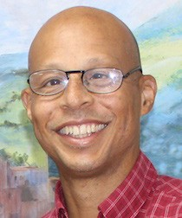We will uncover the Feast of Tabernacles 8-day observance in our next Insights article.

Reporting from Jerusalem, Kim S. Brunson
CFI News Insights Correspondent

