CFI News Insights
Christian Friends of Israel
feedback@cfijerusalem.org
www.cfijerusalem.org

June 10, 2021 /Jewish Year 5781
Old Embers Stoke a New Fire:
Convergence of Flashpoints between Ancient Adversaries
Part 1 of 2

“Ashkelon will see it and fear; Gaza will writhe in pain, And Ekron, for her hope and expectation, has been ruined. The king will perish from Gaza, And Ashkelon will not be inhabited” Zechariah 9:5 (AMP).

During President Trump’s tenure, the terror activity from Palestinian Gaza had almost come to a halt. There was a stabbing here, maybe a car ramming there, that was motivated by sectarian enmity, but it has been remarkably quiet for many months within the borders of Israel. That is, until the past month. So much has happened within the Israeli-Palestinian context, that it will require 2 Insights to give the topic justice. In this segment, I will summarize the military conflict between the IDF and Hamas/Jihad to include some unprecedented nuances this time around. In our next offing, I will focus more on the civilian conflicts that are taking place between Arab and Israeli Communities and the political forces that may have had sworn enemies scripting behavior, to achieve internal political leverage.
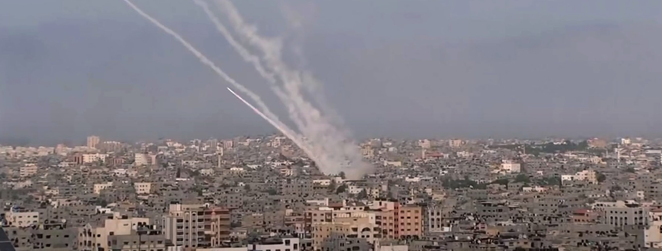
Gaza militants fired more than 2000 rockets into Israel (YouTube)

Calendars Coincide

“So I will send a fire [of war, conquest, and destruction] on the wall of Gaza And it shall consume her citadels” Amos 1:7 (AMP).

As Israel entered the period where it celebrates the liberation of Jerusalem and Shavuot (Pentecost) within the space of 2 weeks, rocket fire resumed from terrorist cells in Gaza. This also happened to be within the Ramadan observances of Islam. Financed by the regime in Iran both Hamas/Jihad now have longer-range missile capability and are able to menace communities that had not been as vulnerable in the past. This includes areas in and around Tel Aviv and even Jerusalem on Jerusalem Day, which was seen as a redline for most Israeli leaders. Terrorist cells sought to overwhelm the Iron Dome Defense system with sheer quantity of

salvos being shot at civilian areas, while the precision conscious Israeli Air Force targeted launchers and weapons depots located within Gaza. The typical battle for the narrative in the international arena has proliferated, as to who is to blame for the conflict, who is inflicting the most damage, and who can claim the moral high ground regarding being discriminant in targets. Two notable things distinguish this flare up from past ones: This time Israel will not cease operations just because the terrorists cease fire temporarily, and even more interestingly, someone “leaked” that the decision had been made for a ground incursion into Gaza by the IDF, which caused Palestinian combatants to furrow into the tunnel structure under the land. At that point, the Israeli Air Force targeted the tunnels; the misdirect seems to have been deliberate, perhaps acknowledging the effect media may have on outcomes and strategy, based on how readily available information is on the world wide web.
The Israel Defense Forces (IDF) operation to strike targets in Hamas’ underground ‘Metro’ tunels network (YouTube)

“The Philistines were standing on the mountain on one side and Israel was standing on the mountain on the other side, with the valley between them” 1 Samuel 17:3 (Amp).

“The Philistines again made a raid in the valley” 1 Chronicles 14:13 (Amp).

Always Adding Chapters
Bible scholars are aware that Rome was the one that named the land, which composes much of Israel, as “Philistina,” to mock the conquered Jewish populations with the name of its most obstinate and persistent adversary, the Philistines. The area remained Palestine and those who inhabited it prior to the modern age were referred to as Palestinian Jews and Palestinian Arabs. However, due to Pan-Arabic nationalism and radical Islam’s need for a common rallying point to justify opposition to the modern Jewish state, “Palestinian” became associated only with those of Arab descent who inhabited the land. The same dynamic enmity for Jews was primed in this population, even though they may or may not be descended from the Philistines in actuality. As believers in the Jewish Messiah, we are aware that the end of this blood feud largely rests on an understanding of who Jesus/Yeshua was….and is. Until that point, we must endure the tug of war over land, rights and religious differences as it plays out. Part 2 of “Old Embers” will focus on the civilian and internal by-product of this conflict that may also demand a supernatural resolution by the hand of the God of Israel; He is the God of all creation.

Reporting from Jerusalem,
Kim S. Brunson

