CFI Projects Monthly Reports for
International
Representatives

Dear CFI International Representative Family,

Thank you for your continued support of the Outreach efforts of Christian Friends of Israel. We continue to strive to encourage those in need and to offer practical assistance during times of struggle. It’s during these times when relationships can be formed which please God and allow us to show Compassion to those who need it the most and have possibly never experienced it before.

During this time of global pandemic, we continue to offer assistance as we are able, and we know each passing day may allow for additional hardships, but we also know the God whom we serve. He is more than able to protect, and provide and heal. We are willing to represent Him to the people of Israel.

Please receive the CFI Outreach electronic updates as a reminder
of the impact each of you have in the lives of so many. We are grateful to represent those of you in the Nations - to those in the Land of Israel.

A friend loves at all times, And a brother is born for adversity.
Proverbs 17:17 (NKJV)

Project Open Gates

Shalom from Jerusalem!

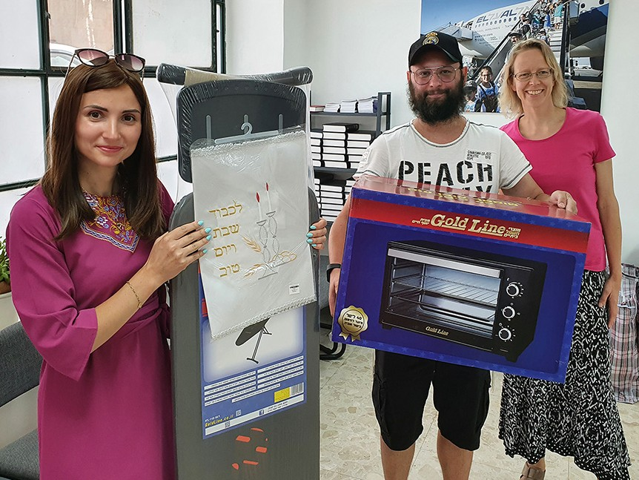
The project “Open Gates” continues to bless new immigrants with household items. This month has not been as busy as the previous two months. Usually our visitors come to receive their gifts by an appointment. The majority of them are from Ukraine, but we have also helped many young olim from Argentina. I am glad that we have this opportunity to support families and individuals during their first months in the Land.

One day we had an interesting family stepping into our welcome room. Some- body had told them about us, and they decided to check what kind of help we offer to them. We welcomed them in.
They were new immigrants from the city of Zhytomyr, which is located about 125 kilometers from Kiev, Ukraine. Artur and Anastasia chose the most needed household items for their temporary home and were very glad. We heard that they have a community of Jewish families that escaped the war and are now living in a camping area not far away from Jerusalem.

To this day about 13 families from that religious community have been blessed by CFI. They have been surprised of the generosity that Christians are showing to them in this time of trouble. While interacting with these interesting people we got to know their Aliyah story.

There was a big Jewish community of more than 400 people in Zhytomyr. When the war began in February a half of them evacuated to West-Ukraine. After four days they travelled by bus to Romania.
Rabbi Shlomo Wilgelm, who is the shepherd of this group of people, contacted Israel and in less than
a week they were in the Holy Land. The community got a permission to settle down at the camping area that is not intended to be habitable for more than a couple of days at time. “With the help of the Almighty we have lived there already four months”, our friends stated today.

This group was welcomed in Israel as refugees. Here in the Land, all of them decided to take the offered citizenship. The government is taking care of their basic needs for half a year.

The husbands of the families who have less than three children cannot leave Ukraine. Thank God that the Jewish families, especially the religious ones, usually are big. Among this group coming from Ukraine we can see men! However, there are many women who moved to Israel with their children only. They do not want to lose their loved ones in the war.

Some of the families have already found a real apartment in the Land. Nobody is really pushing them out from the camping area, but nobody wants to live there forever. It is better to have a real home with your own kitchen and living room.

Please, pray for these precious people, who left everything behind and who are starting a new life in their ancient homeland. They did not really plan to make Aliyah, but now they are here! Just like Vitali and Olga with their four children (on the photos). May they get to know their God closer and closer during this time of changes.
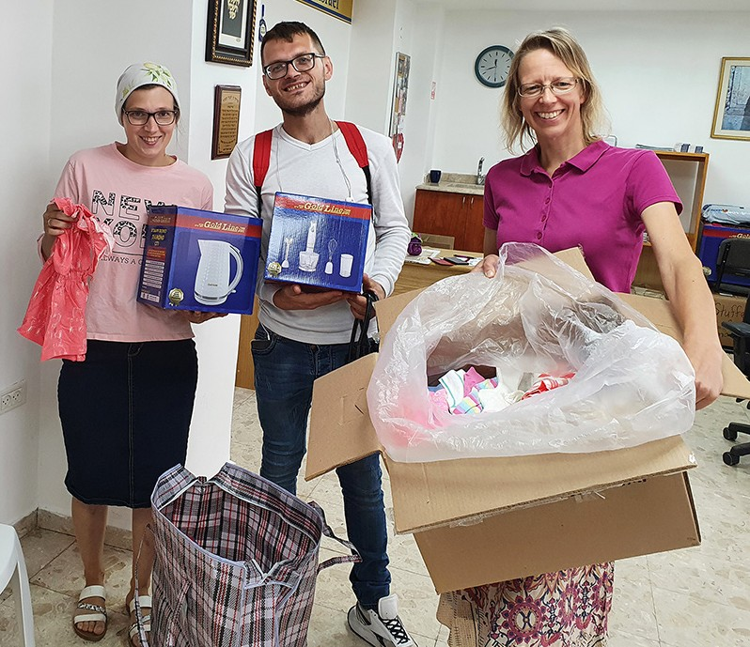
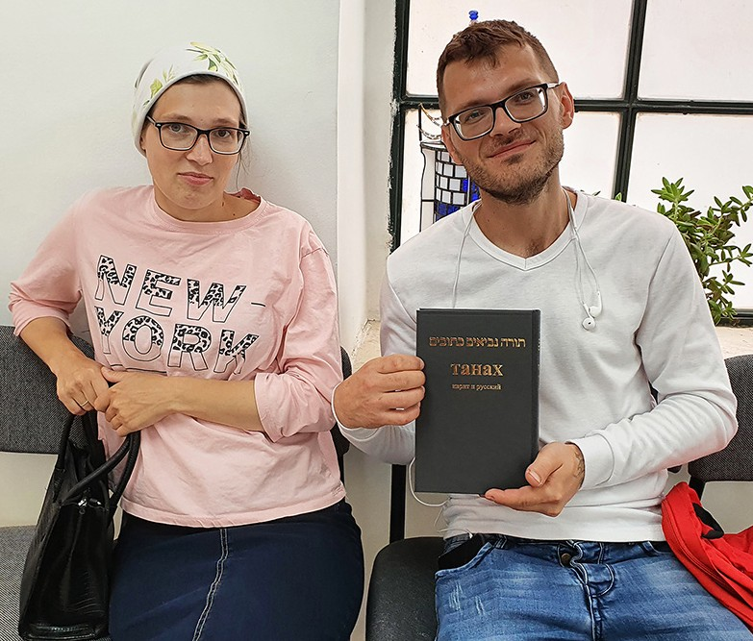

“When you search for me, you will find me; if you seek me with all your heart. I will let you find me, says the Lord…” Jeremiah 29:13-14.
Tiina Danilevski Project Supervisor

Project Bridal Salon

Greetings from the CFI Bridal Salon!

Thank God that we have this opportunity to serve Israeli families with our beautiful items. In the beginning of this month we provided a precious couple, parents of a bride to be, with elegant gowns. Usually people don’t have evening dresses in their closet here in Israel. You don’t need those things very often. But the wedding is a celebration, where not only the bride and the groom wear the best clothes, but also the parents should “stand out” from the crowd. Our Bridal Salon has been a great blessing for many mothers and fathers in the Land. Pnina and Valentin were happy to get from us a beautiful evening dress, jewels, a pair of shoes, a suit, a shirt and a vest.

Last week we enjoyed choosing a wedding dress for a volunteer, who is getting married to an Israeli man. Priscilla comes from Holland. She is a tall, attractive woman with the figure of a model. Her skin color makes our dresses look even more beautiful. We made a photo session with her and had fun. In half an hour we found for her two very good options. Both of them were “queenly” dresses. It took a while to decide, which one of them is ‘the Dress.’ Priscilla was even thinking of taking both the gowns with her, as some of our clients do, but at the last moment she made the decision. She chose the bigger and puffier one, which makes her look like a queen indeed. We found for her also a lovely veil, a necklace, head pieces and a pair of shoes. Her fiancé came
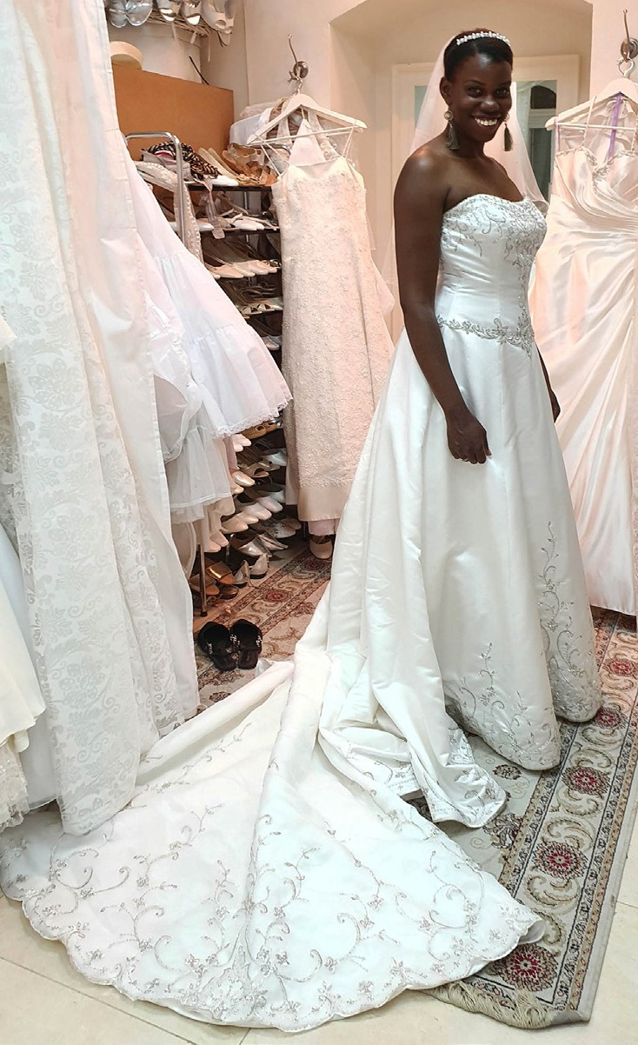
to pick her up. He is much shorter than his bride to be, but he looked very happy. I am sure that he will be ‘in a positive shock’, when he will see his chosen one, Priscilla, in that special dress. I would like to be there and see that moment.

“You have ravished my heart, my sister, my bride, you have ravished my heart with a glance of your eyes, with one jewel of your necklace.” Song of Solomon 4:9

God bless you, friends! May the Lord be glorified in our lives more and more!
Tiina Danilevski Project Supervisor
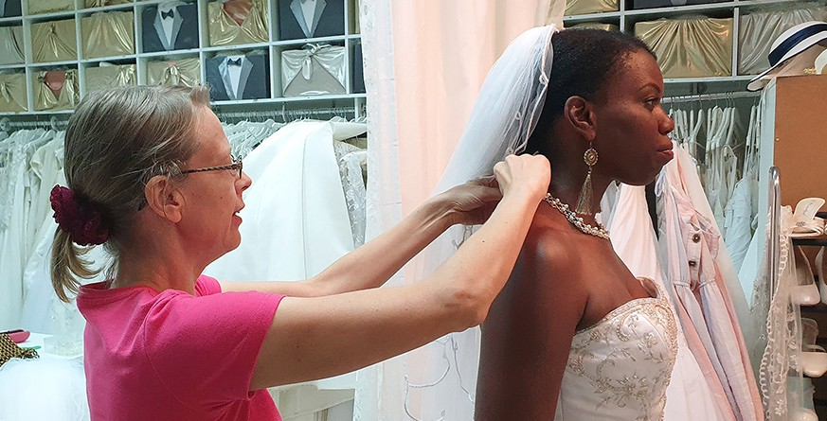

Project Under His Wings

Shalom Friends of Israel,

“Greater love has no one than this, that one lay down his life for his friends” (John 15:13).

On 5 May this year during Yom Haatzmaut (Independence Day) - Israel’s national day Israelis flocked to parks, hiking trails and beauty spots, for barbecues and picnics, as Yom Haatzmaut is a real family day Two Palestinian terrorists came to Elad, a city in Central Israel, to attack passers-by, killing three people and injuring up to nine others. One of the terrorists had been wielding an ax and knife, and the other possessed a firearm.

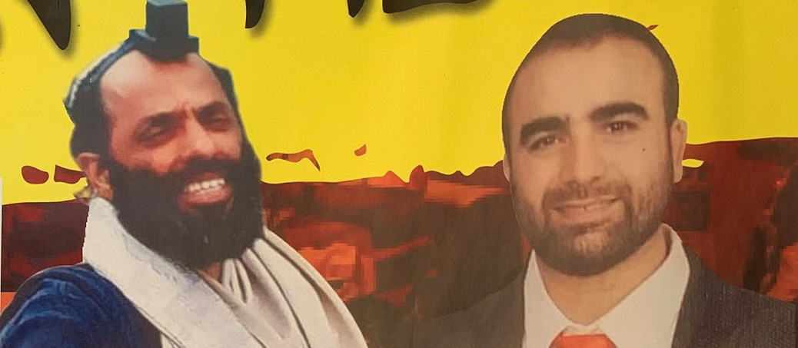
By God’s help, Project UHW reached out to the widows of two deceased victims of terror – Yonatan Havakuk
(see pictures), and Boaz Gol
both in their 40s.

Yonatan Havakuk survived his wife Limor and 5 children. And his son Yosef who is traumatized after witnessing the brutal killing of his father by terrorists, who even ran after him. Yonatan bravely fought the two terrorists and injured them to prevent them from going to kill others. Police said Yonatan at least
saved 200 people from being killed or injured. It reminded me John 15:13 that says, “Greater love has no one than this, that one lay down his life for his friends.” Yonatan was a very special man who looked for teenagers who had strayed from life and took them to his side to help them. He touched and impacted their lives profoundly.

And Boaz Gol also survived his wife Galit and 5 children. Boaz loved to study Torach. He was on his way to a learning center to study Torah when he was attacked and killed by these two terrorists.

One thousand Israelis from all over Israel came to their funerals when they read in the news of what had happened.

It was a great loss and deep sorrow for their families as, both of them were wonderful and loving fathers. During our visits to Limor and Galit, some of their children were at home. The visits were very special and they were deeply touched by our love and support.

Thank you to our supporters, for your financial support which enables Project UHW to comfort those who mourn in Zion. God bless you.

Maggie Huang Project Supervisor

Project Communities Under Attack

Dear Friends of Israel,

“By His stripes we are haled” (Isaiah 53:13).

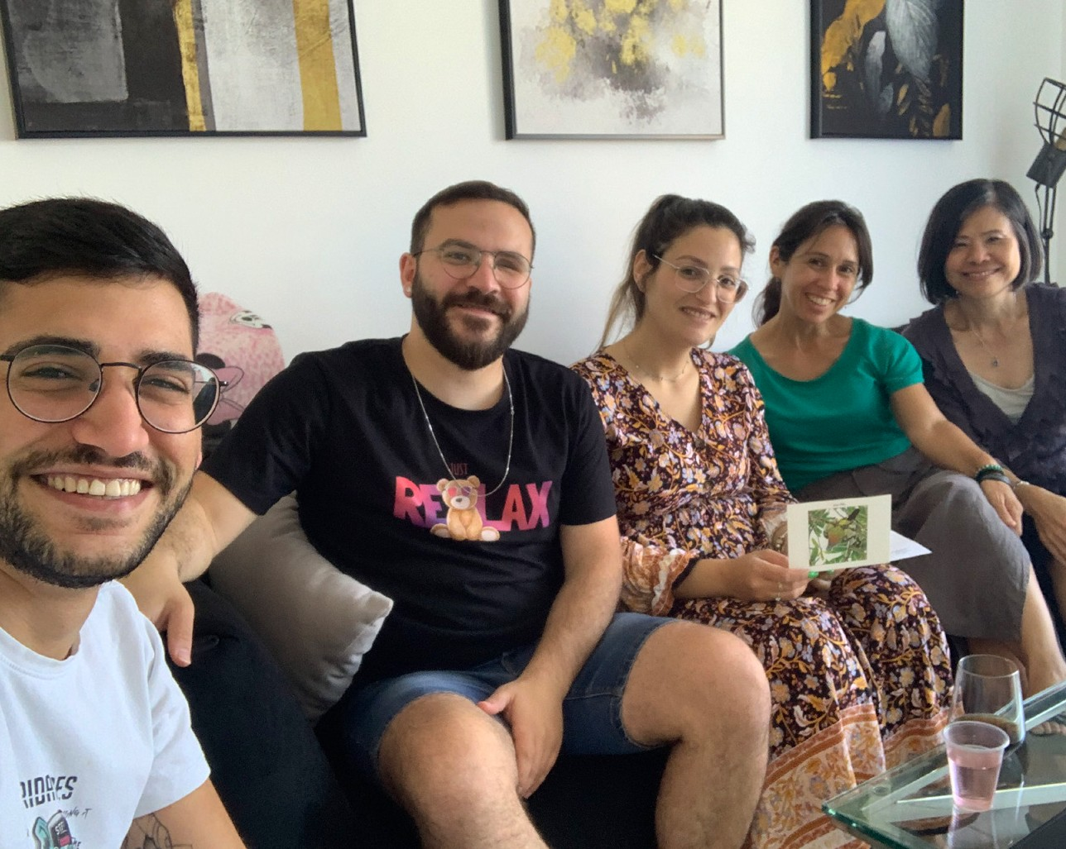
Shalom. Ron lost his left eye because of missile explosives during his army service and he also was traumatized. I was very glad to know that he was married last year and he and his wife are expecting their first baby. Ron’s singing is very beautiful; he was on a talent show of the Israeli TV and won the competition. He had an opportunity to raise fund to make a music album but he did not make it through due to his trauma setting in. He said he has another opportunity to try again. May he succeed this time. Our visit to Ron (the man in the middle) was very inter- esting, partly was because the pres- ence of his brother in law (the brother of his wife) who said he is an atheist.

I discovered that the reason he became an atheist was after seeing many tragedies happen so that he no longer believes in God. We had many conversations on the Scriptures as well as life, and I prayed they made difference to this young man as well as Ron and his wife Dorina.

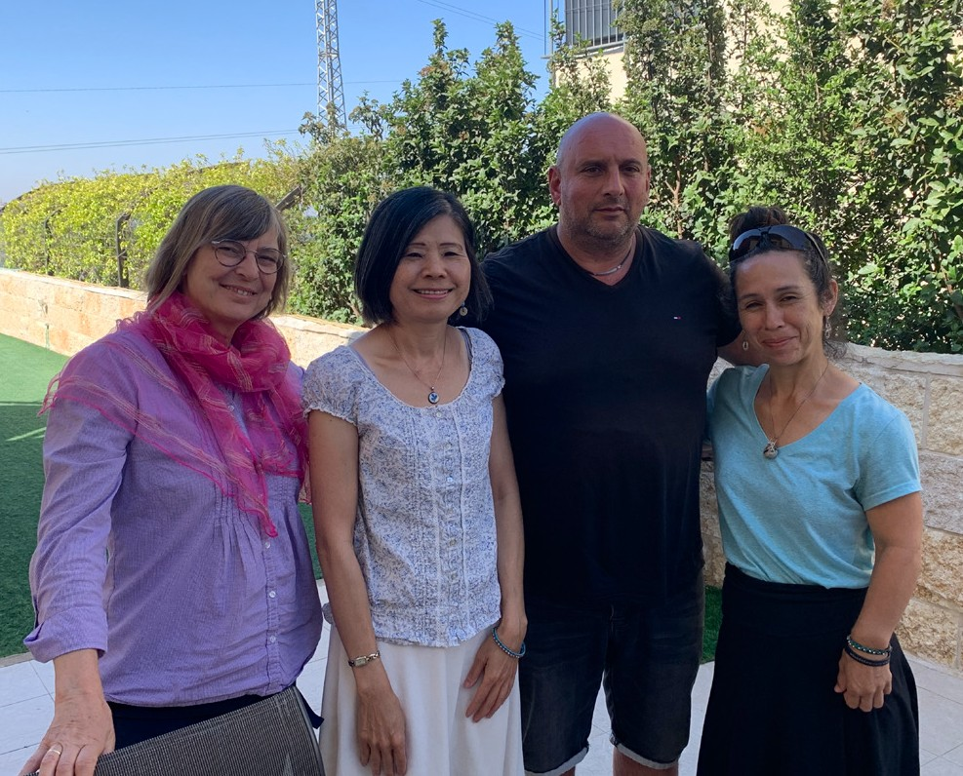
Moshe and his wife’s catering facility was destroyed by last August’s fire attack. Moshe has serious hernia problem and he has already gone through 15 surgeries but it keeps coming back and his doctor does not have a solution for it, except continue surgery. During the visit I can tell that Moses was in great pain.
Knowing that he needed to go to doctor’s appointment shortly, I asked him could I pray for him before we leave, he said yes.

Moshes was deeply moved by the prayer, and I prayed that the prayer will stay in his mind and that God gives him revelation of the Healer by whose stripes we are healed (Isaiah 53:13).

Thank you for your financial support to Project Communities Under Attack, God bless you and your family.

Maggie Huang Project Supervisor

Project Wall of Prayer

GROWING DEEPER AND BLOSSOMING

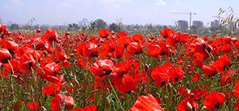
“The root of the righteous gives forth of itself” (Proverbs 12:12, CJB). “He will be like a planted tree over streams of water, producing its fruit during its season. Its leaf never droops – but in all he does, he succeeds” (Psalms 1:3, TLV).

We praise God for bringing new life into Israel! Summer is here! Brilliant flowers and trees are blooming, and the streets are bustling with tourists. The CFI office has also
been buzzing with international visitors and calls. We have not seen this volume of visitors and activity since before the covid pandemic.

In honor of Shavuot (also called Pentecost and Feast of Weeks), Christian Friends of Israel sponsored a 3-day online Shavuot 2022 Conference from June 3-5, 2022. The keynote speakers were CFI
Co-founder Sharon Sanders, Rev. Rick Ridings, Chairman of the CFI Board, and Pastor Robbie Coleman, CFI International Development Director. This teaching event featured an intriguing round-table discussion between Jewish scholars David Nekrutman and Jonathan Feldstein, and CFI leaders Sharon Sanders and Robbie Coleman. They discussed relationships between Christians and Jews. Tommie Coleman, CFI’s Education Consultant, provided the worship music. The Wall of Prayer department participated by offering prayers for Israel and the nations in English, French, Polish, Portuguese, and Spanish. These twelve intercessors were part of our international prayer team and originated from Brazil, Canada, Columbia, Germany, Poland, Switzerland, the United Kingdom, and the United States. You may view the conference by visiting our website at https://www.cfijerusalem.org/.

Shortly after Shavuot, we hosted the Annual General Meeting. It was heartwarming to embrace some of our international representatives with whom we pray online each month. They gathered with the Board of Directors and Leadership for the meeting. We are expecting more representatives and guests from around the world in the days to come.

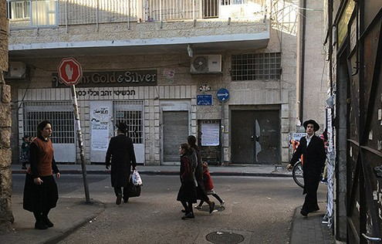
Last month, we enlarged the Wall of Prayer by reaching eastward to launch the Pacific Region Prayer Team. It is exciting to see God moving in all our prayer meetings hosted from Jerusalem. As we expand, we are also going deeper into the land of Israel. This month we took advantage of this growing season by extending our “roots into the ground,” praying in more places within the fabric of Israeli society. We participated in a worship and prayer meeting at a drug rehabilitation center operated by believers, where we intend to come regularly. It was a joy to encourage and pray for participants at a women’s support group meeting. As God directs our steps, we prayerfully go to those areas spreading the aroma of His presence and deepening relationships.

God has answered our prayers for a co-laborer for this season. Tzipporah has already been a great blessing and an encourage- ment in planning and implementing prayer visits. This month we visited Mea Shearim and Geula praying “onsite with insight.”
We also joined with Jewish and Christian believers in intercession for Israel at several Jerusalem prayer houses. Other strategic locations were identified for future visits. God is at work!

“For I will proclaim ADONAI’s Name, ascribe greatness to our God! The Rock – blameless is His work. Indeed, all His ways are just” Deuteronomy 32:3-4, TLV.

We are so thankful for your prayers, encouraging words, and love gifts. It inspires us to continue the work that God has called to do. Sometimes I can feel the Holy Spirit giving me fresh wind and fire. May God graciously reward you.

Linda McMurray Project Supervisor

Project Forsake Them Not

“Oh, give thanks to the Lord, for He is good! For His mercy endures forever. And say, “Save us, O God of our Salvation; Gather us together, and deliver us from the Gentiles, to give thanks to Your holy name, to triumph in Your praise” (1 Chronicles 16:34-35).

It is a great joy and a privilege for us to witness today, how the Lord in His great mercy, saved His people during the Holocaust, delivered them from the hand of the Gentiles, and gathered them here, in the Land of Israel. We had many wonderful visits in May, visiting 35 people and making nine trips all over Israel.
Oftentimes we see the entire atmosphere change when we speak about the good things the Lord has done and give Him praise. Hopelessness leaves, and hope arises, brought in on unseen wings of grati- tude. Praise and joy lift the hearts of our dear friends, setting them free from sadness and despair.

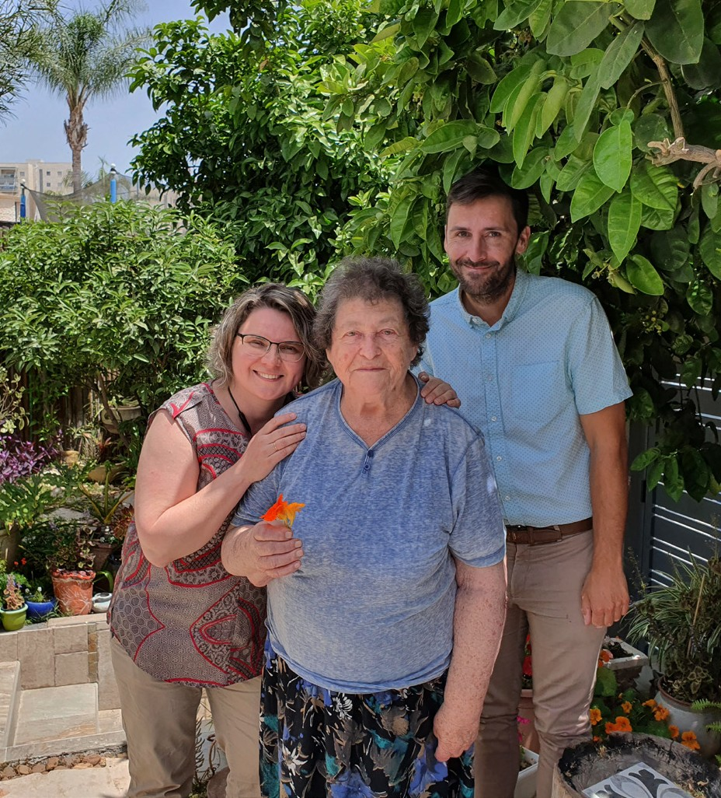
Luba from Sderot was so happy to greet us when the three of us – Tristan, Sara, and I, came to visit her. She got very excited and showed us her beautiful garden and the flowers her daughter planted. Luba lives with her daughter and son-in-law; she is well cared for and deeply loved, but most of the days she spends by herself. Nevertheless, she does not feel lonely because she talks to God all day and sometimes feels tangible peace and someone’s presence.
Luba was five years old when the war started; it is hard to listen to her story. She experienced killing raids, miraculous escapes from death, betrayal, and being saved by kind people. There is no trace of pain or bitterness in Luba’s heart. Her message to people is very simple – be kind and trust God. He will defend His people and save them from their enemies. It was such a blessing to see the Lord triumph in Luba’s life and for us to give Him thanks together.

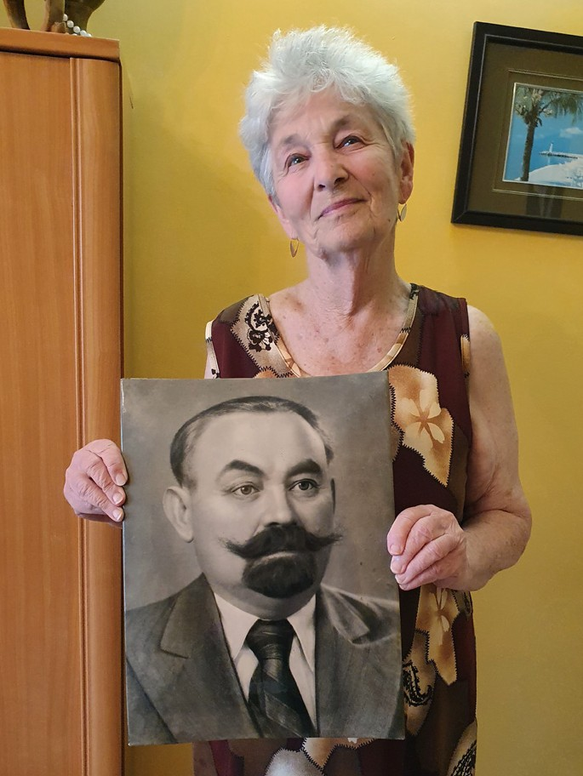
Golda is a 96-year-old Auschwitz survivor who lives with her daughter’s family. Golda’s eyes always light up when she sees us. She loves the word of encouragement from the Scriptures we bring, and I often read a Psalm to her. Golda’s real struggle is at night when memories from the past come in like a flood. This struggle is also very real for her daughter Edita, whose heart breaks for her mother. Still, Golda always lifts up her eyes toward heaven and praises Him, who spared her life. We also would like to share with you a letter Edita sent us after the visit:

I am Edita, the daughter of Holocaust survivors. My father passed away here in Israel, and my mother, Golda Edelshtein born in 1926 in Carpathian area in Western Europe, is living with me now. I am writing this letter of gratitude to the Christian Friends of Israel.
Your mission to help elderly people who survived the cruelty of the Holocaust is very important. On behalf of my mother, I would

especially like to thank Olga Kopilova who has come to visit us for many years. Her visits are warming the heart of my mom. When Olga comes, she is sincerely interested in my mother’s health situation, and when she leaves, she asks my mother to be strong and hold on until her next visit. We realize that we need such visits; they are like a glass of fresh water. Elderly people like my mother appreciate such attention very much! I wish that Almighty G-d would give more years of life to my mother in the good health condition that she has now. I also wish to see Olga visiting us in all these years yet to come. I trust that the faith in God that Olga has, will keep her and guide her. May G-d help you for the sake of
all these people.

It is very special to us when we can read and to say together with our precious friends the words of Psalm 59, “But I will sing of Your power; Yes, I will sing aloud of Your mercy in the morning; For You have been my defense and refuge in the day of my trouble. To You, O my Strength, I will sing praises; For God is my defense, My God of mercy.” (Psalm 59:16-17)
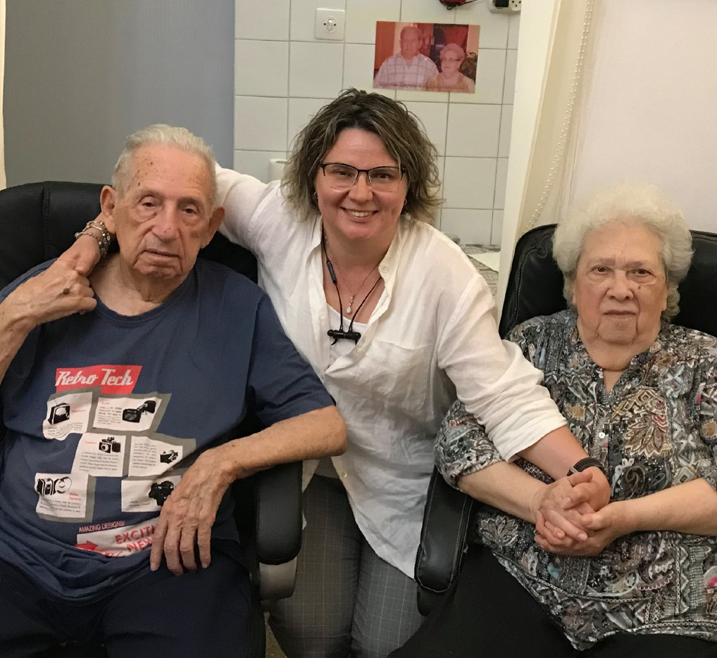
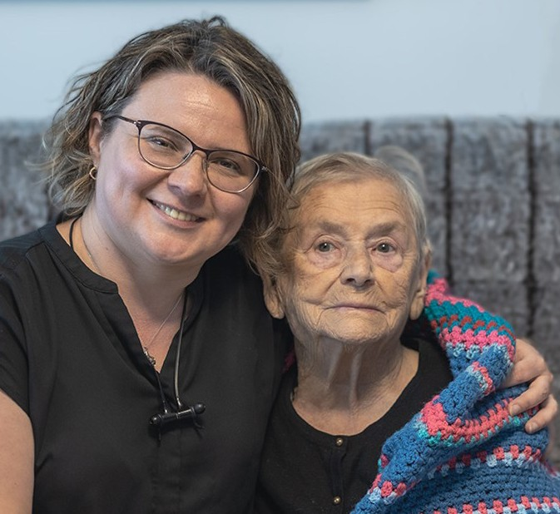

Thank you so very much for the incredible support you have been to CFI and to the Holocaust Survivors. As a team here, we give thanks to the Lord for your love, care and financial gifts to Israel and her people. It is a great privilege for us to share with you what the Lord has done, with eager expectation for greater things to come. Let us triumph in His praise together.

“Blessed be the Lord God of Israel From everlasting to everlasting!” (1 Chronicles 16:36a).

Olga Kopilova Project Supervisor

