CFI Projects Monthly Reports for
International
Representatives

Dear CFI International Representative Family,

Thank you for your continued support of the Outreach efforts of Christian Friends of Israel. We continue to strive to encourage those in need and to offer practical assistance during times of struggle. It’s during these times when relationships can be formed which please God and allow us to show Compassion to those who need it the most and have possibly never experienced it before.

During this time of global pandemic, we continue to offer assistance as we are able, and we know each passing day may allow for additional hardships, but we also know the God whom we serve. He is more than able to protect, and provide and heal. We are willing to represent Him to the people of Israel.

Please receive the CFI Outreach electronic updates as a reminder
of the impact each of you have in the lives of so many. We are grateful to represent those of you in the Nations - to those in the Land of Israel.

A friend loves at all times, And a brother is born for adversity.
Proverbs 17:17 (NKJV)

Project Open Gates

Greetings from CFI Startup Store!

The situation here has changed. Our place is not crowded anymore, but anyway we are serving new immigrants from different places every day.

This month we have had as much olim from Russia as from Ukraine. All of them have a touching story to tell. All of them have lost a lot, because of the war.
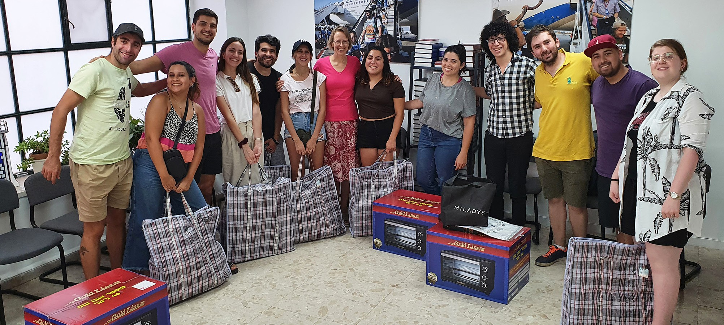

We have also helped young olim from Argentina, and other places from South-America. There have been some young people from Europe and the States visiting us, too. The majority of these visitors are living and studying Hebrew in a big language school here in Jerusalem. After 9 months of studies
they need to find another place to live and they have to become self-supported. It is so good that we as Christians can bless them with our gift. These students are passing the message about our Store in their school, and every week we have small groups of them coming in. It is refreshing to see these precious people who are starting their life in the Land.

We had also one family of Iranian Jews getting gifts from Christian Friends of Israel. They usually don’t speak English or even Hebrew, only Persian. We communicated with the help of their friend, who took clothes from us some years ago and who eventually brought them to our place. He already knew some Hebrew.

Here are some words from our guest book:

“Thank you so much to the Christian Friends of Israel for being so kind and generous. It has been such a wholesome experience being welcomed and treated with such beautiful gifts. It definitely made being Ole Chadash (new immigrant) a much easier experience. We are so grateful.”
Love from Demi, Libby, Nona and Yael

“A great many thanks to the Christian Friends of Israel for your generosity and kindness. Your warmth has been very touching as we have settled in to Israel”

“I thank your organization for helping us, new immigrants. All what you do – very valuable to us. Thank you!!!”
David, Yisak, Tamar, Noah

“A great thankfulness for the support in the beginning of the new life in the Holy Land! I left Moscow, the war and depression giving up all my previous life! I am sincerely grateful for your generous help!”
Theodor
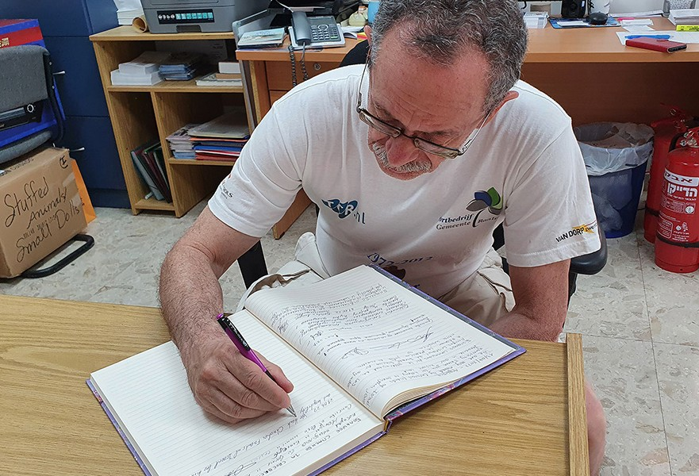
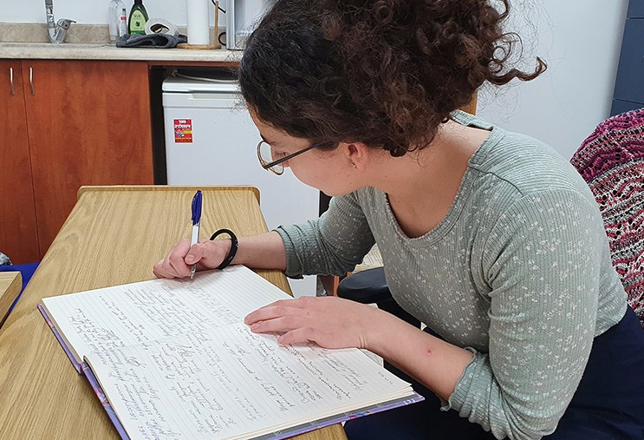

Remember that we are doing this work together for the Glory of the Lord. He keeps His promises to Israel and to every one of us.

“Now the Lord said to Abram, “Go from your country and your kindred and your father’s house to the land that I will show you. I will make you a great nation, and I will bless you, and make your name great, so that you will be a blessing. I will bless those who bless you, and the one who curses you I will curse; and in you all the families of the earth shall be blessed.” Genesis 12:1-3
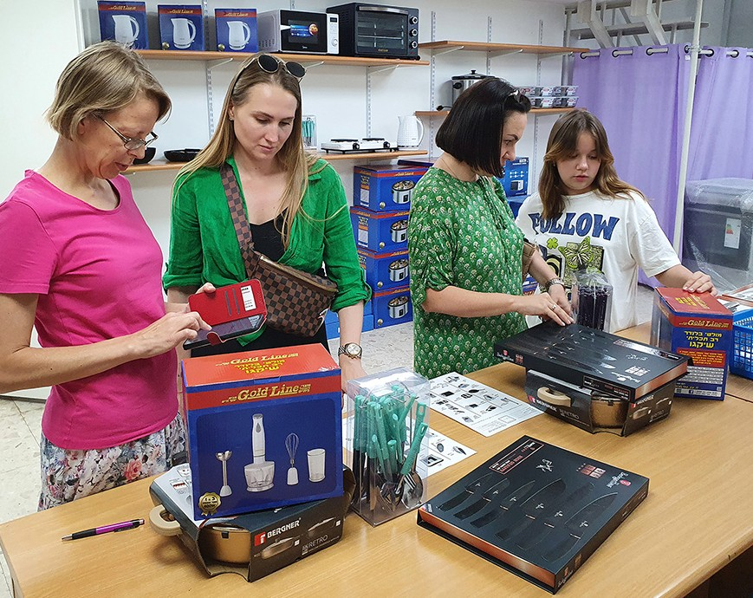
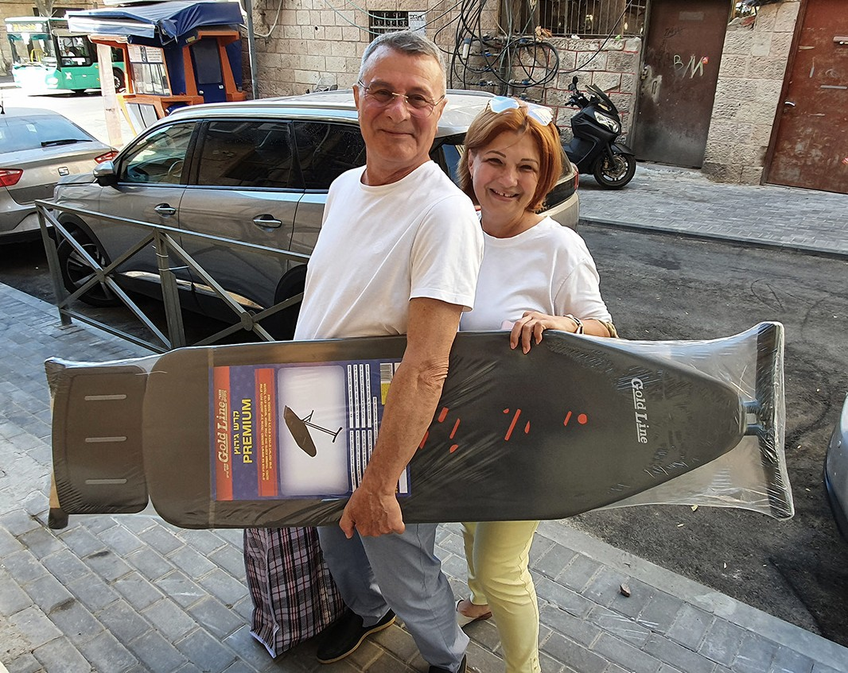

Project Bridal Salon

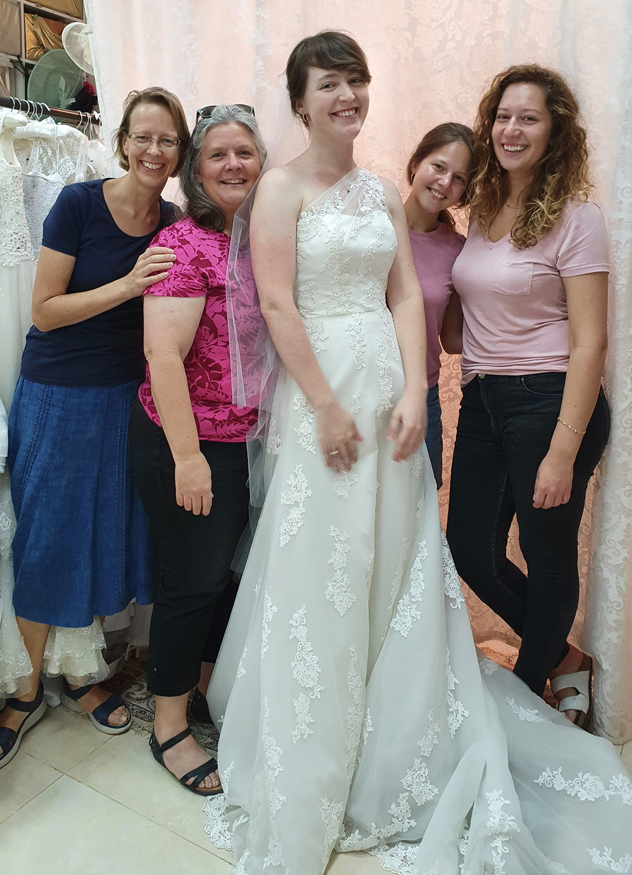
Shalom from CFI Bridal Salon!

We have blessed several people this month. For example Madeline found a gorgeous dress and some beautiful accessories for her wedding. Her mother, who was helping her to make the right choice, got an evening dress and an elegant shawl for the celebration.

One of our clients has an unusual story that I want to share with you today.
Eden is a Jewish lady, who found her wedding dress in the CFI Bridal Salon 13 years ago. Our organiza- tion also gave her a wedding ring that time.
The first years of marriage the couple lived in Israel. Then they moved to South-Africa. Four children were born one after another. Their life was busy.
In 2014 Eden, with their babysitter, were robbed in their own apartment. The babysitter was bound.
When Eden got home one day, the criminals threat- ened her with a gun demanding that she give them the phones, her jewels and some other things.
Eden agreed. Thank God, no one was harmed physically. It was a disgusting experience, but Eden got over it.

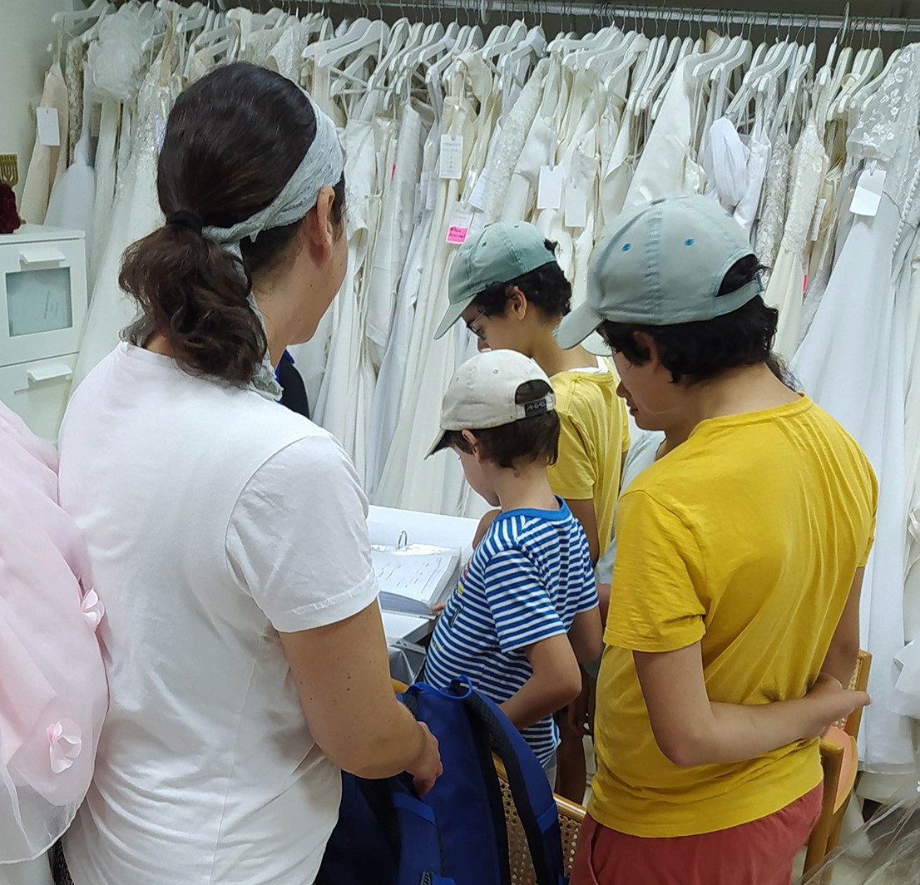
Not long ago the family moved back to Israel. They found a place to settle down in a small town near Beersheva.
Eden remembered CFI and contacted the Bridal Salon. She explained her situation. She really wanted to have a wedding ring, but they didn’t have the finances to buy one. She asked, if we could give her one more ring in place of the lost one. We agreed.
She came in with all of her kids. We gave her a beautiful golden ring with a diamond from our collection of rings. May the Lord bless the person, who donated it for our salon. It was a big blessing for a Jewish mama.

Thank to you all, who are supporting this ministry with your prayers and finances.

“Give, and it will be given to you. A good measure, pressed down, shaken together, running over, will be put into your lap; for the measure you give will be the measure you get back.” Luke 6:38

Blessings from Jerusalem!

As I transition into my new role of Project Coordinator for Under His Wings, I asked God to lead me and equip me. He is so very faithful! God led me to a world-renowned biblically based trauma-healing course with The Trauma Healing Institute, led by expe- rienced ministry workers from around the world. Not only were both my teammate and
I were given the opportunity to attend this rich course which equips us to minister better to those suffering from physical, emotional and spiritual trauma, but a Trauma Healing Leader “happened to be” in Israel for a month and gave us a “mini in-person” course!
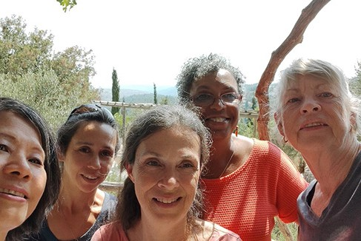
Our mini-trauma healing course in Israel

Project Under His Wings
Through this training, I was ministered to in a personal way, as I was better able to understand and work through some of my own traumatic experiences.

To give you a glimpse of my life, I will share that I spent 10 years in the military in the National Guard and 2 years deployed, one of which was spent in Iraq as a Military Police Lieutenant and Executive Officer. I then spent the next 15 years in local law enforcement, being a part of a highly trained, highly responsive crime fighting team. Needless to say, there were many traumatic incidents from which I needed recovery! Thank God, my life and my teammate’s lives were preserved countless times…

I believe that even if one does not experience trauma in combat or war or terror there are still many life events that can wound and affect us to varying degrees, such as divorce, the inability to have children, the death of a loved one, a personal attack or betrayal of someone once trusted… etc.

These experiences that affect us all differently and to varying degrees, if left alone or unresolved can be debilitating. As a believer, and as one who struggled through trauma, I know the path is not easy, but I also know that the Word of God is a healing balm and that our Abba Father not only knows how to heal but he longs to heal us if we allow Him to.

Indeed, “The Lord is near to those who are discouraged; he saves those who have lost all hope.” Psalm 34:18

I thank God for this spiritual equipping as we learn how to listen better, how to ask question better, and most importantly understand God’s desire to heal us and others through His Word and through the gift that he offers freely to all who will accept it. Please pray that not only will we retain and use the principles learned during this course, but that there would be True Healing as a result. We look forward to that day when… He will wipe away all tears from their eyes, and there will be no more death, suffering, crying, pain. These things of the past are gone forever. Revelation 21:4

Neomi G. Project Supervisor

Project Communities Under Attack

As new Project Coordinator of Communities Under Attack (CUA), I was able to “experience” at least from a closer perspective than most, the latest war in Israel, dubbed “Operation Breaking Dawn” which lasted only 3 days (August 5-7) and during which 1,100 missiles from Gaza were fired at Israel. Being that we are located in Jerusalem, there was little inconvenience to us, other than perhaps, an increased level of alertness for potential terror attacks in the City. In fact, only two rockets made it to the outskirts of Jerusalem, although officials were prepared for more.
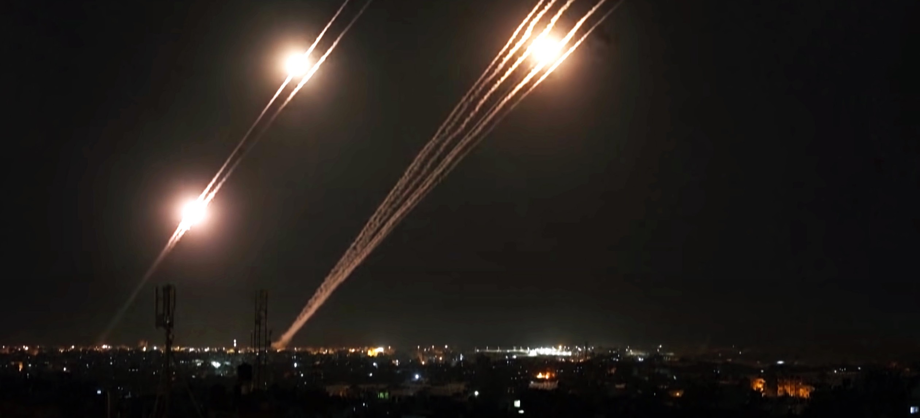

Praise God that out of 990 rockets that actually made it into Israel, only 380 needed intervention from the Iron Dome and all but one fell harmlessly into open areas. Another 200 fell back into Gaza and tragically caused the deaths of their own civilians. However, while we “Jerusalemites” and indeed anyone North
of Tel Aviv, carried on as usual, those brave and hardy souls whose lives and livelihoods exist in and around Gaza, to include the oft hit areas of Sderot, Nir Am, Nahal Oz, Kfar Aza, Nitzamin, Kerem Shalom, Beer Sheva, Ashkelon to name a few…these communities were forced to live from bomb shelters for the entirety of the confrontation and one family from Sderot lost their home when a rocket hit it directly, while they were sheltered below!

Although 12 Islamic Jihad terrorists were killed and many terror sites destroyed in Gaza in this short August war, there was still an emotional and mental cost to be paid and we pray and ask for prayer for those families affected by the continuing trauma of war. Please pray for opportunities for Team CUA
to meet with them and for Abba to heal them with his Word and his Truth. Sadly, most in Israel did not see God’s hand of protection over them and over their Land and instead praised the military and the Iron Dome, rather than God. Please pray that God would open eyes and hearts and that He would take his rightful place amongst his people. May they be reminded of God’s word to Zerubbabel through the prophet Zechariah.

‘Not by might nor by power, but by My Spirit,’ says the LORD of hosts. Zechariah 4:6

Neomi G. Project Supervisor

Project Wall of Prayer

ONE SPIRIT

“For it was by one Spirit that we were all immersed into one body, whether Jews or Gentiles, slaves or free; and we were all given the one Spirit to drink” (1 Corinthians 12:13, CJB).

God has worked in amazing ways on behalf of the Wall of Prayer outreach. For several months, I asked the Lord to send someone to Jerusalem to accompany me on prayer trips regularly. I was pleasantly surprised that He answered by sending a Jewish woman who had previously lived in Israel. I knew Tziporah but had not seen her for several years. We both lived in the United States in cities 3 hours apart. We occasionally talked when she visited the Messianic Jewish congregation I attended, but God worked out every detail so that our paths would cross in Jerusalem. He spoke to me about partnering with Tziporah, and after she prayed about it, the Lord confirmed to her that this was to be a Jewish/Gentile connection. Now we live 5 minutes apart and go on prayer adventures in Israel, wherever God directs us. Other believers, Jewish and Gentile, sometimes join us as we travel, praying “onsight with insight.”

Tziporah and I have walked and prayed together in Jerusalem, Ashkelon, Kiryat Arba, Otniel, and Mitzpe Yericho. Most of these cities are in contested areas and are subject to rocket attacks, so prayer is needed there. We plan to go to Beit Shemesh and possibly some other sites. My prayer partner and friend will return to the US in a few weeks, but we will remain connected and continue praying together online. I will miss Tziporah greatly but hope to see her when she comes back for visits. Just as the Lord answered prayer by sending her for this season, I believe He will send others for the next season. When God answers your prayer, it builds your faith to trust Him more. This seems to be a time of connecting with Jewish believers, so I will watch as God directs our steps.
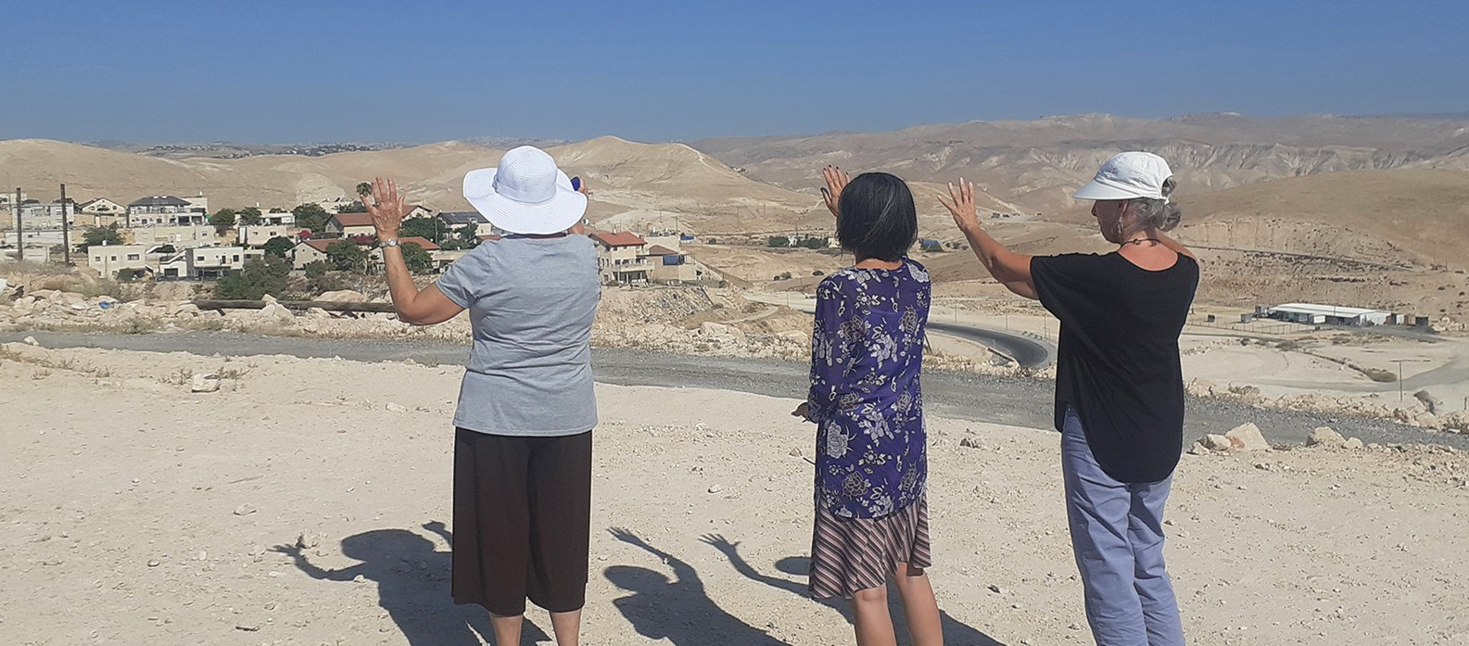

Recently several from our team attended a prayer meeting where Jewish, Christian, and Arab believers regularly come together in worship. The presence of the Lord was powerful! Gathering with other believers encourages the Body of Messiah to be strong in the Lord despite the persecution they may face. I also enjoyed joining a new online prayer group of Messianic Jewish people from Israel and America. God is at work connecting people.

I have noticed when Jewish and Gentile believers pray together, their intercession takes on a new dynamic; the prayers go to a deeper level. This is true of our on-site prayer trips and our online prayer sessions.
Consistently praying with people creates a bond and spiritual synergy. As the Jewish believers pray for their nation, they pray with heartfelt passion reminding God of His covenant with them. It stirs the hearts of the Gentile believers, and we come alongside to encourage and support, crying out together in agreement. In 1 Corinthians 12, Paul speaks of Jews and Gentile believers being part of one unified body immersed into and drinking from that one Spirit of God. What a beautiful picture of unity made possible by the blood of Yeshua.
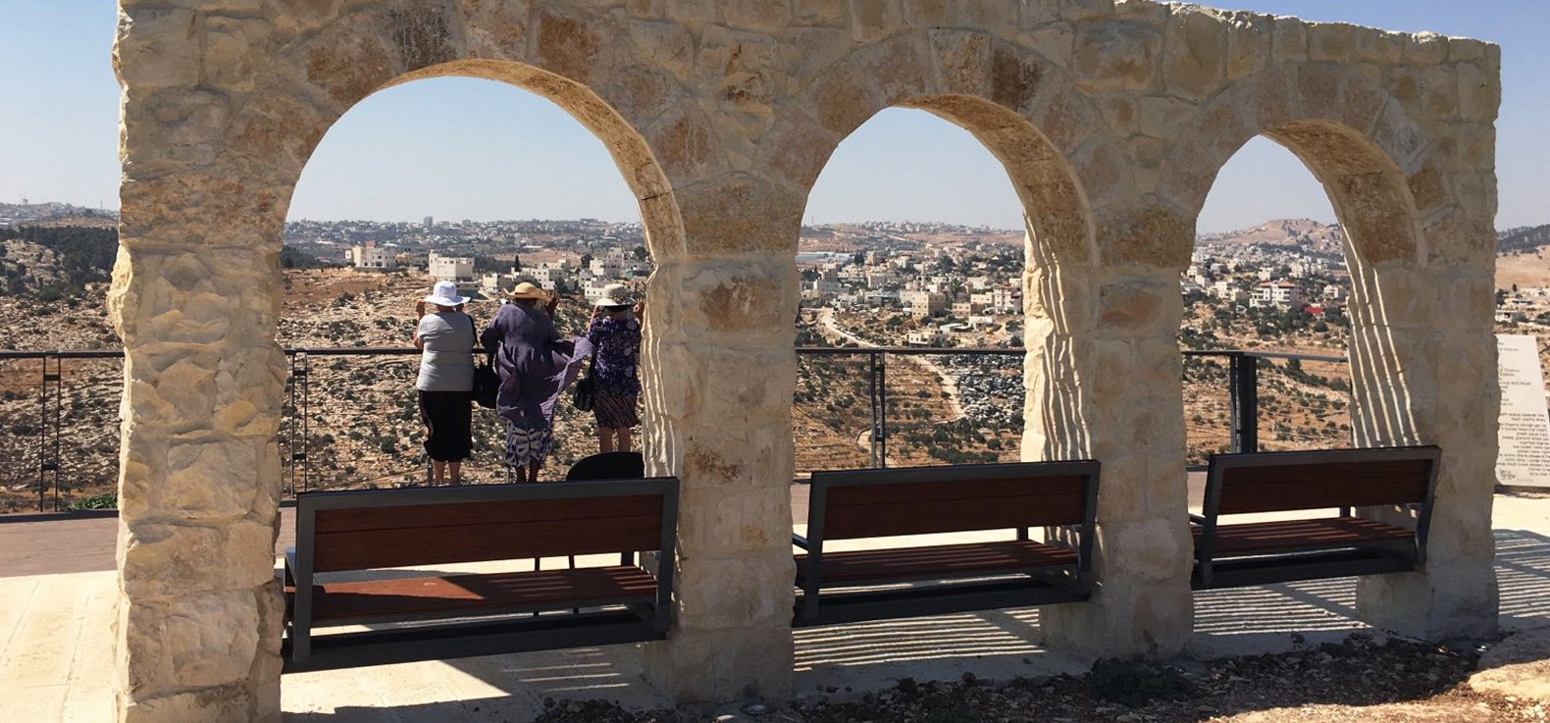

To Our Prayer partners and supporters,
We are grateful to all of you. Thank you for your faithful love, prayers, and financial support of Israel. It is a joy to pray with you as we join hearts and hands to intercede for God’s People and His Land. When we unify with Israel, we have the peace of knowing we are pleasing God by loving what He loves. May His blessings overflow in your life.

Linda McMurray Project Supervisor

Project Forsake Them Not

“Sing praises to the Lord, who dwells in Zion! Declare His deeds among the people. When He avenges blood, He remembers them; He does not forget the cry of the humble” (Psalm 9:11-12).

Not only the present, but also the past is important. As a team here, in Jerusalem, we have the privilege to be your feet and hands when we visit precious Holocaust Survivors. You, in return, also become our mouthpiece, when you share stories we hear from witnesses of tremendous atrocities.
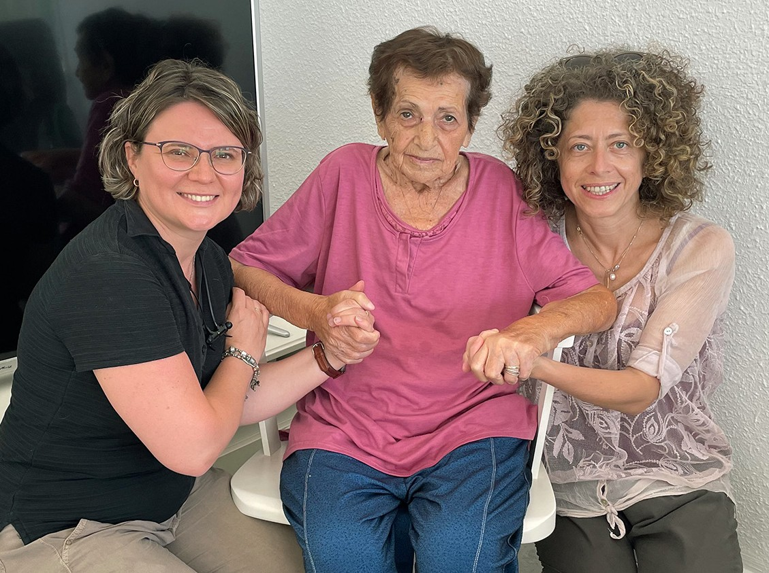
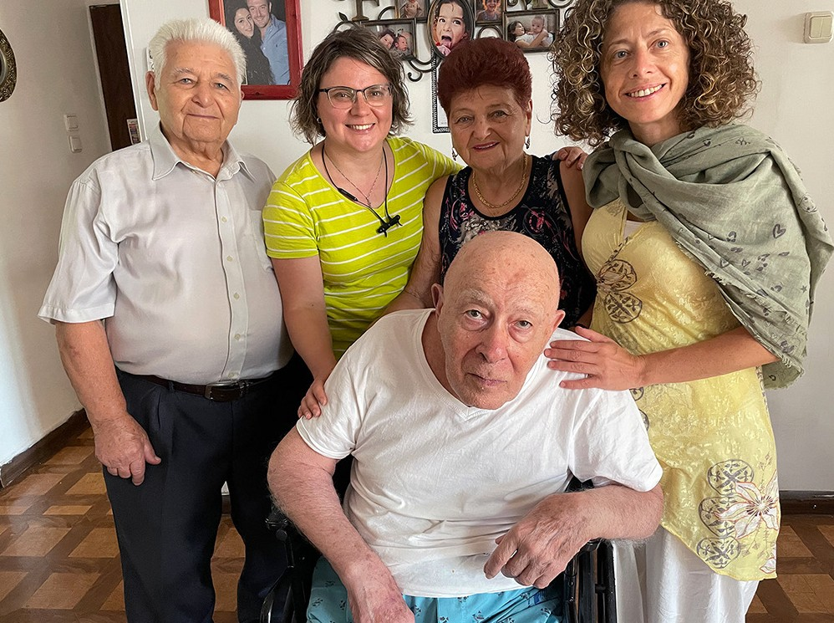

Zina never met her little brother Gersh, but she feels burdened to share his story, so that his name is never forgotten! We promised to help Zina in keeping the memory of a little angel and share his story with you.
In the autumn of 1941, the German Nazis drove all the Jews of the Rishkany district of Moldova to the Vinnitsa region in Ukraine. In the column were mother and father with two young sons, mothers’ parents, two sisters and two brothers with families, dad’s four sisters with families. Along the way, more residents of other areas were added to the column. “Our walk was accompanied by barking dogs and the shouts of SS guards. It lasted for few weeks. Only once did we stop in the forest because of the heavy rain.” Zina recounts.
The first of Zina’s family to die was her grandfather – he was thrown down from the bridge into the Dnies- ter River. Everyone who was not able to move independently was also that day thrown into the river; that is all elderly and the sick.
The ghetto was established in the village of Obodovka. That hellish place became forever home for 75 family members and relatives, including Zina’s grandparents and little brother Gersh, whom she never met.
Ghetto prisoners lived in abandoned houses - without glass in the windows, some - without doors; they starved. Sometimes it was possible to negotiate with the indigenous inhabitants of the village, when they dared to approach the barbed wire enclosing the ghetto, and exchanged some things for food. At first, the Germans guarded the camp, and then the allies - the Romanian fascists, replaced them. Under the cover of night, men used to go to the village to get food for their children. Both the Germans and the Ro- manians knew about it. Nevertheless, if the former did not take any action at night, the Romanian mon- sters rounded up and committed atrocities. Once, during the raid, they did not find Zina’s father, who es- caped the ghetto to get some food for his sons, who were waiting for him. The eldest was then six years old, and Gersh, who softly was called Arshaly, was four years old. Mother was punished in public, forced to say where her husband was. A Romanian officer grabbed her and dragged her along the ground

between the inhabitants of the ghetto, who were driven out to see this spectacle, so that everyone would learn the lesson. Mother lost not only her hair, but also skin on her head. Many years later, she recalled the incident and said, “If I knew where your father was hiding, I probably would have betrayed him.”
The children also were not up to games. Once Arshaly found a piece of glass and hammered it with a stone. He then “extracted” salt, without which they suffered, no less than from hunger.
One day he approached his mother and said: “Mom, throw me into the well and it will be so much easier for you all.”
It was said that Arshaly was of indescribable beauty. Curly blond hair and huge blue eyes. Many said he looked like an angel. Once, the Italian allies of the Germans visited the ghetto. One of the officers ex- claimed, “This child is an angel!” and gave Arshaly a chocolate bar.
When the chocolate was divided between family members, the little boy wanted to be sure that everyone got a piece and only then took his share.
Many Jews died of starvation when finally the ghetto was liberated by Soviet troops in the spring of 1944. No one had anything left to trade; the neighbouring fields were empty. A woman from a neighbouring village liked mother’s skirt, so mother immediately took it off her, remaining in her undershirt. When a woman looked at Arshaly, she said, “He looks like an angel. They usually don’t live long.”
Mother was so pleased to receive a jar of yogurt in exchange for her skirt that she did not pay attention to these words. She was so looking forward for a feast, but the day turned into grief. After having some yogurt after a week of starvation, Arshaly died of ruptured intestines.
In 1990, when Zina first visited Israel, she recorded her brother’s name in the Book of Remembrance in the National Holocaust Memorial Yad Vashem.
Gersh, your name will not be forgotten!

We are grateful for every visit and every story, which was shared with us! In July we were able to visit 43 witnesses of the horrors of Holocaust, bring His hope and light into their hearts and homes.
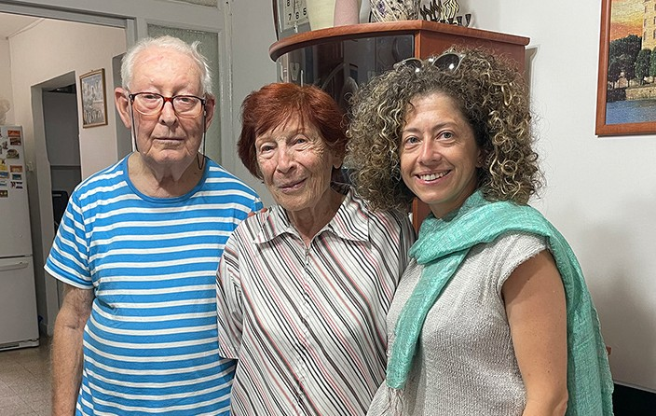
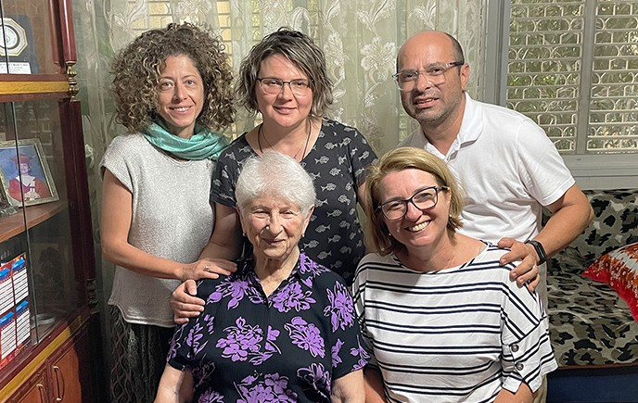

Thank you so very much for your faithful support and prayers for Holocaust Survivors and our team here. As the Lord never forgets the cry of the humble, let us also Let us all be faithful in our callings to comfort His people and not forget His inheritance.

“We have thought, O God, on Your lovingkindness, In the midst of Your temple. According to Your name, O God, So is Your praise to the ends of the earth; Your right hand is full of righteousness” Psalm 48:9-10.

Olga Kopilova Project Supervisor

