CFI Projects Monthly Reports for
International
Representatives

Dear CFI International Representative Family,

Thank you for your continued support of the Outreach efforts of Christian Friends of Israel. We continue to strive to encourage those in need and to offer practical assistance during times of struggle. It’s during these times when relationships can be formed which please God and allow us to show Compassion to those who need it the most and have possibly never experienced it before.

During this time of global pandemic, we continue to offer assistance as we are able, and we know each passing day may allow for additional hardships, but we also know the God whom we serve. He is more than able to protect, and provide and heal. We are willing to represent Him to the people of Israel.

Please receive the CFI Outreach electronic updates as a reminder
of the impact each of you have in the lives of so many. We are grateful to represent those of you in the Nations - to those in the Land of Israel.

A friend loves at all times, And a brother is born for adversity.

Proverbs 17:17 (NKJV)

Project Forsake Them Not

“I waited patiently for the Lord; and He inclined to me, and heard my cry. He also brought me up out of a horrible pit, out of the miry clay, and set my feet upon a rock, and established my steps. He has put a new song in my mouth – Praise to our God; Many will see it and fear, and will trust in the Lord. Blessed is that man who makes the Lord his trust” (Psalm 40:1-4).

Every time we take this scripture to our precious Holocaust Survivors and read it together with them, we are reminded of the Lord’s great faithfulness to His people. Every time we sit at the feet of the ones He brought out of the horrible pit, we also see how He established their lives upon the rock and directed their steps to come to Zion.
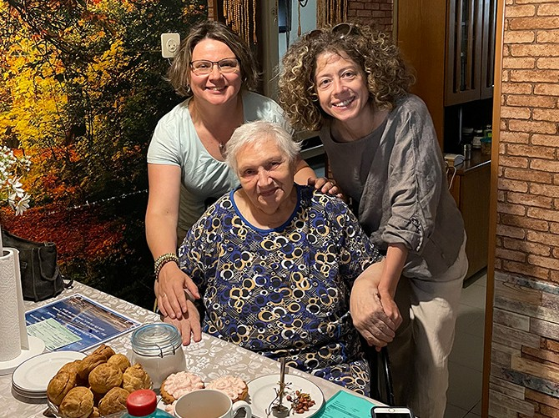
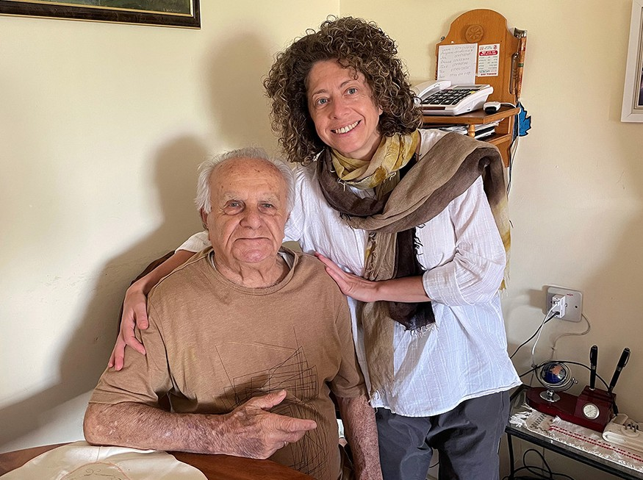

In June we were able to make 11 trips all over Israel and visited 44 people. We also participated in a Birthday party in Ashdod with little gifts and birthday cards for 36 people. We are incredibly grateful for every visit, for every smile we see on people faces. We experienced many precious moments during our visits and it is impossible to put them all in writing, but I would like to share just one.

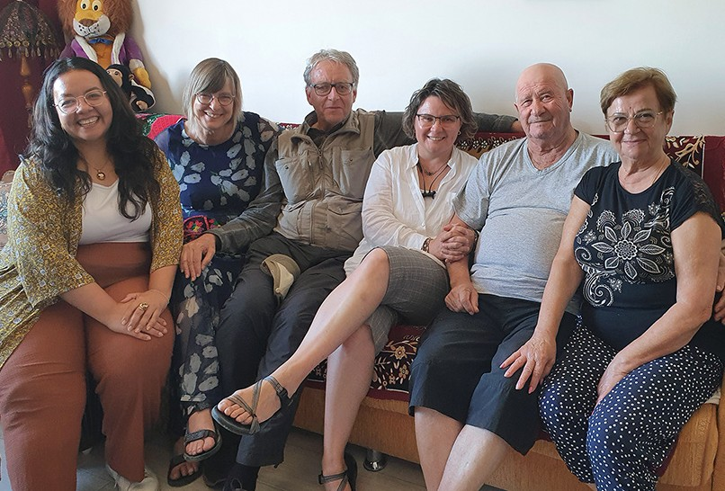
Njusja and Alexander are a very special couple. They
both suffered so much during the WW2 and have some heart-breaking stories to tell, but their hearts are full of grati- tude to God, who saved them.

“One day Germans on horses came into our courtyard. We had a well in the middle and they commanded me to give water to their horses. I was only a little boy and could not reach the well handle to draw the water. They were furious. They shouted at me louder and

louder and hit me severely with their sticks. They could see I was not able to do the task but they did not care”, Alexander said sadly. “We suffered a lot, no doubt about it, but we thank God that He saved us”, said Alexander and Njusja many times during our visit.
Once Njusja and her brother were very sick and had been taken to the hospital but there was little hope for their survival because their mother had no money to pay for any medication. “The rabbi comforted our mother and said that he was praying for us. A miracle happened and soon we went back home”, said Njusja.

We deeply treasure memories from our visits and it is an honour for us to share them with you.

Once again, we say THANK YOU so very much for your financial support, prayers and love toward Israel and Holocaust Survivors. Thank you for making it possible for us to be witnesses of God’s mercy and faithfulness to the ones, who made the Lord their trust.
Thank you for making it possible for us to sing a new song – Praise to out God, together with our precious friends.
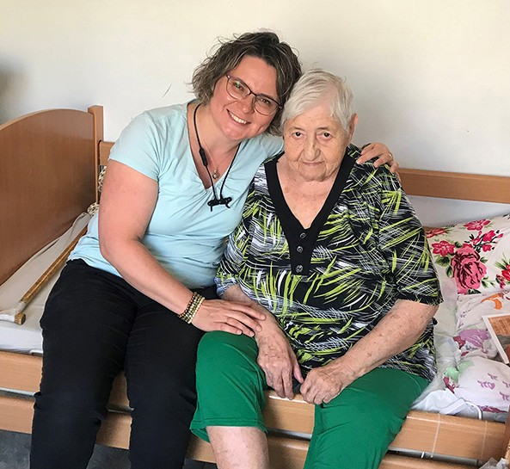
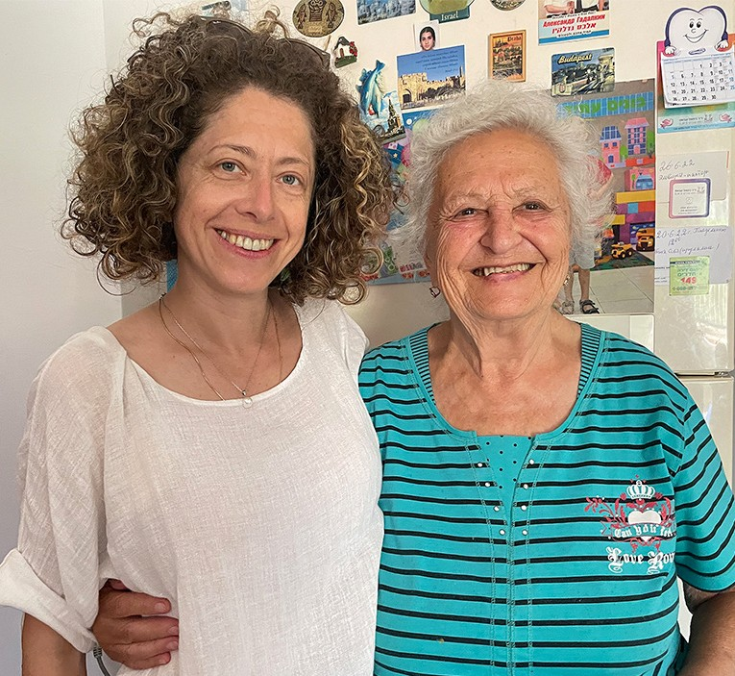

“As for God, His way is perfect; the word of the Lord is proven; He is a shield to all who trust in Him” (2 Samuel 22:31).

Olga Kopilova Project Supervisor

Project Open Gates

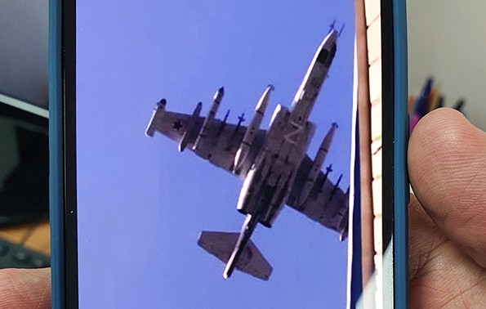
Shalom from Jerusalem!

Our project “Open Gates” continues to serve new immigrants. This week has been busy. New groups of olim hadashim (both from Ukraine and
from Russia) have come to Jerusalem. They live in hotels not far from us. Usually the message of our help goes from mouth to mouth very fast. It means that we have families and individuals coming to us every morning and afternoon. Thank God that we are able to give to them different household items. Many of these people lost all property they had.

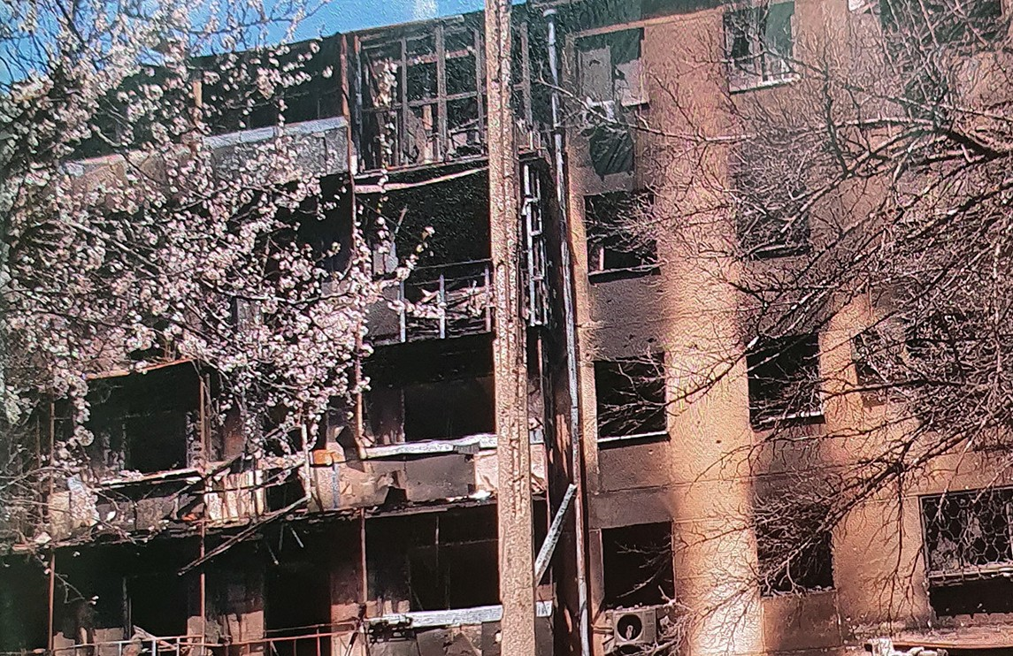
One family from Mariupol told us, how they escaped from the big building, where they lived, only with the clothes that they had on them. They all had apartments in the same building: the grandparents, their children and the grandchildren. The building was bombed and after a while it totally burned down. Even the windows melted in the
fire. With the help of God and some courageous people this family was able to leave the ruined city. They moved to Israel through Russia.
Valentin and Angelina with their household were very grateful for the help we gave them.

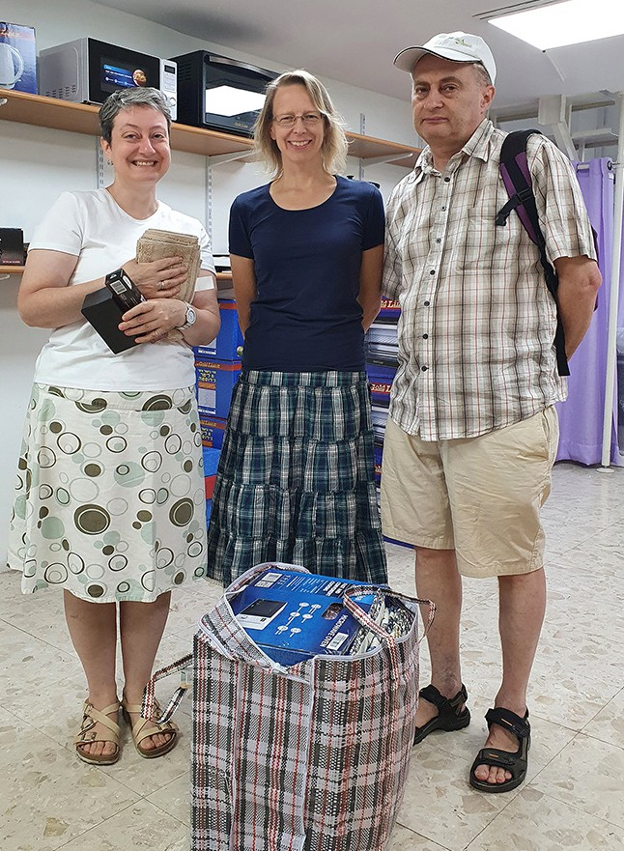
Another couple told us, how they closed their successful business in Moscow before coming to Israel. Because of the current situation they could not take any finances with them. Now Vladimir and Vera are here starting everything from zero. They will try to sell their apartment in the future, but it is possible that they will lose the right to have it as their property in the near future. May the Lord help them to get everything they need here in the Promised Land. God is the Same Provider through all the ages.
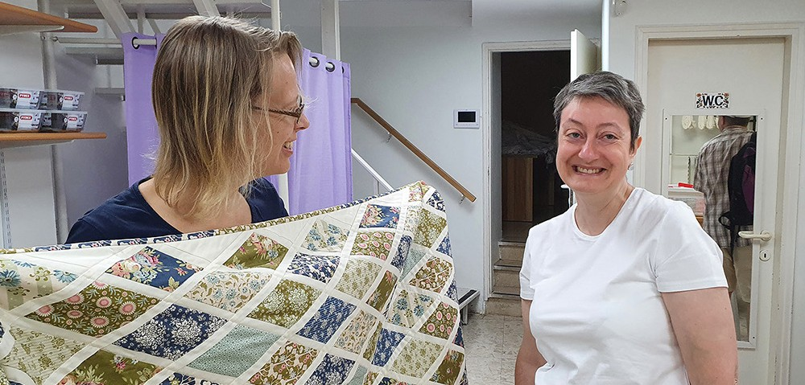

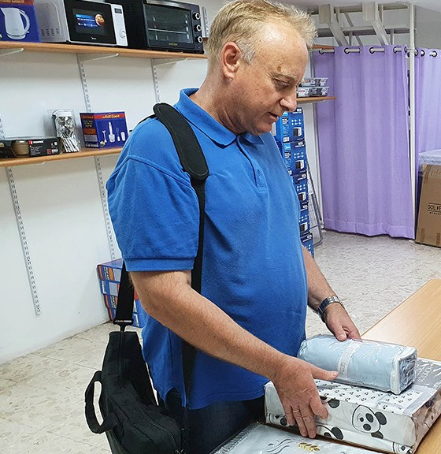
Alexander came to Israel from Crimea. He and his son had a long journey through Russia. His pregnant daughter lived in Odessa and moved to Poland in the beginning of the war. There she gave birth to her child. Alexanders wife also went to Poland be near to her daughter and to the newborn baby. She plans to come to Israel in a month. You could see the sorrow
and almost a depression in Alexander’s essence. “We planned to have our pension and rest having every- thing what we need in Crimea. Now we need to work again…” He got our gift, thanked us and left. There was a feeling that we did so little for him. May the Lord be with this family in the new chapter in life. May they find their comfort in Him.

“As a mother comforts her child, so I will comfort you; you shall be comforted in Jerusalem” Isaiah 66:13.

There are so many stories to tell. Thank you for your prayers and for all the support! May God of Israel be glorified in all we do!
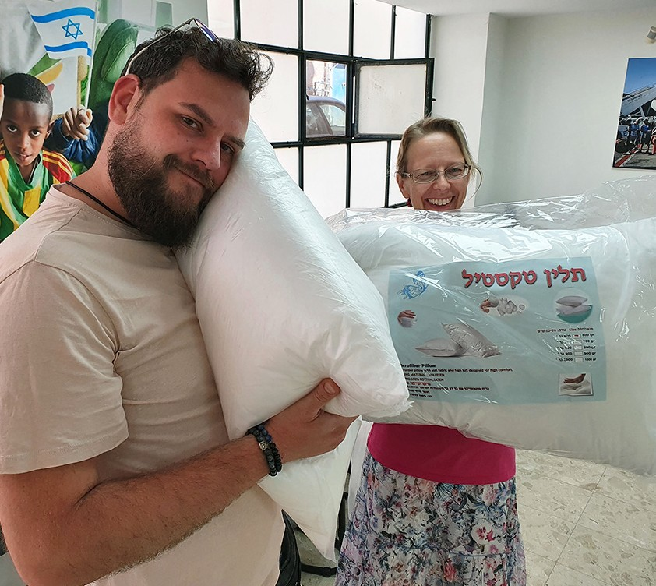

Tiina Danilevski Project Supervisor

Project Bridal Salon

Greetings from CFI Bridal Salon!

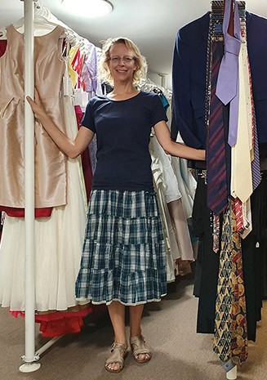
There are different people coming to our place every week. Besides brides-to-be we served this month one groom, one mother of a groom and one mother of a bride. There are more parents to come before the month ends.

Christian, the groom, got a suit and a bow tie.

Ruth found a beautiful evening dress and a short cloak of lace and some jewels for the wedding of her son.

Marilyn also found an evening dress and a bolero. Her daughter took a veil for her wedding.

Allysandra was also in need of a veil and other accessories for the coming celebration. She left our place with a big bag full of different things. “This is like in a fairy tale.” she said.

Temima moved to Israel a couple of years ago. She comes from the States. She heard about CFI Bridal Salon from her friends. She was surprised, how large our collection of
dresses is. “I feel I am in the States,” she said. We found for her two very good options. She took some time to think. In two weeks she made her decision. Temima came back and got the dress. I think she made the right choice. The gown is beautiful and gorgeous and it fits her perfectly.

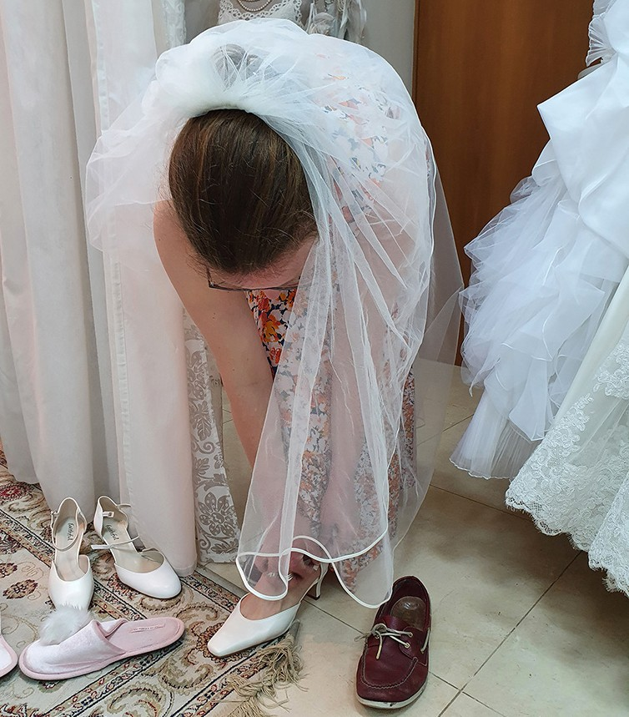
All our clients are grateful to Christian Friends of Israel for our help and care. May the Lord bless the celebrations of these precious people and guide them in life here in the Land.

God bless you all for being partners in this ministry of God’s love.

“I made your name known to them, and I will make it known, so that the love with which you have loved me may be in them, and I in them” John 17:26.

Tiina Danilevski Project Supervisor

Project Under His Wings

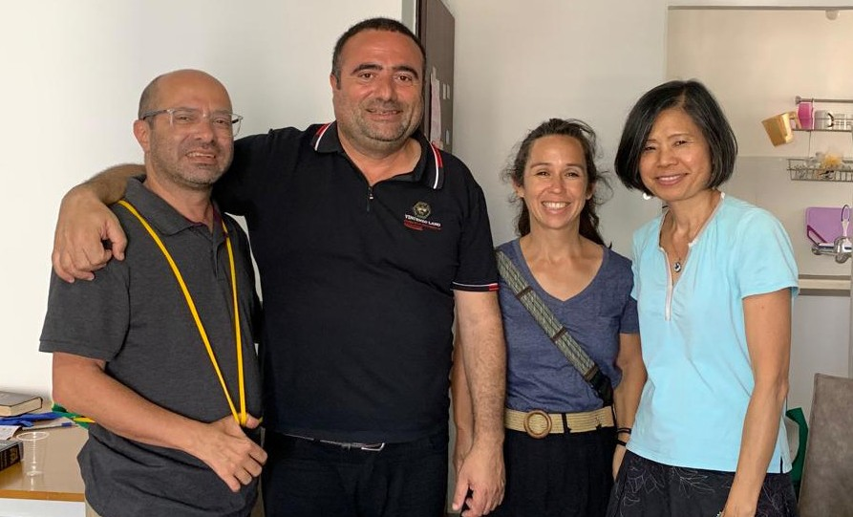
Shalom Friends of Israel,

Team UHW visited with Yossi, a middle-aged man, injured years ago in a suspected terror attack/accident on a bus, damaging his legs and ability to work on his feet. Conversing with Yossi, was at times, quite a
challenge as his mind is very active and goes in many directions! As with many Jewish people suffering from trauma both physical and mental, Yossi grasps at anything that can alleviate the pain, all of which are truly just ‘band-aids’ on the real problem of mankind’s
broken relationships with Abba-Father. Our hearts went out to Yossi in empathy, as we were able to see that he was desperately grasping for help in many different directions with no real solution, as he seems unable to find or keep a job. The reality is that his life is very dysfunctional and broken, as he has not found the True Source of help. As Yossi is somewhat religious, we freely engaged in discussion about man’s relationship to and with God & God’s commandments, meant to keep us pure, and…we all felt that there was a moment of breakthrough. Our friends from Brasil were present on this visit & we felt that Yossi saw in Pastor Abeni an example of a brother - father love, a love which Yossi so desperately craves. One sentence rings in my head, “you’ve given me the problem (man’s broken relationship with Abba God) but not the solution…” bringing to mind the prophet Jeremiah’s words in “For My people
have committed two evils: They have forsaken Me, the fountain of living water, and they have dug their own cisterns – broken cisterns that cannot hold water”. Please pray that God supernaturally reveals His Solution to Yossi that he may have the love and relationship with the Father that he requires to be made whole.

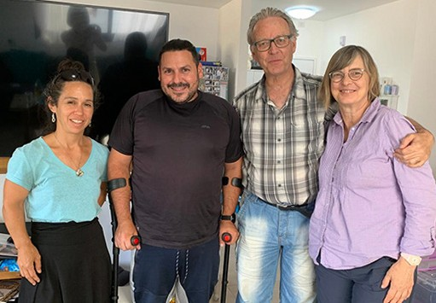
Motti is quite the engaging warrior! Despite having a bad leg and multiple surgeries on his ankle he is full of life and determined to be walking without support, for his child who is past ready to be born. He has such vigor and strength and although suffering from PTSD from his 15-year tenure in one of the most elite units in Israel…he has sought help and by God’s grace found a wife and a reason to live. He comes from a line of soldiers with his grandfather fighting in the French Legion, to his father just finishing 40 + years (!!) of elite service in defense of Israel. We applaud Motti for carrying on the legacy and seek to encourage him in his new life as a father and a husband… Our
guests from Holland who accompanied us on our visit had a great time catching up with Motti, who was married in Holland and loves to explore the land! We had great conversation and really it felt like we had known this special man for many years and indeed our Project Supervisor has! She saw him go from a broken hero to someone with new and renewed hope for life. We only pray that Motti will see the TRUE reason for life. The Creator of LIFE and true happiness, the Fount of Living Water. Please pray for Motti, his wife and new baby! “…but whoever drinks of the water that I will give him shall never thirst; but the water that I will give him will become in him a well of water springing up to eternal life.” John 4:14
Maggie Huang Project Supervisor

Project Communities Under Attack

Dear Friends of Israel,

“The Lord Is close to the broken hearted” (Psalm 34:18a).

Project CUA team visited 2 elderly couples who have tasted sorrow and hardship more than others.

Esther and Daniel live in the South of Israel, their home was damaged by rocket a explosion which also caused trauma to their entire household.

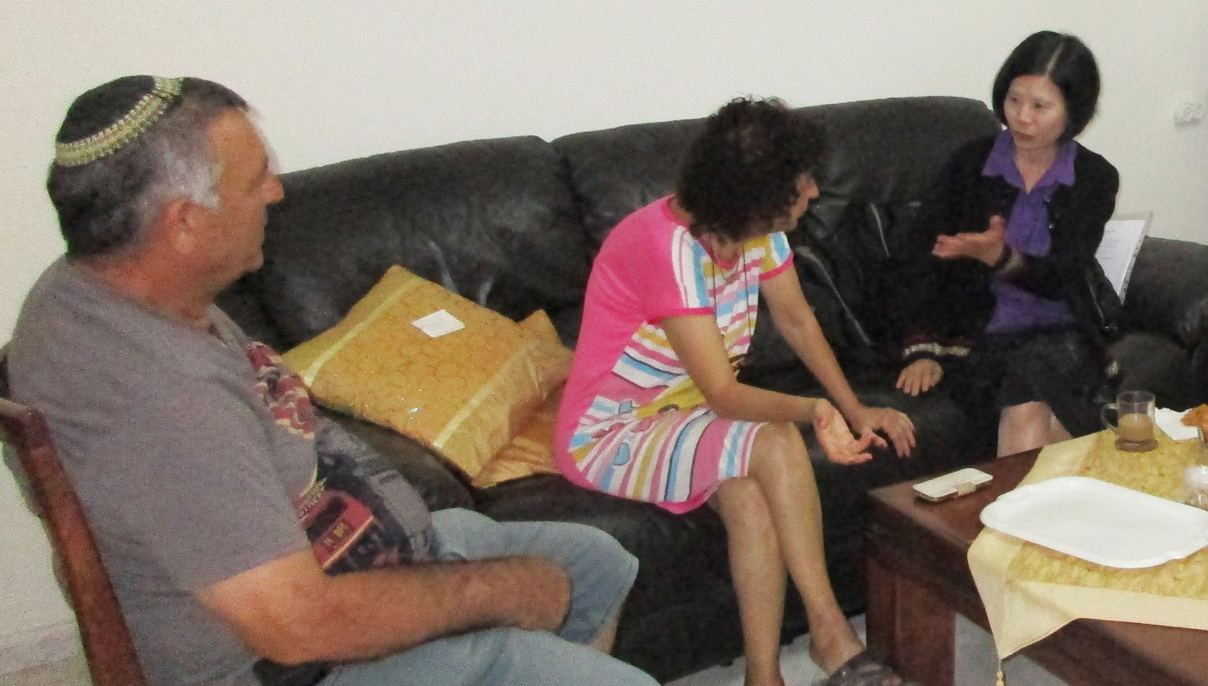
Esther’s parents were from Morocco and Daniel’s parents were from Iran. When Daniel was just one year old, his father was killed by Palestinians who hate Israeli Jews. His mother raised Daniel and his 6 older siblings alone. Sorrow and poverty was part of their life during Daniel’s child- hood and young adulthood. While Esther was traumatized by the ongoing rocket attack, she said any loud sound will trigger her trauma after she experienced the rocket explosion next to their home.

Eddie and Mazal are another elderly couple. The medical staff made a huge mistake at the birth of their first child, damaging the cranial nerve as well as the limbs of their baby girl Sarit so that she became 100% handicapped. Sarit passed away 3 years ago. On the other hand, Mazal has suffered Alzheimer’s disease and her situation was spiraling downward rapidly so that she totally could not recognize Eddie nor all her children and grandchildren. It has been a great sorrow for Eddie. Eddie is a very kind man, but going through so much hardships one time, he said to me that he did not know what he has done wrong, that it seems God is punishing him with all these hardships. It opened door for us to discuss many issues as well as scriptures.

God is close to the broken hearted (Psalm 34:18a), He used the Project CUA team to comfort these two elderly couples, sharing the messages of hope which they have never heard.

Thank you for your financial support for Project ‘Communities Under Attack’, our work will not be possible without your support. The Lord bless you and keep you.

Maggie Huang Project Supervisor

Project Wall of Prayer

DIRECTED STEPS

“The steps of a [good and righteous] man are directed and established by the Lord, and He delights in his way [and blesses his path]” (Psalms 37:23 AMP).

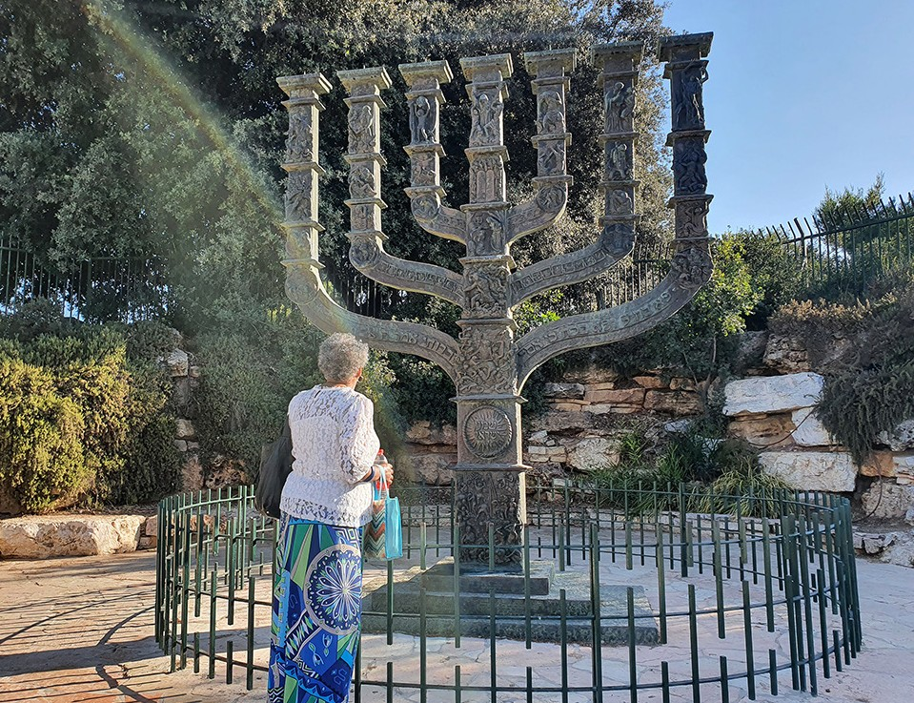
In July, the Lord guided the Wall of Prayer team to several ‘divine appoint- ments.’ While the Israeli government prepared for US President Joe Biden’s visit, intercessory teams went to their prayer closets and some to the Knesset building to pray for guidance for the nation’s leaders. Israel is at a crucial time because its governing coalition dissolved on June 22 due to disunity. Israelis will return to the polls on No- vember 1 to choose members of the Knesset, making this the fifth election in less than four years. As watchmen, we will continue to pray that the Knesset members walk in unity with God and one another.

The Lord directed me to take a team to Judea to pray in ‘contested’ areas. An intercessor, Tzipporah, asked to bring a friend, another Jewish prayer warrior, and we gladly welcomed her. To my surprise, her friend said she had been receiving our prayer newsletters and desired to join one of our prayer trips. She does not live near Jerusalem but was visiting Tzipporah at the right time! This was a ‘divine appointment’ scheduled by the Master of the Universe. We felt God’s presence as we interceded for residents living
in areas where there is sometimes danger. I will share details about the visit in future editions of our
Watchmen Prayer Letter and Wall of Prayer newsletters.

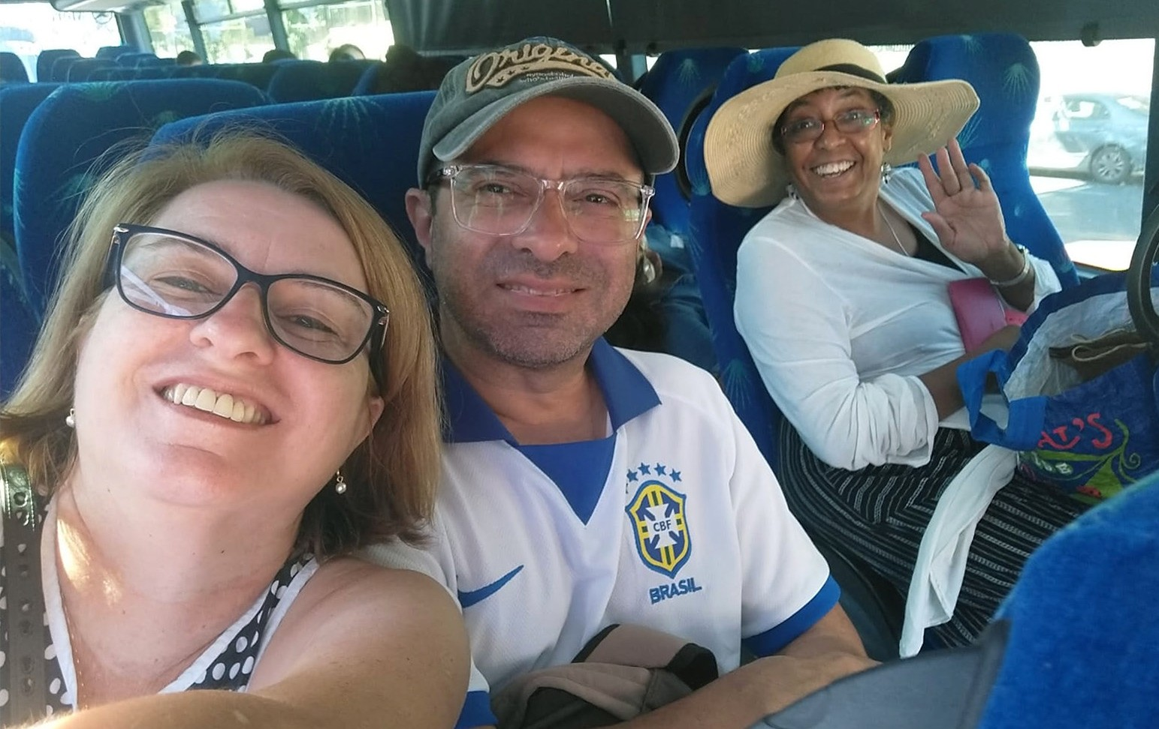
God provided more opportunities to pray with others as we wel- comed our friends and CFI Brazil Representatives, Abeni and Claudia Bastos. In February, they graciously hosted me in their home in Santa Rita do Passa Quatro, Brazil. Being able to spend time with them in Jerusalem brought me great joy! They were a blessing and an encouragement to the entire CFI Jerusalem staff because they came bearing gifts, offering prayers, and even cooking a Brazilian meal.

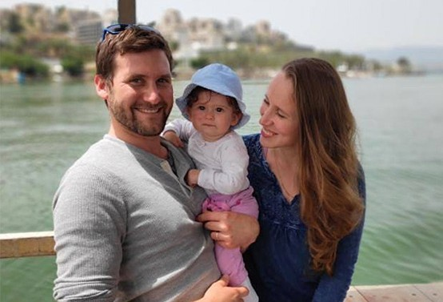
On the weekend, I traveled with Abeni and Claudia to help them connect with their friends, Ziv and Katya, who were Jewish Believers.
While en route, they told me how much I would enjoy meeting this young family, and they were right. After hearing the couple’s story, sharing a meal, and watching them interact with their
children, I understood why God had brought me there. We prayed in their home and the building in Rosh Pina where the kehilat (congregation) meets. It was another ‘divine appointment’ which emphasized that God has many ways of directing us where He wants us to be.

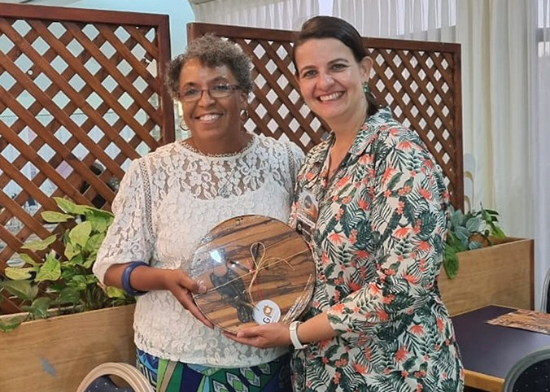
Mayla, another Brazilian prayer partner, contacted me saying she would be in Jerusalem on tour and had a special gift for CFI. After our dinner, she presented a beautifully hand-crafted clock made of Brazilian wood, which is now hanging in our headquarters. I was moved when she explained that their prayer team had divided the list of staff at CFI Jerusa- lem so that each person could be reg- ularly covered in prayer. What great love! That ‘divine appointment’ was a tremendous encouragement as Mayla and I walked, talked, and prayed on the streets of Jerusalem.

To our precious loved ones, prayer partners, and donors:

The Lord will reward everyone for their work in the Kingdom of God, whether you serve on the frontline or in the kitchen. In 1 Samuel 30:24, David told his army, “The share of someone who stays with the equipment will be the same as the share of someone who goes out and fights – they will share equally.” How valuable to God and to the staff here at CFI are all of you who serve in any capacity!

We appreciate you. May God’s choice blessings rest on you!

Linda McMurray Project Supervisor

