September 2021 /Jewish Year 5782
Lifting up Lod (ֹלד)
“ ‘...You shall love Adonai your God with all your heart, and with all your soul, and with all your strength, and with all your mind; and your neighbor as yourself…’, he said to Yeshua, ‘Then who is my neighbor?’...Yeshua replied, ‘Which of these three seems to you a neighbor to the one attacked by robbers?’ And he said, ‘The one who showed mercy to him.’ Then Yeshua said to him, ‘Go, and you do the same’ ” Luke 10:27-37 TLV.

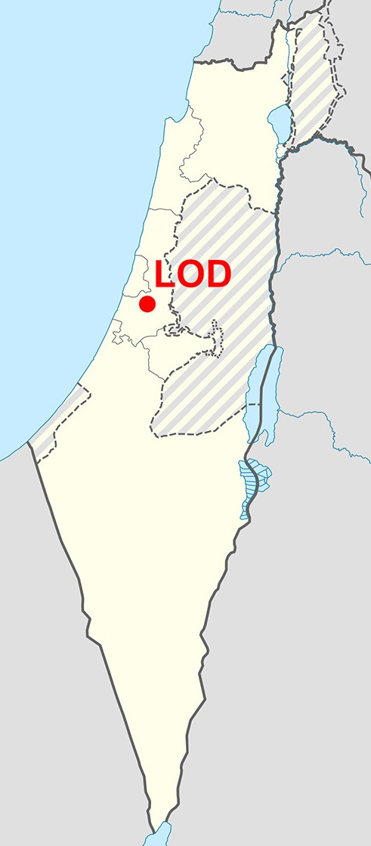Situated in the coastal plain of Israel, 16 kilometers (10 miles) southeast of Tel Aviv is the city of Lod. It is a transportation center for the country. In Scripture, Lod is mentioned as a town of the tribe of Benjamin and as one of the cities whose inhabitants returned after the Babylonian captivity. Throughout its history, it has been called different names by the civilizations who conquered or influenced it. In the New Testament, Lod was referred to by its Greek name, Lydda, as the place where Peter healed a paralyzed man (Acts 9:32-38). This city was conquered by several empires including the Roman, Byzantine, Moslem, Ottoman, and the British empires.

In July 1948 during Israel’s War of Independence, thousands of Arab inhabitants vacated Lod. The Jewish immigrants who settled in the city came in waves, first from Morocco and Tunisia, later from Ethiopia and then from the former Soviet Union alongside the Arabs who remained there. Lod is home to an absorption center (a facility for temporary housing and training for new Jewish immigrants arriving in Israel). Absorption centers give immigrants the chance to learn Hebrew, to get to know Israel, to obtain professional training, and the opportunity to form a supportive social network. In 2019, Lod had a population of 77,223. In this city, Jews, Christians, and Muslims, including Bedouins live in neighboring areas.

This is an ethnically diverse city where many residents struggle with economic and social integration into their adopted country. The income of Lod’s citizenry is well
below the national average. To improve life in this city, bicultural youth movements, volunteer aid organizations, educational start-ups, sports organizations, businessmen, and conservationists are sponsoring programs.

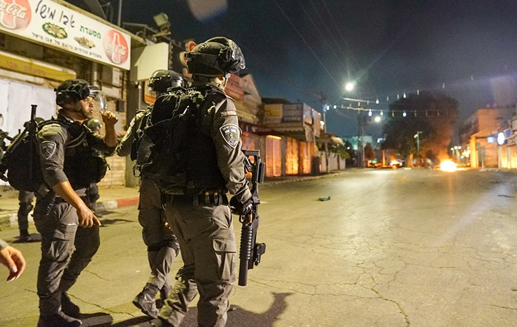
Aside from being a vital transportation hub with a major railway and road junction, Israel’s main international airport, Ben Gurion Airport, is situated on its northern outskirts. The airport and related industries are a major source of employment for its residents. In
2019, Ben Gurion Airport handled 24.8 million passengers. It is among the five best airports in the Middle East due to its passenger experience and high level of security. The airport has been the target of several terrorist attacks, but no attempt to hijack a plane departing from Ben Gurion airport has ever succeeded.

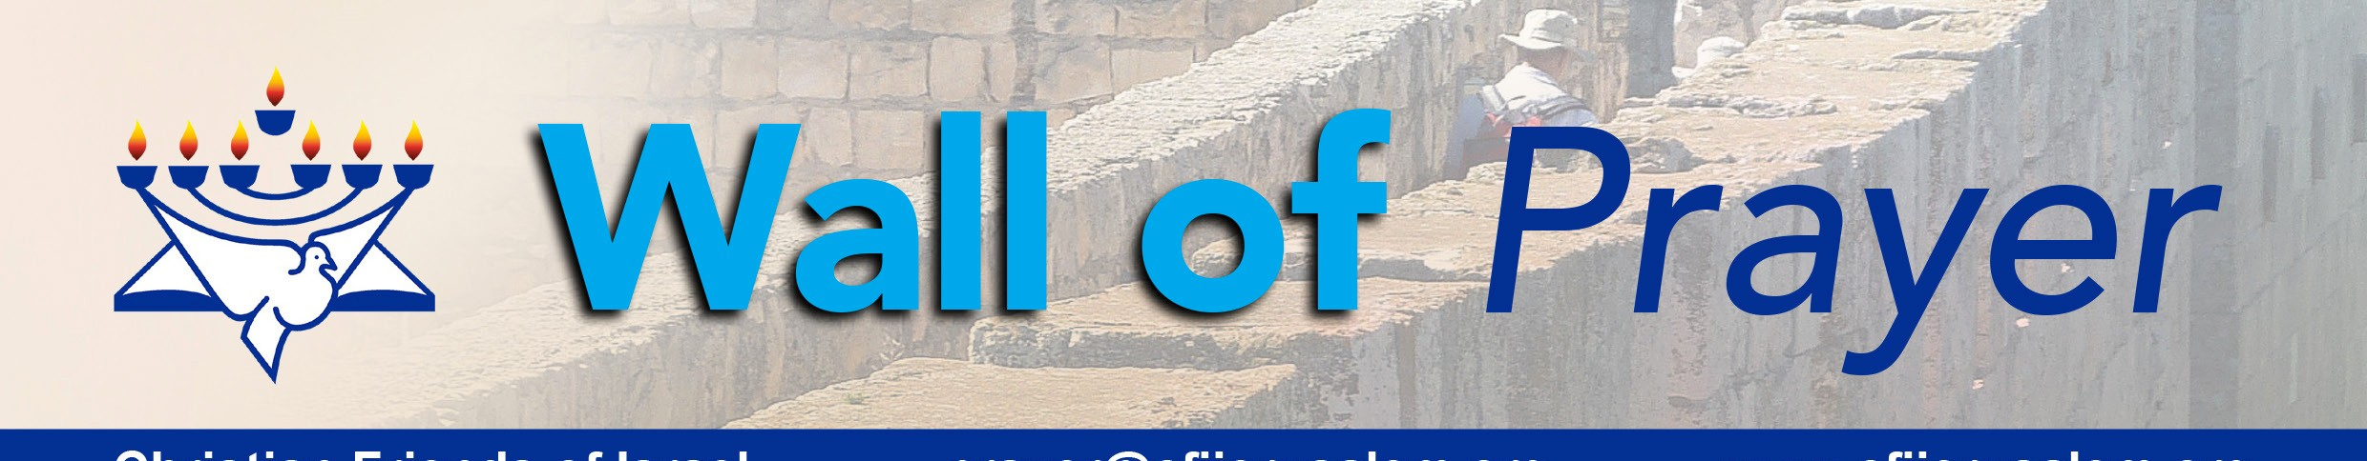The Arabs and Jews of Lod experienced major upheaval during the 2021 Gaza Conflict. The heightened tension during the 11 days of rocket fire to and from Gaza, spilled over and erupted into violence in other parts of Israel including this city. On 11 May 2021, Prime Minister Netanyahu declared a state of emergency in the city due to
Christian Friends of Israel
prayer@cfijerusalem.org
www.cfijerusalem.org

Disorders in Lod, May 2021. (CC BY-SA 3.0, Wikipedia)

riots with widespread arson and violence from both Arabs and Jews. Some radical people from outside Lod entered the city and escalated the mayhem. This marked the first time since 1966 that Israel used emergency powers in a community. Sadly, some of the neighbors from different backgrounds who had lived together in peaceful coexistence now say they look at each other with fear and suspicion.

Yeshua, the Prince of Peace, explained what it meant to be a neighbor in the parable we refer to as The Good Samaritan (Luke 10:25-37). From His teaching, we learn that our neighbor is anyone in our proximity with whom we can share God’s love. We are commissioned to love not only people who are like us or with whom we feel comfortable but also all whom God places in our path.

(Sources: Jewish Virtual Library, Wikipedia, Knesset Research and Information Center, Got Questions, the Holy Bible).

Let’s lift up in prayer the people of Lod!
- Honor the Lord for His supreme fairness and justice. He invites everyone from all backgrounds to follow Him and to come into His Kingdom, the place of eternal life and peace. “... glory and honor and shalom to everyone who keeps doing what is good, to the Jew first, then to the Gentile. For God does not show favoritism” (Romans 2:10-12 CJB). “For God so loved the world that he gave his only and unique Son, so that everyone who trusts in him may have eternal life, instead of being utterly destroyed” (John 3:16 CJB).

- Thank God that whatever He said will come to pass. His promises are true. “Forever, O Lord, Your word is settled in heaven [standing firm and unchangeable]. Your faithfulness continues from generation to generation; you have established the earth, and it stands [securely]” Psalms 119:89-90 (AMP).

- Bless the Lord for doing just as He promised: bringing Jews from many nations back to Israel, the land of their forefathers. Thank Him for those who have already made aliyah (immigrated) and for those that are yet to come. “Therefore say, thus says Adonai Elohim, ‘I will gather you from the peoples and collect you out of the countries where you have been scattered, and I will give you the land of Israel’ ” Ezekiel 11:17 (TLV).

- Ask God to draw Israel to the beautiful words of the Torah, which point to the coming Messiah. May the Lord fulfill His Promises in Ezekiel 11:19-20 (TLV), which say. “Then I will give them one heart. I will put a new Spirit within them. I will remove the heart of stone from their flesh and give them a heart of flesh...They will be My people and I will be their God”.

- Beseech our God to open doors of opportunity for immigrants to thrive and assimilate in Israeli society. ”The seed is healthy: the vine will give its fruit. The land will give its produce; the heavens will give its dew. I will give the remnant of this people all these things. Just as you were a curse among the nations, house of Judah and house of Israel, so now I will deliver you; you will be a blessing. Don’t fear, but be strong” Zechariah 8:12-13 (CEB).

Our Dear Intercessors:
As we take you on a journey to various places in Israel through our newsletters, magazines, and videos, we pray that you gain insight into the history, daily lives, and future of Israel. What a privilege we have as Gentile Christians to be grafted into Israel through Messiah Yeshua! It is our pleasure to pray for Israel with you online. If you wish to join our monthly prayer meeting, please contact us at the email address shown below. Shalom!

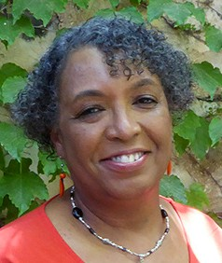
In His Love,
Linda D. McMurray
Wall of Prayer Supervisor

