January 2021

CFI Projects Monthly Reports for
International
Representatives

Dear CFI International Representative Family,

Thank you for your continued support of the Outreach efforts of Christian Friends of Israel. We continue to strive to encourage those in need and to offer practical assistance during times of struggle. It’s during these times when relationships can be formed which please God and allow us to show Compassion to those who need it the most and have possibly never experienced it before.

During this time of global pandemic, we continue to offer assistance as we are able, and we know each passing day may allow for additional hardships, but we also know the God whom we serve. He is more than able to protect, and provide and heal. We are willing to represent Him to the people of Israel.

Please receive the CFI Outreach electronic updates as a reminder
of the impact each of you have in the lives of so many. We are grateful to represent those of you in the Nations - to those in the Land of Israel.

A friend loves at all times, and a brother is born for adversity.

Proverbs 17:17 (NKJV)

Project Forsake Them Not

I believe that most, if not all of us, love to receive gifts, whether a small token, or something bigger we were dreaming about. The beauty of gift giving is that it is usually not earned or even deserved. The gift is usually a free will offering from the one, who chooses to present it. There is joy in both the giving and receiving. The biggest gift we can ever receive is the gift of life given to all mankind by the Creator. The Lord is a Giver of good gifts, and we were made into His likeness. Lately we had many opportunities to remind our precious survivors of such a gift, and to celebrate the special gift of their lives. We were also able to bring them some practical gifts on your behalf. We are indeed ever so grateful for the privilege of being able to do it.
As you already know, every year we create a new card to send to our friends for their birthdays. As we prayed and discussed the matter, the Lord gave us wonderful idea – to use the painting of one of the Ho- locaust Survivors, Efim Malkin, presented to us as a gift a few years ago, as the backdrop for our cards.
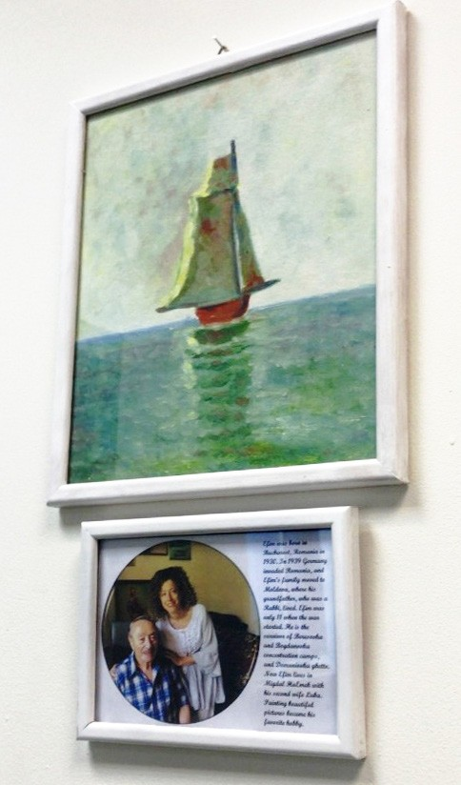
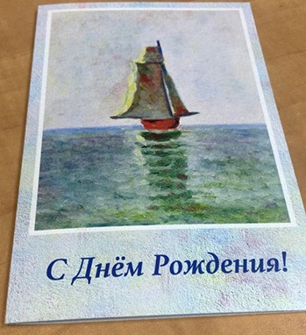
Efim was born in Bucharest, Romania in 1930. In 1939 Germany invaded Romania, and Efim’s family moved to Moldova, where his grandfather, who was a Rabbi, lived. Efim was only 11 when the war started. He is the survivor of Beresovka and Bogdanovka concentration camps, and Domaniovka ghetto. Now Efim lives in Migdal HaEmek with his second wife Luba. Painting beautiful pictures became his favourite hobby.
Efim gladly agreed with our idea, and allowed us to use his painting. Our Media team helped us in creating a beautiful card and soon we had it printed out as a
high quality gift. Inside we included the words from Psalm 107: “Oh, that men would give thanks to the Lord for His goodness, and for His wonderful works to the children of men! Those who go down to the sea in ships, who do business on great waters, they see the works of the Lord, and His wonders in the deep. Then they cry out to the Lord in their trouble, and He brings them out of their distresses. He calms the storm, so that its waves are still. Then they are glad because they are quiet; so He guides them to their desired haven. Oh, that men would give thanks to the Lord for His goodness, and for His wonderful works to the children of men!” We are also praying this card would be a blessing and comfort to many.

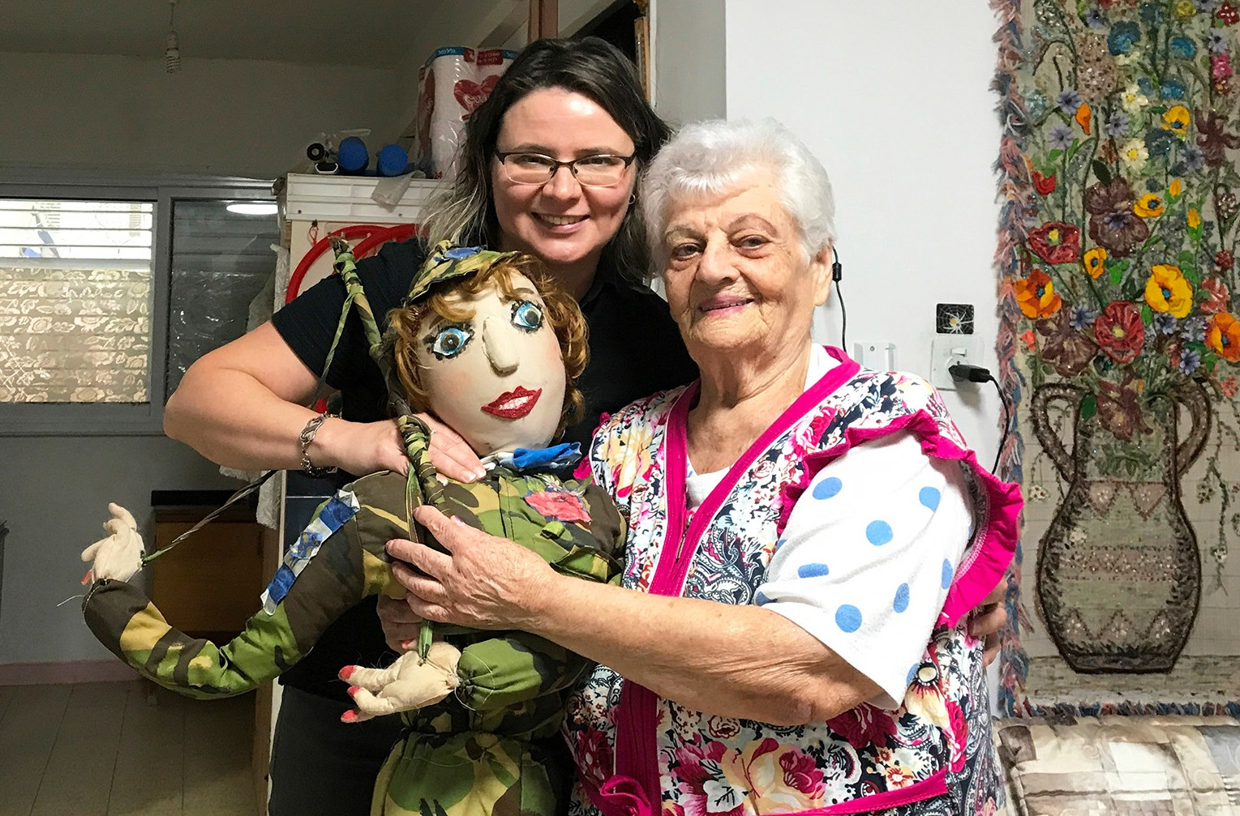
We also received a very special gift, created by a very precious lady Maya, 29 years ago. A gift that brought a lot of joy and laughter to many children and adults in Sderot, a town which for decades, experienced constant rocket attacks from Gaza. This gift that we received with great responsibility and honour was a puppet soldier doll. For many years, Maya performed at many different events with the puppet dolls she created herself. Her goal always was to bring joy to others. Now,
as Maya turned 90, she is not able to do it any longer, and she found homes for every doll, in

hopes that her legacy of joy would continue to live. Maya was born in the village of Yampol in Ukraine in 1930 and was the youngest of 4 siblings. In 1932, after her father died of typhus and their house was destroyed by flooding, all the children went to different orphanages. During the war Maya’s life was
miraculously saved many times, as the Germans raided orphanages in search of Jews and betrayal was common. Despite all the hardship of her life, Maya is one of the sweetest people we know.

We also were able to celebrate a very special birthday, the 80th, with Boris and his closest friends. It was indeed a privilege for us, as the number of people for gatherings is very limited. The story of Boris’s sur- vival is remarkable, and indeed his life worth celebrating. Now, as Boris looks back on his life, he sees God’s mighty hand in preserving his life and helping him to go through it. “Every day is a gift, and I am ever so grateful for it,” he said. We also were grateful to join the celebration, and to be among the closest friends.
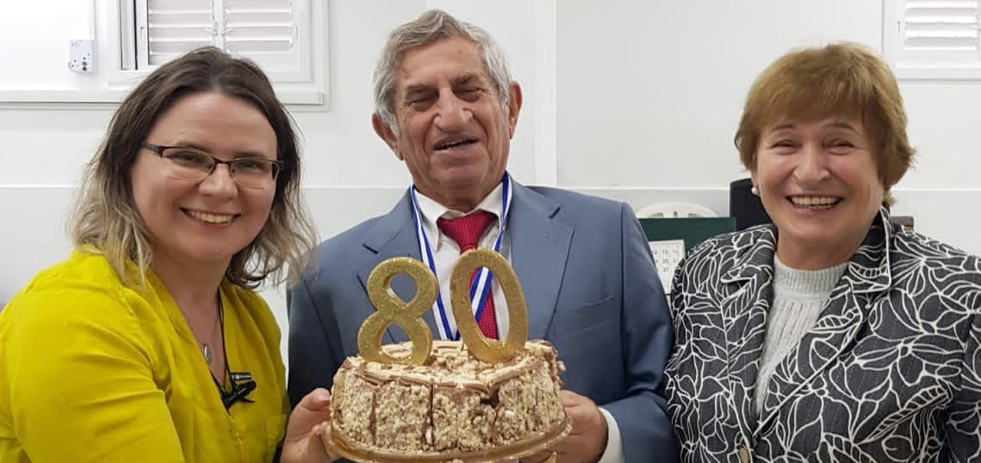

All this, and so much more, would not be possible without faithful and loving support from all our friends in so many different nations! Thank you for all your gifts, which I believe reflect God’s heart and impact so many lives! Thank you for once accepting the biggest gift of His love and life, you are willingly and generously sharing it with others, for the glory of His precious name!
Our prayer is that we all would pour out our lives as living sacrifices, as the act of worship to the Giver of Life.

“Every good gift and every perfect gift is from above, and comes down from the Father of lights, with whom there is no variation or shadow of turning.” (James 1:17)

Olga Kopilova Project Supervisor

Project Open Gates

Greetings from Jerusalem!

The life is busy at our distribution center. People are coming to get clothing every morning. We still work with one person or a family at one time. In the afternoon we are opening the boxes. I am very thankful for the good quality clothes that we received from the States.

You usually don’t have heating in your apartment in Israel. So, in winter our clients are seeking mostly something warm to wear for themselves and for their families.

On Friday there were two young emigrants from Brazil at our place. One of them made Aliyah only a month ago. “I am desperate!” she said. She couldn’t bring many suitcases with her from her previous homeland, so she was cold. Adva found sweaters and a lot of other things to make her life a little warmer. We gave a fleece blanket to both of the girls. Tatiana was also happy to get good and warm items for herself. It is a great feeling to be a hand of God by giving practical help to the emigrants at this time. We are doing it together with you, my friends in the nations.

Today there was a couple who visited us for the last time. They came from the Ukraine exactly three years ago, and this was their fourth visit to our distribution center. I asked the husband what is his opinion about Israel. “At least it’s not boring here.” He said with a smile on his face. For the both of them the first year in Israel was the most difficult. Now they are working in their home as physiotherapists. Evgeniy used to work in a hospital for 20 years before they made Aliyah. “There is a great need of therapeutic physiotherapy here in Israel” he says. Svetlana likes her new homeland a lot. Only the corona virus is making things difficult again. “When you are not allowed to visit other countries, you start to suffer some- how.” She says. It is understandable, because their children do not live in Israel. I took their contact information in case, if somebody over here needs some physiotherapy☺.

I am thankful for your prayers and support. “Let us be a light at this dark season”

Tiina Danilevski Project Supervisor
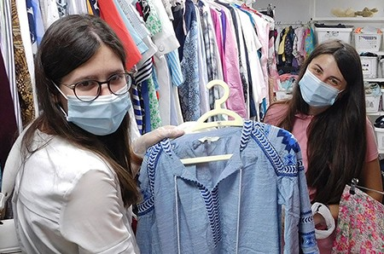

Project Bridal Salon

Shalom our friends in the nations!

It is still very quiet here in our Bridal Salon in Jerusalem. People are waiting for a better season to have their weddings. At the moment you are not allowed to have any large gatherings here in Israel. So, our mission is to wait and to be ready to serve future brides and grooms, when the season will change.

One girl came to us last week. She needed a veil. Her wedding was to be in a week. We found two good options for her. She was grateful.

Today one grandmother came to ask, if she can take a dress for her granddaughter, who is going to be married in two months. I asked her to come back with the girl. The old lady was nor sure, if the young bride to-be will come, because she and all the family are religious. Let’s see how it will go. It is very difficult for a grandmother to find a fitting dress for her granddaughter. If there is not another way, let her try ☺.

We are still getting dresses as a donation from different individuals. Our little room is full at the moment. May the next year be a year of weddings! Please, pray that many future couples in Israel will find their way to our Bridal Salon in the near future. There is a huge financial crisis in many people’s life at the moment. It is also a reason, why Israelis are not in hurry to plan weddings this winter. We can be a great help for those who can’t wait any longer. May the Lord use us to provide beautiful wedding gowns for many families!

Thank you for your prayers!

Tiina Danilevski Project Supervisor
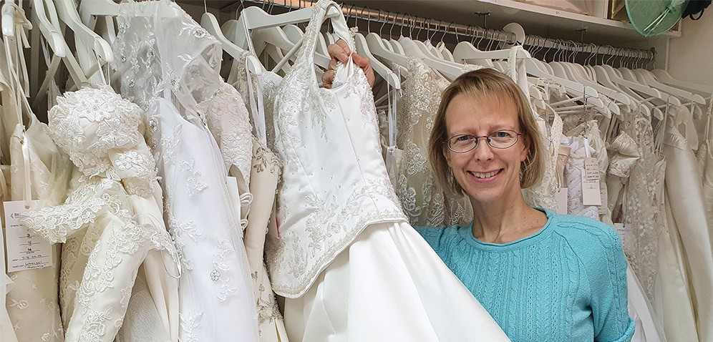

Project Under His Wings

Shalom Dear Friends of Israel,

“Strengthen the feeble hands, steady the knees that give way;” (Isaiah 35:3)

Surrounded by enemies whose goal is the annihilation and destruction of Israel and the Jewish people, the great responsibility of defending their nation, has also been placed upon the shoulders of the Israeli teenagers serving in the army right after their high school in order to protect this country, alongside those who work in the military as their profession.

Because of this compulsory responsibility, many young Israelis have been exposed to trauma while performing their military duties. Daniel is one such young person.

I was visiting Daniel right before the Eve of Hanukkah – a holiday to commemorate the Feast of Miracles, and this holiday is especially meaningful to Daniel as his survival from the terror attack during one of his missions was a miracle, as he fell head down from high place directly to the ground and lost consciousness.

What transpired from that attack has affected Daniel mentally, emotionally and spiritually, making him withdraw himself from people. During the visit, when Daniel went to bring me some drink, his older brother told me privately that Daniel has declined the requests of visits from his friends, but praise God that he accepted my request.

Through the Ministry of Project UHW, I have the privilege to reach out to a great multitude of Israelis affected by terror attacks. Thankfully, with God in the midst of the visits, many lives have been deeply touched (Isaiah 35:3). Daniel is a very kind, sweet and quiet young man who is a little bit shy. My heart goes out to him as one who has been so profoundly affected by the terror attack he went through. Please remember Daniel in your prayers so that what has been planted in Daniel’s heart through this visit will continue to minister to his inner being.

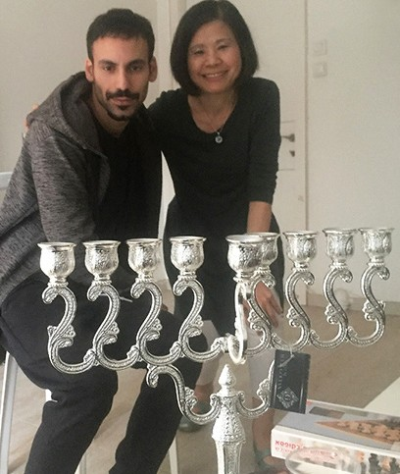
When I was playing my violin with some Hanukkah songs for them, surprisingly their mother showed up. She just came back from work and heard the Hanukkah music.
She came in to join us, in Daniel and his brother’s own living room, inside their parents’ house. We greeted each other, and I told her it was my great pleasure to meet her. She and her husband are wonderful parents, according to Daniel and his brother, and she said likewise, as she had heard them talk about our organization and me many times. She asked me to pass their deep gratitude to all of
our supporters “for your love and your generosity of giving to this Project” saying, “it means so much to their entire family”. Thank you for allowing Project UHW to touch lives on your behalf.

Wishing you and your family Merry Christmas and Happy New Year.
Maggie Huang Project Supervisor

Project Communities Under Attack

Dear Friends of Israel,

“A light for revelation to the Gentiles, and the glory of your people Israel.” (Luke 2:32)

When I got to Dafna’s home in Southern Israel for a scheduled visit, she and her 10-year-old son Itai were watching a Christmas program on TV. Like many Israelis, Dafna was fascinated by this special holiday, and wanting to know what Christmas is all about. I told them Christmas is not about Santa Claus nor Christmas presents, but about the Good News from Heaven in fulfillment of the prophecies of the Tanach (Old Testament) concerning the Birth of the Messiah of Israel and Savior of the world, promised by God through His servants the prophets (Luke 2:32). He is the Lamb of God who takes away the sin of the world (John 1:29).

I shared with Dafna one thing to which she could relate, and then she started to open up her heart, allowing God to minister to her deep wounds caused by her ex-husband who was very abusive to her.

Project CUA also visited Yuri and Taya – a couple living in Northern Israel who experienced the love of God in a very special way.

During the visit I shared the scripture from my personal devotion that morning, which I felt was from God for them. It says, “Thus says the LORD: ‘In a time of favor I have answered you; in a day of salvation
I have helped you;’” (Isaiah 49:8a). Yuri told me that was exactly what he experienced when he was seriously injured by a rocket and went through the valley of death. People from the ambulance service attending the scene of the rocket attack were shocked and asked how he got out from the devastation. Yuri was taken to hospital after he made his way to them and then collapsed. God further ministered to Yuri and Maya through Project CUA during the visit.

Thank you so much, supporters of Project CUA, for being co-laborers of this project to comfort His people (Isaiah 40: 1), making an impactful influence in the lives of rocket victims. Please pray that God will give revelation to the rocket victims from the messages that they heard during the visit.

May you and your family have a blessed Christmas as you celebrate the Birth of our Savior and Lord.

Maggie Huang Project Supervisor
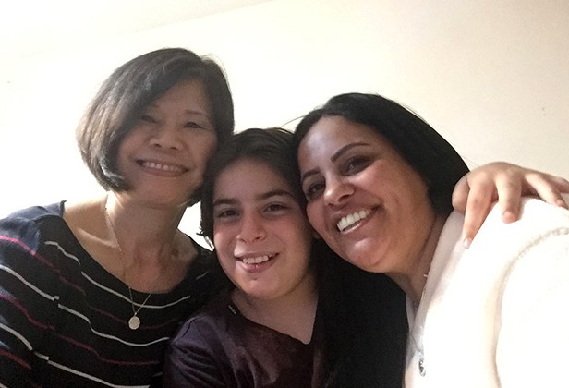
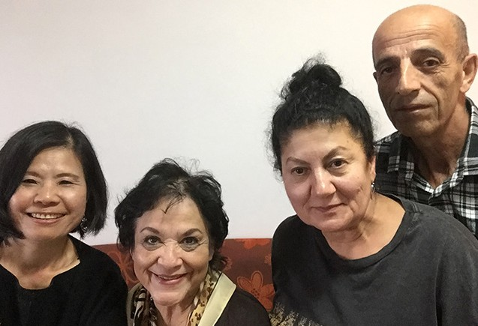

Project Wall of Prayer

Praying for Israel with the Nations

“On your walls, Jerusalem, I have set watchmen. All day and all night, they will never hold their peace. You who remind Adonai, take no rest for yourselves, and give Him no rest until He establishes and makes Jerusalem a praise in the earth” Isaiah 62:6.

Since the launching of our Israel Watch Prayer Network, intercessory teams continue to gain momentum
– beginning in Jerusalem. In our weekly prayer meetings, the Jerusalem staff prayer group is experiencing greater direction and intensity in the move of the Holy Spirit where we intercede for Israel, CFI staff, and the leadership.

Our monthly Zoom prayer sessions with Israel Team #4 are also progressing. As watchmen from different places have begun praying together, they are becoming more comfortable and learning to flow as a team as the Holy Spirit empowers them. One dedicated prayer warrior who does not have computer access enjoys coming to the Jerusalem office each month to pray with us and to pick up her newsletters. Her prayers are an inspiration to us. God is at work!

There is a sense of anticipation among some of the CFI Representatives as we also gather for monthly Zoom Prayer meetings. It is a vehicle for not only corporate intercession for Israel, but also for sharing ideas, encouragement and global fellowship. As a result, some reps have initiated group prayer sessions in their countries. God is moving among these Watchmen!

During Chanukah, Israel Watch took a step into another global prayer arena with other Christians who are praying for Israel. Jonathan Feldstein of Genesis 123 Foundation invited us to participate in a prayer event, Global Chanukah Prayer for Israel: Celebrating the Miracles. During the Women’s prayer session, Sharon Sanders, along with some CFI representatives, staff, and Israel Watch intercessors prayed for Israel on-line. The event was aired live for several days as Christians from countries around the world were featured praying for Israel. It was a privilege to be part of this global prayer. To God be the glory for the things He has done. (Portions of the event can be viewed with this link: https://fb.me/e/4JppHqqab.)

Thank you for your prayers, words of encouragement, love, and liberal support which you have shown to Israel through CFI. May the Lord bless you bountifully. “The generous will prosper; those who refresh others will themselves be refreshed.” (Proverbs 11:25 NLT)
Linda McMurray Project Supervisor
