RaisingThe Bar
Christian Friends of Israel
feedback@cfijerusalem.org
www.cfijerusalem.org

January 2021 /Jewish Year 5781
Keeping Our Eyes on the Wheat Fields

Another parable He put forth to them, saying: “The kingdom of heaven is like a man who sowed good seed in his field; but while men slept, his enemy came and sowed tares among the wheat and went his way. But when the grain had sprouted and produced a crop, then the tares also appeared. So the servants of the owner came and said to him, ‘Sir, did you not sow good seed in your field? How then does it have tares?’ He said to them, ‘An enemy has done this.’ The servants said to him, ‘Do you want us then to go and gather them up?’ But he said, ‘No, lest while you gather up the tares you also uproot the wheat with them. Let both grow together until the harvest, and at the time of harvest I will say to the reapers, First gather together the tares and bind them in bundles to burn them, but gather the wheat into my barn’ ” Matthew 13:24-43.

Our learning today is about the most important of the Seven Species of the Land: wheat. In Hebrew we say ‘chi-ta’. The sound that is transliterated does not exist for ‘ch’, so try the throaty sound “h” from the back of the throat. From wheat comes bread-food for the hungry. The Hebrew word for tares (weeds) is ‘esev rah’ which need to be controlled in any field from taking over the wheat. I used to watch my father when I was a child walking his wheat fields pulling out the weeds from their roots so that his field would be clean. He had to be careful to not uproot the wheat.

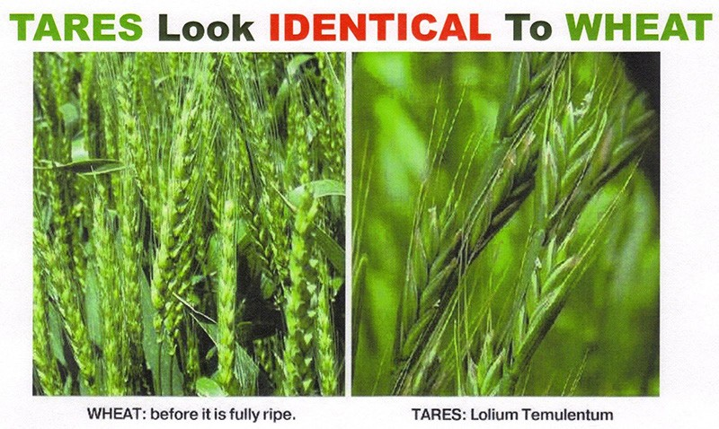
At Passover time in Israel we do not eat bread with ‘hametz’ (symbolic of sin). As my Jewish friend and I study the Bible we are looking at more meanings behind the words. It is interesting that Jesus (Yeshua) tells us that we are to let the wheat and tares grow together in the end times. In Genesis 1 and 2, God created the universe. He said His creation was “very good” (‘tov meod’ in Hebrew). On the third day when He created the plants such as wheat, He said “very good” again because He knew the wheat needed to do its duty to produce bread. However, when Adam and Eve sinned and it was
seen in Heaven, the wheat no longer produced only wheat but it was found growing with tares (because of sin). It is thought that the roses were without thorns before the sin of Adam and Eve. Everything changed, animals began eating one another, and the wheat was growing with tares. Jesus is saying that the first couple in the garden sinned, the tares began to grow and will continue, until He arrives to fix all that went wrong. Before eating the fruit, both man and woman were of pure mind and heart. This is what Jesus desires for His Kingdom which is coming to the earth, pure hearts and minds. We see Jesus teaching us that tares and wheat “look” pretty much alike, but the Lord will determine at that time whether He truly knows each believer or not. “But I will reply, ‘I never knew you. Get away from me, you who break God’s laws’” (Matthew 7:23). When He comes, He will solve the problem of sin mixed with those of pure hearts – He will judge. All creation needs the Lord since Adam and Eve. When He comes He will gather into His “barn” (His Kingdom) pure bread

for the Kingdom, without “hametz” (sin). May our lives show us daily whether we still have some “hametz” in our hearts toward others, motives and behavior in our walk with God.

Let Us Enter the Throne Room of Grace
- Pray for rain for the Land. Even without the expected winter rainfall, the Land is very beautiful and the Sea of Galilee very full; however, we do need the seasonal rain in order to maintain the amount of rain in the Sea of Galilee and other smaller lakes and reservoirs. Amidst Covid, the Land remains beautiful to behold in the valleys, hillsides and vales. “I will send you the seasonal rains. The land will then yield its crops, and the trees of the field will produce their fruit” (Leviticus 26:4).

- Intercede fervently for Israel’s government leaders that God would give the system He wants and which is right for Israel. May the Biblical concept of leadership emerge among the present candidates. As God separates the wheat and the chaff now more than ever before, wherever there is darkness ruling, let it be exposed, and may Godly leaders emerge. “You shall appoint for yourself judges and officers in all your towns which the Lord your God is giving you, according to your tribes, and they shall judge the people with righteous judgment” (Deuteronomy 16:18).

- Thank God for more Muslim believers in the Middle East countries but pray for the persecuted Christians in Iran, Iraq, Syria and around the Middle East. “Do you remember what I told you? ‘A slave is not greater than the master.’ Since they persecuted me, naturally they will persecute you. And if they had listened to me, they would listen to you” (John 15:20).

- Beseech God to remove from the United Nations the hateful nations that are passing many resolutions against Israel (many in 2020) than any other nations. “His words are as smooth as butter, but in his heart is war. His words are as soothing as lotion, but underneath are daggers!” (Psalm 55:21).

- Proclaim His Word that “every jot and title” which the Lord told us would come to pass in the Torah will do so in these end times, bringing Israel through all of her struggles and giants that face her and bringing her back to Him with not one atheist in the House of Israel. “I tell you the truth, until heaven and earth disappear, not even the smallest detail of God’s law will disappear until its purpose is achieved” (Matthew 5:18).

- Rejoice in Him that we are getting closer to His Return. Now as He sat on the Mount of Olives, the disciples came to Him privately, saying, “Tell us, when will these things be? And what will be the sign of Your coming, and of the end of the age?” (Matthew 24:3). Today we have more signs each and every week confirming His Soon Return.

- Ask God to change hearts as Hamas lead its first-ever joint military exercise with Gaza terror factions recently making their plans against Israel. “Call your councils of war, but they will be worthless. Develop your strategies, but they will not succeed. For God is with us!” (Isaiah 8:10).

- Close in prayer with asking God to help us all “Watch and Pray” as He asked us to do as we near the Coming of the Lord and His Kingdom rule. We must remember that the antichrist kingdom is also rising. We must be ready for whatever comes as we live day-to-day, one day at a time, waiting for His Return. With His Return will be the “rising of Israel” to enlighten the entire world. “But take heed to yourselves, lest your hearts be weighed down with carousing, drunkenness, and cares of this life, and that Day come on you unexpectedly. For it will come as a snare on all those who dwell on the face of the whole earth. Watch therefore, and pray always that you may be counted worthy to escape all these things that will come to pass, and to stand before the Son of man” (Luke 21:34-36).

May the Lord bless each of you wherever you are. Many use the Watchman’s Prayer Letter around the world. It is a privilege to write and be in touch with all of you. Thank you for including Christian Friends of Israel in Jerusalem and around the world in your prayers, that God will sustain us, strengthen us, expand the vision and cause us to be more fruitful than ever before, even in dark times. With your help and prayers, we will move through tough times together.

Working Together for Him,
Sharon Sanders
Christian Friends of Israel - Jerusalem

