CFI Projects Monthly Reports for
International
Representatives

Dear CFI International Representative Family,

Thank you for your continued support of the Outreach efforts of Christian Friends of Israel. We continue to strive to encourage those in need and to offer practical assistance during times of struggle. It’s during these times when relationships can be formed which please God and allow us to show Compassion to those who need it the most and have possibly never experienced it before.

During this time of global pandemic, we continue to offer assistance as we are able, and we know each passing day may allow for additional hardships, but we also know the God whom we serve. He is more than able to protect, and provide and heal. We are willing to represent Him to the people of Israel.

Please receive the CFI Outreach electronic updates as a reminder
of the impact each of you have in the lives of so many. We are grateful to represent those of you in the Nations - to those in the Land of Israel.

A friend loves at all times, And a brother is born for adversity.
Proverbs 17:17 (NKJV)

Project Under His Wings

The joyous fall Feasts of the Lord, Yom Terua (Trumpets) and Sukkot (Tabernacles) were marred by terror, death and injury. As many Jews go to the Temple Mount (Al Aqsa Mosque) during these days, the enemy used this to agitate those that would gladly be agitated, namely Palestinian terrorists, intent on using any situation to kill Jewish soldiers and civilians. The violence, this time, was focused on IDF soldiers and on “settlers” (Jewish people who have settled in Samaria/Judea, in the midst of large Arab
populations). Over the course of 1 month there were 7 shootings, 2 vehicle rammings, 2 stabbings and 3 murders of precious Jewish lives. Young Ido Baruch was murdered as he guarded a settler march, who were demonstrating in light of the recent wave of violence perpetrated against their communities. Ido was 21 years old.

Young Noa Lazar, IDF Military police was murdered several days earlier as she guarded a checkpoint in North Jerusalem. Noa was 18 years old.

Chaim David, a 30 year old security guard at the same checkpoint as Noa was shot in the head during the attack and fights for his life at a hospital in Jerusalem. Chaim David made Aliyah in 2017, where he came to join the IDF as a lone solider.

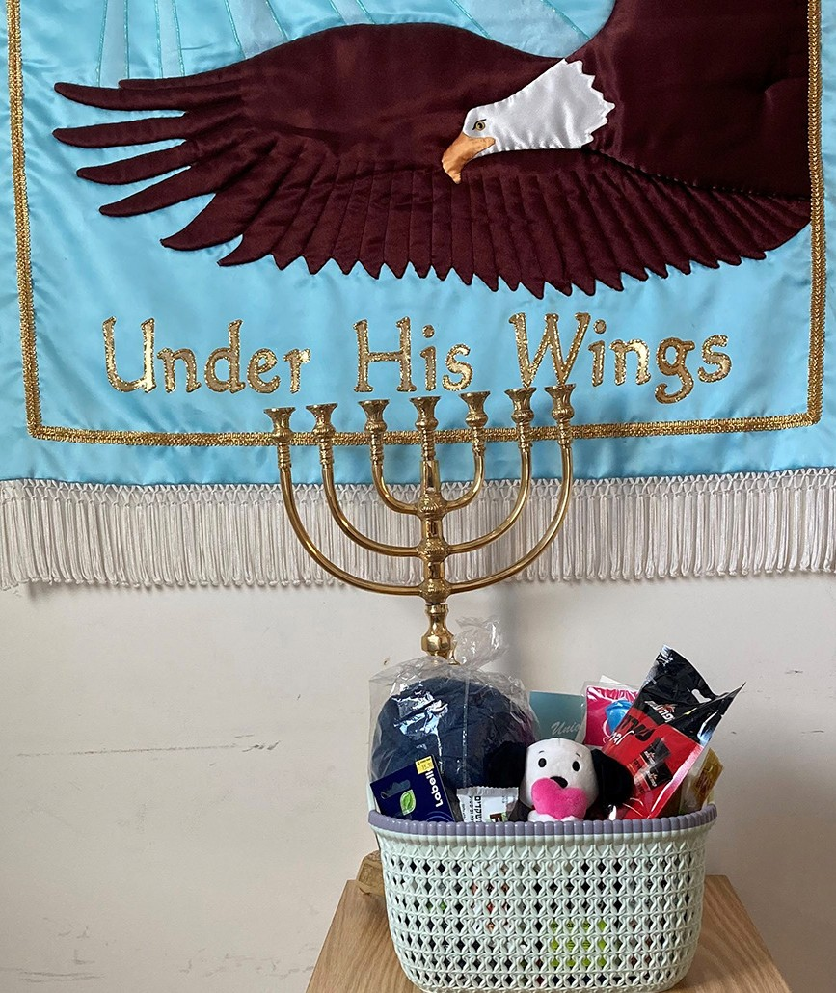
As these incidents of tragedy and terror unfolded in and around the beautiful week of Sukkot, I asked God how to reach out. I felt the need to visit Chaim David’s family, whom it was reported were by his bed- side as he underwent neuro- surgery. Thank God for the foresight to prepare a “hospital basket” just days earlier, along with the donation of stuffed animals from back home, I was able to bring with me a present of love along with my prayers and the prayers of many behind me.

It is always a miracle to find a person at a hospital and to be allowed to speak to the family, and God indeed opened doors and made this possible. I met a sweet Uncle and precious Sister of Chaim David. Her name is Simcha or Joy in English. With tears in her eyes, Simcha ac- cepted the gift and prayers from not only myself and Christian Friends of Israel but from you!

From believers from across the world. Her tight hug expressed what words could not and I was able to impart God’s love as well through this sweet meeting.

“The thief comes only to steal and kill and destroy. I came that they may have life and have it abundantly” John 10:10.

Please pray for Chaim David, for his family, and most of all that God would meet him and them, where they are… as only God can. That this tragedy would be turned into triumph as our prayers cover them and the Spirit draws them.

Neomi G. Project Supervisor

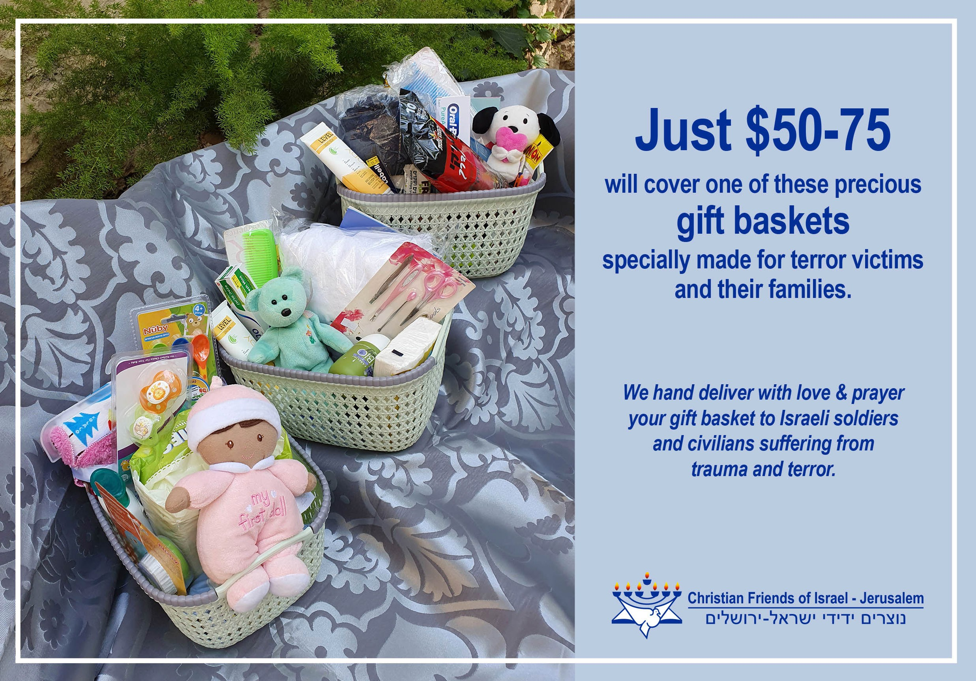

Project Wall of Prayer

God is at Work!

“Lord my God, you have done many things— your wondrous works and your plans for us; none can compare with you. If I were to report and speak of them, they are more than can be told” (Psalms 40:5, CSB).

At the beginning of this new Jewish year, 5783, people from around the world began to pour into Israel to celebrate the High Holy Days. For the last two years, the Covid pandemic restricted travel and gath- erings, so it was a tremendous blessing to see the streets filled with international pilgrims. Several ministries based in Israel resumed their large meetings and hosted inspiring worship and intercession services. We praise God for answering our prayers for open airways!

CFI hosted visitors from Finland, Germany, Kenya, South Africa, and the Philippines. I joined an anointed prayer session at a 24/7 worship center, Succat Hallel, with scores of worshippers from Kenya and Uganda. For years, Sukkot has been my favorite holiday, but now I see its importance from the viewpoint of some believers in the nations. The prophet Zechariah predicted a time when countries would come against Israel and be defeated. Zechariah 14:16-17 AMP says, “Then everyone who is left of all the nations that went against Jerusalem will go up from year to year to worship the King, the Lord of hosts, and celebrate the Feast of Booths (Tabernacles). And it will be that whichever of the families of the earth does not go up to Jerusalem to worship the King, the Lord of hosts, there will be no rain on them.” Even if that scripture may refer to a future time, Believers worldwide sacrificially come to Jerusalem to worship the Lord and bless Israel at Sukkot. In doing this, they bring blessings to their homes. After all, God promised to bless those who bless Israel (Genesis 12:3).
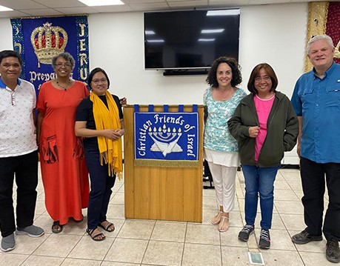
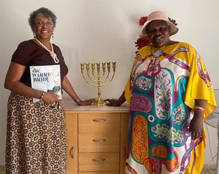
Meeting with 3 Filipino pastors Hosting Kenyan Prayer leader in my home

God is at work among the nations! Several new prayer warriors from various countries have joined our online prayer meetings. The Israel Watch world map now has many new photos of people who pray for Israel. When they came to our office and viewed the map, they wanted their pictures added. It was encouraging to learn that a Kenyan prayer group prays weekly for Israel, and a 24-hour prayer house in the Philippines wishes to partner with us. We praise God for intensified prayer coverage in these times of increased spiritual warfare!

God is at work among the young people in Israel! One of the highlights of this Sukkot season was attending a Messianic worship celebration led by Shilo Ben Hod and his 24/7 House of Prayer group, Solu (meaning “Build up” in Hebrew.) I have watched this young man lead worship at prayer meetings and teach young people to carry the heart of God by singing & praying from the scriptures. He brings youth together from different people groups and has the vision to prepare the way for revival and Messiah’s return to Israel. It was exhilarating to be among a crowd of young people worshipping freely. We continually pray that Israeli youth will remain strong in the Lord, boldly serving as “salt and light” to those around them.
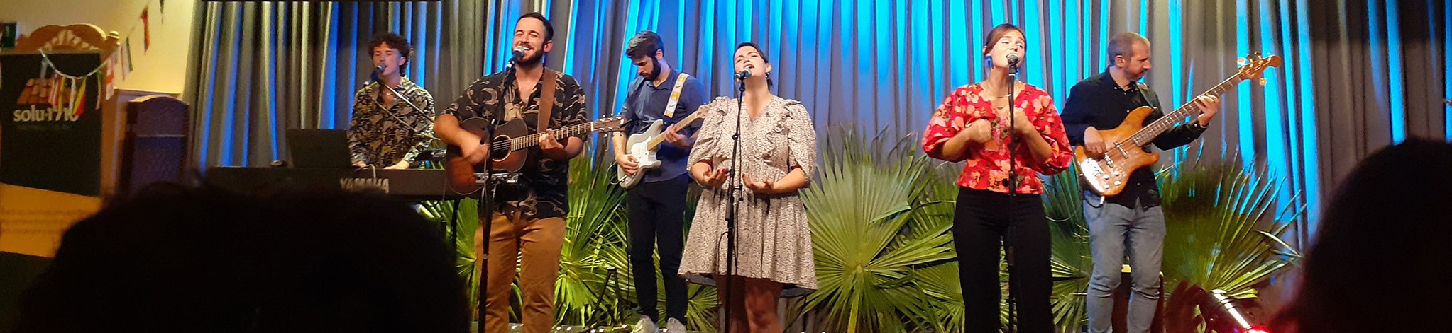

God is also at work among Israel’s older generation. A heartwarming incident reminded me of this fact. A friend and her spouse lead worship for a weekly prayer meeting in a men’s drug rehab center operated by Jewish Believers. Nothing is as uplifting to me as watching men pray and sing to the Lord with all their hearts! I can only join the meetings periodically, so I was glad to be with them again. We sat in a large circle; everyone sang together and took turns praising God and praying aloud. Afterward, the pastor gave brief words of inspiration.

One man especially caught my attention. I had seen him on other occasions, but his countenance was different this time. I could tell the Lord had been working in his life; God was softening his heart. After the meeting, I asked my friend to translate my words of encouragement for him.

After we left, I discovered the significance of God’s work through this facility. I learned that this man was one of a few Arabs in the residential program and had just had his 67th birthday. When the others celebrated his birthday, I was told he broke into tears because he had never had a birthday celebration.
That is a miracle! Only the blood of The Lamb can wash away sins, bring healing, and break down walls, allowing Jews and Arabs, Russians and Ukrainians, to live under the same roof, worshipping the One True God of Israel. To God be the glory!

God is at work in Israel! Right now, we see lives changed a few at a time, but the word of God from Joel 2:28 and Zechariah 12:10 promises a time when masses of Israelis will turn to Him. We continue earnestly praying for the Kingdom of God to be revealed on earth as it is in heaven. Will you join us in prayer?

Friends, donors, and prayer partners, I attempted to give you a glimpse of what God is doing through this report. We say a hearty “Thank you!” You are helping to make a difference in the lives of Israelis and others on the earth. Without your prayers, love, and support, we would be unable to remain in Israel, traveling, writing, praying onsite, and visiting homes and facilities. God has promised to reward you for your service in His Kingdom. Hebrews 6:10 CJB says, “For God is not so unfair as to forget your work and the love you showed for him in your past service to his people – and in your present service too.”
Linda McMurray Project Supervisor

Project Forsake Them Not

“Command the children of Israel, and say to them, ‘My offering, My food for My offerings made by fire as a sweet aroma to Me, you shall be careful to offer to Me at their appointed time”
Numbers 28:2.

In the month of September the season of special significant dates, described in the Holy scriptures started. Those days are national holidays in Israel, which are celebrated together with family and friends. For many years our team took an active part in organizing different events together with the Holocaust survivors during God’s appointed times. This year was slightly different as we decided to dedicate more time and attention to personal visits for those who were prevented from much fellowship due to the health condition. Each year it becomes more and more difficult for survivors to attend big gatherings and events.

Boris is the leader of an organization in Holon and he would have been the first one calling us with invitation, but this year he had a heart attack followed by surgery and difficult recovery in the hospital. We just wanted to pay a quick visit to him, but even that was refused because of many doctors’ appointments, which Boris had to follow. One day we made last minute appointment with Boris’s friends
- Ludmila and Arkady from the same town. We do not know what happened, but on the day of the visit,
Boris called us to say that he and his wife were coming to celebrate with their friends and with us for the upcoming holiday. That was a wonderful surprise, as it was the first time Boris came out after a long recovery to celebrate God’s appointed time together with us!
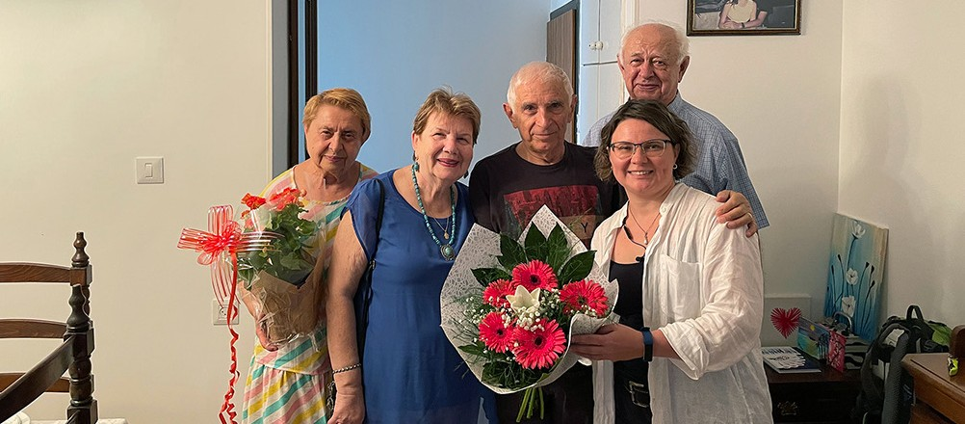

It was also a special privilege for us to celebrate holidays together with Evgenia and Haim in Kiryat Yam. Both of them are survivors and Evgenia is the leader of organization in their town. It was in 2018, when we organized a big celebration for the entire organization there and it was unforgettable for everyone.
Since then we became a good friends with Evgenia and her husband. During the last years Haim’s health had deteriorated, but Evgenia was not willing to give Haim away to a nursing home and she is diligently taking care of him together with a 24/7 care giver called Rustam. That makes it difficult for Evgenia to dedicate time to organize the feast for survivors and to even go out and celebrate it with the family. Evgenia was uplifted when she heard we were coming to visit them for celebration. When we arrived, Haim was sitting in his wheelchair nicely dressed and widely smiling to us, anticipating the sweet time of fellowship.

Especially in such appointed times as these our hearts, together with the hearts of our precious friends - Holocaust survivors, are overflowing with gratitude and praise to God Almighty! We also recognize how important your prayers are to us, and also your faithfulness and generosity! Thank you for very much for being with us during this season!
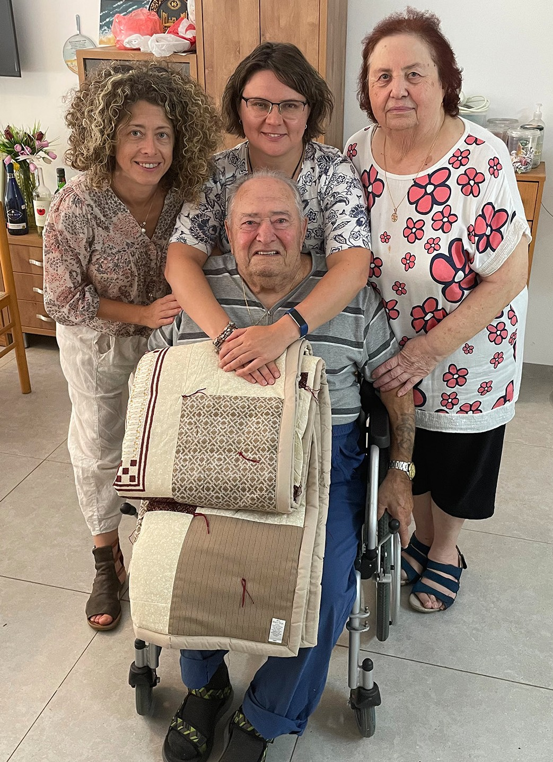
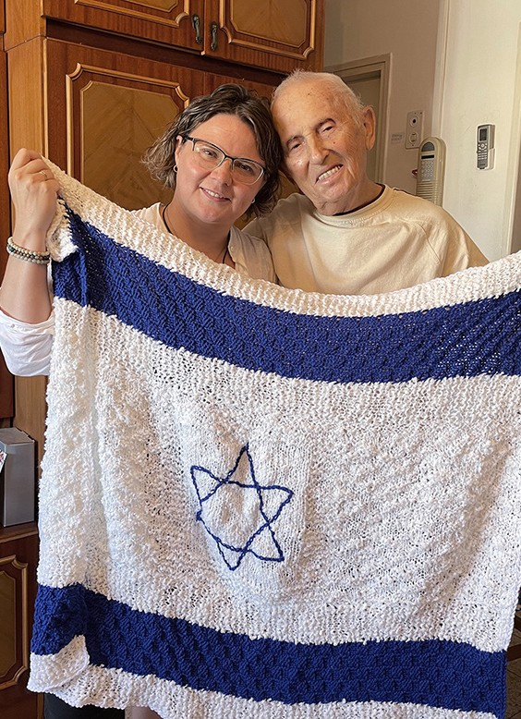

“Behold, how good and how pleasant it is for brethren to dwell together in unity! It is like the precious oil upon the head, running down on the beard, the beard of Aaron, running down on the edge of his garments. It is like the dew of Hermon, descending upon the mountains of Zion; For there the Lord commanded the blessing - Life forevermore” (Psalm 133:1-3).

Olga Kopilova Project Supervisor

Project Open Gates

Greetings from already rainy Jerusalem!

The month of October has been special with all the Feasts and different gatherings. It has been the quietest time of the year in our Store so far. However almost every day we have people coming to our place and getting different items as a gift for their households. New immigrants are grateful for the help they get through Christians.

There is a big wave of Aliyah starting to move from Russia. We are preparing the “emergency bags” for those who have left everything behind to come to Israel. The mobilization of men who don’t want to fight against Ukrainians is causing a lot of pain and fear in Russia. It is time to flee from there, if you can do it. Those who are able to prove their Jewishness are in a better situation than many others. They can come to Israel. Please, pray that God will open the doors for them. They may need to leave everything behind, but they have a God-given future waiting for them in the Land. “For surely I know the plans I have for you, says the Lord, plans for your welfare and not for harm, to give you future with hope” Jeremiah 29:11.

We as Christians should pray for the plan of God to become true! “May Your Kingdom come! May your will be done in the lives of all new immigrants of Israel!”
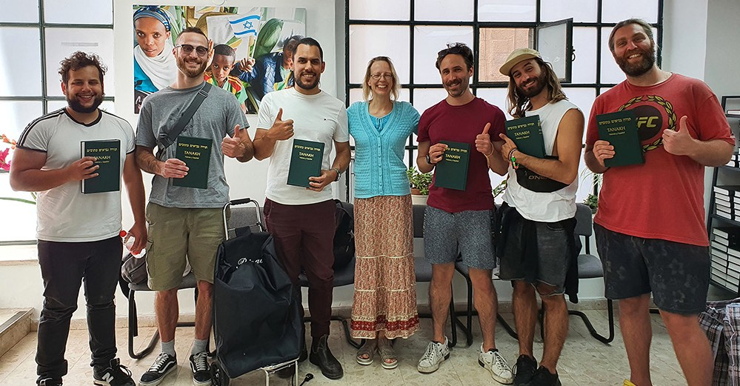

There were two young olim from France visiting our place some weeks ago. We also helped a future family, who had made Aliyah from Germany. These people were also very thankful for the love and care of Christian Friends of Israel. Every week we serve olim from Argentina and from other places in South- America.

It is fun to see people from different cultures and backgrounds. Please, pray that God’s love will touch their hearts. The items they take with them will be a reminder of the visit to our place. I hope that these

people will start to ask some questions of themselves. “Who are these Christians? Why are they helping us? Do they know God in deed?” May we be a light for them in Yeshua.
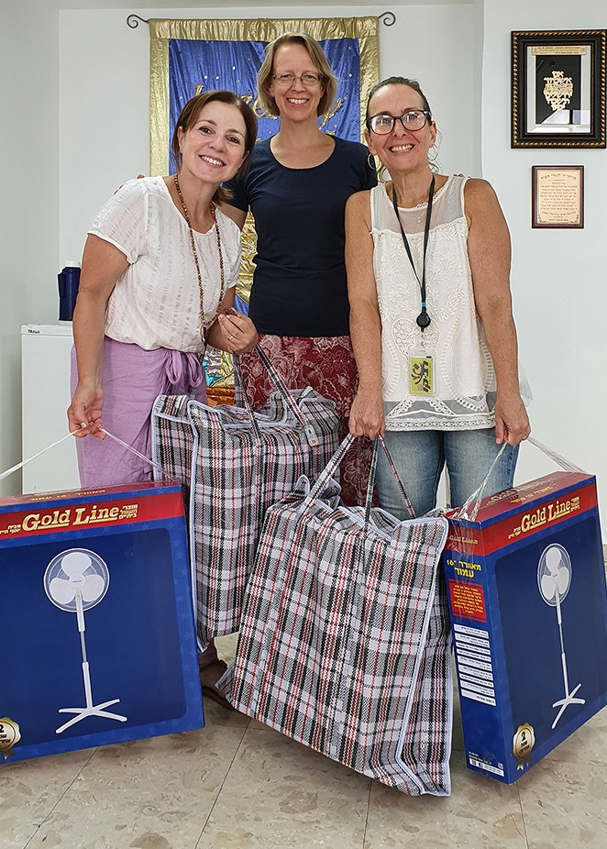
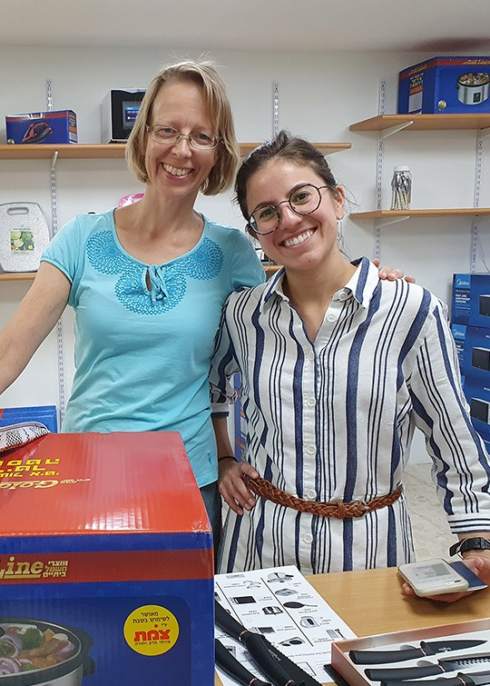
“You are the light of the world. A city built on a hill cannot be hid. No one after lighting a lamp puts it under the bushel basket, but on the lampstand, and it gives light to all in the house. In the same way, let your light shine before others, so that they may see your good works and give glory to your Father in heaven.” Matthew 5:14-16

Blessings from the city of the great King!

Tiina Danilevski Project Supervisor

Shalom from the CFI Bridal Salon!
Project Bridal Salon

This month we have served different people. Diana needed a wedding dress at the last moment because the one she had ordered never came to Israel by mail. We found her a beautiful gown within an hour. It was the first dress she tried on, and she immediately felt good in that gown. A lovely veil and a bolero complet- ed the outfit. The fiancé was as happy as his bride-to- be. Now they were ready to have their wedding.

The most recent clients we served were French-speak- ing Israelis. The bride-to-be was only 18 years old.
Hadar had found a perfect wedding dress in a boutique, but the price was unbelievably high: 14000 shekels (about 4000 euros)! It was too much even for French Jews. Somebody told them about our Bridal Salon, and they decided to come and have a look. Hadar liked one of our dresses, although it was very different from the “perfect” one. They decided to take that dress with them and make some alterations. The cost won’t be much compared to the prices of the boutique. Hadar’s mother found an evening dress and a shawl for the coming celebration. The little brother got a Hebrew-French Tanach for his school program.
Everyone was happy.
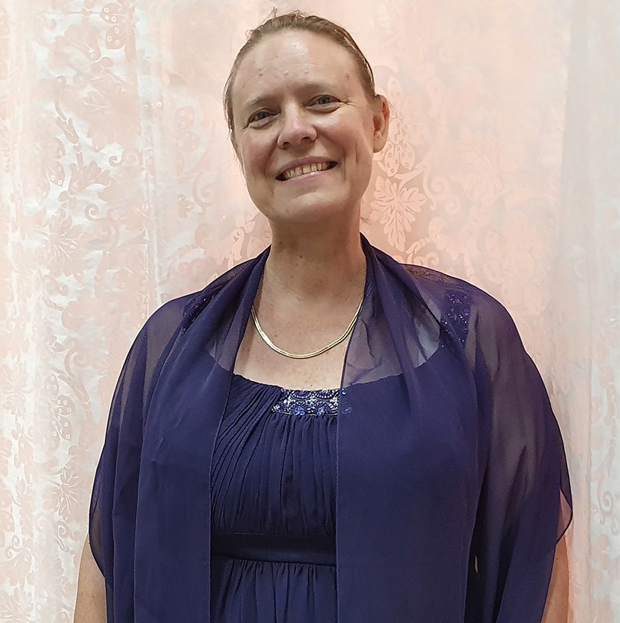

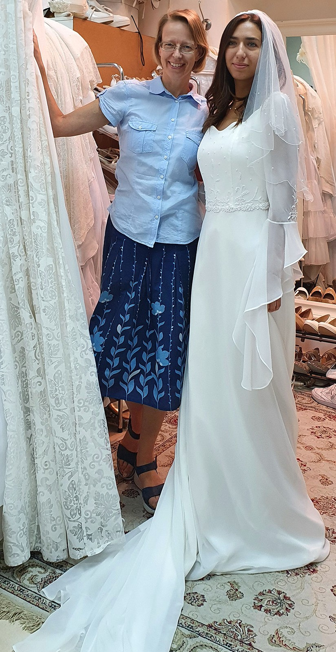

Alexandra and Gabriel came to our place in need of a suit. Their wedding was to be in two weeks. We found a good suit for this young groom, who also volunteers in the Land.
Alexandra had a dress, but it needed to be steamed. We made an appointment with her the following week. Our steaming machine did a good job. It was a blessing to help these young servants of the Lord.

Thank you for keeping us in your prayers!

Tiina Danilevski Project Supervisor

