CFI Projects Monthly Reports for
International
Representatives

Dear CFI International Representative Family,

Thank you for your continued support of the Outreach efforts of Christian Friends of Israel. We continue to strive to encourage those in need and to offer practical assistance during times of struggle. It’s during these times when relationships can be formed which please God and allow us to show Compassion to those who need it the most and have possibly never experienced it before.

During this time of global pandemic, we continue to offer assistance as we are able, and we know each passing day may allow for additional hardships, but we also know the God whom we serve. He is more than able to protect, and provide and heal. We are willing to represent Him to the people of Israel.

Please receive the CFI Outreach electronic updates as a reminder
of the impact each of you have in the lives of so many. We are grateful to represent those of you in the Nations - to those in the Land of Israel.

A friend loves at all times, And a brother is born for adversity.

Proverbs 17:17 (NKJV)

Project Forsake Them Not

“Weeping may endure for a night, but joy comes in the morning.” (Psalm 30:5b)

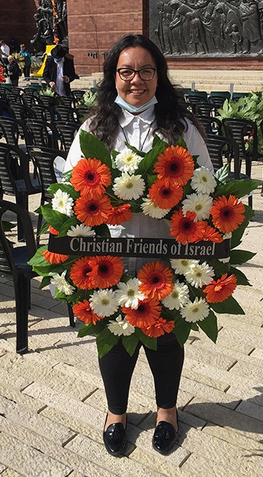
As the day comes after the night, so indeed joy comes after weeping, bringing hope and comfort. We all have experienced it personally, and with one another. It is so wonderful when we can rejoice with one another, but there is certainly a lot of comfort and depth when one can weep in a friend’s arms. It has been a privilege for us as a team here to experience that sweetness of fellowship with our dearest friends and family of Survivors.
As many COVID restrictions are lifting here in Israel, we were able to participate in different Holocaust Remembrance events and travel to different towns to visit people.

The Holocaust Remembrance event took place in Yad Vashem with the wreath laying ceremony. Though the number of participants was small, we were grateful that CFI representatives were able to participate. I was on a visit with Klara when the remembrance siren went off.
We could hardly keep our tears from running, standing silently in the moment when no words are adequate. I saw how the memories of the past took their brushes and paint and began to colour their shadowy impressions upon Kiara’s mind; but not for too long! The
siren was over, and the heaviness was lifted. Klara looked at me with a big smile – she was so grateful she wasn’t by herself, she wasn’t left alone with the horrible past on such a day. After sharing with me
some of her painful memories, Klara enjoyed speaking about her grandchildren and great grandchildren. She is very grateful for her family and finds it a great joy in seeing them growing and doing well. After a lot of weeping in her life, Klara now takes joy in every day.

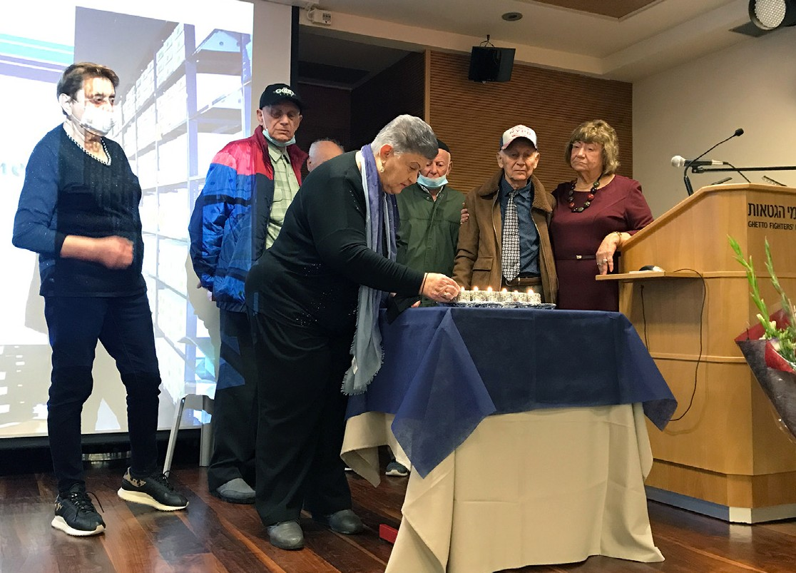
We were also invited to participate in the first event since the lockdown, of the Association of the Concentration Camps and Ghetto Survivors in Lohamei Hagetaot Museum. Over 100 Holocaust Survivors from all over Israel gathered together to commemorate the memories of
the perished family members, but also to express the deep desire for life and a future. After the lightening of six candles and listening to a very educational lecture on the bravery of those who were murdered in the concentration camps, we all enjoyed wonderful music and lunch together. What a wonderful example of rejoicing together it was!

My visit with Yitzhak and his wife Roza was very special. Yitzhak was always very kind, but careful towards Christians. As an orthodox couple, they both honour Tanah and often read it, especially the book of Psalms. They shared with me that their grandson recently became an organ donor for a mother

of many children, a lady he never met, and is recovering from surgery now. They also told me how they read and prayed the Psalms during all those hours of waiting, and how grateful they were for answered prayers. We spoke of the goodness of the Lord and shared testimonies as we looked into the scriptures together. Yitzhak was just full of joy when he walked me back to the car. It was hard to depart, but my heart was rejoicing after such a wonderful time together.
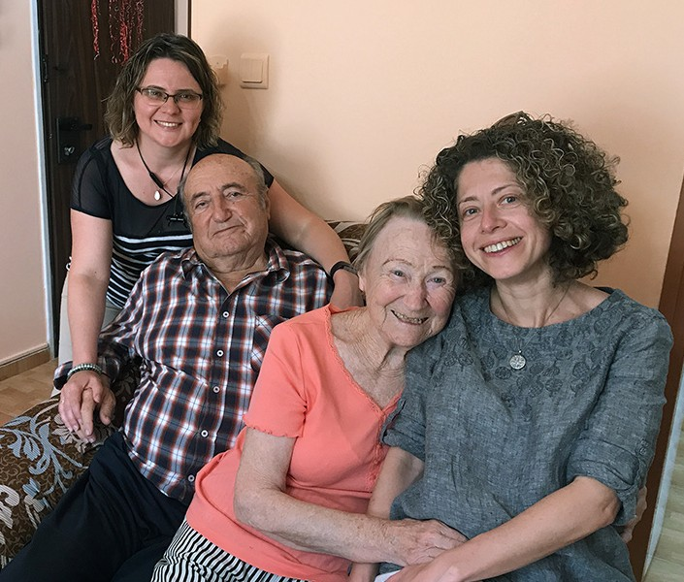
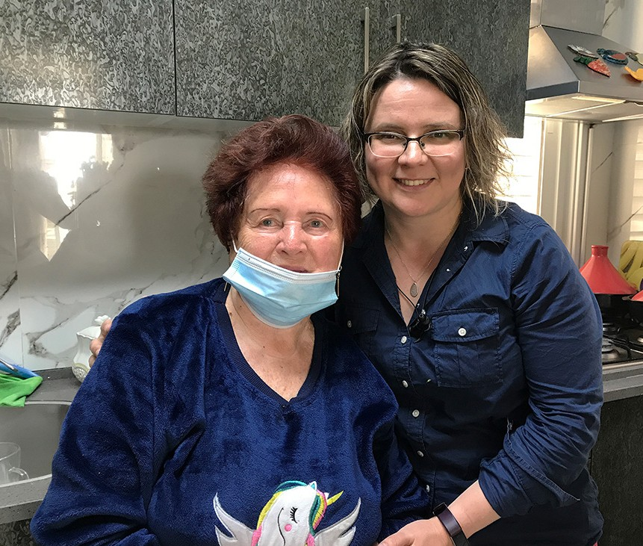

We are ever so grateful for every visit we were able to make, every tear we shed together with our precious friends, every smile we enjoyed with each other. It was a gift, both for them and for us as a team here. Once again we would like to say THANK YOU for being with us on this journey, THANK YOU for helping us to bring some joy and comfort to those who had an extreme dose of weeping in their lives. Let’s continue to pray that the joy which comes in the morning fills the hearts and lives of many Holocaust Survivors.

“I will extol You, O Lord, for You have lifted me up, and have not let my foes rejoice over me” (Psalm 30:1).

Olga Kopilova Project Supervisor

Project Open Gates

Shalom our friends and coworkers!

Despite the specific situation in this Land our distribution center is open for visitors. It is still quite peaceful in Jerusalem. The local people are not afraid to come to take clothing, but those clients that come for example from Tel Aviv, Ashkelon, Netanya and Haifa, need to think twice before they travel anywhere at the moment. Some appointments were canceled because of the danger of the rockets, but there were clients who came to us from other cities anyway. One of them was Anna who lives in Rishon LeZion, close to Tel Aviv. She came
to take clothes for the fourth and last time. CFI serves new immigrants during their first three years in the Land. We still have plenty of women’s clothing in our place. Anna used the opportunity and took a lot of beautiful items for the coming summer and also for her unknown
future. She was very grateful and left us a note:

“A huge Thank you to your organization!
It is difficult to explain with words how much joy and emotion we experienced through your gifts. Making Aliyah is a difficult process. That’s why your help during this difficult life period is irreplaceable! The beautiful clothes, with an excellent quality, are a great joy and a real help
that you can feel and touch! I wish you success in the future plans of your ministry!
With a lot of respect, Anna Mezdrochin”

Anna’s friend, Irena, was also very touched by the big amount of clothes that we allowed her to take for herself. The girls told about their experiences of the war, how difficult it is to go to the bomb shelter many times during the day and night. One night they went there three times. It was very difficult to work next day.

Last Friday we had two girls from Tel Aviv. They said that it is the first time in their life that they have this kind of situation with rockets and everything. Anyway, life goes on in Israel and also in our organization. Tomorrow we will have some visitors from Ashkelon. It will be interesting to hear their story too.

May the Lord give us His peace every day and hour, so that we can pass it to those who we meet on our path. The CFI distribution center is a good place to encourage different people, especially new immigrants of Israel. Thank you for your prayers and for any kind of support! Thank you for being with us!

Project Bridal Salon

Shalom from the city of the Great King!

The CFI Bridal Salon in Jerusalem is open for clients. At the moment we don’t have a lot of appointments, because of the war that is going on. Anyway there are some people who are knocking on our doors. It
is good to be ready to help them. Tomorrow we will serve the mother of a groom. Next week there will be an appointment with a bride-to-be. Somebody needs just a veil or some jewels. One girl canceled her appointment. She is from another city and she wants to be sure that she is safe during this time of rockets. The dresses can wait.

Thank you for your prayers for Israel! It is the best support at the moment.

Psalm 93 (NIV)
The LORD reigns, he is robed in majesty; the LORD is robed in majesty and armed with strength; indeed, the world is established, firm and secure.
Your throne was established long ago; you are from all eternity. The seas have lifted up, LORD, the seas have lifted up their voice; the seas have lifted up their pounding waves.
Mightier than the thunder of the great waters,
mightier than the breakers of the sea – the LORD on high is mighty.
Your statutes, LORD, stand firm; holiness adorns your house for endless days.

May we all be in His shalom.

Project Under His Wings

Dear Friends of Israel,

“…not a famine of bread, nor a thirst for water, but of hearing the words of the LORD” (Amos 8:11b).

Kochi was a heartbroken widow whose husband was battling cancer; he recently succumbed to death caused by covid complications, leaving behind Kochi and their 11 years old son. Before her husband’s passing, Kochi had been taking care of him as a nurse but she had not been working for several years; now she has several health problems of her own. Her situation was seemingly hopeless – with her health problems, sorrow and dire financial situation. After listening to all her hardship I felt the Holy Spirit say, “sweet comforting words of man would not help her cope with all her problems, what she needs is her inner being strengthened” (Ephesians 3:16). I shared with her what the Lord had put in my heart. After that I saw an apparent change in the atmosphere of her home as well as that of her mind. She said to me, “What you shared with me was amazing and very wise, please come back to visit me every week.”
I encouraged her to read the Tanach, which I had brought to her.

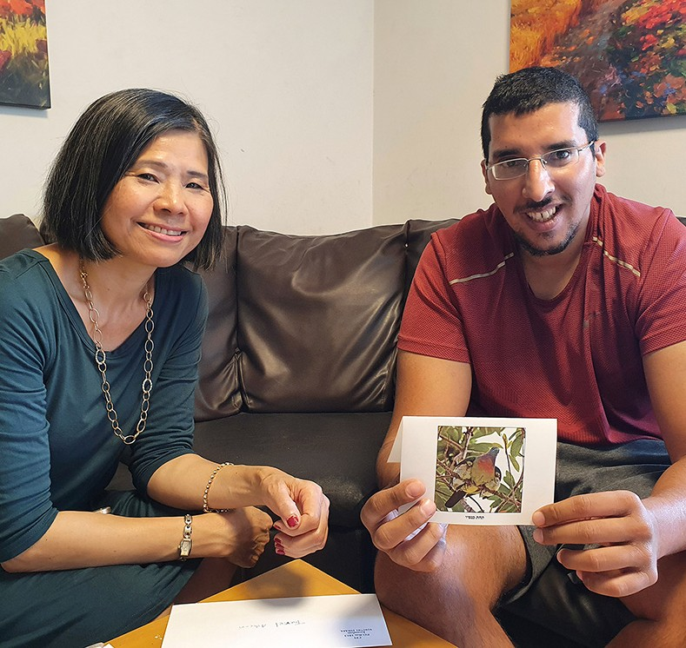
And Tzuriel; this young man was troubled by an evil spirit, which caused him to say nasty words to several people, including me, when he called asking for help. I told him that if he was going to be disrespect- ful that I would end the phone conversa- tions with him. He was enraged and said to me, “No need your help! And who are you to tell me that I am not God”. So I hung up the phone. A couple of months later he contacted me asking for forgive- ness. I answered that I would forgive him but please tell me why you behaved like that, so it would help me understand his situation better. At our visit he told me what he encountered. I told him that the demons and the spiritual realm are real but there is One who is greater than all the demons…and he listened attentively and believed.

Truly there is a BIG famine in the land of Israel, in the majority of the Israeli Jews – People of the Book, not a famine of bread, nor a thirst for water but for the Words of the Living God. Please pray that God would put a deep hunger in His Chosen People for His words so that they will know the truth and the truth will set them free from all the misconceptions passed down to them from their traditions and so on.

We are very grateful to you – our supporters, without your generous financial support and prayer we would not be able to reach out to Israeli Jews affected by terror attacks, sharing the Living Word of the Truth of God with them. God bless you and keep you and your loved ones (Numbers 6:24-26).

Project Communities Under Attack

Dear Friends of Israel,

“I will restore your leaders as in days of old, your rulers as at the beginning. Afterward you will be called the City of Righteousness, the Faithful City.” (Isaiah 1: 26)

Between the 10th – 14th May 2021, Israel was bombarded by more than 2,300 rockets and mortars from Gaza. Starting on 10th May evening (Jerusalem Day), the ongoing barrage of rocket attacks sent 70% of Israelis to bomb shelters for refuge. In response Israel pounded Gaza with airstrikes and called up 9,000 more reservists (Operation Guardian of the Walls). 12 people in Israel were killed and 312 were injured by rocket fire; houses and properties were also damaged. Rockets are continuing be fired into Israel at the writing of this update. Please pray for protection and safety of Israeli citizens as well soldiers and reservists who are protecting this country.

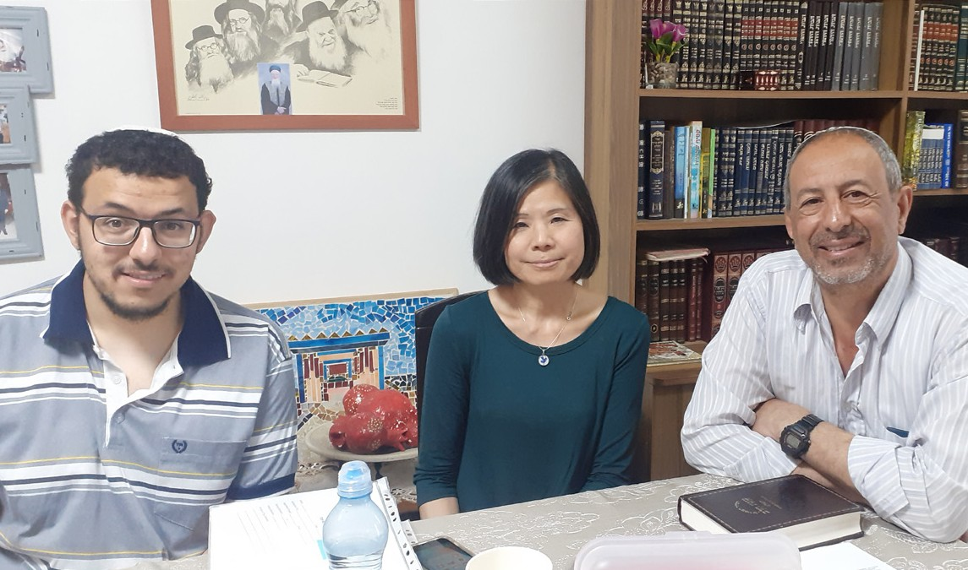
Project CUA visited two families of former IDF soldiers traumatized by Israel’s previous war with Hamas in 2014. The two former warriors have been in dire situations; we are asking our supporters and intercessors to pray. The trauma is too much for Elad to bear, in that he has attempted committing suicide several times. He only drinks one bottle of flavored water and one small bottle of protein milk to survive, and has been living in darkness, as he cannot bear to hear any sound as small as a flying bee, nor see light!

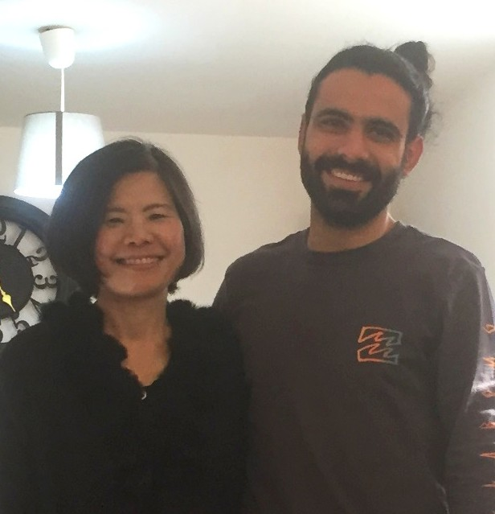
Itzik had been dealing with the bureaucracy and injustice of the Trauma Recognition Department of the Ministry of Defense for traumatized victims, to recognize his real situation, but to no avail. Out of desperation Itzik immolated himself about one month ago in front of the building of Trauma Recognition Department for their horrible treatment to him, and he was seriously burne d. He is still at ICU and has long way to go for recovery.

Many wounded Israeli soldiers become very bitter as they feel they have been betrayed and discarded by their country after they were wounded in defense of Israel. Against all the hindrances in bureaucracy let us pray:

- Asking God to fulfill His promise of Isaiah 1:26, to restore the righteous judges to Israel as in days of old, in the trauma recognition Department of Israel.
- That traumatized Israelis, as well as their families will have encounters with Him who says, “Come to Me, all who are weary and heavy-laden, and I will give you rest” Matthew 11:28.

Thank you for your prayer and financial support for Project CUA despite these challenging days. God bless you according to Genesis 12:3.

Project Wall of Prayer

WARRING IN PRAYER

“The weapons we fight with are not the weapons of the world. On the contrary, they have divine power to demolish strongholds…” (2 Corinthians 10:4 NIV).

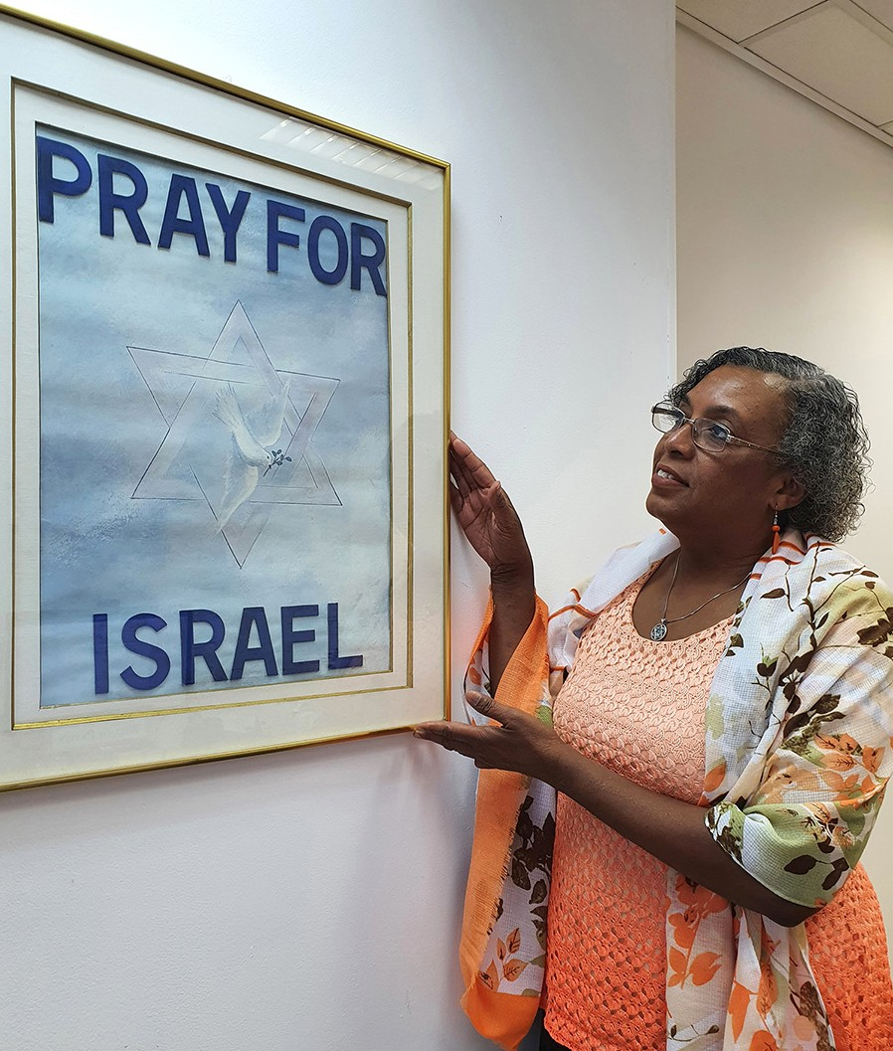
This has been a time of escalated warfare in Israel, both spiritually and physically. We realize that the clash of kingdoms in the spiritual realm is manifested in the physical realm. As Muslims spent a month fasting and observing Ramadan and the Jews celebrated Jerusalem Day, in honor of the Old City being reclaimed by Israel, the age-old battle over territory again erupted in violence.
Beginning on May 10, hundreds of rockets were launched by the Iranian-backed Hamas organiza- tion from the Gaza Strip into Israeli cities, towns, and villages including Jerusalem, Israel’s capital, and the Tel Aviv metropolitan area.

During this volatile time, our vigilant prayer warriors from various nations assembled to intercede for Israel. We met some new prayer partners during one of the online prayer meetings, because our intercessors recruited others to help provide spiritual protection for God’s people. In times of trouble, prayer usually increases. The Lord wants people to always look to Him!

On a Shabbat some staff gathered in a worship/warfare session singing out to God from Psalm 3:3: “... But thou, O Lord, art a shield for me; my glory, and the lifter up of mine head.” We raised songs and prayers to the Lord in multiple languages praising God for His promises of safety for Israel. We believe God heard us.

Although most of us were not in the targeted areas, our phones were beeping day and night with “red alert” signals indicating rocket attacks somewhere in Israel. Those beeps prompted us to pray for God’s protection and peace over His people. Several times this month, I talked with Joseph who lives in Sderot, a city near Gaza. He poured out his heart describing his stress and lack of sleep due to the continual barrage of rockets. Joseph lives alone and said that CFI was the only family he had, so he needed to talk to us. Later he was invited to go to a safe place where he could be with others and rest during this difficult time. CFI provides prayer, encouragement from God’s word, and assistance to many like Joseph who are suffering.

We are fervently praying for the Israeli Defense Force (IDF). I visited a family whose son was home from the IDF on a short leave. He is serving at a strategic border and is nearing the end of his term of duty. In two years his younger brother, who is still in high school, will begin his time of mandatory military service. As we talked, I mentally contrasted this family to another household we had visited. The other family was

looking for help for their son who suffered from Post Traumatic Stress Disorder (PTSD) due to his experiences in the IDF. Despite treatment and therapy, he could no longer function in society. We pray for the healing of those suffering from PTSD and cry out to the Lord for the young people and their leaders who are bravely defending the nation. Although Israel is recognized for its sophisticated warfare technology and well-trained forces, victory ultimately comes from the Lord who enables them to triumph. David explained in whom we should place our confidence in Psalm 20:7, “Some trust in chariots and some in horses, but we trust in the name of the Lord our God.”
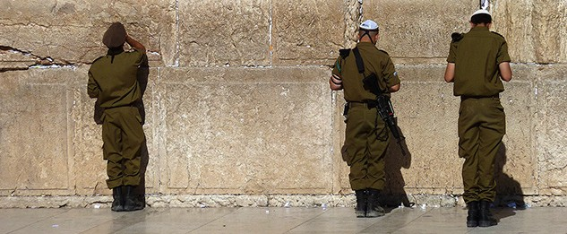

Even when nations sign peace agreements, lasting peace will only be achieved when the Prince of Peace reigns in Jerusalem. Until that time, we will continue to call upon the Lord who constantly watches over Israel, the apple of His eye. As Psalm 121:3-5 states, “...He who keeps you will not slumber.

Behold, He who keeps Israel shall neither slumber nor sleep. The Lord is your keeper…”

Thank you for your generous care and support for the people of Israel through CFI. We greatly appreciate your prayers and messages of encouragement. The Lord will surely reward you. “The generous soul will be made rich, and he who waters will also be watered himself.” Proverbs 11:25.

Linda McMurray Project Supervisor

Project First Fruits

First Fruits impacts Haifa’s believers and vice versa! (Part 1)

“After spending some time there, he left and travelled through the territory of Galatia and Phrygia, strengthening and encouraging all the disciples” Acts 18:23 (AMP).

The highlight of this past month for the project was a 4-day excursion to Haifa with my wife Marcia (the Hope for the Future project supervisor) where we interacted with congregations, amutahs, and individuals on behalf of CFI Jerusalem…those were only the official interactions! We were introduced by Director Eric Benson of House of Victory to two additional faith-based neighbors that he has. CFI will be looking for opportunities to partner with both in the near future.

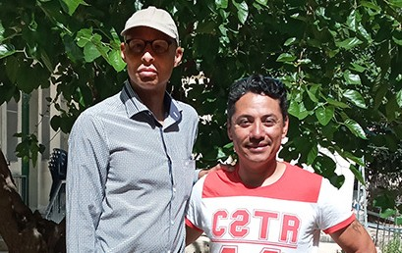
OM is a Christian outreach long established in the land to all communities and currently helmed by a young Colombian named Didier and his family. They distribute literature to every type of community in the land regard- ing the gospel and are quite courageous to spread their message and try to act as a support mechanism for congregations and fellowships in the land. I indicated to them that we have Spanish speaking volunteers on staff that I will connect the family with, which was a message of great encouragement for them.

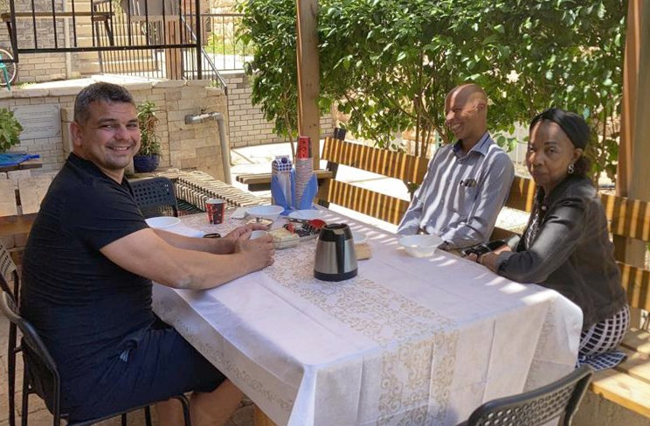
In a large property right across the street overlooking the view from Haifa to Lebanon, I met with Max from Ukraine, who was recruited by Israel for his Olympic level wrestling abilities. He experienced
a career ending in injury and sought the voice of Father God. He has since established Beth-El a men’s drug rehab shelter, a hostel for international tourists, a small Russian speaking community group of believers and has even become a refuge for Palestinian women escaping bad situations in the West Bank and Syria. His testimony regarding Aliyah to Israel was quite inspirational.

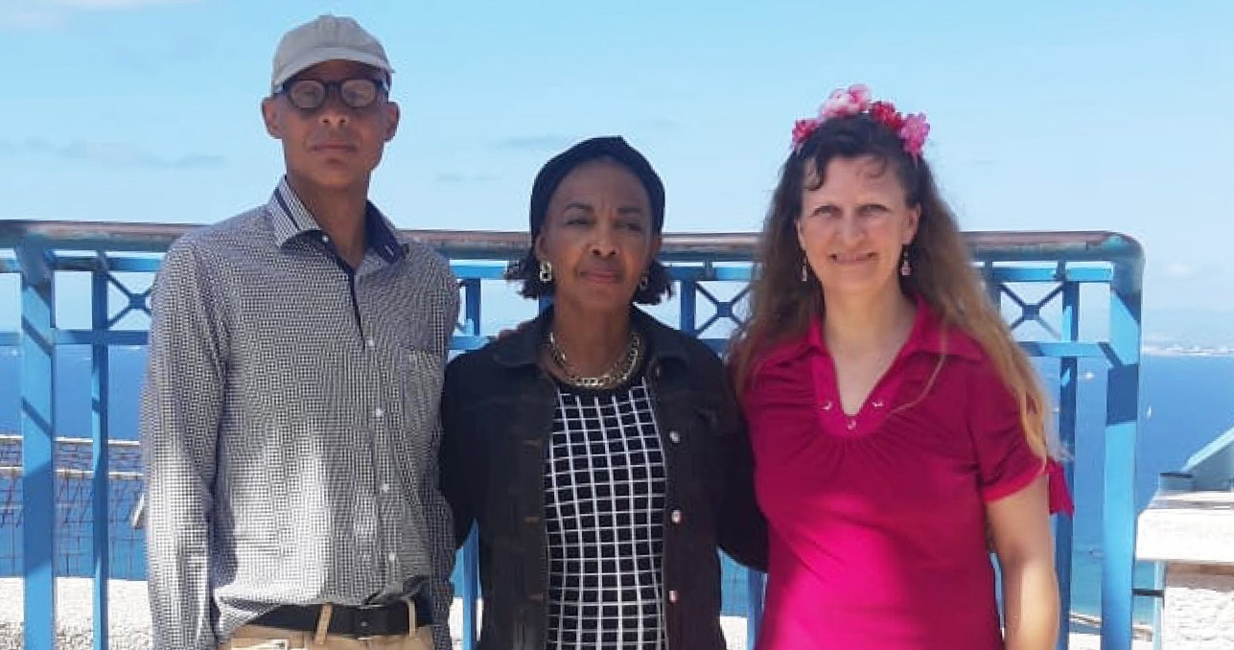
“For it is not [intended] that others be relieved [of their responsibility] and that you be burdened [unfairly], but that there be equality [in sharing the burden]” 2 Corinthians 8:13 (AMP).

We also shared a meal with Karin, the Danish administrator of HOV, who will re-locate to Jerusalem in July and her Russian husband, a recovered alcoholic
and former IDF tank operator, with a strong

burden for secular Russian speakers. We plan to help them with their transition, via CFI and others that feel they have an assignment to the people and the land.

With COVID restrictions lifting, CFI and other faith based service organizations in the land will once again be able to welcome new boots on the ground to help honor God, by serving the people of his land.

I do not have enough space in this month’s report to even touch on many of the highlights, so I will prob- ably feature them next month. We were not idle during the months of lockdown and we pledge with your monthly prayers and steady financial support to strengthen our covenant relationships with believers in Yeshua in the land and to operate in like manner within all our CFI projects.

Kim Brunson Project Supervisor

Project Hope For The Future

The Heart of Ethiopian Family “Honor”

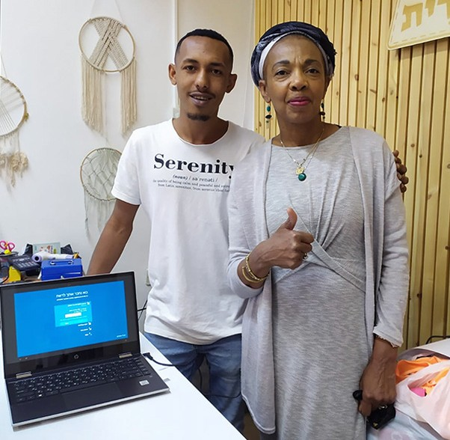
The percentage of single-parent homes within the Ethiopian Israeli community of families is exceptional- ly high, approximately 25% in 2020. This is more than twice the ratio of the single-parent families in the Israeli population as a whole. While families in two-parent homes may not experience some of the same struggles and uncertainty about children working and supporting the family unit, all families have been subjected to the need for the children to become significant contributors to the income and wellbeing of the household. A single mother will depend on that older boy to help with all the family’s financial bur- dens. The mother will expect this son to put all other priorities aside until the son’s duty is satisfied. This stems from their love of the Torah and the cultural mandates passed down through multiple generations. “Fathers, do not exasperate your children: instead, bring them up in the training and instruction of the Lord” Ephesians 6:4.

This month, two of Hope for the Future’s clients fell into the category of having to honor their parents with substance, while they could not really support themselves adequately. One of our recipients has no children, is single, and is presently studying at Tel Aviv University. This young man had presented himself as
a studious and a hard worker. I discovered, after much-needed paperwork and administration, that his financial statement did not match up. After inquiring about the inconsistency, I was informed that Abavora had to take care of his mother and family for a year, making him unable to pay for his college tuition. Due to a medical discharge from IDF, I deciphered how he manages to be caught up enough to remain enrolled in school. Because of his strong
work ethic, dedication, and hard work towards his degree, he made it happen; thus, we felt an urgency to assist him in purchasing a much-needed laptop. After a few bids, Hope for the Future decided to buy the laptop for him. After I had a glimpse of the long math equations Abavora had to calculate in his mathematics class, I am confident that this laptop will be put to good use!

“A wise son brings joy to his father, but a foolish son brings grief to his mother” Proverb 10:1.

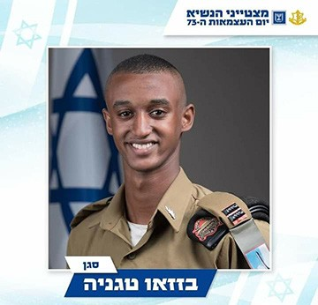
A “shout out” to our Beni Brak friends and one of their own students, Bazazo Thaganya. This young man began to learn with WIZO-Pardes Katz while he was still in grade school. He received a Presidential award on Jerusalem Day!
His mother was a recipient of food vouchers, as she works and cleans. She has such a great smile! Two years ago, she was despondent; her mother was in Ethiopia and had not been released to come to Israel; now, after many prayers and tears, she lives in Beersheba, having received her desire to be in Israel.

“Children are a crown to the aged, and parents are the pride of their children” Proverbs 17:6

We give thanks for the goodness of God as we pray and honor those that we can bless at CFI!
Marcia Brunson Project Coordinator

