CFI Projects Monthly Reports for
International
Representatives

Dear CFI International Representative Family,

Thank you for your continued support of the Outreach efforts of Christian Friends of Israel. We continue to strive to encourage those in need and to offer practical assistance during times of struggle. It’s during these times when relationships can be formed which please God and allow us to show Compassion to those who need it the most and have possibly never experienced it before.

During this time of global pandemic, we continue to offer assistance as we are able, and we know each passing day may allow for additional hardships, but we also know the God whom we serve. He is more than able to protect, and provide and heal. We are willing to represent Him to the people of Israel.

Please receive the CFI Outreach electronic updates as a reminder
of the impact each of you have in the lives of so many. We are grateful to represent those of you in the Nations - to those in the Land of Israel.

A friend loves at all times, And a brother is born for adversity.

Proverbs 17:17 (NKJV)

Project Forsake Them Not

“Rejoice always. In everything give thanks…” (1 Thessalonians 5:16, 18a). What a wonderful commandment the Lord has given us – to rejoice with grateful hearts in everything, to rejoice in the fact that He is our God and we are His people. I believe joy comes with a grateful heart, a heart that remembers the goodness of the Lord and recounts His marvellous deeds.
A joyful heart is the will of God for His children, and we can see it very clearly in the scriptures. As we entered the fall feasts of the Lord in September, we entered a time of rejoicing, a time of remembrance of wandering in the dessert and entrance into the Promised Land.

Unlike any other year, this year we couldn’t celebrate Rosh HaShana, the Jewish New Year, or the Feast of the Booths, Sukkot, together with our precious holocaust survivors, as Israel entered a three-week complete lockdown because of COVID-19. Nevertheless, we were able to make many phone calls, and even had a Zoom meeting to celebrate Rosh HaShana together with active members of the Association of the Ghetto and Concentration Camps Survivors. What a wonderful time we had, filled with laughter and many warm greetings. We even ate apples dipped in honey, representing a sweet year ahead.
Where there is joy, there is hope. It was wonderful to see how people’s spirits were lifted up, eyes bright- ened and how joy victoriously defeated loneliness and hopelessness.
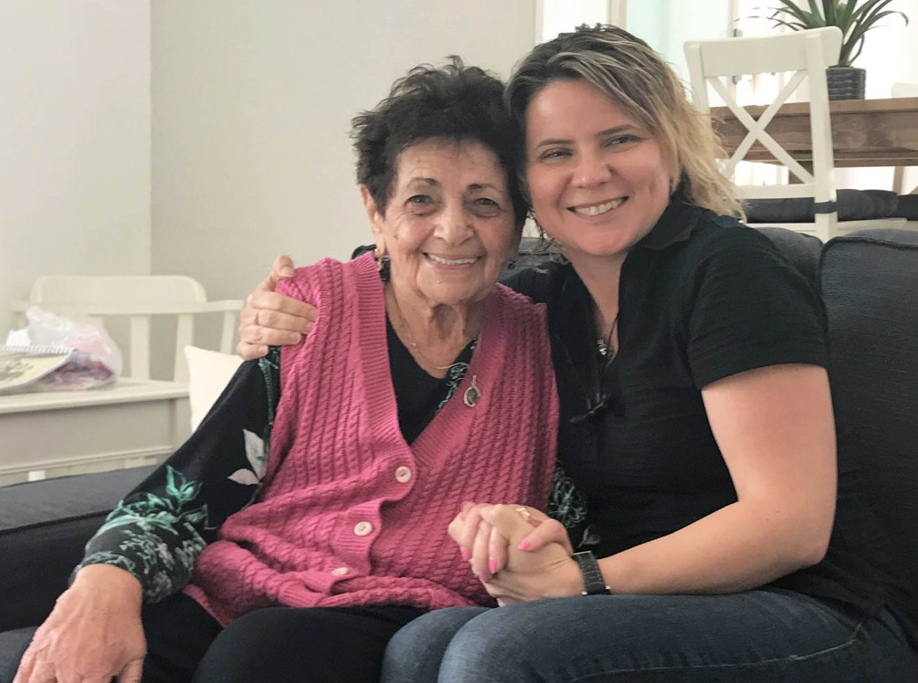
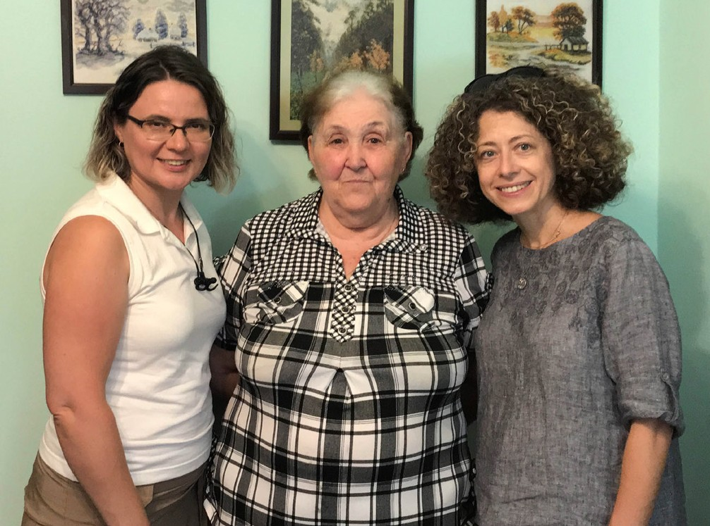

We also had some wonderful visits before the lockdown, when we witnessed the incredible power of joy and thankfulness in the lives of the holocaust survivors, the power that keeps them alive and inspires all those around.
Tamar turned 92 in March. Being an Auschwitz survivor, she lost her entire family in the Holocaust. Newly married, she and her husband Gad came to Israel in the early 1950s and helped to build the country through many challenges and losses. Only three years ago Tamar’s house burned to the ground, depriving them of many precious possessions. The house was rebuilt, but Gad never moved into it – he passed away shortly after the fire. We never saw Tamar in despair or tears, but just the opposite. She chooses to live and is thankful for every good or bad day. The earthly treasures seem of no real value to her; she appreciates them when she has them, but doesn’t mourn when they are gone. Tamar is a mystery even to her children, who admire her ability to smile and rejoice daily. Our last visit with Tamar was just a few days after she had a heavy fall on the hard floor. She was in pain and couldn’t walk, but still so excited that we came all the way from Jerusalem to see her! There was truly no limit to her joy and happiness. She appreciated the attention and fellowship more than the gifts we brought. She never stopped smiling. What a joy it was for us to visit Tamar again. Yes, we did rejoice together!

As a team here, we want to say THANK YOU for helping us to reach out to the Precious Holocaust Survivors in the sunset years of their lives. We are grateful for the opportunity to lighten their desire to live and to bring joy and hope into their lonely hearts. THANK YOU for making it possible for us to rejoice with His precious people. May the Lord fill your hearts with His joy and hope during this uneasy season. Let us rejoice in Him together.
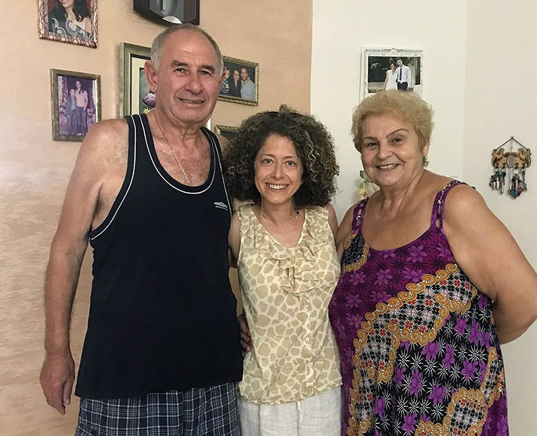
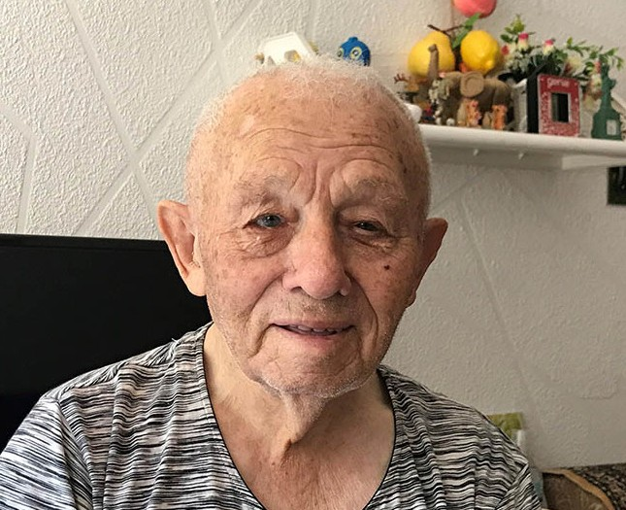

“Rejoice with those who rejoice, and weep with those who weep” (Romans 12:15).

Olga Kopilova Project Supervisor

Project Open Gates

Shalom and blessing from CFI distribution center!

Our last visitor before the lock down was a new emigrant from Poland. His process with the documents was long and complicated, but with God’s help he made Aliyah one month ago. This young man was very thankful to get the food vouchers before the Feast time. We don’t have a lot of men’s clothing at the moment, but to my surprise this happy visitor found many good-looking items for himself. I saw and understood that a grateful attitude about things and situations can make miracles ☺. That day we also had nice bedding items, which somebody had brought in. Our friend took sheets and pillow cases to his apartment. I invited him to come back in a month, and I am sure that he is more than willing to come. He
needs help and support with his first steps in the Land, but he trusts in the Lord. It is great that we can be an answer to his prayer as well.

I am happy to tell you that we will have a container coming from the States next month. It means that we will have a lot of clothes to give to people for many months. This is an answer to prayer! Even if we can’t receive as many visitors as we used to, because of the restrictions, a lot of individuals will be blessed
by our distribution center. I have the privilege to see it with my own eyes. There have been phone calls already. At the moment we are not allowed to make appointments, but I hope that the situation will change soon. People still want to come to our place.

This week I have been sorting things and making a better order in our storage room and in the shopping area. It is good to use this moment for cleaning the place. Some extra items, we will use to donate to other ministries. For example we are able to give excellent baby clothing to an organization, which is helping needy mothers with their challenges with the pregnancy and their newborn babies.

May the Lord use us in this place He has put us. May His light shine through us wherever we are and whatever we do. Thank you for your prayers and your willingness to be part of this good work that we are able to do in the Land. The Jewish people are coming back to their homeland, and it is great to be a blessing to them. Thank God for His goodness!
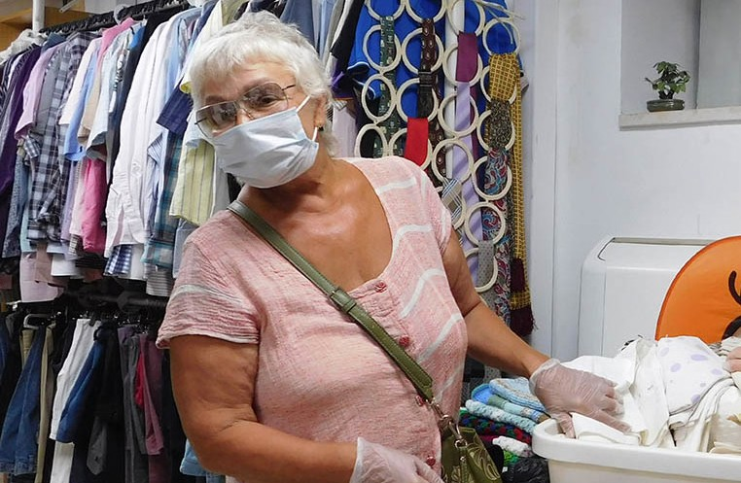
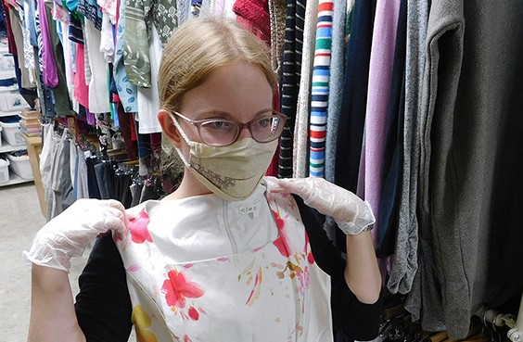

” … Thus says the Lord God: Behold, I will take the people of Israel from the nations among which they have gone, and will gather them from all sides, and bring them to their own land; and I will make them one nation in the land, upon the mountains of Israel…” Ezekiel 37:21-22

Tiina Danilevski Project Supervisor

Project Bridal Salon

Shalom ubracha, all our friends from the nations!

The CFI Bridal salon has been closed because of the lock down. It is not allowed to make appointments yet. Everything here in the Land is under a question mark at the moment. It is difficult to plan weddings or other celebrations this year. Israelis love to have big weddings. I understand that many future couples are still waiting for a better season to plan their day. Only one ‘bride-to-be’ contacted us this week.

But we are ready to serve them, when the time comes. I believe that it will be busy again over here. Many people have challenges with their finances at the moment. It is great that we can offer good wedding gowns for future brides and grooms. Please, pray that the Lord will give us more opportunities to bless the families of the Land. Pray, that He will be seen through us, so that our clients would understand that it is all about Him. We are here serving them, because He let it happen. The dresses, shoes, jewels and all the other items are here, because the Lord put in somebody’s heart, willingness to donate these things for the use of the brides of Israel. May the CFI Bridal salon continue to be available for His use!

Thank you for coming along side us!

Tiina Danilevski Project Supervisor

Project Hope For The Future

Flowing in the Agape Love

Our days are numbered as word says, “Man’s day are determined, you have decreed the number of his months and have set limits he cannot exceed“ Job 14:5 KJV.

Every essential request we receive from the families or individuals who are experiencing untimely hard- ship, establishes a narrative of the call on Christian Friends of Israel’s purpose for being in Jerusalem, the city of the Great King. Every day that we are in the office there is a phone call from a client that testifies to the difficulties many Ethiopians are experiencing in the land. We have to address each case a step at a time, and day by day. Our biggest objective is to see the whole picture and apply Abba’s agape love in each scenario.

Many families living through this season come to us through organizations unable to fulfill their material needs. For example young mothers who decided to give birth to their children only to face trails, being unable to provide bare necessities for the family. We know that our name Christian Friends of Israel gives us amble opportunity to show unconditional love at times when finances cannot satisfy all the needs these families may have.

One of the families, that we reached out to before the festivities connected with the High Holy Days, had such great hardship. They have experienced unemployment since March, and an unplanned addition
to the family! We have no idea how certain circumstances flood the lives of good people. What is within our power to do, we will do by being sensitive and showing agape love. We did bend over backwards a little; I made a personal trip on the lite rail to obtain information for this family to get diapers and other baby items. I was also able to connect them with another agency that could do more for them than we could, on that day and at that time. Our hopes are that their days, though imprinted by such hardship and despair, will be redirected by experiencing the Lord’s best for them! Please join us in prayer for the many families affected during this time of need with only the bare necessities; prayer that will make a difference. While this can be somewhat unnerving, the bigger picture only gives us satisfaction that we have indeed made a difference. One of the women, a part of our “sowing seeds,” contacted me at the last minute indicating that she needed help with food for the two weeks of Rosh Hosanna and Sukkot. I felt this need very personally, because I know that she is a dutiful worker. Her son broke his foot and was unable to get clearance to return to IDF duties. She also has a pre-teen living at home so with one day left to help her get an application in, we had the food voucher in her hands before the close of the day! Even a day earlier than expected! Thanks to the agape love, from the heart of our directors, we were able to facilitate good will to those in need. With social distancing restrictions upon us, I was able to present her with the vouchers in the central bus station’s atrium.

Hope for the Future’s mandate is to make a difference where we can. It is within our operation to see the heavenly flow of agape love into hearts and lives of God’s first-born, Israel!

Marcia Brunson Project Supervisor

Project First Fruits

“The LORD, a Provider and the One Who Rescues Me” Psalm 34:1 (AMP).

This past month prior to the Fall Feast days, the Israeli government imposed a lockdown similar to the one that was imposed prior to Passover this year. Despite having to work from home from late September to Mid-October, the project was able to remain productive in our benevolent support for a wide range of believers in Yeshua in the land once again. Previously, we had assisted a couple in Rishon LeZion with food vouchers and an auto payment. We followed up by assisting the husband with obtaining the needed industrial tool supplies, for him to work in his own business properly and more efficiently in the community. This type of investment is also empowering to a head of household who has suffered loss due to injury,
COVID and persecution for his belief in Yeshua. The family is now back on track to be completely
self-sufficient. We were also able to provide rent for an Arab Orthodox family that resides in the Shurafat section of the city. Pending a painful divorce, a lady is residing with her elderly parents and lost her main income along with others in the hotel industry, affected by the loss of incoming tourist revenue. Beyond this, based on her skillset and being fluent in both Arabic and Hebrew, we believe we have set her on a course for one or two positions that will bring future prosperity and influence in the nation as a believer. We were also able to provide supplies for the gardening vendor of a new women’s shelter house in the Beersheba region of the nation. This garden will not only have aesthetic value, but will serve as part of the inner emotional healing that many of the women residing in the home need, following spousal aban- donment or physical abuse situations. Sometimes these situations occurred because the wife came to faith in Yeshua or was determined to enter the workforce, or obtain additional training or education to enhance the quality of life for their children, and were discouraged or prevented from doing so. This garden will be growing a lot more than plants or vegetables.
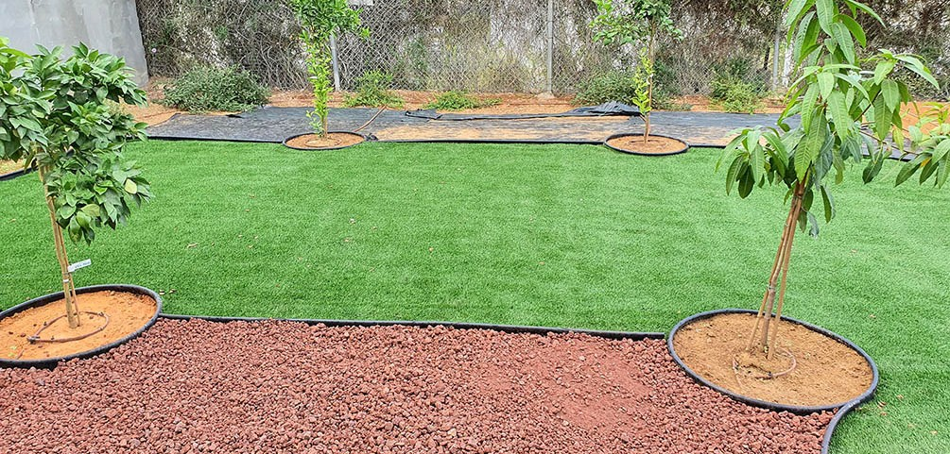

“And other seed fell into good soil, and as the plants grew and increased, they yielded a crop and produced thirty, sixty, and a hundred times [as much as had been sown]” Mark 4:8 (AMP).

As we were released from this Rosh Hashanah/Yom Kippur/Sukkot lockdown, while visiting a ministry family who completed Aliyah from Brazil who we will feature in our next report, we were able to catch up

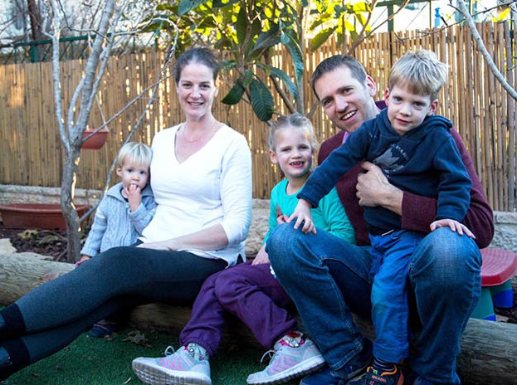
with the Bakkers of Tsur Hadasseh. Last year, in what was a major national news story, the mother of the family lost her father while he was trying to protect her mother from a counseling patient who apparently had a psychotic break.The grand- mother resides in the family home now and has recovered from her injuries. This family, (which includes 2 of 4 special needs children) seems to have soldiered through their grief. We enjoyed a hearty Shabbat dinner and I was able to renew some of my grandfather activity with their children at the local playground! First Fruits cultivates relationships!

It has been your reliability as donors, volunteers and intercessors that allows us to support and interact with this diverse set of believers from Hungary, Great Britain, the Netherlands, the former Soviet satellite nations and native born Israelis and Arabs! We are privileged to partner with the Father of all, in the care of His creation!

“Through [skilful and godly] wisdom a house [a life, a home, a family] is built, and by understanding it is established [on a sound and good foundation” Proverbs 24:3(AMP).

Kim Brunson Project Supervisor

Project Under His Wings

Shalom Dear Friend of Israel,

“…to bind up the brokenhearted…” (Isaiah 61:1).

Shortly before we entered the second lockdown in Israel, I was scheduled to receive three terror victims in our office, as home visits were prohibited. Listening with understanding to the suffering and plight of the victims of terror attacks, builds trust and then it enables them to open their hearts to God, allowing Him to work.

Avraham came to visit Israel from his homeland in Iran when he was a teenager but he was stuck here because of war and ended up settling in Israel after he met his wife, whose family made Aliyah to Israel also from Iran. But they were disowned by her parents who opposed her marrying Avraham, as they demanded that she only marry a man who was from a wealthy family and of similar social standing to their own. Avraham suffers post trauma because of a terror attack, and his wife has cancer so that both of them have been unable to work. With no support from both of their parents in this time of need, life has been harsh and very difficult for this family. Avraham thanked Project UHW for being a great support to him and his family when he had no one could turn to.
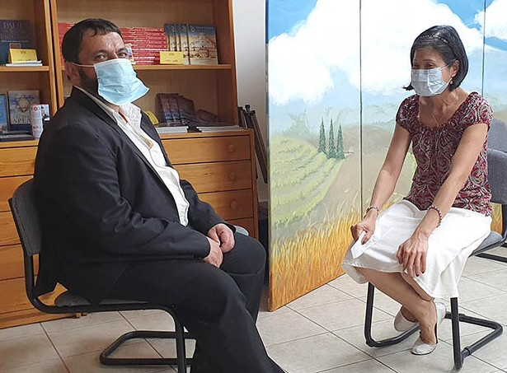
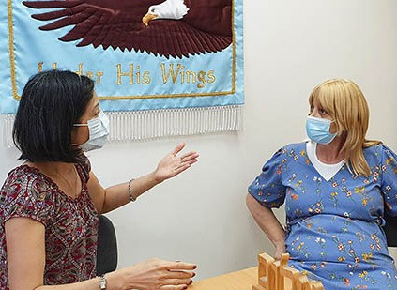

Vickie is a mother who was very broken, as her son Avi became mentally ill, caused by a terror attack which he went through. Yet praise be to God who is close to the brokenhearted and has bound up Vickie’s wounds via the ministry of Project UHW (Isaiah 61:1). Let us stand with Vickie through prayer, interceding to God for Avi’s healing and restoration.

Eli was the third person who was supposed to come to our office for an appointment, but the meeting had to be cancelled as he was infected with Covid 19. I prayed for Eli’s recovery and I will visit him at an appropriate time.

I thank God for blessing Project UHW with supporters like you. This Project would not be able to do what it has been doing, without your support and prayer. The Lord bless you and keep you and your family during this challenging time, which has turned the whole world upside down.

Project Communities Under Attack

Dear Friend of Israel,

“Whoever is generous to the poor lends to the LORD, and he will repay him for his deed” (Proverbs 19:17).

The first national lockdown in Israel, caused by Covid 19 started in March and lasted for about two months, during which the Israelis were not allowed to hold the Pesach (Passover) feast nor have mass gatherings, as the Israeli government was trying to contain the spread of this virus, and we were working from home.

At the writing of this CUA update, we are working from home in a second lockdown, as the infection in Israel has skyrocketed, with infection numbers reaching as high as over 9,000 on some days, so that Israel has one of the highest infection rates in the world, for the size of its population.

Praise God that Project CUA was able to provide Sukkot food vouchers for 55 ‘rocket victim’ families in the South of Israel before the second lockdown. The recipients were very grateful for this help and blessing for the Sukkot holiday. There are as many as 120,000 Israelis registered as unemployed, and the government help has been hindered due to bureaucratic procedures; so many have been in a dire financial situation.

This much-needed help, has meant a lot to victims of rocket attacks. In a time like this they have to cope, not only with the stress caused by the Covid 19 pandemic, like the rest of their fellow Israelis, but also the trauma and danger of attacks from Gaza, with the continued rocket fire into their communities, in South Israel bordering Gaza.
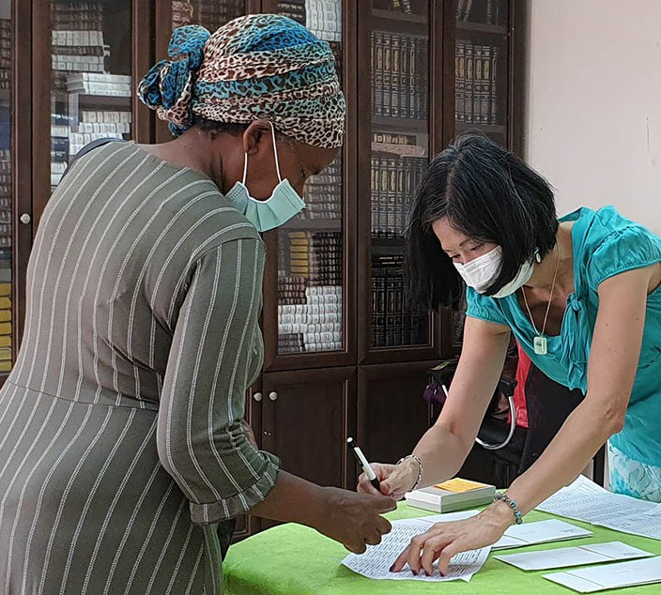
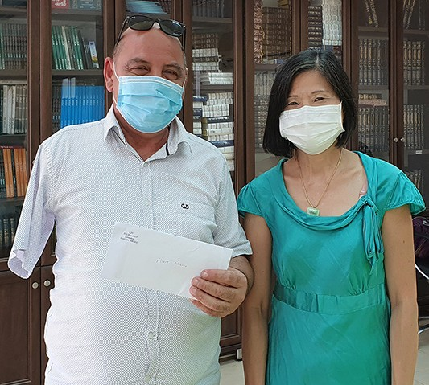

Thank you so much for your generous support for Project CUA, the Lord bless you according to His promise in Proverbs 19: 17.

Project Wall of Prayer

REDEEMING THE TIME

“Look carefully then how you walk! Live purposefully and worthily and accurately… making the very most of the time [buying up each opportunity], because the days are evil...be...understanding and firmly grasping what the will of the Lord is” (Ephesians 5:15-17 AMPC).

Sometimes the Lord uses circumstances that we perceive as delays or detours to lead us into experiences that we may have otherwise missed. The Israeli government mandated a second lockdown which spanned almost two-thirds of the month of October. Most businesses were closed, and travel was restricted to 1 kilometer – except to buy food or medicine. Those limitations sound very confining, but God knows to how to use even times of restriction to accomplish His purposes.

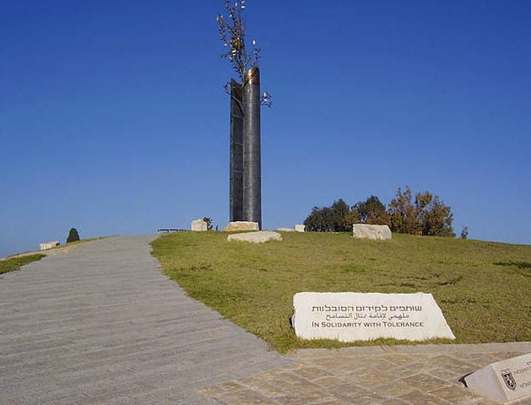
Some of the CFI Jerusalem staff live in close proximity to one another, so a group took advantage of this time to research places of significance within our own vicinity. What a surprise it was to learn that we live within 1 kilometer of the local United Nations complex and the Tolerance Monument!

Despite our daily travels through the neigh- borhood, we had never gone up the big
hill to discover what was on the other side. Now that there was time to investigate our area, we prayerfully took advantage of the opportunities. Our walks in Jerusalem were precious times of “praying onsite with insight” as we worshipped, interceded, and declared
God’s Word over Israel praying to the north, south, east and west. Each walk revealed areas of amazing significance right in our area! As we walked and prayed, both our spiritual insight and our love for Israel grew.

This second lockdown was not a waste of time. It was a pause in our agenda so that we could be available for some Divine prayer appointments that God had scheduled for us. “Now we know that all things work together for good for those who love God, who are called according to His purpose.” (Romans 8:28 TLV)

We are thankful for the love, prayers and generous support that you have shown to Israel through CFI. Jesus said that whatever kindness or generosity you show to even the least of His little ones will be counted as done to Him. May the Lord bless you.

Linda McMurray Project Supervisor

Project David’s Shield

“For You are my rock and my fortress; For Your name’s sake You will lead me and guide me” (Psalm 31:3).

“Be strong and of good courage, do not fear nor be afraid of them; for the LORD your God, He is the One who goes with you. He will not leave you nor forsake you” (Deuteronomy 31:6).

What a year this has been. Wherever you live in the world, one thing is for certain – we have all had a shared experience this year that is like none other. One other thing is for certain – and more importantly so – we have an unchangeable God who is stable and trustworthy; nothing catches Him by surprise.
While the above scriptures were spoken by and/or to the Jewish people, we - as those who have chosen to come alongside them and worship the One True God - can also trust in His promises for our lives.

The current defenders of Israel – just as their ancestors – rely on these Scriptures, and many others. Most at least have a Zionist understanding, if not also acknowledging their Biblical mandate in protecting this Land. While the “might of Israel’s army” is strong, even stronger is the One who goes with them. He will lead and guide them for His Name’s sake, for He is their rock and their fortress. They are encouraged to be strong, of good courage, to not fear nor be afraid of their enemies – not because of their own might
- but because their God will go with them, never leaving nor forsaking them. We give thanks that He is unchangeable, stable and trustworthy ~ Elohim Chaim, the Living God!
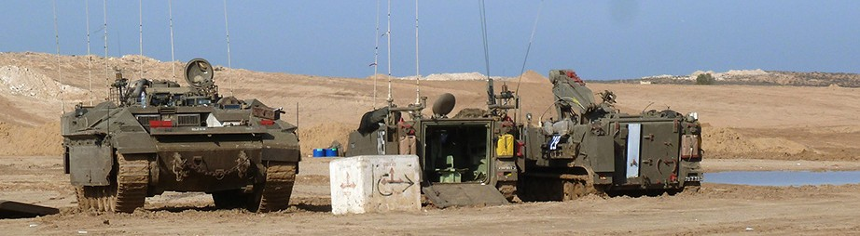

While many of us have been put on hold with our lives, the Israeli soldiers keep marching on. There is never a break from the enemy – whether that is a nation, terror group, person or virus. Project David’s Shield continues to be an encouragement in difficult times and provide items of comfort to make things a little less challenging. Some of the items gifted have been high quality backpacks for Lone Soldiers,
supplies for Reserve Duty units, GPS tactical radios for the Border Police, and food vouchers for specific Lone Soldiers.

So, we give thanks to you – our Partners in this fight against the darkness that tries to dispel the Light. Thank you for being a gift to Project David’s Shield. It is becoming less and less popular to side with Israel, as many view this as a political agenda – however, we know that what we are seeing in the natural is only a glimpse of what is really going on in the Heavenlies. We are grateful to our God who has revealed His plans and purposes for Israel – the People and the Land.

“I have fought the good fight, I have finished the race, I have kept the faith.” 2 Timothy 4:7

Jim McKenzie Project Supervisor

