CFI Projects Monthly Reports for
International
Representatives

Dear CFI International Representative Family,

Thank you for your continued support of the Outreach efforts of Christian Friends of Israel. We continue to strive to encourage those in need and to offer practical assistance during times of struggle. It’s during these times when relationships can be formed which please God and allow us to show Compassion to those who need it the most and have possibly never experienced it before.

During this time of global pandemic, we continue to offer assistance as we are able, and we know each passing day may allow for additional hardships, but we also know the God whom we serve. He is more than able to protect, and provide and heal. We are willing to represent Him to the people of Israel.

Please receive the CFI Outreach electronic updates as a reminder
of the impact each of you have in the lives of so many. We are grateful to represent those of you in the Nations - to those in the Land of Israel.

A friend loves at all times, And a brother is born for adversity.

Proverbs 17:17 (NKJV)

Project Forsake Them Not

Have you ever felt lonely? Loneliness is a prison of the heart. The COVID-19 pandemic has only added to the feelings of isolation, and has become torturous for some. Loneliness, though isolating by nature, never comes to the heart alone. It has its faithful companions like depression, anxiety, pesky thoughts and bad memories.

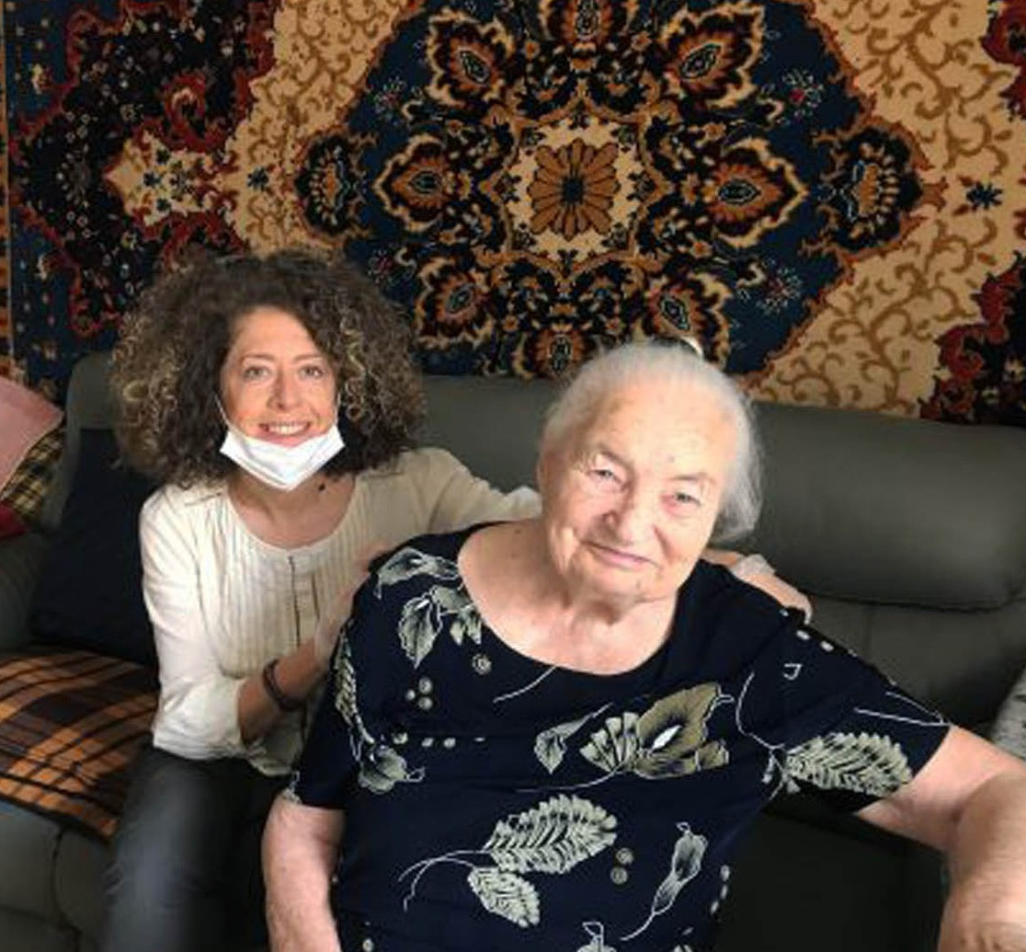
As a team here, we feel the urgency to reach out to our precious friends, the holocaust survivors, to bring the light and love of God into their daily rou- tines, even more so these days. Any expression of attention brings release and a feeling of new life. A phone call, a visit, a card of encouragement with scripture, and even a birthday card reminds them that they are not so alone after all.
“The birthday card you sent me with the words of prayer in it brought the presence of God into my day and my life. It is what we really need today.” Those are the words of the Holocaust Survivor, who called me few days ago to express her gratitude for the card we sent her. The prayer included was Psalm 139. We continue to pray that the Word of God would draw the weary hearts of His people to Himself.

Another lady also called to tell us how emotional she was when she read the words of her Birthday card, words that so deeply spoke to her heart, and made her feel so loved and cared for. It is also encouraging for us when we hear such testimonies. This gives us hope that loneliness can be defeated.
We were grateful for the opportunity to make some visits, despite the current pandemic, in order to deliver gifts and to listen to people’s hearts. We also see the change in the dynamic and character of the time spent together; our visits have brought even more depth, honesty, trust, warmth and love.

For instance, Arkady is usually very quiet, and his wife Ludmila does all of the talking. On our last visit, however, Arkady couldn’t keep it inside any longer; he needed to speak. Isolation had brought back memories that he thought had passed away long ago. In the beginning of the lockdown, somebody rang the doorbell of their apartment. When Arkady opened the door, he found a big box with food in it. Suddenly tears flooded his eyes; he couldn’t stop crying and Ludmila got really concerned. Memories of another late night doorbell in 1976 overwhelmed him. Back then he wondered who could be such a late visitor. Arkady, when looking to see who it might be, had seen a well-dressed lady. No, he did not
recognise her. She was an image from the past he possibly couldn’t remember. When he was a little boy during the war a lady from the SS police station in the Ghetto in Ukraine, almost every day for two years, brought the tiny poor Arkady a slice of dark bread – a treasure, that sustained him and made it possible for him to survive. Later he found out that she was a spy for the Red Army, and after completing her task she went back to Latvia.

Over 32 years later, in 1976, she found Arkady and drove hundreds of kilometers to see him. She needed to know that that boy survived and was doing well in life. He was indeed. Their visit only lasted 20 minutes, but Arkady will never forget the kindness of her heart. It was also a great comfort for Arkady to know,

when he saw the food parcel, that there are still people today who are ready to help those in need. And what speaks louder than bread to a hungry little boy, that still lives in that elderly man’s heart? Four hours spent together with that wonderful couple was a huge gift and joy for both us and them.
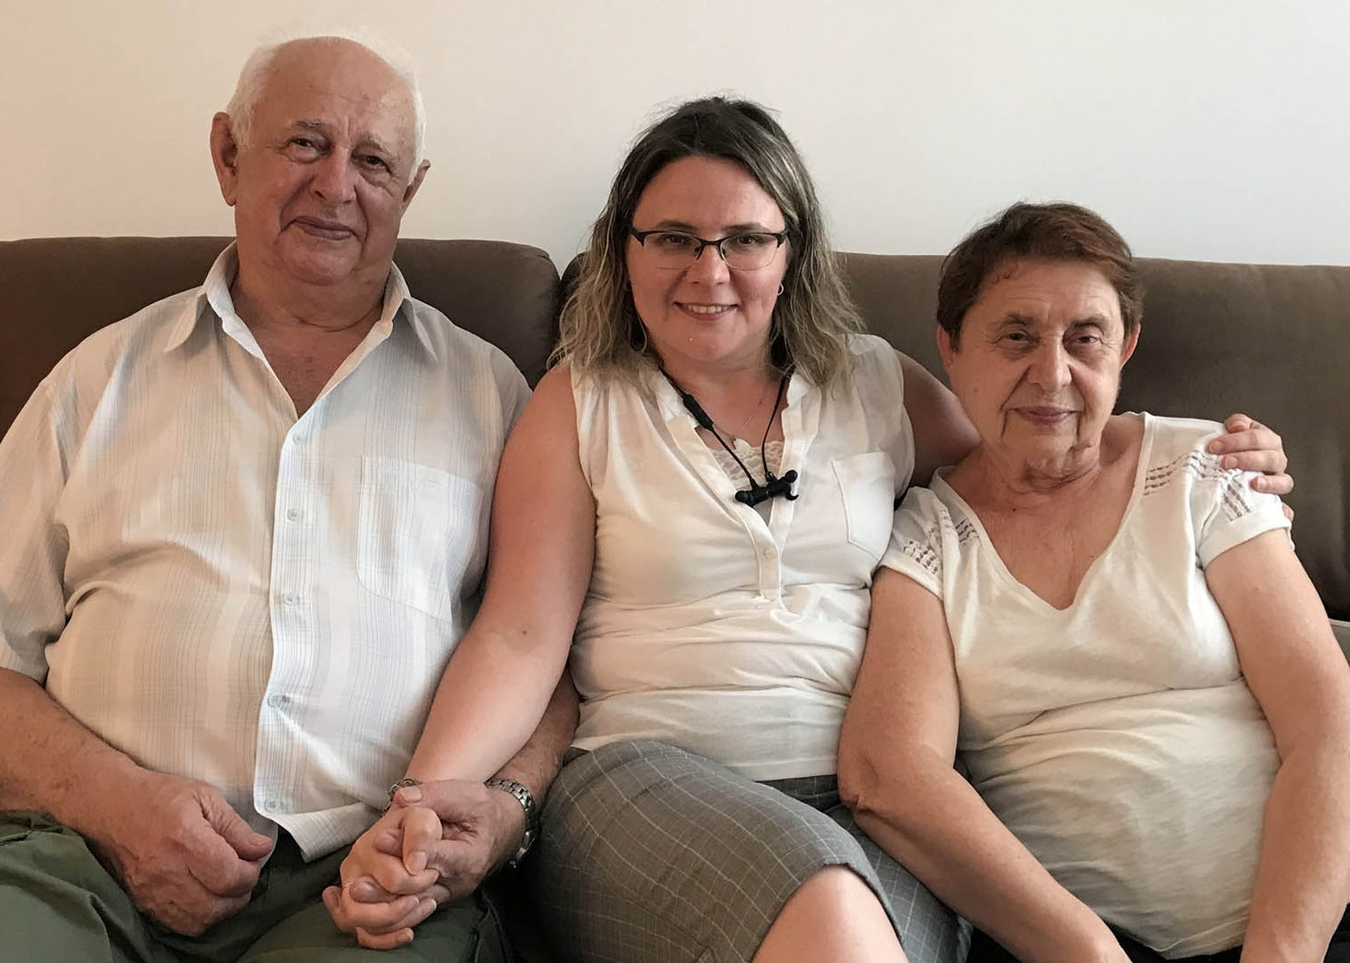

We so greatly appreciate your faithful support and prayers, as we seek to bring comfort and love that shatter the power of loneliness to the precious Survivors of the Holocaust during this challenging time. THANK YOU!

“Blessed be the Lord, who daily loads us with benefits, the God of our salvation! Selah Our God is the God of salvation; and to God the Lord belong escapes from death.” (Psalm 68:19-20)

Olga Kopilova Project Coordinator

Project David’s Shield

The Nation of Israel is ever reminded that her enemies are present and sometimes they will literally knock on her doors. Such was the case as recently as July 27 2020. The IDF thwarted an infiltration attempt into Israel by a Hezbollah terror squad. The terrorists, who were armed with assault rifles, crossed the Blue Line and were in Israeli territory before they were stopped by IDF troops.

Iran and Hezbollah, an Iranian proxy, are using Syria as a Launchpad for terror against Israeli civilians. Since the outbreak of conflict in Syria in 2011, Iran has provided significant military and financial support to the Syrian government led by Bashar al-Assad. Iran has long-sought influence over Syria, as control over Syria increases Iran’s ability to threaten Israel with attacks and its overall control in the region.

“The IDF takes this breach of Israeli sovereignty very seriously and will continue to operate to protect Israeli civilians from all acts of terror. We hold the government of Lebanon responsible for all activity conducted within its borders.” https://www.idf.il/en/

CFI and Project David’s Shield continue to seek opportunities to encourage and show support through affirmation of the IDF mission and by conveying to them that prayers from the Nations continue to be offered up for wisdom and protection as they defend the very existence of the State of Israel. A God mandated existence…

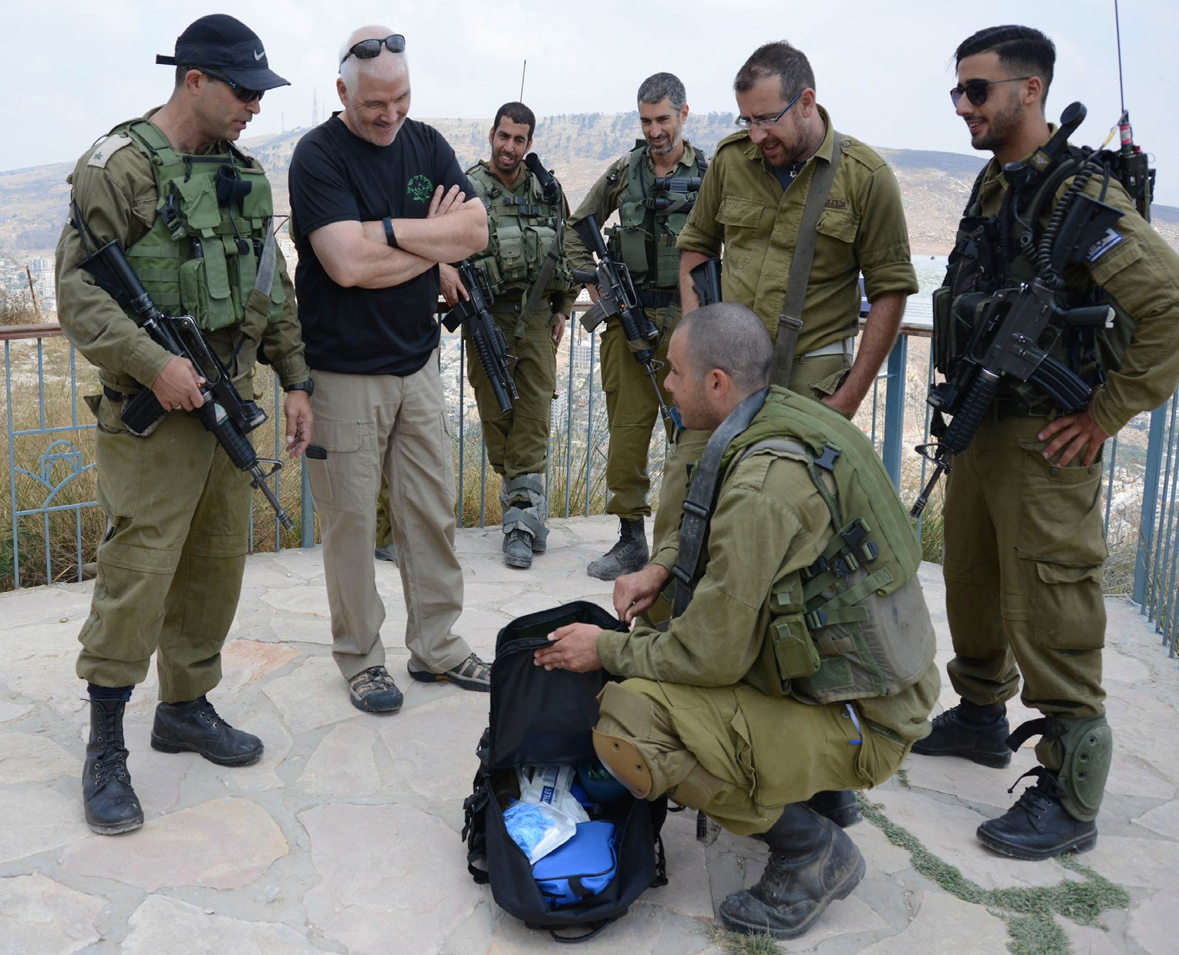
Recently, we were able to provide tactical communi- cation radios to a Border Patrol unit that is tasked with Special Operations. Some of the new features and technical advantages that these radios provide will result in a much higher level of security than current models allow. This request came directly to CFI and highlights the trust and appreciation that the defenders of Israel place in our relationship.

It’s solely due to the giving and support and prayers of those in the Nations who agree with God’s plan to restore the Jewish people to their land (Ezekiel 36:8,24).

Thank you for your blessing Israel.
Jim McKenzie Project Coordinator

Project Open Gates

Greetings from Jerusalem!

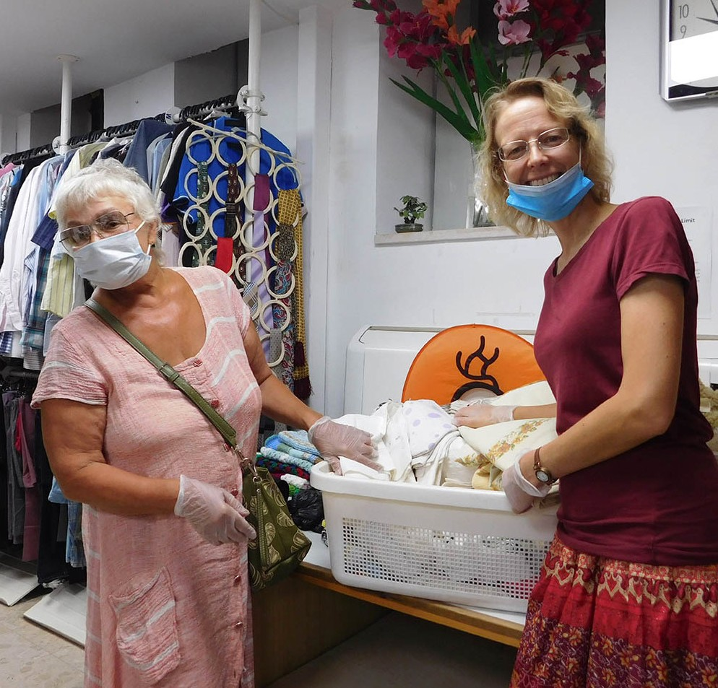
It has been busy at our CFI distribution center. I get a lot of phone calls every week. New emigrants want to have an appoint- ment and come to take clothing for them- selves and for their families. It is interesting to meet them and get to know about their lives, especially now during the Covid 19 period you can hear interesting stories.
Sometimes we are in a hurry trying to find good clothes in 30 minutes and we don’t have time to talk about our lives, but some- times the clients share about things they are going through. One family from Russia
made Aliyah in June 2020. They had to be in quarantine for two weeks. They were given a room in a hotel somewhere near the sea. They could not leave the room until the two weeks were over. With a little child it was not so easy to be in one room for so long a time. Fortunately for them there was a little bal-
cony included in the space, so they could “go out” and see the sea. One of the first things that the family did after their quarantine was to go to the beach.

Yesterday there was a young woman visiting the DC. Fernanda made Aliyah from Brazil in January 2020. She took only the warm clothes for winter with her, because her aunt was going to visit her during the springtime. The aunt should have brought suitcases for Fernanda already packed with summer clothes, but because of the corona everything changed. The aunt’s visit was canceled and the summer clothes stayed in Brazil. It is impossible for a new emigrant to buy the many new things needed during their first period in the Land. Thank God that Fernanda knew about us. She came and found good garments for herself. Thank God we still have plenty of shorts, dresses, tops, t-shirts, especially for young ladies like her. Fernanda was thankful and surprised at how many good clothes she was able to find at our place. I was happy too. It is a great joy to see how we can bless the Jewish people as Christians. It was some- thing so real, what happened here yesterday with Fernanda.

Rivka Sara was another new emigrant from Brazil who was blessed by us this week. She made Aliyah in March. You could see that she didn’t have many nice clothes to wear. When I offered her some dresses and other garments, she was more than happy to receive them. “This is so beautiful! I love this,” she said many times. Rivka Sara found good shirts, good skirts and many useful items for herself. She is a religious lady, but in spite of that she wanted to be helped by Christians. In these kinds of cases I would like to give people much more than we have here. Let’s pray that the Lord will make a way for different Christians to do good in this Land. Let there be more opportunities to bless His people in practical ways. I am happy to have a little role in God’s big plan of blessing here at our Distribution Centre, and I am doing this with you, my brothers and sisters in the Lord.
Tiina Karkkainen Project Coordinator

Project Bridal Salon

Shalom, dear friends and coworkers!

We have had interesting people coming to the Bridal Salon lately. I feel that the Lord is using us to encourage His people by this specific service.

Last week there was a tall Israeli lady looking for a wedding dress in our salon. She was unsure, when their wedding would be because of the corona situation. She tried on different options. The last one was the best. Many times you just feel, that this is the one. So did our new friend, Alona. We found a beautiful veil too and a head piece for her. I put everything aside. Next day she called and told me that their hupa was going to take place the next day. She came in to pick up the dress and she was so thankful to us.
We received some pictures from Alona right after the wedding. Thank God that we were there to provide her with a good looking wedding gown just in time. Many people confirmed that she looked stunning in it.

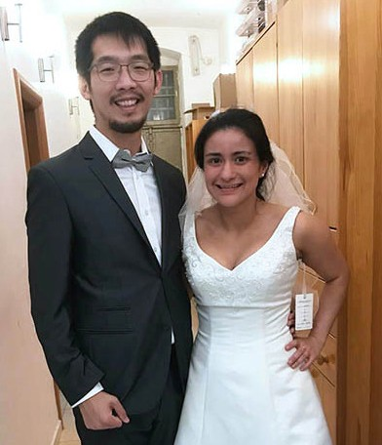
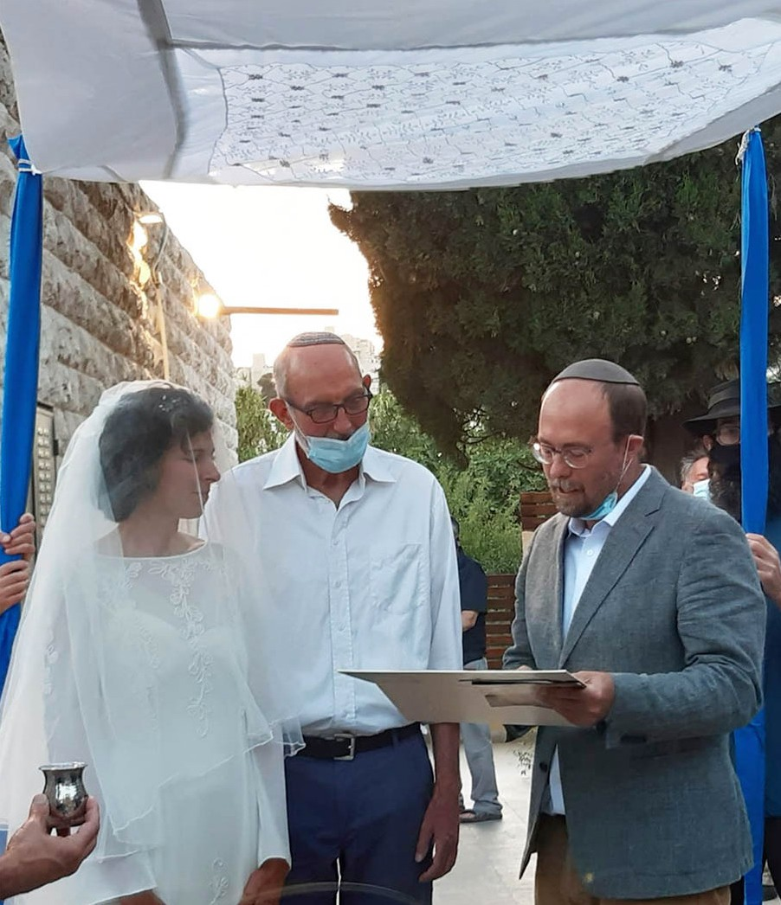
This week there was a couple from Haifa looking for wedding gowns in our Bridal Salon.
They are students who decided to get married this special year, 2020. Sarah could not so quickly decide which dress to wear, so she took two dresses with her. Amos found a good suit for himself. I am happy that they didn’t need to spend more time or money to find their wedding clothes. We are a blessing for many people.

I myself got married at the end of June. I found everything that I needed at our place: The dress, the bolero, the shoes, the necklace and the veil – everything was from here. Thank you so much for this opportunity.☺ Also my husband used our services and found his suit at CFI Bridal Salon, as I wrote to you some months ago. We are now a happy couple starting our journey in Jerusalem. What a joy it is to have beautiful wedding pictures as a memory of our special day.
God bless you all. He is Faithful.
Tiina Karkkainen Project Coordinator
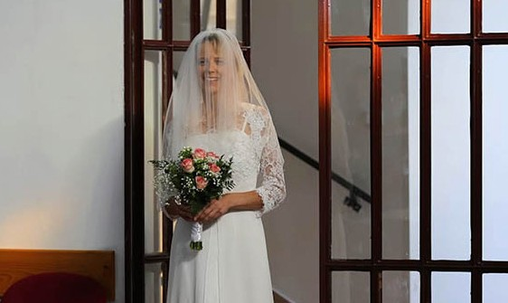
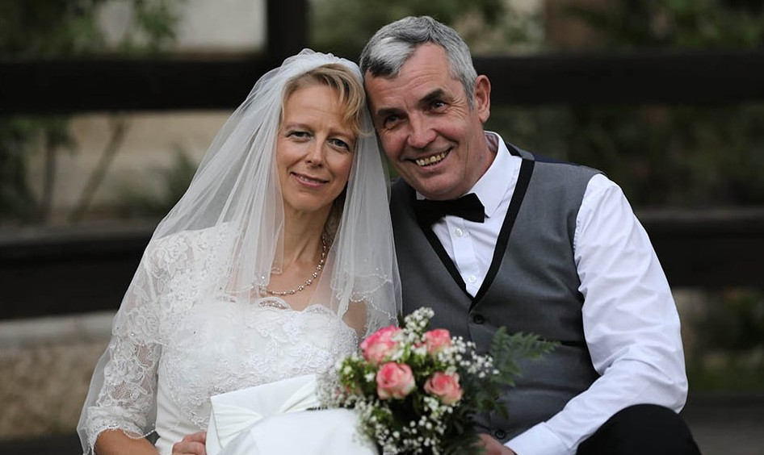

Project Hope For The Future

Grace to the Great Mountain

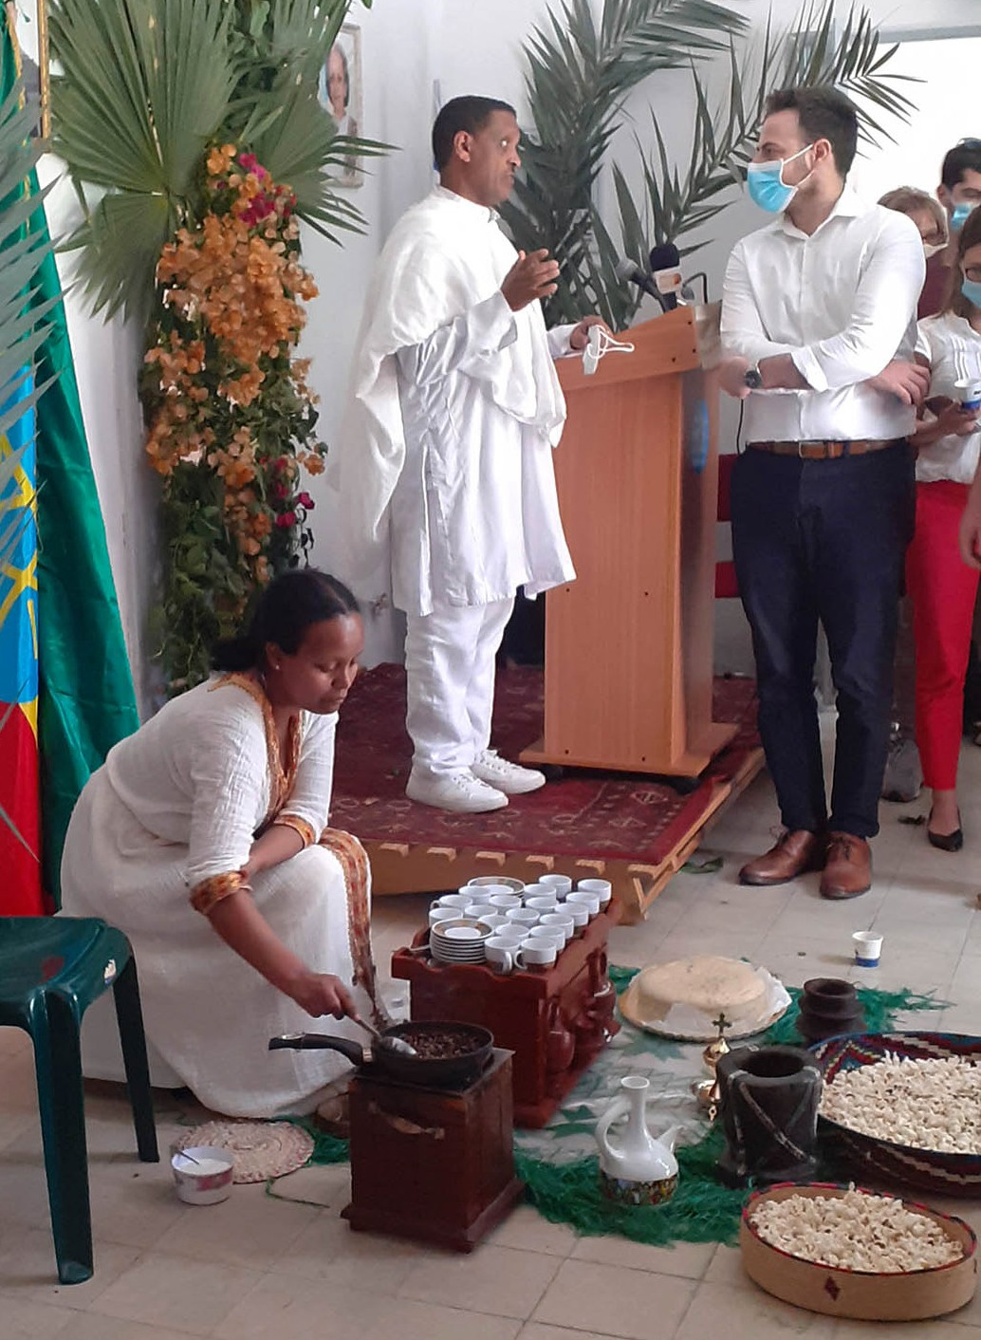
Accompanied by many Ethiopian Israeli restaurateurs and coffee bean exporters, the honorable Ambassador Rentu from the Ethiopian Consulate in Tel Aviv, did a fantastic job of educating the public on the Ethiopians’ financial plight for exports from Ethiopia into Israel. A few of our HFF clients are independent caterers who cooked delicious food for this event. The committee that set this up did an excellent job educating the audience with statistics relating to imports of coffee and existing Ethiopian restaurants in the land. By seeing and smelling the plethora
of Ethiopian bread, coffee, and cuisine, we experienced the awe-inspiring beauty of Ethiopia!

Our Hope for the Future project has a new method to help with the plight, by injecting new ideas to combat unemployment and poverty. We hope to help create opportunities! Our initial concern has been single mothers unable to sustain longevity in work with young children, and those physically unable to hold jobs outside of their homes. With careful consideration and research, an idea came to help the community, starting with a small group of women with hearts to succeed. One of the
clients said, “A lot of the younger generation lack the vision to trust small beginnings, which would then propel them into a bigger view; they are not excited about working hard or waiting for the ideal occupation.”

The concern overall is whether in its current disadvantaged position, the Ethiopian community can survive or if, in the long run, they will manage to climb up the socio-economic ladder and significantly improve their status. High mountains stand in front of many that are marginalized, unable to see beyond the significant lack.

“What are you a great mountain? Before Zerubbabel, you will become level ground. Then he will bring out the capstone accompanied by shouts of grace, grace to it!” (Zechariah 4:7)

A subsidiary project created for clients of HFF, designated the S.E.W. Cooperative Initiative as a means to constitute a new view of “Sewing Seeds” to help stimulate Ethiopian wealth. This initial effort is in the beginning stages, so please continue to pray they will avail themselves of this opportunity to be enabled to become self-sufficient, self-employed with great options to maintain the co-op for the economy of the community.

Our start-up began by identifying mothers or young women struggling to make ends meet. With the unfortunate forced global shutdown, many have experienced underemployment or unemployment. The groups hit the hardest were freelance workers, caterers, housecleaners, hair braiders, or other work obtained on an as-needed basis.

The efforts to establish an opportunity for the women began after our initial meeting. The process of purchasing the sewing machines took lots of research and many inquiries to match our efforts with

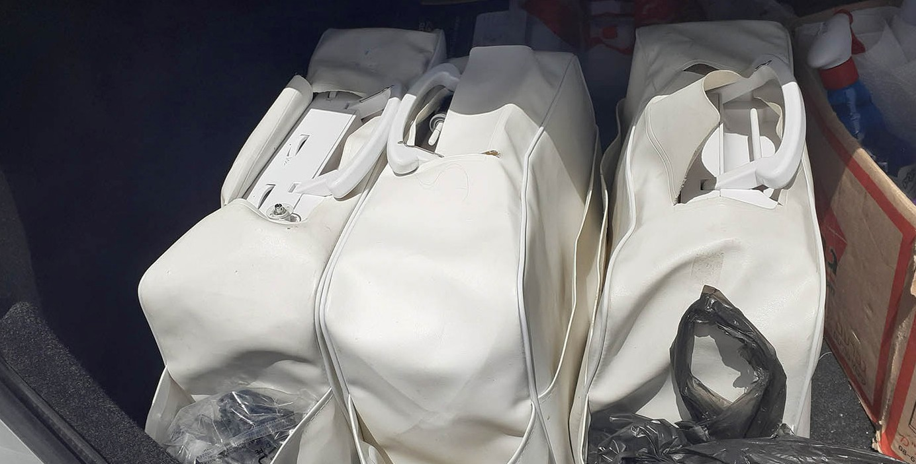

a company that would work hand in hand with us. With the help of a devoted group, we were able to buy three machines for 3000nis! Along with this purchase, we received a free tutorial seminar on the mechanics of the devices and use. We continue to be thankful for all the prayer that will surround “Sewing Seeds” this year, as this launching pad establishes new possibilities for our clients to say to “Grace, grace” to the high mountains in their paths.

Marcia Brunson Project Coordinator

Project First Fruits

And now I commend you to God [placing you in His protective, loving care] and [I commend you] to the word of His grace [the counsel and promises of His unmerited favor]. His grace is able to build you up and to give you the [rightful] inheritance among all those who are sanctified [that is, among those who are set apart for God’s purpose – all believers. (Acts 20:32)

Helping people put their lives together based on our mutual faith in God’s Messiah Yeshua, this is our heart for individuals, families and congregations in Israel within the First Fruits project at CFI. Recently, with your generous and sacrificial financial support, we have been able to provide chairs for Beresheet Revival Congregation as they took possession of their own space to worship, pray, teach and host ministry activities in Jerusalem. It is the first Hebrew-speaking majority Ethiopian fellowship in the state of Israel. With the vision of the leaders there, it will not be the last, as their intent is to expand to other localities across the entire country. CFI is pleased to help them at their inception. We were also able to interact with the House of Victory in Haifa, were we had previously provided the property with appliances for the apartment units, for men recovering from addiction. My wife Marcia (Hope for the Future Outreach Coordinator) and I were able to share encouraging teachings with the men that are residing there and afterwards, were able to enjoy a meal of fellowship with these gentlemen, who have committed to walk away from substance abuse into a path of biblical discipleship. One gentleman asked for specific personal prayer from us and exhibited a desire for a more intimate understanding of his value to God and His purpose in life; this was quite a profound interaction. There were 2 other individual ladies that First Fruits was able to assist during this period of time. One is an émigré from Ukraine who is attempting to leave an abusive relationship via divorce, whose husband is actually incarcerated due to the violent episodes. She has been able to receive food assistance for her household, which includes a severely handicapped child and legal fee support to secure her status as a resident, so that she may remain in the land and
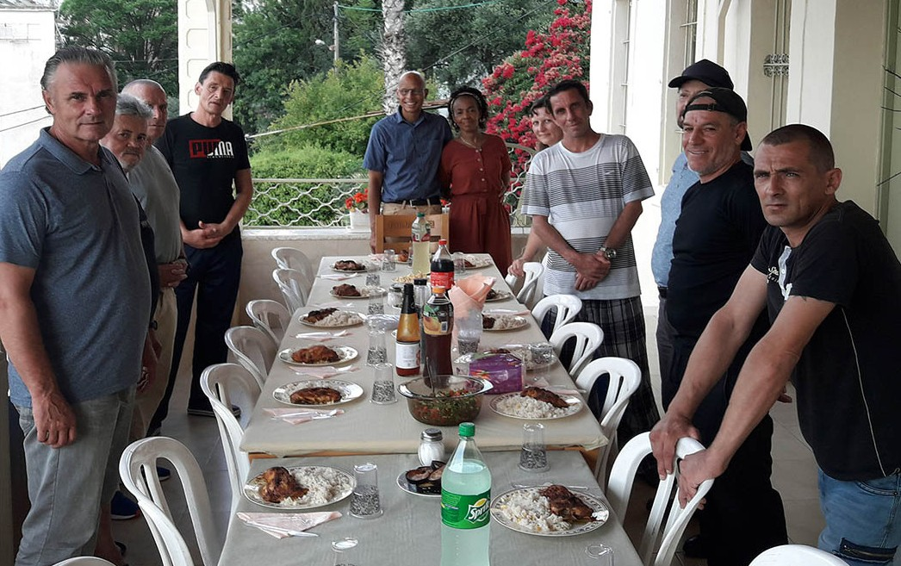
prosper. The other is a young Domari gir from
the Old City attending an Arab Christian college who aspires to become a human rights attor- ney, actually advocating for women across the earth who are experiencing a similar situation as the first lady that we are assisting, to a much more pervasive and serious degree. We were also able to assist her household with food and support her daily transportation to and from her campus, which is just beyond the “green line,” where the commute options are limited, and where attendance is so central to success in her studies.

As diverse as the body of believers is within Israel, we are able to funnel resources that you entrust us with, in a manner, which is acceptable to the King. We will continue to look for the most effective methods to encourage followers of Messiah, whether it is with ministry, scripture, conversation or substance on your behalf because we know you love Israel as much as we do here, mostly because God is particular about Israel!

God gives them security, and they are supported; And His eyes are on their ways. (Job 24:23)

Kim Brunson Project Coordinator

Project Under His Wings

Dear Friend of Israel,

“God is our refuge and strength, an ever-present help in trouble.” (Psalm 46:1)

Thankfully, gradually Project UHW is allowed to go out for visits starting from late June. However the Israeli government is weighing lockdown again as cases spike. Let us lift up the Israeli government in prayer that God gives them wisdom to cope with this great challenge of increased Corona infection.

Project UHW ministered to several terror victims in July who were in dire situations. Having to cope with the stress caused by the Corona pandemic is difficult enough; they also have to deal with added stress, also caused by this pandemic, that made them feel overwhelmed.

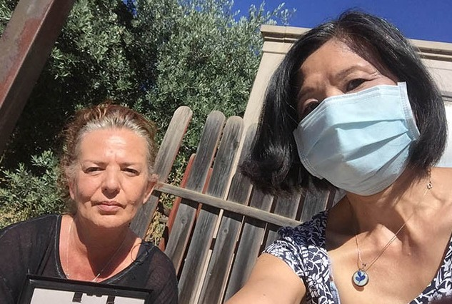
Giselle is a terror victim and a tour guide who was very broken when I went to visit her. As a tour guide she has had no income since February as no tourists have come to Israel since the outbreak of Corona. As a result her debts have accumulated greatly as she does not have any family to help her. Tearfully she told me that she had reached a point where she might have to let go of her rented apartment even though she has no place to go as she has been unable to pay her rent, as well as other expenses for months. On the other hand the bank has refused to grant her an extra loan. I encouraged her to put her trust in God despite her situation. While praying
for her during the visit, I asked God to give her favor in the eyes of whoever she needs to deal with, including her landlord. A few days later she told me that she felt much better and that her landlord was willing to renew her contract despite the rent she owed him. Praise God, who truly is our ever-present help in time of trouble (Psalm 46:1).

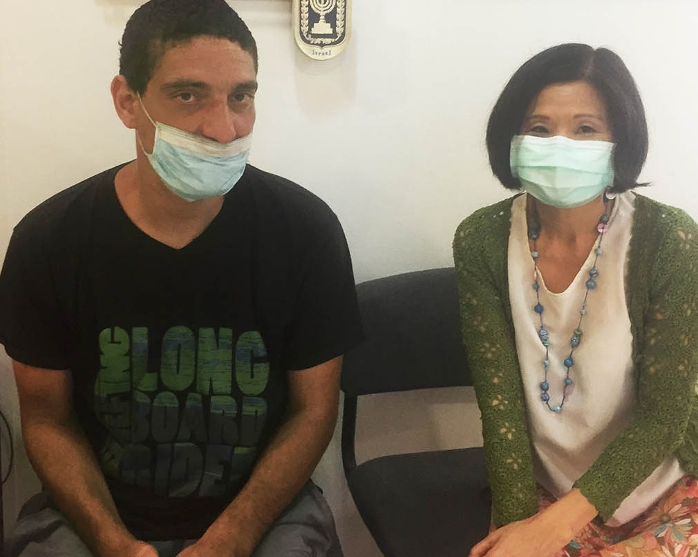
Avi is a 34-year-old young man whose mental state has worsened since the terror attack he went through when he was 14 years old. In that terror attack one of his friends was killed and he and his other 8 friends were seriously injured. Avi was hospitalized in a mental hospital several times. I felt God’s love and His compassion for him, and under the leading of the Spirit of God, I spoke words of life and hope to him while ministering to him.
He listened very attentively and receptively, and at the end of the meeting I saw his entire countenance changed.
Praise God. Please keep these precious terror victims in prayer that Holy Spirit continues doing the work, which He has begun, and bring them out of trauma.

Thank you for standing with Project UHW via your support. May The Lord bless you and your family.

Project Communities Under Attack

Dear Friend of Israel,

“God is faithful, through whom you were called…” (1 Corinthians 1:9)

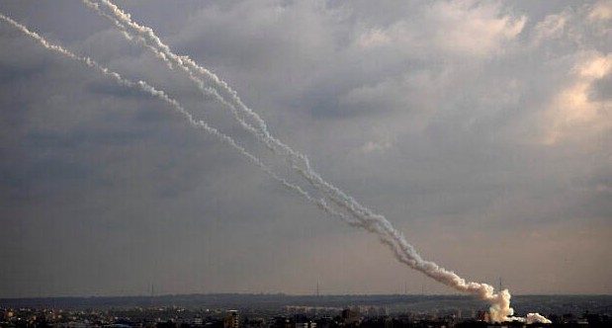
After the writing of my last update, Palestinian terror groups in Gaza fired three rockets into Israel in late June, growing tensions along the border region appeared as the Israeli government considered annexing portions of Judea and Samaria. Two rockets struck in open fields and another rocket was intercepted by the Iron Dome anti-missile system. In response the IDF struck Hamas targets in Gaza, including some underground infrastructure.

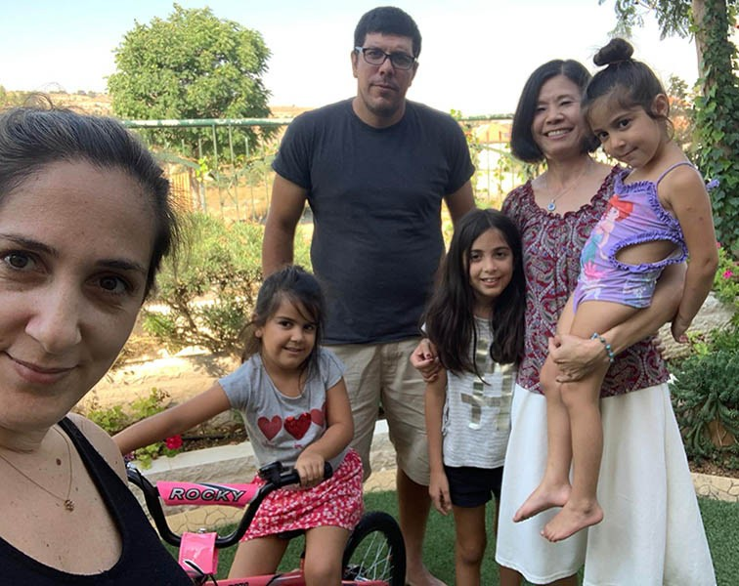
Affected by the Corona pandemic, the funds of Projects CUA & UHW are very low at
this period in time, as donors have either lost their jobs or been unable to work so that the financial support has substantially decreased. As a result these two Projects are unable to provide more financial help to victims in need as in the past. I prayed
asking God to fill this gap with His presence so the victims would not feel disappointed by less financial assistance that we could
provide for them, as most of them have been in great financial hardship. God truly is very faithful (1 Corinthians 1:9) He answered this prayer. The Holy Spirit was at work when I was ministering to these traumatized rocket

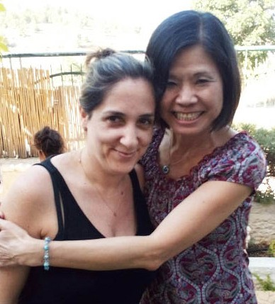
and terror victims so that every visit turned out to be of great encour- agement to them, and one of them (Amichai) was so deeply touched by the visit that he asked me to visit him and his wife and their 3 young daughters the following week, this time at their home.

And praise God that He also ministered to Amichai’s wife Shimrit. She has been carrying all the responsibilities on her shoulders as Amichai has been unable to work because of post trauma resulting from his army service. Tension between them arises from time to time due to misunderstanding and expectations. Please remember this precious family in prayer.

Thank you for your support for Projects CUA. Our work would not be
possible without the help of supporters like you. May The Lord bless you and provide for all your needs.

Project Streams Of Blessings

LEAN ON ME
Though one may be overpowered, two can defend themselves. A cord of three strands does not break easily. (Ecclesasties 4:12)

Good and bad situations that occur in our life are only steps, leading us to flow into the river of God for moments in destiny that He already has written for our lives. Joseph never thought to go through challenges and oppositions even within his own family and people, until he saw his dream come true. Yet, even in the darkest moments on the verge of fainting, his Faith and joy were strengthened; while he allowed God to prepare his spirit and mind for what was about to come.
In times of scarcity and famine, and when a door of heaven opened to bless many, Joseph’s eyes never stopped depending on the power of God to make things possible, and most importantly; show the love and compassion as a delegate of the Kingdom of Heaven for all those who suffered in time of need.

In these hard times of Covid-19, we can mark the lives of many people by bearing witness to God’s faithfulness and how He has transformed our hearts to be a blessing to others. All of us in life have gone through difficult moments, perhaps different from Joseph’s life; but if we see it through the divine plan of Heaven, these are opportunities in our agenda that are enabling us to be the Hand of God for His People.

CFI in Jerusalem through the Streams of Blessings project, has dedicated time to assist the many needs of the Jewish people in this harsh crisis that the world is facing. We cannot meet all of them, but we have put food on their tables and most importantly, we have wept and prayed with them with all our hearts. It is our responsibility to do so, and we thank God for each of our donors in the nations, who at distance are joining join us in this effort.
Together we know that God has called us to impact the lives of many people and like our Forefathers, show them that the Lord of Israel is the one who guards and cares for His People. Unless the Lord builds the house, the builders labor in vain. Unless the Lord watches over the city, the guards stand watch in vain. Psalm 127:1
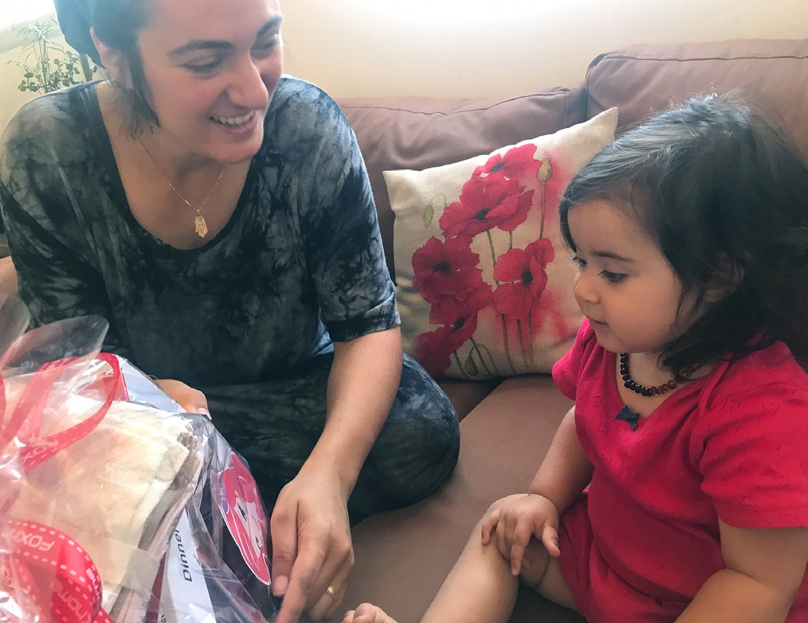
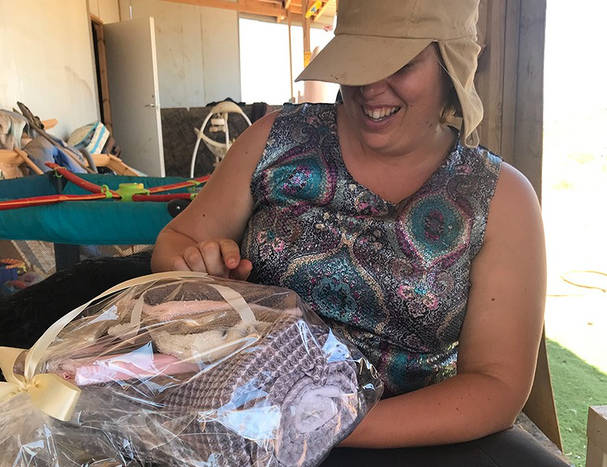
From the Talmud: Do not be daunted by the enormity of the world’s grief. Do justly, now. Love mercy, now. Walk humbly now. You are not obligated to complete the work, but neither are you free to abandon it.

