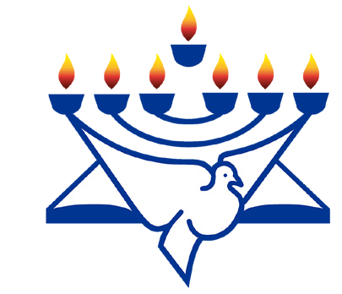
CFI News Insights
Christian Friends of Israel
feedback@cfijerusalem.org
www.cfijerusalem.org

May 10, 2022 /Jewish Year 5782

Resumption of Hostilities
Radical Islamic Terror across Israel

“But if you do not drive out the inhabitants of the land from before you, then it shall come about that those whom you let remain of them will become as pricks in your eyes and as thorns in your sides, and they will trouble you in the land in which you live” (Numbers 33:55).
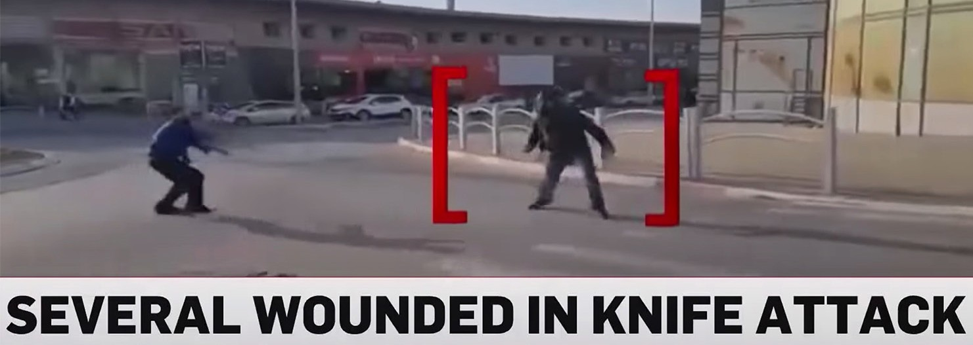
Four Killed, Several Wounded In Knife Attack In Israel’s Beersheba (YouTube)

As March transitioned into April in the land of Israel, this month registered a confluence of major holidays observed by the three major monotheistic religions of the fertile crescent region. Unfortunately, this occurrence coupled with the freedom that the nation and the world has gained from the covid pandemic, has seen the return of Islamic terrorist activity. In separate incidents across the land and affecting a broad demographic, 14 victims lost their lives and were mourned this month. From Beersheba, to Hadera to Bnei Brak to Tel Aviv, families have had to cope with catastrophic losses of husbands, fiancées, mothers, sons. In between these incidents, sporadic knifings and rocket fire have also occurred. Following these atrocities by “lone wolf” Islamists has been a well-organized and coordinated Temple Mount exhibition that started nightly during Ramadan in the Damascus Gate area of defiance of Israeli civil authority by rock hurling, fireworks and Molotov cocktail tossing, young Arab males.
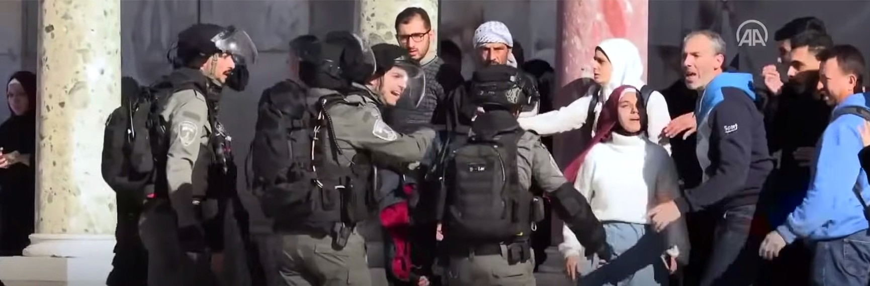
Palestinians clashed with Israeli police at the Al-Aqsa mosque in Jerusalam (YouTube)

The cynical use of Al-Aqsa Mosque to stage makeshift weaponry under the guise of “worship” during the Islamic holy month is usually manageable and easy for authorities to ignore… until these rocks were directed at civilian worshippers at the Western Wall, not just Police or Army Reserve targets that the Arab/Palestinian community have identified as agents of the Zionist state or enforcers of the “occupation.” This seems also to be aimed to give the Ra’am party (Muslim Brotherhood-Israel) faction within the Israeli coalition of national government, leverage or a bargaining chip regarding Arab/Palestinian agenda goals with the threat of dissolving the current government, if certain demands are not met.

“… and every spirit that does not confess Jesus - acknowledging that He has come in the flesh but would deny any of the Son’s true nature - is not of God; this is the spirit of the antichrist, which you have heard is coming, and is now already in the world” 1 John 4:3 (AMP).

As believers in Yeshua/Jesus and grafted into the covenant of Abraham, based on the first commandment of Exodus 20:3, there are not to be any other gods before YHWH. As much as the world would point to reasons of conflict being land claims, economic or political fairness or cultural disparities, the central issue in the conflict here is the definition of Who God is, whose God will be worshipped from this location and whose God will ultimately rule from this location in the coming years. In our time in the region, we are encouraged by stories of Arabs and Palestinians coming to faith in Yeshua and word of Iraqis and Iranian Jews (who are Muslim, but not Arab) having dreams of “a man in white” who identifies Himself as Jesus/Yeshua/Issa and are reconciling with Jews and repenting of harboring enmity against Jews, the state of Israel and the persecution of Christians within their own lands. We must encourage our Jewish brethren not to respond eye for eye as may be the expected indignant reaction. We must pray for the authorities to remain vigilant, without being arbitrary or vindictive with the sons of Ishmael. We look forward to the day when it is obvious to all, who The Father of Creation is, and when this millennials’ long family feud is ultimately resolved, both in the hearts of men and fully reflected in the atmosphere of this great land, once The Son of David is enthroned.

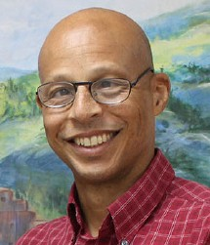
Reporting from Jerusalem,
Kim S. Brunson

