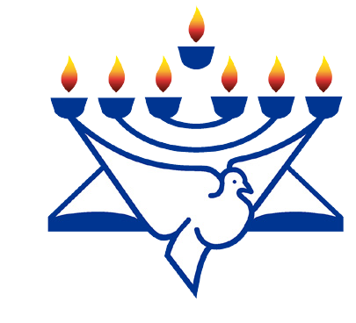
RaisingThe Bar
Christian Friends of Israel
feedback@cfijerusalem.org
www.cfijerusalem.org

October 2020 /Jewish Year 5781
A Place of Choice
“Multitudes, multitudes in the valley of decision! For the day of the LORD is near in the valley of decision” (Joel 3:14, NKJ).
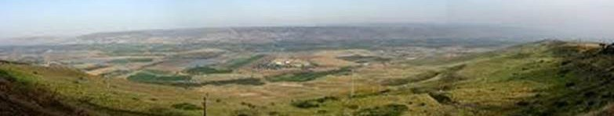

While we may or may not be seeing the actual “Valley of Decision” (Hebrew: hachlatah = decision) taking place at this time in history, the passage from the book of the Jewish prophet Yoel (Joel) tells us that there will be a time in history when the nations of the earth will come together to make choices, to come to a conclusion, or a resolution, after consideration, to make a decision on their own. That decision would be based upon a people and country: Israel.

Whether it is future, or figurative, a valley has been used to indicate an important place for these decisions. Valleys can be depressed areas of land between mountains and hills, or it can be a spiritual platitude upon which settlements are made. God has given men choices, either to choose “blessing or cursing”. Deuteronomy 30:19. Wise nations choose blessing. Those who misjudge or make poor choices will inherit cursing for their nations. The path of blessing which God chose for the nations was that they would bless the nation whom He chose as His Chosen People. As God promised Abram, “I will bless those who bless you...” (Genesis 12:3).

Never before has this scripture passage been more relevant than in what we have been witnessing here in the Middle East and in Jerusalem during the past month. We have seen the determination of certain Arab nations, choose to proclaim to the world, that they are recognizing the Nation of Israel and that they have made up their minds to come together to support Israel in acknowledging her and to make “peace” with God’s People. The final results of these decisions are yet be determined, as to how solid the “peace agreements,” known as the “Abraham Accords” will be in the coming years.

When it was announced here in Israel and around the world, and people asked what I thought, I hesitated because everyone wants “peace” in the world and it is a good thing. What sounds really great, is Islam doing a turn around, but it is well known in Islamic history that they move into a place or location very quietly and peacefully for a period of time before the spirit behind it rises up and shows its ugly head. I don’t believe Islam can truly reform without knowing our Hebrew Lord (Yeshua) or the God of Israel. I also believe that only the “Prince of Peace” (Yeshua) or Sar Shalom, in Hebrew, can usher in lasting peace under His Father’s rule, right in Jerusalem.

This is the destiny of Jerusalem, where the King will rule all nations and all knees will bow to the God of Abraham, Isaac and Jacob and Yeshua will rule as Hebrew Lord and Messiah and King of the Nations. Right here is where the Torah will proceed from, (Isaiah 2:3; Micah 4:2) in full understanding according to the Almighty, where God will rule Supreme over all.

But now, presently in this year of 2020, some nations have arrived in the “valley of decision” earlier than others and we shall wait to see what happens according to the Word of the Lord. In the meantime for the present,

Israel is certainly expanding her circle of friends with nations such as Kosovo, Serbia, and others joining the Muslim countries, to open up embassies in Jerusalem in the future. More countries are expected to join, and we shall see as we proceed with caution and with Godly wisdom.

As we ponder on the passage from the Psalms which tells us, “The words of his mouth were smoother than butter, But war was in his heart; His words were softer than oil, Yet they were drawn swords” (Psalm 55:21, NKJ). Let us pray that an era of relative peace will prevail while Israel finds her way back to unity, brotherhood, and most of all, God and His Word for their lives and nation.

The upcoming “moedim” (appointed times) will hopefully draw many to take stock of their lives, their transgressions before their Holy God and RETURN to God and His Ways, not the ways of the nations or of the rest of the world. This must happen in order for Israel to fulfill her Great Commission of becoming an ‘Or’ (light) to the nations. Isaiah 42:6, 9; Isaiah 51:4.

Let Us Enter into Prayer Together
- Pray for the many new congregations of believers which have sprung up all over (Jews and Arabs worship- ping together having found Messiah on their own by the Spirit of God). “How good and pleasant it is when God’s people live together in unity! It is like precious oil poured on the head, running down on the beard, running down on Aaron’s beard, down on the collar of his robe. It is as if the dew of Hermon were falling on Mount Zion. For there the LORD bestows his blessing, even life forevermore” (Psalm 133:1-3).

- Thank God that a spirit of political peace has come to many new countries acknowledging Israel but we need a spiritual reason to make it stick like glue. It must be built on the Rock, Yeshua. Jeremiah 6:14; 8:11. His Peace will be perfect and lasting.

- Ask God for discernment to know what the Global Imams Council, which is building relationships with all religions, is all about. It seems to be a social evolution between adherents of all religions and we must be careful not to be deceived. And He said: “Take heed that you not be deceived. For many will come in My name...” (Luke 21:8).

- Offer a sacrifice of praise for the RETURN, a time of repentance for the USA. We also need a “return to God” in Israel very badly, a national solemn assembly, as in the nations. Pray for this to take place. God will be there to meet us. “...but unless you repent you will all likewise perish” (Luke 13:5).

- Bring a sweet aroma and exalt the God of Israel asking that all Israel be saved and redemption come and deliver her from the plague and the ways of the world, may the Spirit of the Lord move mightily to assist her in stepping up to become the light (Heb. ’Or’) she is destined to become. “I desire therefore that the men pray everywhere, lifting up holy hands, without wrath and doubting...” (1 Timothy 2:8).

- Pray for the safety of Prime Minister Netanyahu, his wife and two sons, during the many demonstrations against him. May a sweet aroma of prayer and concern arise from the nations, …that they may offer sacrifices of sweet aroma to the God of heaven, and pray for the life of the king and his sons (Ezra 6:10). Whatsoever is commanded by the God of heaven, let it be diligently done for the house of the God of heaven: for why should there be wrath against the realm of the king and his sons? (Ezra 7:23).

Amidst the storms that surround us all, may we be found in perfect peace, for perfect peace (a person: Yeshua) is here to steady us and guide us when we pray. Thank you once again for continuing to be Watchmen from the nations for the one-and-only: Israel. Let us see the Israel of God before our eyes, please God, before we depart this world. Your prayers are definitely sweet, aromatic and pleasing unto God for His Chosen People.

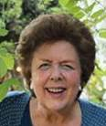
Always in the Lord Yeshua,

Sharon Sanders
Christian Friends of Israel - Jerusalem

