CFI Projects Monthly Reports for
International
Representatives

Dear CFI International Representative Family,

Thank you for your continued support of the Outreach efforts of Christian Friends of Israel. We continue to strive to encourage those in need and to offer practical assistance during times of struggle. It’s during these times when relationships can be formed which please God and allow us to show Compassion to those who need it the most and have possibly never experienced it before.

During this time of global pandemic, we continue to offer assistance as we are able, and we know each passing day may allow for additional hardships, but we also know the God whom we serve. He is more than able to protect, and provide and heal. We are willing to represent Him to the people of Israel.

Please receive the CFI Outreach electronic updates as a reminder
of the impact each of you have in the lives of so many. We are grateful to represent those of you in the Nations - to those in the Land of Israel.

A friend loves at all times, And a brother is born for adversity.
Proverbs 17:17 (NKJV)

Project Communities Under Attack

Shalom dear Friends of Israel,

“Hear my cry, O God; listen to my prayer“ (Psalm 61:1).

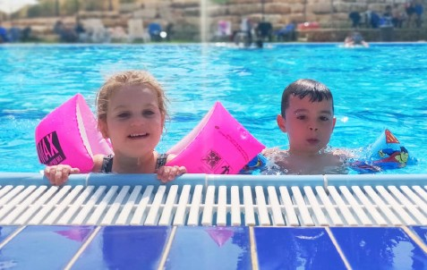
I am in awe, as well as amazed, at God’s leading. Recently I was prompted to contact Aviad, a trauma- tized former soldier with a young family, to see how they were doing. It was a surprise to hear him tell me that he was also thinking about me as he and his young family were deeply moved by my visit. He said that I, although being a stranger, in fact love and care about him and his family more than his own parents and biological family. He also told me that they just moved to new place recently and that I am always welcome to visit them. So I went.

Aviad and his wife Ziv have worked very hard, to buy a house to raise their two small kids. Praise God that their dream came true – they now have their own house, located near Hebron Mountains and the community has a nice swimming pool which their two kids enjoy!

During the visit Aviad told me of his struggle against his trauma and feared that he would end up in a similar fate to some traumatized persons - a broken marriage. He admitted to me that there have been
tensions between him and his wife and that they are holding on to the marriage for their kids’ sake as they are young. I told him what others said about his ‘fate’ is not true, if he asks God for help (Psalm 61:1). I asked if I could pray for him before I left; he said certainly. After prayer, he told me that it was amazing that the prayer was exactly his thoughts and heart cries. Please lift up Aviad in prayer that he will cry out to God for help and that God will deliver him out of trauma and preserve his marriage.

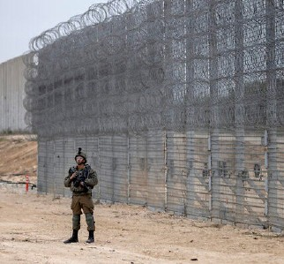
There is a good news concerning the Gaza borders. Following 3.5 years of construction, the Israel-Gaza border barrier is complete. The NIS 3.5 billion ($1.1 billion) project is meant to end the threat of cross-border tunnel attacks from Gaza, which its Hamas rulers have utilized to deadly effect. The 65-kilometer (40-mile) barrier includes radar systems, maritime sensors and a network of underground sensors to detect militant tunnels. Israel has fought four wars with Hamas since the Islamic militant group seized power in Gaza nearly 15 years ago, most recently in May 2021. Previously, Palestinian militants tunnelled into Israel and kidnapped Israeli soldiers. May the completion of this 30-foot-high “smart fence” be effective to prevent infiltrations from the Gaza strip into Israeli territory.

Thank you for your support to Project CUA. Wishing you and your family Merry Christmas.

Maggie Huang Project Supervisor

Project Wall of Prayer

Welcoming New Immigrants

“Don’t fear, I am with you. From the east, I’ll bring your children; from the west, I’ll gather you. I’ll say to the north, ‘Give them back!’ and to the south, ‘Don’t detain them.’ Bring my sons from far away, and my daughters from the end of the earth” (Isaiah 43:5-6, CEB).
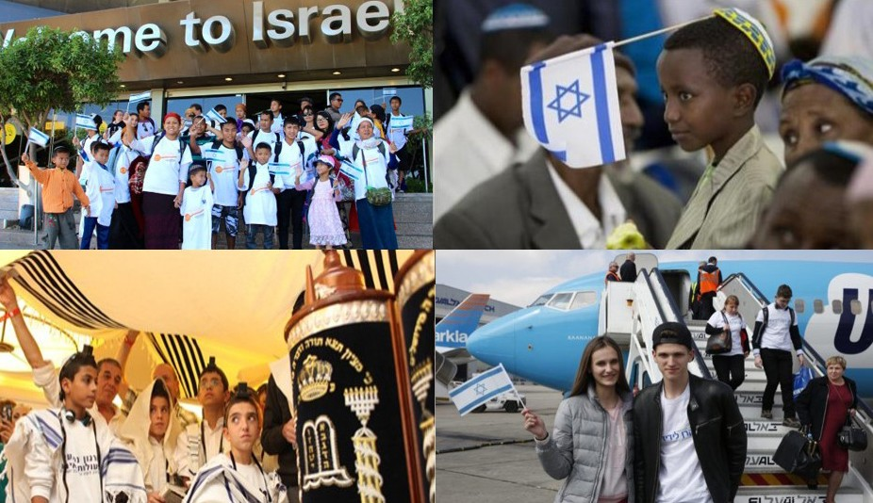
Jewish immigrants come from many nations of the world

Are you a person who has prayed several years for Jews who are making aliyah (immigrating) to Israel? That is the testimony of many who are friends of Israel. In 2014 while still living in the US, I met a visiting Ethiopian Israeli pastor and wife. As a result of that introduction, a relationship blossomed between my US congregation and that Messianic pastor from Jerusalem. The Lord has a way of bringing something or someone across our paths to affect the direction of our lives. God may draw our attention to something by highlighting it – much like He did with Moses and the burning bush. That encounter at Mount Horeb shaped the course of Moses’ life and the history of Israel.

After meeting that couple, our congregation began researching and disseminating information on Ethiopian Jews. We began praying for open doors to those longing to make aliyah and come home to Israel. As
we petitioned the Lord, we also donated to help them make smoother transitions from the rural culture of Ethiopia to modern life in Israel. Over the next few years, the pastors traveled between Jerusalem and Indianapolis, Indiana – exchanging pulpits, Shabbat meals, and Sunday dinners. Our tours to Israel began to include a Shabbat service translated into Amharic, Hebrew, and English. Only God knew that meeting this couple would eventually lead to my moving to Israel and serving new immigrants through CFI - Jerusalem. Many of you may have similar testimonies of how the Lord directed your path.

When this group of new olim (immigrants) walked into our Welcome Center, my heart filled with joy! It was a pleasure to serve them. When you have prayed for something for a long time and it finally happens, doesn’t your heart soar with gratitude for God’s faithfulness? Proverbs 13:12 says, “Hope postponed grieves the heart; but when a dream comes true, life is full and sweet.” Those who join our online Israel Watch prayer meetings can attest that earnestly praying for aliyah is an essential part of our petitions to the Lord. When we pray for aliyah, we are aligning with God’s Word!
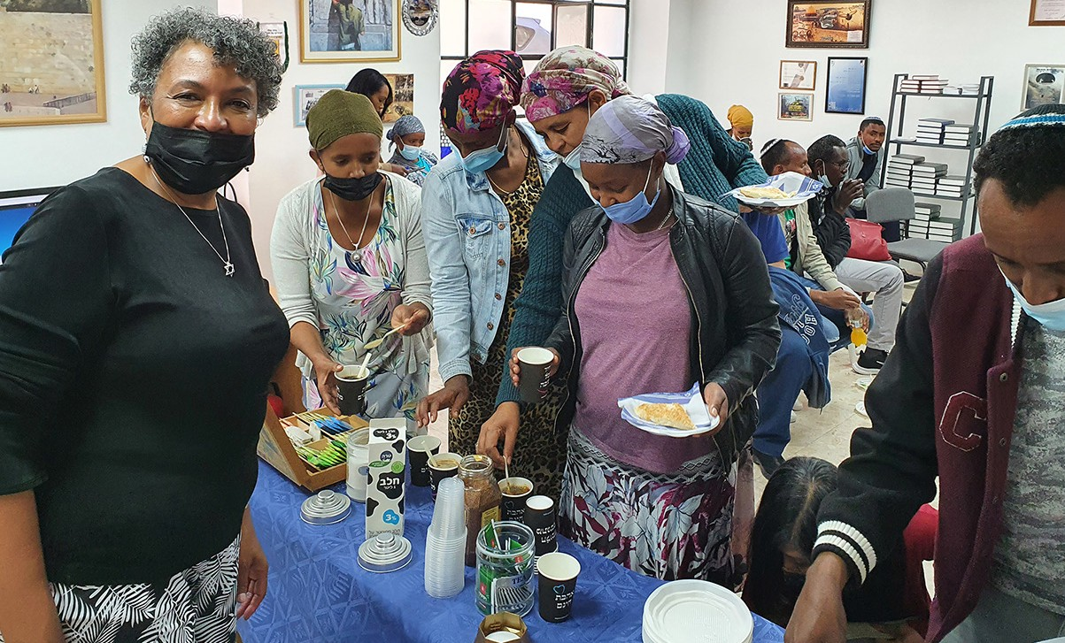

CFI provides goods, services, and encouragement to the Jewish Immigrants whom God is sending from nations around the world! It is impressive when we realize the various backgrounds of the Jewish population living in the land of Israel! “This is what the Lord God says: ‘When I gather the house of Israel from the nations to which I’ve scattered them, I will show them my holiness before the

watching world, and they will live on the land that I gave to my servant Jacob’ “ (Ezekiel 28:25, ISV).

To our dear supporters, thank you for continuing to pray and give to help more Jewish people “come home” to the land of their forefathers. God will reward you in ways you had not dreamed.

Linda McMurray Project Supervisor

Project Forsake Them Not

“Sing, O heavens! Be joyful, O earth! And break out in singing, O mountains! For the Lord has comforted His people, and will have mercy on His afflicted” Isaiah 49:13.

Every wounded soul needs healing and comfort. We often find this comfort through a listening ear and compassion for other people. How much deeper is comfort, that comes from the Lord Himself, how much mercy He pours out.
Every event with the Holocaust Survivors and every home visit is a testimony of the power of love and acceptance and manifestation of Lord’s comfort through kindness and God’s word.

Recently CFI staff members had a wonderful privilege to host the leadership of the Association of Con- centration Camps and Ghetto Survivors for a special event, a reunion between our organisations. It was a time of remembering former days, sharing the testimonies, with great excitement looking at the pic- tures taken 15-20 years ago.
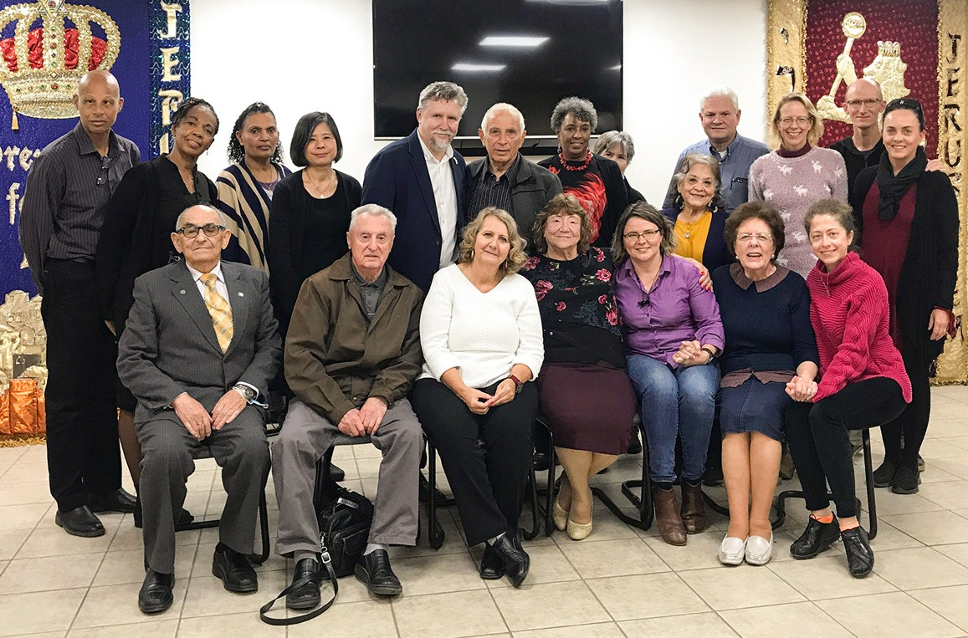

Gita Koifman (the chairperson of the Association) remembers fondly:
“I will never forget when I first came to CFI to introduce myself and to ask for help. Many people de- spised me for turning to Christians for support. When I entered the office, I saw two beautiful ladies. I also learned and saw how beautiful ladies can cry. We cried together and never parted our ways since.” There was so much joy, love, honour and tears. Our hearts were bound together, again and again. It was so wonderful to witness that love doesn’t fade, nor grows old. It deepens and matures, bringing healing and restoration.

Gita also presented Sharon Sander and the Forsake Them Not team with a reward – a beautiful golden medal, as recognition of friendship and huge input into the work with the Holocaust Survivors.
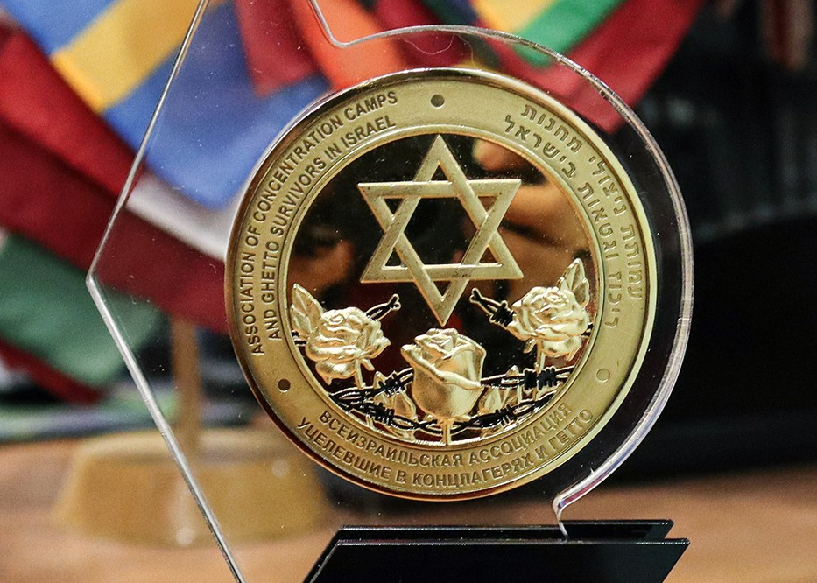

“Everyone knows Tanya and Olga. We have no idea how these two girls are able to visit so many peo- ple, all over Israel, but we, as leaders, always hear about them. More than that - they don’t just come to visit friends, they are accepted as family members. They love us, and we love them back,” said Gita.

We all were grateful for a wonderful time together, what a sweet reunion it was.
It is a true privilege for us indeed to be friends and family members to so many precious people, who suffered so much, and to witness the mercy of God in their lives.

Thank you so very much for all your prayers and faithful support. Let us never get tired of lifting His special possession before the throne of grace of their Maker to see His mercy on His afflicted ones.

“Even the captives of the mighty shall be taken away, and the prey of the terrible be delivered; For I will contend with him who contends with you, and I will save your children.” Isaiah 49:25

Olga Kopilova Project Supervisor

Project Open Gates

Greetings from rainy Israel!

God is blessing the Land with water from heaven. I personally like the winter season. The ground becomes green again. The air is fresh and pleasant to breathe. It is at the same time challenging and fun to have rain over here. You just need to dress warmly and have a radiator turned on at your place.

Our “Get Started - Store” is giving to new immigrants several household items that they can choose for themselves. One of the most popular electrical devices at the moment is the oil radiator. Christians are making Jewish homes warmer in a very real way. It is a wonderful.

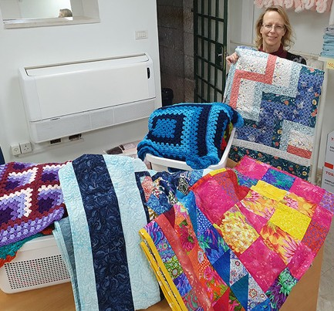
We have also handmade blankets to offer as an extra gift to our visitors. Many of them are touched by the thought that somebody spent countless hours by knitting a big blanket for them. The lovely patchwork in the quits, which we also
got lately from UK, is also a testimony of love and appreciation of Christians to God’s chosen nation. Let’s pray that our gifts will continue to talk about love and
friendship to their new owners, who have moved to Israel from different countries and backgrounds. I am very privileged
to be here physically and to pass these pretty and useful items to the new immi- grants. I try to explain them that all over the world there are Christians who are supporting and praying for them. Usually it makes them smile and often I hear them say: “Thank you so much!”

Please, keep praying for Israel and specially for new immigrants who have made (or are making) a bold step of Aliyah to their historical homeland. It is not easy to leave everything behind and to move to an almost unknown country, even if it is your heritage. God is there to help everyone of them, but we need to pray anyway. May these families and individuals get to know Him as their loving Heavenly Father and as the Lord and God of Israel.

Let us continue to support Israel! It may not be a popular thing to do, but it is our call and privilege.

Pray for the peace of Jerusalem: May they prosper who love you. Peace be within your walls, and security within your towers. For the sake of my relatives and friends I will say, “Peace be within you.” For the sake of the house of the Lord our God, I will seek your good. Psalm 122:6-9

May the Lord, maker of heaven and earth, bless you from Zion! Psalm 134:3

Tiina Danilevski Project Supervisor

Project Hope For The Future

“Arise, shine, your light has come!” Isiah 60:1a

Our friends across the globe have recognized God’s blessing on the Land of Israel and have expressed obedience to His instruction to bless the precious people that have returned to live here in peace. God’s grace and mercy brought us gentiles into the olive-tree connection with Israel:

“The Lord called you a thriving olive tree, with fruit beautiful in form” Jeremiah 11:16. “I am like an olive tree flourishing in the house of God” Psalm 52:8.
We are blessed by the heartfelt love to undergird our projects. Special thanks to this group of “angels” Project Olive Group for sending sewing and knitting materials, exquisite Mohair wool yarn of different colors! It was such a blessing and a surprise to receive the boxes in our last shipment from the UK.
I am so excited and cannot wait for the students to see the special love sent for them from afar. We are so grateful for our relationship. It has enriched us at Hope for the Future and Hope Resource Center; the narratives change for the Ethiopian community as we launch together.
“ Arise, shine, for the light, has come, and the glory of the Lord has risen upon you” Isaiah 60:1. This is an example of the nations that have firmly planted their hearts in Hebraic soil and will find their identity and wellbeing in having the connection of the blessing with Israel.
This season of Hanukkah, the blessing of the pressed oil, created the historic sustained light. It is a miracle of a single night’s supply of oil that burned for eight days so the temple in Jerusalem could be rededicated more than 2,000 years ago. God had preserved His people from complete destruction from the Greco-Syrian Emperor.
Our hearts shine the light of the candles in the Nations, a light that shall never go out! Light, courage, and faith are in our worship as it was restored in Jerusalem many years ago. This light is to kindle inspiration. The lights of Hanukkah motivate us to reflect the light of The Father and have it shine from our hearts.
We pledge to help make this a better place and to shine His love.

“I am the Lord, I called you in righteousness, I will take you by the hand and keep you; I will give you as a covenant for the people, a light for the nations” Isaiah 42:6.

In Bnai Brak this year, Hope for the Future took part in a Hanukkah celebration for the children. We see this generation have so many hurdles to overcome, mainly when schools no longer operate as dynamically as they did three years ago. Our purpose is to shine His light in any dark place and be lights of Hope, love, and faith. CFI provided funds for the event orchestrating this community Hanukkah celebration for
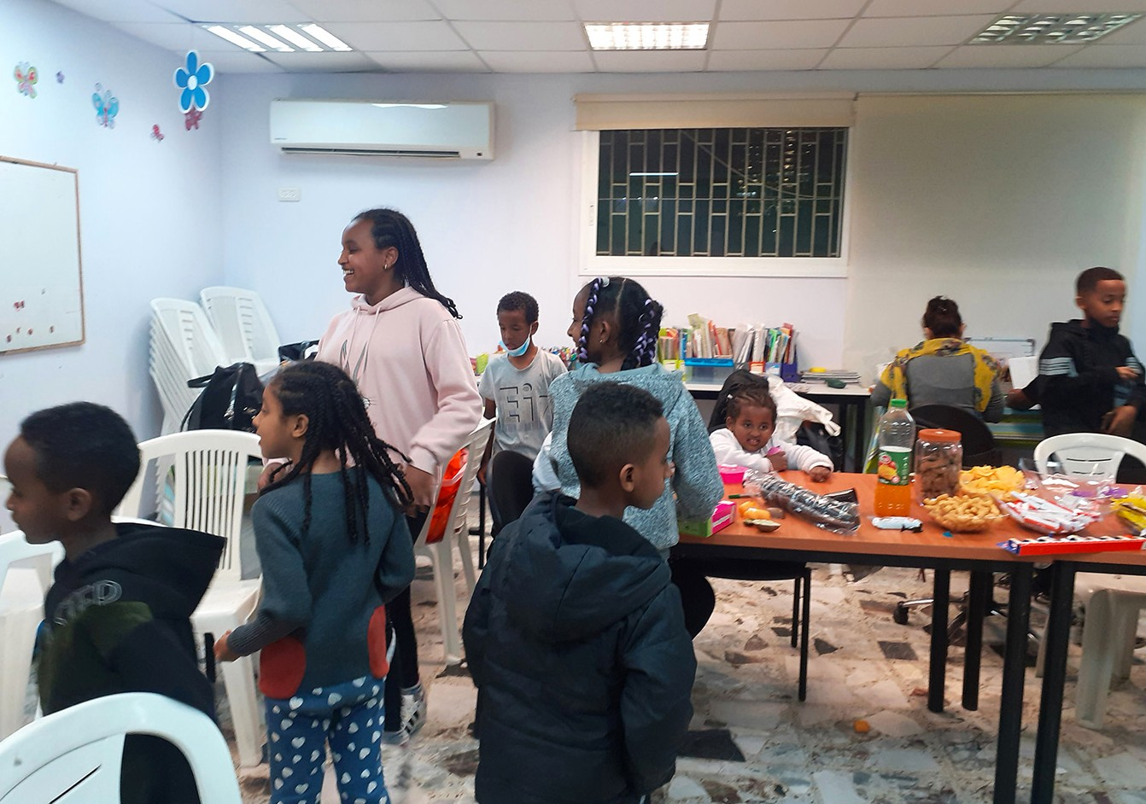
the Ethiopians. The event began with games and laughter. We were able to get those beautiful donuts (sufganiyot) to highlight the days’ activities.
Shining a light takes a heart that is filled with anointed pressed oil. Let us not forget the unconditional love today in our homes. Thank you with all of our hearts for the sacrifices you make to help make life happen here in Israel for the Ethiopian Jewry!
A light in the darkness... Redemption of His people... And sacrifice...

Marcia Brunson Project Coordinator

Project First Fruits

Shalom from Jerusalem!

“For this I will give thanks and praise You, O LORD, among the nations; I will sing praises to Your name” 2 Samuel 22:50 (Amp).

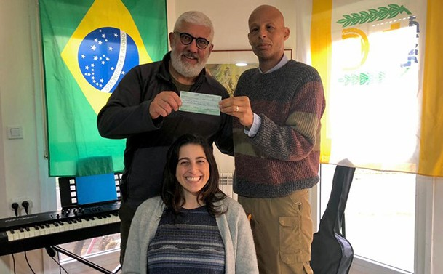
December was somewhat challenging as the FF project needed to suspend expenditures that had been accrued this year. This was partially due to COVID response strain and some reduction of support during the previous quarter.

Despite this, we were able to begin providing support to Yehoshua A., head of a Brazilian ministry family that has begun a Tour Guide School in anticipation of a more relaxed travel period in Israel by the end of next year. Our support was pledged back in 2019, but with COVID, the hospitality industry as really been on hold. We were delighted to make good on our word to him and keep the family encouraged as they enter the next phase of their lives.

We were also able to fellowship with Yael L., a Bulgarian immigrant that has been very instrumental in the recovery process for Ray, our Co-founder. She prepared goulash for myself and the HFF project supervisor, who happens to be my wife Marcia and we had a delightful time in the Lord. The highlight of the month was something that we had not been able to do up until now.

“After these things I looked, and this is what I saw: a vast multitude which no one could count, [gathered] from every nation and from all the tribes and peoples and languages [of the earth], standing before the throne and before the Lamb (Christ), dressed in white robes, with palm branches in their hands” Revelation 7:9 (Amp).

This month, we held a First Fruits Project Reception where we were able to honor various recipients of support from our tenure and connect them to other friends of CFI. Refreshments were served and there was a warm welcome from our Co-Founder Sharon. We conferred upon 2 of the 4 honorees we had chosen, to receive a certificate of commendation for their contribution to the Body in the land. To repre- sent Russian speaking citizens was Dov Bikas of Aviv Ministry who stewards a home for battered wives and mothers along with a drug and alcohol rehab residence for men in Beersheba. Our Arabic speaking recipient was Amoun Sleem, head of the Domari Society of Gypsies serving this community of Indian de- scent that reside mostly within the Arab Christian quarter in the Old City. (We will also confer certificates to Hebrew and Amharic speakers in the near future, who were unable to attend our function.) We were also privileged to host Elana, of Christian Friends of Magen David Adom, Bishop Glenn and Dr. Ruth Plummer of COGIC and a group from HaYovel, who had graciously hosted our staff the week prior, on their compound in the north. With this function we also revealed our new partnership with Derek Prince Ministries as the exclusive distributor of his literature in Israel…at no cost for those who receive!

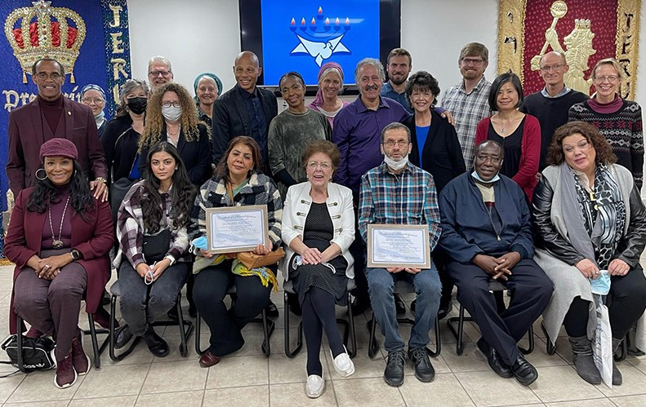

We bless you for helping us transition into this new era - not just a new year!

Kim Brunson Project Supervisor

Project Bridal Salon

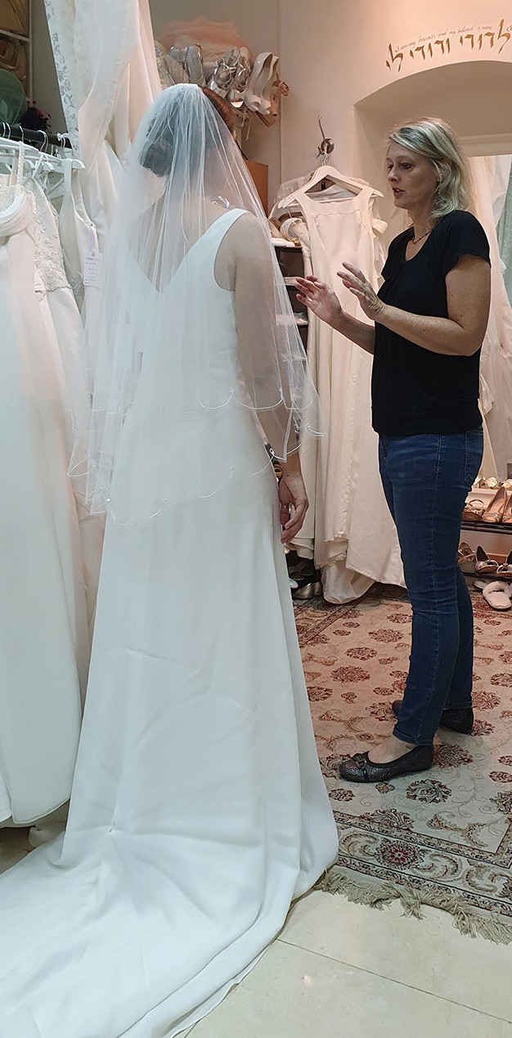
Shalom from Jerusalem!

It is not so busy in our Bridal salon at the moment, but still people are contacting us and coming to see our collection. Today we served a bride to be who made Aliyah from Argentina five years ago. She found a beautiful dress and her mother, who made Aliyah only two weeks ago, wants to come and see the evening dresses in the near future. They seemed to be surprised by the good selection of different items that we have over here. The mother took pictures of our room from different angles :)

A week ago there was another young woman with her mother visiting our place. She wanted to have a light and simple dress without too many decorations. The first dress she tried on was ‘the Dress.’ Some other options were also very beautiful, but she wanted the simple one.
When our clients put on a veil, their essence changes. They kind of see themselves under the chuppah already… The mothers who come to help their daughters to make the best choice, often have tears in their eyes at that moment. It is interesting to notice.

Yesterday we had a young family with 4 children at our place. They will have a family celebration in two weeks. We found something for everyone of them. The little girls were so happy in puffy princess dresses. God has provided a lot of beautiful gowns for children, especially for girls.
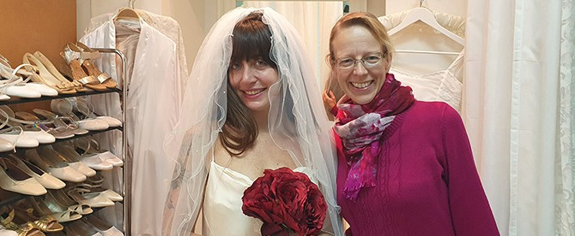

Tiina Danilevski Project Supervisor

Project Under His Wings

Dear Friends of Israel,

“The LORD rebuke you, Satan!” Zechariah 3:2a.

Shalom. Since mid-November Israel has seen an uptick of terror attacks which have resulted in death and many injuries. These terror attacks were carried out by ‘lone-wolf’ Palestinians through car ramming, stabbing and shooting attacks which took place in the Old City of Jerusalem and the Biblical area of Samaria.

On 17 November one 16-year-old Palestinian stabbed and wounded two young Border Police officers inside the Jerusalem Old City. Both of them were taken to Hadassah Hospital for treatment.
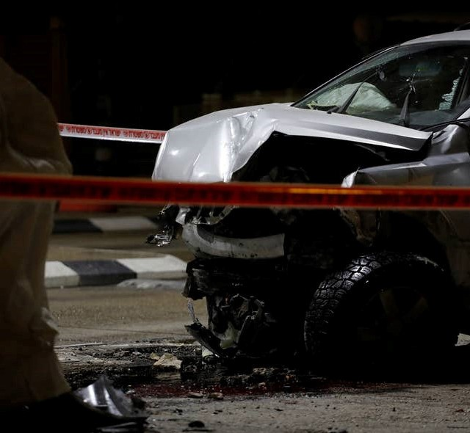On 21 November there was a fatal shooting attack in Old City as well; a 25-year-old lone immigrant from South Africa named Eliyahu David Kay who was on his way to pray at the Western Wall was killed and another two Israeli Jews were wounded. On 4 December an Ultra-Orthodox man was stabbed near Damascus Gate again in the Old City of Jerusalem and was taken to hospital for treatment. On 6 December there was a car ramming terror attack at one checkpoint in Samaria, wounding a 34-year-old security guard. The wounded guard was taken to Sheba Medical Center near Tel Aviv in a serious condition; and two days later on 8 December, one 26 year old religious woman was stabbed by one Palestinian teenaged girl in North Jerusalem when she was taking her children to school.
The assailant’s car after the attack, December 6
She was taken to Hadassah Hospital for treatment.

It usually takes great effort and time to get hold of the Israelis affected by terror attacks in order to reach them. Shortly after these attacks our Project UHW Coordinator went to several places in the Jerusalem Old City and spoke with several police officers and security forces in an attempt to reach out to the new terror victims. One officer, who personally knows some of the wounded security forces, said she would pass my contact information to them. I pray that they will contact me.

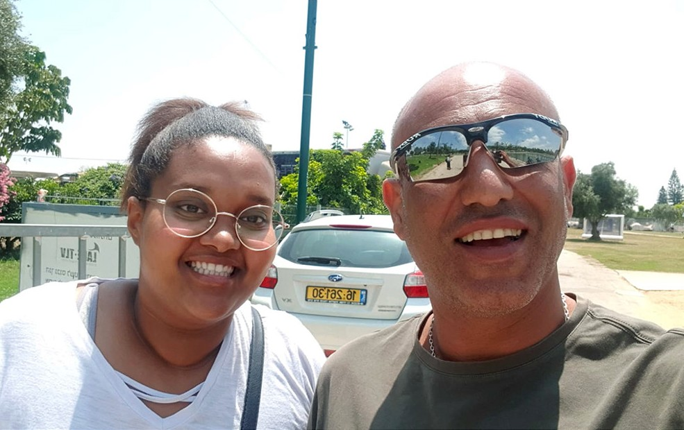Please lift up the safety the Israeli security forces in prayer and that they will be alert to their surroundings; please also pray for the security situation in Israel, espe- cially in the Jerusalem Old City as well as Samaria that God quenches the murderous spirit (Zechariah 3:2a).
Sivan & Guy

Aside from the great effort to reach out to new victims, UHW continues its daily operations to minister to the needs of some terror survivors, such as Atseda, Sivan and Guy.

Thank you so much for enabling Project UHW in our outreach to terror victims through your faithful support. God bless you and Merry Christmas.
Maggie Huang Project Supervisor

