July 2020 /Jewish Year 5780
Tel Aviv-Yafo: A Port-of-Entry
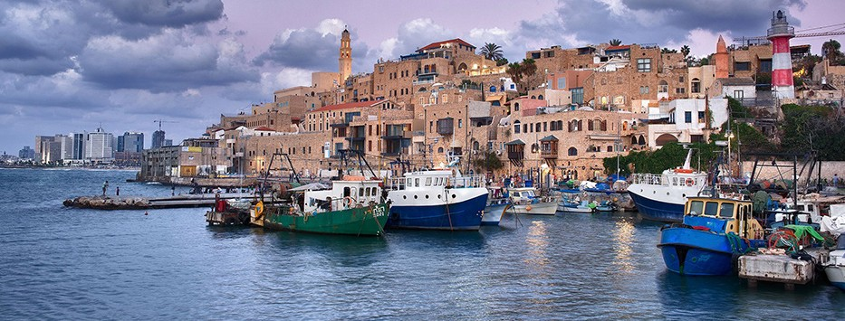
Jaffa Port (CC BY-SA 3.0, by Noam Armonn, Wikimedia)

“But Jonah went down to Jaffa and found a ship going to Tarshish...away from the presence of Adonai... there was such a mighty storm on the sea that the ship was about to shatter. So the sailors were afraid and cried out, each man to his own god” (Jonah 1:3-5a Tree of Life Version).

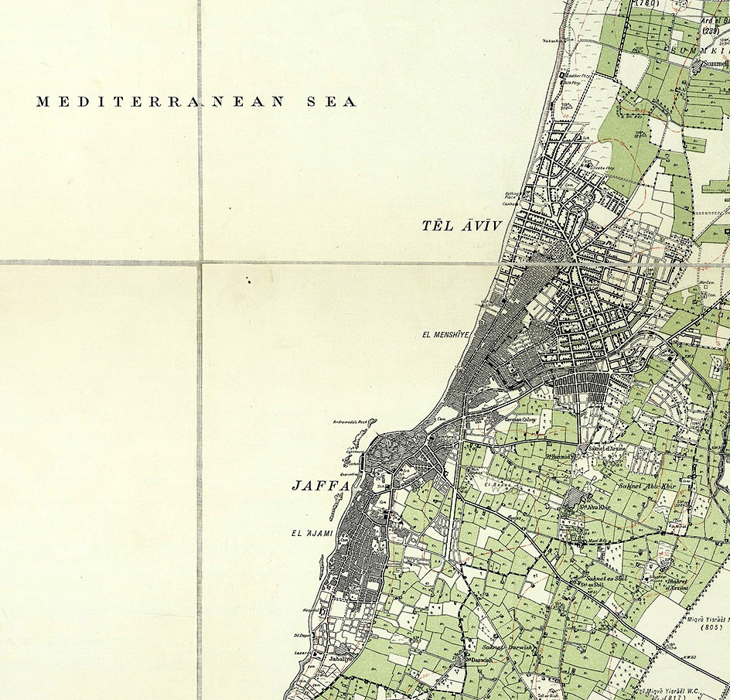Tel Aviv-Yafo (often referred to as just Tel Aviv), is located on the Israeli Mediterranean coastline. It was founded in 1909 on the outskirts of the ancient seaport city of Jaffa (also known as ‘Joppa’ or ‘Jaffa’ in scripture and ‘Yafo’ in Hebrew). In 1950 Tel Aviv and Jaffa were merged into a single city. (Wikipedia)

In Biblical days, Jaffa, was a bustling place, a port-of-entry, a place of exchange of merchandise and cultures. Ships from various nations traversed the Mediterranean Sea transporting merchants, their goods, and their gods. Descendants of the tribe of Dan who resided in this area made their living from ship-making and sailing. (Judges 5:17). Since ancient times, this seaport area has been a place of commerce and travel. It was through the harbors of Jaffa that the cedars of Lebanon were imported to build both Solomon’s Temple and the Second Temple. (2 Chronicles 2:15; Ezra 3:7). It was from Jaffa’s ports that Jonah embarked on a mission to escape God’s assignment
– only to be stopped mid-stream and rerouted until he delivered

Jaffa 1929 (CC BY-SA 3.0, Wikimedia)

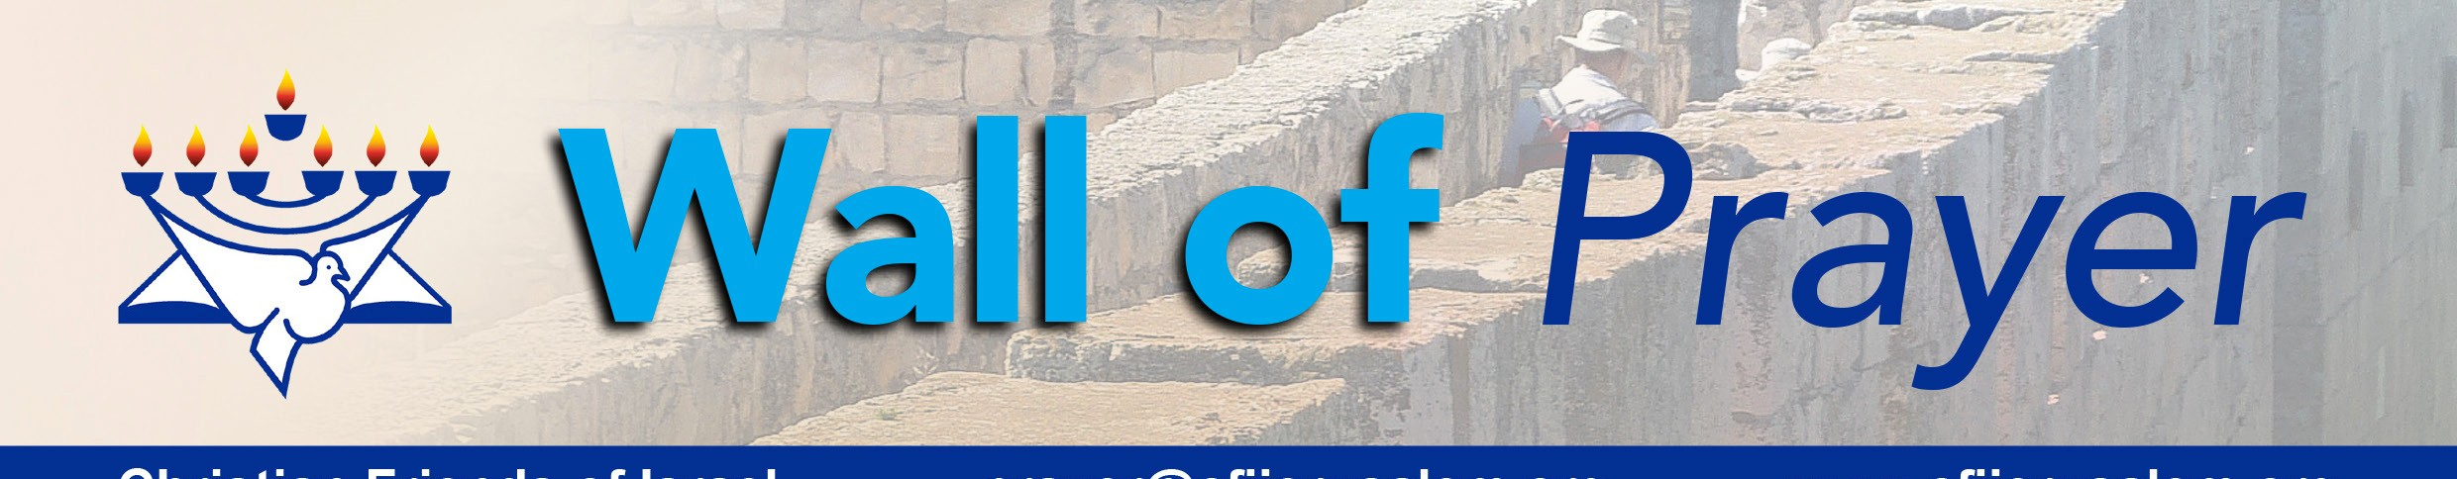the Word of the Lord to a distant nation, Nineveh. Jonah’s amazing voyage which was initiated in Joppa resulted in the preservation of the entire city as they repented and turned to follow the ways of God.
Christian Friends of Israel
prayer@cfijerusalem.org
www.cfijerusalem.org

Today that same area, now called Tel Aviv, is a modern, cosmopolitan hub of activity – Israel’s second most populous city. It remains a gateway, an entry point into the country and is now considered the economic and technological center of Israel. The Global Financial Centre Index has ranked Tel Aviv 26th in the world. This city has the largest economy per capita in the entire Middle East. It houses a government center and the main base of the Israel Defense Forces (IDF), as well as the embassies of several countries. (Wikipedia)

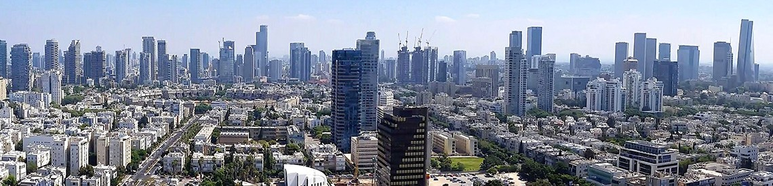
Panorama of the city of Tel Aviv (CC BY-SA 4.0, by RaphaelQS, Wikimedia)

Tel Aviv has become an international center of fashion and design, and is known for its high cost of living, modern homes, and vegan restaurants. According to Wikipedia, Tel Aviv has been named “the best gay city in the world” by American Airlines; it is one of the most popular destinations for LGBT tourists internationally. Despite all the glamour and glitter that abounds in this metropolis, there is great spiritual darkness. Thanks be to God for strategically placing some to be the “lights” in Tel Aviv. May Jonah’s timeless message of turning to God ring out once again in the region from which he launched!

Thank You for Sending Out Prayers for Tel Aviv-Yafo
- Thank God that He hears the prayers of those who are committed to Him. “The eyes of the Lord are on the righteous, and his ears are attentive to their cry” (Psalm 34:15).

- Praise the Lord for his unwavering commitment to Israel. He will keep His promise to restore His Chosen People. He is trustworthy. “But Zion said: ‘Adonai has forsaken me; Adonai has forgotten me.’ …Even if these forget, I will not forget you. Behold, I have engraved you on the palms of My hands” (Isaiah 49:14 – 16).

- Rejoice in the fact that nothing goes unnoticed by our God! “The eyes of the Lord are everywhere, keeping watch on the wicked and the good” (Proverbs15:3). God knows everything in advance, and nothing takes Him by surprise. “O the depth of the riches both of the wisdom and knowledge of God! How unsearchable are His judgments and how incomprehensible His ways.” (Romans 11:33).

- Entreat the Lord to turn Tel Aviv toward Him wholeheartedly. “Let the wicked forsake his way, and the unrighteous one his thoughts, let him return to Adonai, so He may have compassion on him, and to our God, for He will abundantly pardon” (Isaiah 55:7).

- Ask God for continued vigilance, discernment and strength for both the IDF and the spiritual prayer war- riors that He has stationed in Tel Aviv. “…Adonai, please open his eyes that he may see...” (2 Kings 6:17). May they thwart the Evil One on every front. “Finally, be strong in the Lord, and in the power of his might” (Ephesians 6:12).

- Proclaim that Israel will experience restoration! They will enter into the rest promised to them through The Way. “My presence will go with you, and I will give you rest” (Exodus 33:14). “I am the way, the truth, and the life!” (John 14:6).

Dear Watchmen:
As we watch the world wrestling and grappling with one issue after another, it reassuring to know that our covenant with the King of Kings surpasses anything we face. He is our Refuge, and our Guide. He holds the ultimate power! The Holy Spirit has promised to lead and guide into all truth. Don’t be discouraged; let’s stay on course! As we continue to intercede for Israel, the overflow of those prayers will also pour onto our nations. What happens in Israel affects the world!
We are recruiting an army of prayer warriors on behalf of Israel. Will you join the “Israel Watch” prayer net- work today? Please contact me at the email address shown below. We need you!

In His Love,
Linda D. McMurray
CFI International Wall of Prayer Coordinator prayer@cfijerusalem.org

