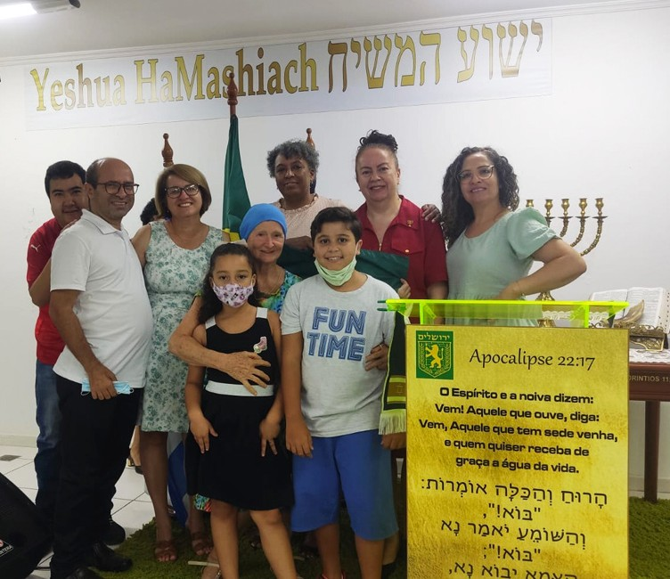
in

Prayer Letter
Watchman’s

Christian Friends of Israel prayer@cfijerusalem.org www.cfijerusalem.org
May 2022 /Jewish Year 5782
Aligning with Israel
“The Lord of Hosts says this: ‘In those days, ten men from nations of every language will grab the robe of a Jewish man tightly, urging: Let us go with you, for we have heard that God is with you’ ” Zechariah 8:23 HCSB.

It is common to see narratives in the media that criticize and berate the nation of Israel. Anti-Semitism (hostility to or prejudice against Jewish people) is rampant today, and can negatively affect communities, churches, and nations. Sometimes, it is blatant, and other times it is subtly woven into the fabric of people’s worldviews.

For those who love God and are followers of Yeshua (Jesus, our Jewish Messiah), loving Israel should not be something to question. Throughout scripture, God pledged His eternal love for Israel. His devotion to Israel remained constant despite the repetitive cycle of their rebellion, dispersion, repentance, and return to Him. In Jeremiah 31:2-4 God says to Israel, “I have loved you with an everlasting love; I have drawn you with unfailing kindness. I will build you up again, and you, Virgin Israel, will be rebuilt.” If we truly love God, we will love the nation of Israel. Psalm 122:5-7 tells us to pray for Jerusalem’s peace and prosperity. God spoke to Israel’s patriarch, Abraham, saying, “I will bless those who bless you, but I will curse anyone who curses you, and by you all the families of the earth will be blessed” (Genesis 12:3 CJB). From this word of God to Abraham we understand that we are blessed as we bless Israel. More succinctly, how we relate to Israel will affect our destiny!

When we align with Israel, we align with God’s purposes for His Chosen people and for the nations. Positioning ourselves with Israel does not mean that we condone any wrongdoing on Israel’s part. Rather, it means that we stand with and pray that Israel and the nations will follow God’s principles for righteous living. This also includes praying that Israel will take her rightful place as a light to the rest of the world. Isaiah 42:6, NASB, says, “I am the Lord, I have called You in righteousness, I will also hold You by the hand and watch over You, and I will appoint You as a covenant to the people, as a light to the nations.”

In February, I visited our CFI Brazil representatives, Pastor Abeni and Claudia Bastos. It was exciting to visit a church in Rio Claro, Brazil, with people who love the nation of Israel. There were scriptures in Hebrew and Portuguese on the walls of this church, the flag of Israel, a beautiful menorah, a shofar, and lively Messianic Jewish music! This pro-Israel church also sponsors ongoing Hebrew classes. Some of the pastors and members had traveled to Israel with Pastor Abeni’s tour group. Their enthusiasm and alignment with Israel inspired me as I spoke about Israel and aliyah (immigration of Jews from the nations of the world to the Land of Israel).

During my visit, one of the pastors asked, “How can the church get in- volved in aliyah?” It was an excellent question because aliyah is significant

Praying for Alignment with Israel
in God’s plan for Israel’s destiny. Zech- ariah 8:7-8, AMP, says, “Thus says the Lord of hosts, ‘Behold, I am going to save My people from the east country and from the west, and I will bring them home and they will live in the midst of Jerusalem; and they shall be My people, and I will be their God in truth (faithfulness) and in righteous- ness’ (Emphasis mine).” I answered this question by responding that churches can support aliyah by praying and giving directly to Jewish people who are immigrating, or to organiza- tions that help Jewish people from the nations to make aliyah. Church members can also donate their time or resources to organizations that assist new immigrants after their arrival in Israel. These are some of the ways to align with Israel and receive God’s promised blessing to those who bless His Chosen People.

- Praise God because of His great love. Despite man’s infidelity to Him, our God is faithful. The covenant He made with Abraham still holds true today. As we see Jews returning to Israel, His Word is being confirmed. “Forever, O Lord, Your word is settled in heaven [standing firm and unchangeable]” (Psalms 119:89, AMP).

- Pray that Jewish people in the nations would respond to God’s call to make aliyah. He promised to gather Jews to Israel and change their hearts. “Moreover, I will give you a new heart and put a new spirit within you; and I will remove the heart of stone from your flesh and give you a heart of flesh. And I will put My Spirit within you and bring it about that you walk in My statutes and are careful and follow My ordinances” (Ezekiel 36:26 TLV).

- Petition God to reveal to Gentile believers any anti-Semitic mindsets they may be harboring. Ask Him to awaken them through His Word and readjust their thinking, helping them to realize that aligning against Israel is aligning against the God of Israel. “I will bless those who bless you, but I will curse anyone who curses you, and by you all the families of the earth will be blessed” (Genesis 12:3 CJB).

- Ask the Lord to direct Christians as to how they can fulfill God’s plan of Gentiles assisting Jews in their return to Israel. “This is what the Lord God says: Look, I will lift up My hand to the nations, and raise My banner to the peoples. They will bring your sons in their arms, and your daughters will be carried on their shoulders” (Isaiah 49:22, HCSB). It is a great privilege to assist Jewish people as they come home to Israel.

Dear Prayer Warriors,
I am happy to be back in Jerusalem. This is an exciting time to be a part of the Kingdom of God! Scriptures are being fulfilled daily as we move closer to the coming of the Lord. Let us continue to do the work of the Kingdom and pray according to Matthew 6:10, “Thy Kingdom come. Thy will be done in earth, as it is in heaven.” Many blessings to you as you continue to pray for the nation of Israel in these end-times. Shalom!

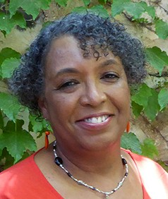
In His Service,

Linda D. McMurray
Wall of Prayer Coordinator

