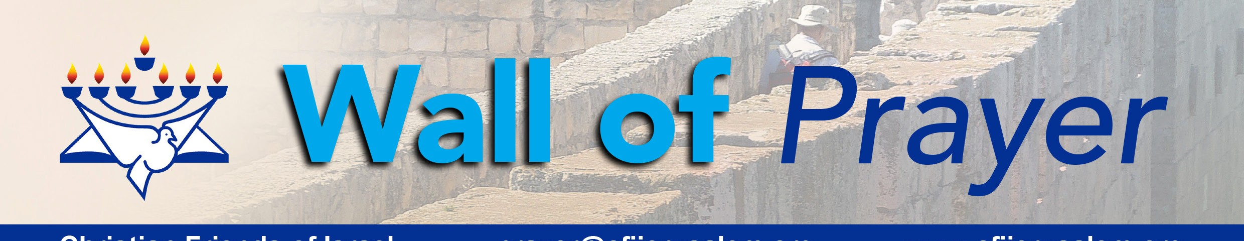
Christian Friends of Israel
prayer@cfijerusalem.org
www.cfijerusalem.org

March 2022 /Jewish Year 5782

Yesud HaMa’ala and the Hula Valley
“And it will be said, ‘Build up, build up, prepare the way, remove every obstacle from the way of My people’” Isaiah 57:14 NASB.

Yesud HaMa’ala is a moshava (colony) situated in northern Israel in the Hula Valley built in 1883 during the First Aliyah (wave of immigration). It was one of the first modern agricultural Jewish communities. A moshava is different from a moshav. In a moshava, all the land and property are privately owned, while the kibbutz and the moshav have collective ownership. A Christian Zionist, Laurence Oliphant, gave a large donation to help prepare the way for the founding pioneers of Yesud HaMa’ala.
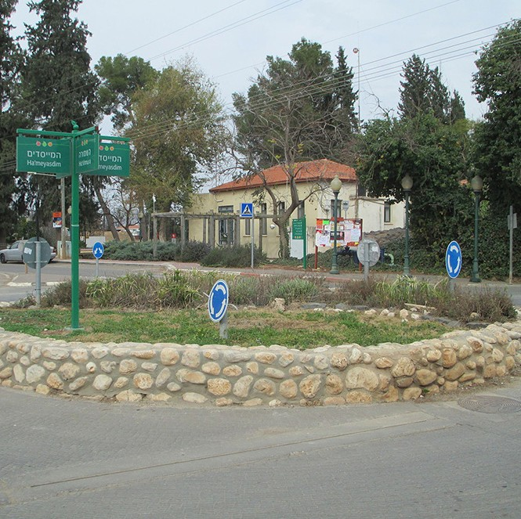
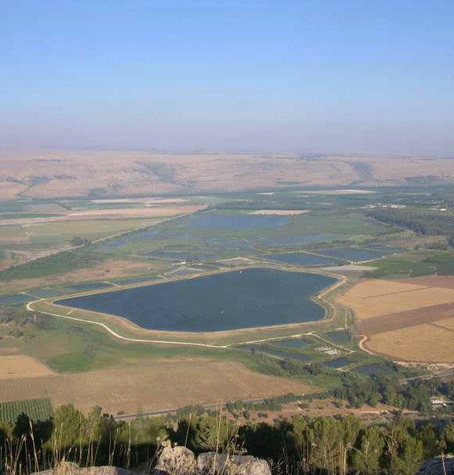
Yesud Hama’ala (CC BY-SA 4.0, by Dr. Avishai Teicher, Wikipedia) The Hula National Reserve (CC BY-SA 4.0, Wikipedia)

In the late 19th century, the Hula Valley consisted mainly of swampland and the 15,000-acre (61 km²) shallow Lake Hula. Rice and papyrus readily grew there. However, this region was also a well-known breeding ground for mosquitoes. Unfortunately, malaria ravaged the new community, so concerns about malaria obstructed further Jewish settlement in the area for over fifty years. By the 1920s, drainage technology and pesticides had been developed, which made moving to the Hula Valley more feasible.

This valley, near the Golan Heights, was and continues to be a contested area. Since the early 1800s, nations that controlled the Hula Valley wanted to drain the swamp, but various wars hindered the process. The Hula draining project did not materialize until after the State of Israel was established in 1948. The goal of the project was to gain more land suitable for growing crops and to eliminate malaria. Israel began the draining operation in 1951 and completed it in 1958. The obstacle to living in the Hula Valley was removed, which was an amazing feat for a young nation. It was made possible by the hand of God empowering His People! Since that time, Israel has made ongoing improvements in the Hula Valley to maintain balance in the ecosystem. In 1993, Israel initiated the Hula Restoration Project by installing pipelines to divert swamp water into the new Einan Reservoir for crop irrigation. They also created a small shallow lake called Lake Agmon. They stocked the lake with plants, fish, and birdlife and surrounded it with green pastures and grazing safari animals to serve as a center for eco-tourism and recreation. The former swamp has become a beautiful tourist attraction.

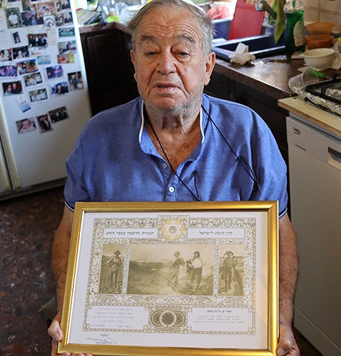
Yesud HaMa’ala’s proximity to Golan Heights has sometimes placed it in the crossfires of skirmishes. In 1964, Syria attacked Israeli farming and fishing activities in the region. Three years later, Syrian forces were driven further from Yesud HaMa’ala when Israel captured the Golan Heights during the 1967 Six-Day War. Hezbollah struck Yesud HaMa’ala during the 2006 Lebanon War, lightly wounding one person, thankfully there were no casualties. One of Israel’s strategic military strongholds is located at the northern Golan Heights border on Mount Bental, so Yesud HaMa’ala residents are quickly alerted if there is danger (Jewish Virtual Library, Jewish Gen KehilaLink, Wikipedia, Jerusalem Post).

Our friend, Arik Lubovsky, a long-time resident of Yesud HaMa’ala, remembers his assistance to immigrants years ago as they made Israel their new home. He proudly displays a certificate of honor from the State of Israel for his outstanding humanitarian service. May others follow Arik’s example of helping the newcomers.

Praying for the Hula Valley
- Praise the Lord for His eternal promises, which we can always trust. He has promised to call for His Jewish children to come home to Israel. Nothing can withstand the voice of God! “I will say to the north, ‘Give them up!’ and to the south, ‘Don’t hold them back! Bring my sons from far away, and my daughters from the ends of the earth’ ” (Isaiah 43:6, CJB).

- Thank God for His promise to protect Israel. As we pray for wisdom and alertness for the vigilant IDF and their state-of-the-art technology, we must realize that the Lord is the ultimate protector. “A Song of Ascents. Of Solomon. Unless Adonai builds the house, the builders labor in vain. Unless Adonai watches over the city, the watchman stands guard in vain” (Psalm 127:1, TLV).

- Ask God to awaken Jewish people to the importance of His word. The Lord has blessed them to become leaders in many technological areas. Their prominence comes from Him and is maintained by obedience to His word. “The Lord your God will make you leaders, not followers. Pay attention to His com- mands that I’m giving you today. Be careful to obey them. Then you will always be on top. You will never be on the bottom” (Deuteronomy 28:13, NIRV).

- Intercede for the new olim (immigrants) who have already arrived in Israel or are preparing to come. Some may have experienced trauma and need comfort and healing, as well as physical necessities. Other potential olim may not be in danger but are wrestling with the decision as to whether they should make aliyah. Please pray for God’s surrounding presence and safe passage for all. “The Angel of the Lord encamps around those who fear Him, and rescues them” (Psalm 34:7, HCSB).

- Please pray that Christians will realize and align themselves with God’s plan for Gentiles to assist Jewish people in making aliyah. His word reads, “This is what the Lord God says, ‘Listen carefully, I will lift up My hand to the [Gentile] nations and set up My banner to the peoples, and they will bring your sons in the fold of their garments, and your daughters will be carried on their shoulders” (Isaiah 49:22, AMP).
To Our Dear Prayer Warriors,
This is the time for intense prayers on behalf of Israel and the nations. As friends of Israel, we have the oppor- tunity to step forward and show our ongoing love toward one another. Proverbs 17:17, CJB, says, “A friend shows his friendship at all times – it is for adversity that [such] a brother is born.”
It was such a pleasure to travel to Brazil and pray with my faithful brothers and sisters there. May we continue to stand together in love.

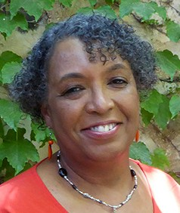
Shalom,

Linda D. McMurray
Wall of Prayer Supervisor

