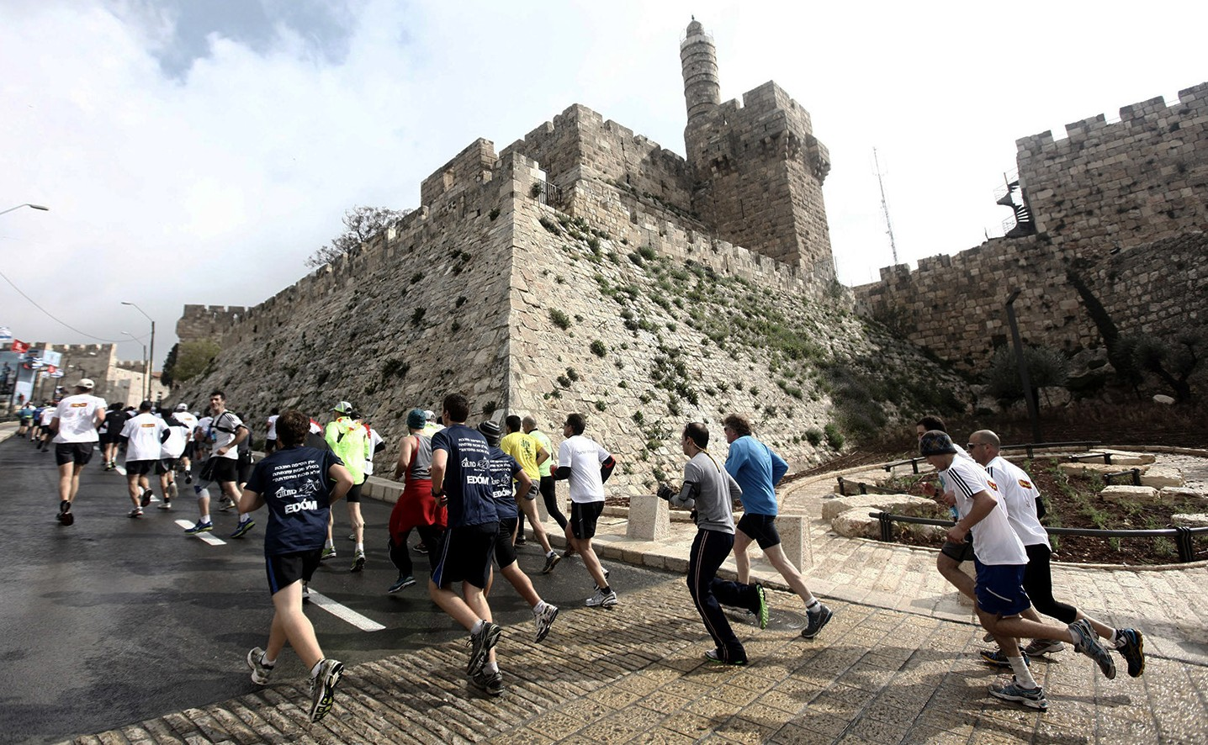
in

Prayer Letter
Watchman’s

Christian Friends of Israel prayer@cfijerusalem.org www.cfijerusalem.org
February 2022 /Jewish Year 5782
ENDURANCE
“Let us run with endurance the race set before us, focusing on Yeshua, the initiator and perfecter of faith. For the joy set before Him, He endured the cross, disregarding its shame; and He has taken His seat at the right hand of the throne of God” (Hebrews 12:1-2, TLV).

On October 29, 2021, over 17,000 runners participated in the 10th International Jerusalem Marathon. This annual event resumed after a year of stoppage due to the coronavirus pandemic. The marathon featured several contests: the Community Race (800 meters), Family race (1.7 kilometers), 5-kilometer Competitive Race, 10-kilometer Competitive Race, Half Marathon (21.1 kilometers), and the Full Marathon (42.2 kilometers). Runners of all ages and abilities participated. The competitive races and marathon course consisted of several steep inclines, including running up Mount Scopus. Runners needed different sets of skills and stamina to complete the community race (almost .5 miles) in comparison to the marathon (26.2 miles), which required special endurance training.

Jerusalem Marathon (CC BY 2.0, Wikipedia)

Derek Prince said, “Endurance is an essential character trait a person must have to survive and be successful in the Christian life.” It is defined as “the ability to withstand hardship or adversity” and “the ability to keep doing something difficult, unpleasant, or painful for a long time.” If endurance is vital, how does a person acquire this trait? In his letter to Jewish believers, Apostle Paul compared a victorious Christian life to a marathon race (Hebrews 12). Marathon runners gain endurance by continually disciplining their bodies with rigorous exercise and long-distance running. It is the physical hardship they endure that produces stamina. This same discipline applies in our spiritual lives. In James 1:2-4, the Apostle James explains how to gain spiritual endurance. He says, “Consider it nothing but joy, my brothers and sisters, whenever you fall into various trials. Be assured

that the testing of your faith [through experience] produces endurance [leading to spiritual maturity and inner peace]. And let endurance have its perfect result and do a thorough work, so that you may be perfect and completely developed [in your faith], lacking in nothing.”

Paul confirms the same principle as James in Romans 5:3-5 where he states that going through hardships produces endurance; endurance builds strong Christian character, and Christian character generates hope, an attitude of confident expectation. Like disciplined runners, believers with spiritual stamina can push past their pain, ignore the tumult around them, focus, and keep moving forward until they reach their goal of pleasing God. Going against the grain of societal norms to follow God’s Word may feel like you are running uphill, but you can succeed by His power. Yeshua is our most outstanding example of endurance. In exchange for obtaining the prize of salvation for humanity, He chose to disregard shameful injustices and endured unde- served scorn, hostility, and finally death on the Cross.

During the Jerusalem Marathon, I noticed that one runner was physically tethered to another, while most were running in groups for encouragement and strength. After a crowd of runners passed, one man came slowly plodding along by himself. He was visibly tired. While cheering on the sideline, I found myself calling out to him, “Chazak! Chazak!” (Be strong! Be strong!). That encouragement was like a shot of adrenaline to him because he immediately lifted his knees, pushed out his chest, raised his head, and began to run with vigor. As I continued to call out those words to other runners, the man on the loudspeaker nearby began echoing the same words. Do you need more spiritual stamina to stay focused as you continue moving forward? I say to you, “Chazak! Chazak!” Is there someone you can encourage to endure hardship until they reach the finish line? If so, please inspire them, and you will be blessed in return.

Praying for Endurance
- Praise the Lord for the strength He gives when people focus on Him instead of their circumstances. As we persevere in this race, let’s fix our gaze on Him and pray that others will do the same. “I will raise my eyes to the mountains; from where will my help come? My help comes from the Lord, who made heaven and earth” (Psalms 121:1-2, NASB).

- Pray that Israelis will rediscover the Word of God in homes where it has lain dormant or been rejected. Many people living in the Land of Israel do not know the God of Israel. Studying His Word and obeying what it says always brings wisdom, endurance, and life. “Study this Book of Instruction continually. Meditate on it day and night so you will be sure to obey everything written in it. Only then will you prosper and succeed in all you do” (Joshua 1:8, NLT). “It is the Spirit who gives life; the flesh is no help. The words I have spoken to you are Spirit and life” (John 6:63, CJB).

- Intercede for olim (immigrants) who are trying to adapt to life in Israeli society. Moving to another country is difficult, so please ask the Lord to give them the ability and endurance to learn Hebrew and find employment. Israel ranks 8th in the list of nations with the highest cost of living; please speak God’s promises to prosper the immigrants in your prayers. “‘I will rejoice over them to do them good and will faithfully plant them in this land with all My heart and all My soul. People will buy fields for money, sign and seal deeds, and call in witnesses in the land of Benjamin, in the areas surrounding Jerusalem, in the cities of Judah, in the cities of the hill country, in the cities of the lowland, and in the cities of the Negev; for I will restore their fortunes,’ declares the Lord” (Jeremiah 32:41, 44, NASB).

- Proclaim God’s word of encouragement over Believers who have been praying for their loved ones. Ask God to remind them that His promises are sure. “Then I will pour out a spirit of grace and prayer on the house of David and the residents of Jerusalem, and they will look at Me whom they pierced.” (Zechariah 12:10a, HCSB).

Dear Prayer Partners:
In these days of increased spiritual warfare, endurance is crucial. Let us run together, keeping our eyes on Yeshua, the Author of our faith and the One who brings our faith to completion.

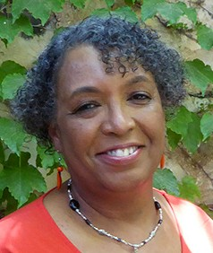
In His service,

Linda D. McMurray
Wall of Prayer Supervisor

