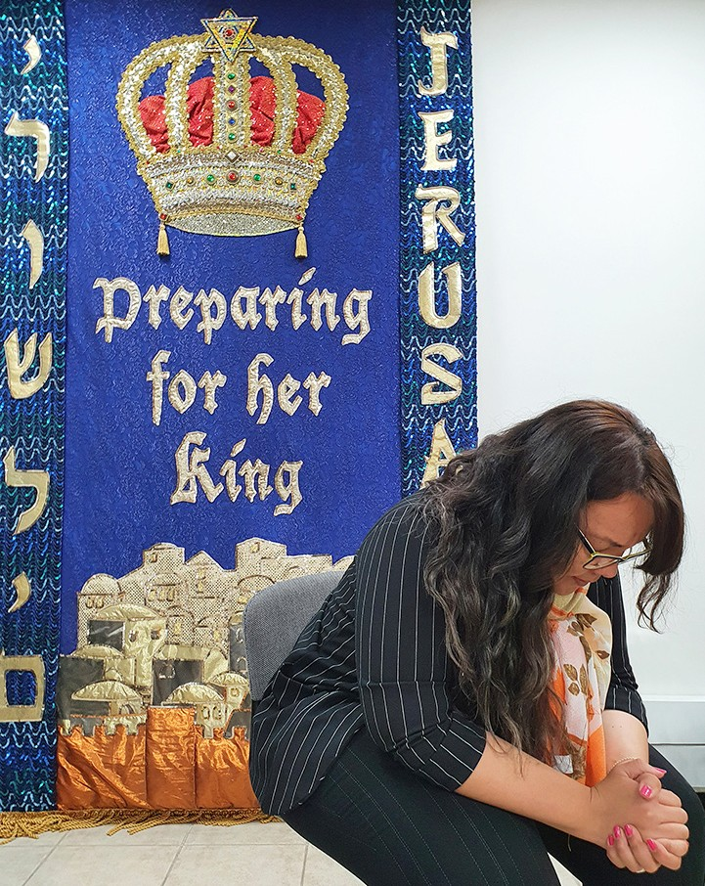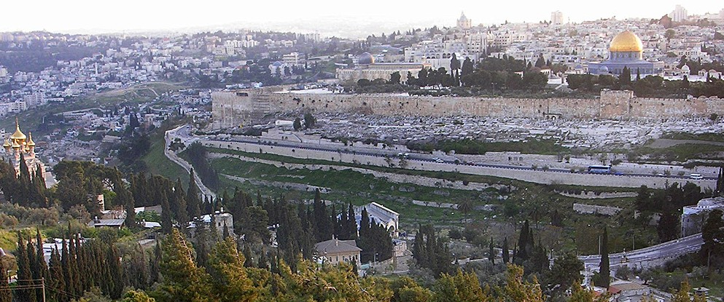
in

Prayer Letter
Watchman’s

Christian Friends of Israel prayer@cfijerusalem.org www.cfijerusalem.org
June 2021 /Jewish Year 5781
The Time of Shaking
“ ‘...My Spirit stands [firm and immovable] and continues with you; do not fear!’ For thus says the Lord of hosts, ‘...I am going to shake the heavens and the earth, the sea and the dry land. I will shake all the nations; and they will come with the desirable and precious things of all nations, and I will fill this house with glory and splendor,’ says the Lord of hosts.” (Haggai 2:5-7 AMP).

God has promised to restore honor and magnificence to Israel in the coming Messianic age. When Messiah Yeshua rules from Jerusalem, the entire world will be affected. It will be an era of peace among nations, and the earth itself will be in a state of wholeness and balance. At that time, even the animal kingdom will be tranquil as spoken of in Isaiah 11:6 (TLV), “The wolf will live with the lamb; …calf, young lion and fattened lamb together, with a little child to lead them. Cow and bear will feed together, … and the lion will eat straw like the ox.” It is with great anticipation that we peer into the future through the scriptures as we await the reign of the Prince of Peace.

As we read Haggai 2:5-7, we see that the time of righteousness and shalom is preceded by a period of great upheaval. The prophet Haggai describes it as a time of tremendous shaking. Before he explains this series of sudden worldwide disturbances, Haggai shares God’s word of consolation and stability; “My Spirit stands [firm and immovable] and continues with you; do not fear!” The Lord reminds us that He is steadfast and unshakable; only those things which are anchored in Him will remain unmoved. Anything that is not of Him will be forcefully moved. Shaking which displaces everything that is loose reminds me of an amusement park ride. You are strapped in a seat that continues to flip over. Anything that is not firmly secured is thrown around. Almighty God promised to be with us during the shaking period and commanded us not to be afraid. We must remain firmly connected to Him if we are to remain safe.

Many believe that we are already experiencing the beginnings of this unsettling of nations. Over the last year, COVID-19 has shaken the world leaving a trail of death and economic disaster. Governments (including the Knesset) are becoming unstable as their leaders battle for authority and economic power at the expense of their citizenry. Rampant corruption in high places is being exposed. At the writing of this newsletter, Hamas is clashing with the IDF and has unleashed over 200 rockets into Israel in the last 32 hours. Haggai describes this time of violent upheaval as affecting the skies, water, and land of all nations.

However, the prophecy does not end with the shaking of nations. God has an everlasting love for Israel. Jerusalem will be center stage in God’s plan for the world. Messiah will return and set up His Glorious King- dom. Representatives from the nations will pour into Israel offering their wealth and precious commodities for trade. All of the nations who withheld from her, by boycott and other censures, will be drawn to this small country because of the magnificent Prince of Peace who will usher in His reign of Shalom.

To stand in these times of shaking we must humble ourselves in repentance before the Lord, and allow Him to cleanse, direct, and draw us closer. Being anchored in the Word of God will keep us from being shaken, according to the scripture in Hebrews 12:27-28 (CJB Version) which says, “…the things shaken are removed, since they are created things, so that the things not shaken may remain. Therefore, since we have received an unshakeable Kingdom, let us have grace, through which we may offer service that will please God, with reverence and fear”.

Praying with Unshakable Faith
Although many things in our world are becoming unstable, our trust is in God who remains firm and unchange- able. Please join us in praying for Israel in her time of need.

- Praise God for His immutable character! He never changes and is always dependable. “Do you not know? Have you not heard? The Everlasting God, the Lord, the Creator of the ends of the earth does not become tired or grow weary; There is no searching of His understanding. He gives strength to the weary, and to him who has no might He increases power” (Isaiah 40:28-29 AMP).

- Worship the Lord for his is willingness to uphold Israel and all those who trust in Him. “Don’t be afraid, for I am with you; don’t be distressed, for I am your God. I give you strength, I give you help, I sup- port you with my victorious right hand” (Isaiah 41:10 CJB). We can have confidence in God’s Word and not be distressed by the instability or danger we see around us. “I always let the Lord guide me. Because he is at my right hand, I will not be shaken” (Psalm 16:8 CSB).

- Intercede for the IDF as they bravely defend Israel’s borders. Ask the Lord to protect them giving them alertness, skill, and His divine strategy. Please pray for a covering of peace over their minds so that they do not become victims of Post-Traumatic Stress Disorder (PTSD.) May they echo David’s words: “Lord, how my enemies have increased! Many are rising up against me…But You, Lord, are a shield around me, my glory, and the One who lifts my head… I will not be afraid of ten thousands of people who have set themselves against me all around” (Psalm 3:1-6 NASB).

- Call out to God to draw His people back to Himself. Ask the Bread of Life to give Israel a divine discontent
– a deep hunger that causes them to seek after Him for more. “Blessed are those who hunger and thirst for righteousness, for they shall be satisfied” (Matthew 5:6 TLV). “For everyone who asks receives, and the one who seeks finds, and to the one who knocks it shall be opened” (Matthew 7:8 TLV).

- Implore the Lord to reveal Himself to those Arabs who are opposing Him in ignorance. May He speak to them in dreams and visions calling them into His service. “…I will pour out My Spirit…Your old men will have dreams; your young men will see visions” (Joel 2:28 NASB).

- Rejoice for the wonderful future we have with the Lord! “In My Father’s house are many rooms … I am going there to prepare a place for you… I am coming again and will take you to Myself, so that where I am, there you also will be” (John 14:2-3 NASB).

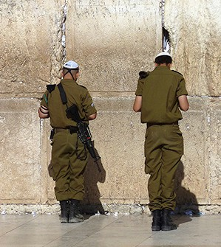
Dear Intercessors,
The battle is on! It is now in this time of shaking that we must anchor our lives more firmly in God – not allowing the instabil- ity of our world to shake our trust in Him. More than ever, our private time spent in the presence of the Lord is crucial. Many of our houses of worship are no longer gathering in person so the fellowship and strength that was gained from meeting together must flow directly from time in His Face. May we leave from those special times spent with Him with a glow on our faces and an unshakable resolve in our Spirits. “Even when I am afraid, I still trust you.” (Psalm 56:3 GW)

In His Love,

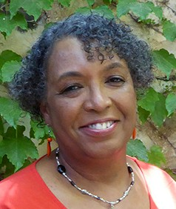
Linda D. McMurray
Wall of Prayer Supervisor

