Haifa (פה
May 2021 /Jewish Year 5781

חֵי) A City of Distinction

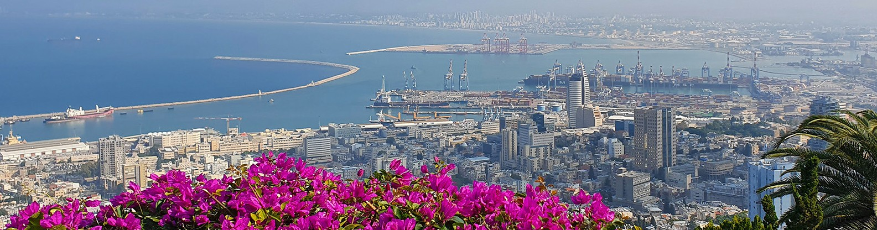

One of the many jewels of Israel is the beautiful, cosmopolitan city of Haifa. During a visit there with my Jewish friends, Ilan and Lori, I discovered some of its unique distinctions. It is a clean, green city built on the side of a hill that extends from the shores of the Mediterranean Sea up the slope of Mount Carmel and is crowned by the high-rise University of Haifa. This city is Israel’s largest major seaport located on the Mediterranean coastline in the Bay of Haifa. From lofty Mount Carmel, Ilan proudly displayed the breathtaking panorama of the sea as seen from his beloved hometown, Haifa.

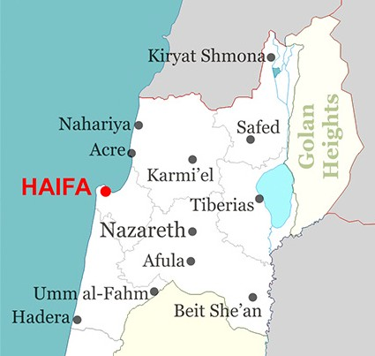Haifa is the third-largest city in Israel – after Jerusalem and Tel Aviv – with a population of 285,316 in 2019. As of 2016, covering 63.7 square kilometers (24.6 square miles), it lies about 90 kilometers (56 miles) north of Tel Aviv and is the major regional center of northern Israel.

Haifa (CC BY 3.0, Wikipedia)
Although Haifa does not appear in the Bible, it is mentioned in other ancient Jewish literature as a well-established seaport city. Over thousands of years, this area has changed hands several times: being conquered and ruled by the Canaanites, Israelites, Phoenicians, Persians, Hasmoneans, Romans, Byzantines, Arabs, Crusaders, Ottomans, and the British. By the sovereign hand of God, Haifa again became a part of Israel in 1948 when the nation was officially established. The influences of all these various cultures are still seen in this city today.

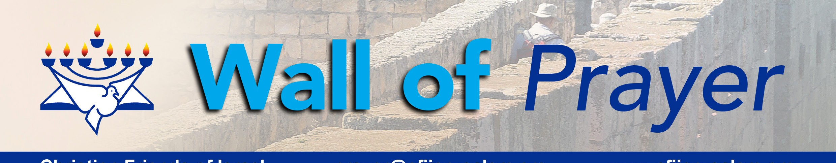
Christian Friends of Israel
prayer@cfijerusalem.org
www.cfijerusalem.org
The Haifa municipality plays an important role in Israel’s economy. It is home to Matam, one of the oldest and largest high-tech parks in the country, and to the prestigious Technion, Israel Institute of Technology. Haifa Bay is a center of heavy industry, petroleum refining and chemical processing, and it produces cement, electronic equipment, glass, steel and textiles. Haifa also has the distinction of owning the only underground rapid transit system located in Israel, known as the Carmelit.

Haifa is a diverse, tolerant, and largely secular metropolis that differs from many other cities in the Holy Land. It has always had a large Arab population and today, is one of the few places in Israel where Jews and Arabs are in regular contact and make genuine efforts to promote coexistence. Others have also found this to be a comfortable place to live including a few Orthodox Jews and some Believers. Haifa is the world headquarters for the Baha’i faith, whose golden-domed shrine of the Bab and gardens are part of the outstanding landmarks in the city. It is a destination for many Baha’i pilgrimages. This municipality is a cultural mecca with its own symphony orchestra, theaters, museums and a zoo. It was surprising to learn that this is the only city in Israel where the buses run on Shabbat (the Sabbath) and where many businesses stay open. Haifa is a port city where people from various parts of the world enter bringing their goods and their ideologies into the Holy Land. (Jewish Virtual Library; Wikipedia)

Another of the famous attractions in Haifa is the entrance to Elijah’s cave. According to Byzantine tradition, this is where Elijah, the Prophet hid to escape the wrath of King Ahab. The site is celebrated by Christians, Muslims and Jews. (Jewish Virtual Library) Scripture tells us the Israelites began worshiping the idol Baal, at the insistence of Jezebel, King Ahab’s wife. Elijah stressed exclusive worship of the God of Israel as the only true God. As God’s punishment for the worship of Baal, Elijah prophesied a great drought, which lasted three and a half years. (I Kings16:29-33)

According to the Biblical account (I Kings 18-19), Elijah staged a contest of power to demonstrate who was the true God. A sacrificial bull was placed on the altar and four hundred and fifty prophets of Baal called on their god to deliver fire, but with no result. Then, Elijah’s prayers were answered as his bull was consumed by fire from heaven. The people recognized the power of the God of Israel and began to cry out, “The Lord, He [alone] is God” (Adonai, hu ha-Elohim)” [I Kings 18:39]. Rain begins to fall, ending the drought. In this manner, the preeminence of the God of Abraham, Isaac and Jacob was manifested on Mount Carmel; His authority has never diminished!

Oh, that the secular residents in Haifa and those embracing false beliefs today would come to the same conclusion as the Israelites did on Mount Carmel in Elijah’s day! The Word of God has promised that they will at the appointed time.
Praying for Haifa

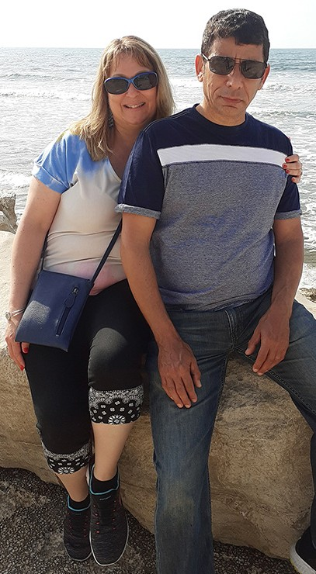
Lori & Ilan - Haifa on Mediterranen

- Magnify the Lord for His supremacy above everything! Although other gods are being worshipped in the Holy Land, there is only one true God – the God of Abraham, Isaac, and Jacob. “Are there any gods like you, Lord? There are no gods like you. You are wonderfully holy, amazingly powerful, a worker of miracles” (Exodus 15:11 NCV).

- Praise God for His unfailing promise to awaken Israel to His true identity. “Then I will pour out on the house of David …a spirit of grace and supplication, when they will look toward Me whom they pierced. They will mourn for him as one mourns for an only son and grieve bitterly for him, as one grieves for a firstborn” (Zechariah 12:10 NIV).

- Interced for the people of Haifa and the surrounding area. We are thankful for their ability to live peaceably with those around them. “If it is possible, as far as it depends on you, live at peace with everyone” (Romans 12:18 NIV). Please pray that they will be spiritually alert and not be lulled into apathy by the influences of mindsets around them. Please lift up the Believers in Haifa so that they will continue to be salt and light to those with whom they have contact. May their light draw others to the Light of the World. “You are the light of the world. A city set on a hill cannot be hidden… let your light shine before men so they may see your good works and glorify your Father in heaven” (Matthew 5:14-16 TLV).

Dear Prayer Partners:
It is such a joy to hear from many of you as you contact us and/or pray with us on the various prayer calls. With each month, we are becoming a closer family. “It is good and pleasant when God’s people live together in peace!” Psalms 133:1.

Thank you for your continual prayers for Israel. I love seeing your faces on the Israel Watch prayer map above my desk. When we look at your faces, we also pray for you as you stand for Israel in your nations. Jewish visitors that come into the Jerusalem office are always impressed that people from across the world love them and are praying for them. If you would like to add your photo to the map, you are welcome to send them to prayer@cfijerusalem.org. May the Lord grant you power, perseverance, and peace.

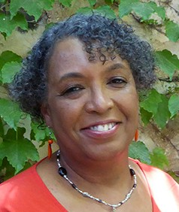
In His Love,
Linda D. McMurray
Wall of Prayer Supervisor

