May 2020 /Jewish Year 5780
SEARCHING THE SCRIPTURES
The Importance of Study
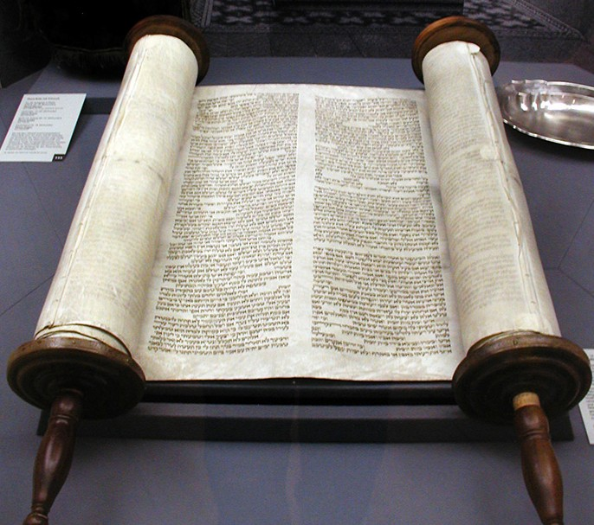
WILL YOU STUDY TORAH WITH ME?
Unless one is given the opportunity to spend years with dear Jewish friends, such as an Orthodox Rabbi, I think it is difficult for a gentile to know the depth of the love of some of the Jewish people for God Almighty. I had the privilege of being friends with a Rabbi who visited our CFI offices in the early days and he ended up spending 18 years with us becoming as a father/grandfather to all of us. There was a special love God gave him for us, and to each of us for him and we found ourselves discussing and talking about everything we all wanted to, without offence or

fear of one another. This is true friendship. I will always cherish those years. The intensity in which Rabbi Yaacov prayed stirred my spirit. The passionate
Torah scroll at old Glockengasse Synagogue, Cologne. (by Zeughaus, CC BY-SA 4.0, Wikimedia)

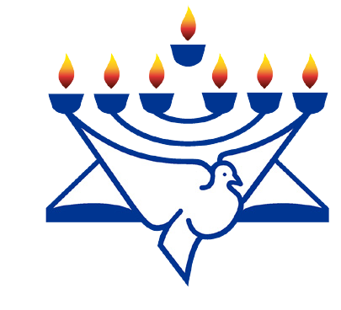love He expressed for the Father in Heaven was inspiring and the knowledge He had of the Hebrew scriptures was amazing. I had a Christian leader from S. Korea once ask me “how can you be friends with someone like that or ask them to speak at your conference...the Jews know nothing.” I will never forget the arrogance that came with that statement and I wanted to say “You have never known a deep relationship and friendship like I have experienced in the Jewish world I live in, how can you make that kind of a judgment?”. And, to say they “know nothing”? On the other hand a Pastor who worked with us for two years told to me “I’ve preached from the pulpit in my church for over 25 years, and after coming to Israel and meeting some of the Jewish people who love the God of Israel, I cannot hold a candle to their knowledge and understanding of the Bible!”. Now who was right? God is the Judge. But I know this, before the passing of our dear Yaacov, he told me “I have made my heart right with God and when I meet Him, I will ask Him “Will you study Torah with me?” His love for God’s Word was amazing and awe inspiring. Oh, that we would have such a love for the Sacred Scriptures as Yaacov had, then we would easily “raise the bar” of our understanding of who Jesus was: a Jew in-the-flesh and the words He spoke were from the Torah, the Jewish Scriptures. As Lance Lambert would say, “Let us love the ‘whole counsel of God’ not just part of it.” Let’s dig deeper into the Word of God and learn much by finding the meanings behind the words. To learn in Hebrew is lomedet. We learn also in Hebrew Anachnu Lomdim (masc.) or Anachnu Lomdot (fem). There are various forms of the word such as limud meaning class, learning, studies. Lehilamed which means to be taught, lelamed meaning to teach or tutor. A few more “forms” would be Lehitlamed meaning to study or to teach oneself, and lamud which actually means educated, learned; well versed, experienced, knowledgeable. I think all Christians might be surprised at the amount of depth
RaisingThe Bar
Christian Friends of Israel
prayer@cfijerusalem.org
www.cfijerusalem.org

of understanding of God’s Word from the Hebrew which many Jewish friends have. If Christians would only study and know the Bible as well, that would be a wonderful progress we would be making in spiritual maturity and fulness. First Fruits of Zion tells us that “Moses searched carefully for the goat of the sin offering, and behold, it has been burned up!”. The words “searched carefully” translate the repeated Hebrew verb darash meaning “to search”. It indicates a diligent search. The Torah (called the “Old” Testament) by Christians actually commands us to study the Torah (Deuteronomy 6:7). To be able to teach it, one must study it first. As we diligently search the Torah, we find Him. Right at the very center of the Torah are the words “Search, search!”. The same words can be understood to mean, “Study, study!” “... One must never stop studying and seeking ever deeper and broader understanding of the Torah” (Degel Machaneh Ephraim).

Let’s Enter the Throne Room of Prayer Together
- Pray for Israeli’s leaders to come to true unity that all the people might recall the blessings of the Lord God of Israel to His People. “When leaders lead in Israel, when the people willingly offer themselves, Bless the Lord!” (Judges 5:2). “My heart is with the rulers of Israel...” (Judges 5:9).

- Remain steadfastly in prayer for the People of Israel, as they face anti-semitism in the world and vowed enemies on nearly every side. “...continuing steadfastly in prayer” (Romans 12:12).

- Thank the Lord Israel is easing out of the total lockdown and getting its people back to work and the economy going again. Praise to the Lord!

- Give God Glory that surveys in Israel recently showed (as Israel celebrated its 72nd Independence Day) that a majority of the public feel part of the State of Israel and shares in its problems. Trust in public officials, government health officials and trust in the Prime Minister has risen. Thank the Lord also that there has been overall decline in peoples’ stress levels during the coronavirus epidemic. We also need to rejoice in God Our Salvation, who has given a good report from the vast majority of Arab citizens that feel they belong in the Jewish State of Israel in a report published before the Independence Day celebra- tions here. 77% of Arab citizens feel a part of the nation and 35-62% felt a sense of belong- ing. (Israel Today information).

- Beseech His Face that the People of Israel will see that the Real Leader of Israel is the God of Israel, and not man. “But Gideon said to them, I will not rule over you, nor shall my son rule over you; the Lord shall rule over you” (Judges 8:23).

- Claim His Promises that God will hide Israel in the shelter of the Most High God during the coming year and a second wave of virus would not come in the winter, comprised of both coronavirus and the flu. “He who dwells in the secret place of the Most High shall abide under the shadow of the Almighty...under His wings you shall take refuge... you shall not be afraid...of the pestilence that walks in darkness...” (Read Psalm 91).

None of us know what tomorrow holds, but God does know. Trusting in HIM will bring us all the peace and security we need to face the future days with courage and confidence in Him. There is so much to thank God for, it’s time we all count our blessings and move forward for His Plans and Purposes for the Nation of Israel.

Serving Him Together,
Sharon Sanders
Christian Friends of Israel - Jerusalem

