July 10, 2022 /Jewish Year 5782

Natural Gas Bonanza?
Euro energy squeeze gives Israeli and Egyptian partners economic boost!

There is precious treasure and oil in the house of the wise [who prepare for the future]. Proverbs 21:20a

Most western nations have an embargo in place against Russia due to the special military action taking place in Ukraine. In response to E.U. support of the resistance to Russia’s invasion, Russia has cut the fuel exported to Germany. This sequence of events is giving the Israeli government the ability to provide natural gas resources to Western Europe that were previously dependent on natural gas from Russia, along with its Mediterranean economic partner Egypt. Israel can now make major economic strides and even compete with energy super suppliers such as Qatar and Saudi Arabia with respect to attracting international capital into the nation. This is good news for the post-virus financial outlook of the land overall, and places Israel in a position of world prominence in yet another category. This characteristic is added to technological and agricultural innovation, humanitarian, and medical benevolent support for other nations regarding disasters, and a reputation for archaeological discovery and historical preservation, that is copied around the world.

“This is what the LORD, your Redeemer, the Holy One of Israel says, ‘I am the LORD your God, who teaches you to profit (benefit), Who leads you in the way that you should go’” Isaiah 48:17(AMP).

The main offshore facility supplying the natural gas through Egypt for the liquification process prior to European transport, is adjacent to the disputed maritime boundary between Israel and Lebanon. This will not affect the deal directly, but it may shed light on future conflicts that Israel may face based on prophetic biblical interpretation and the reasons why; envy and covetousness. The majority Muslim nations that surround Israel and currently remain in a state of war with her to this day, operate in situations between failed economies and even fractured political structures. These nations tend to accuse Israel of co-opting their resources directly or they make an
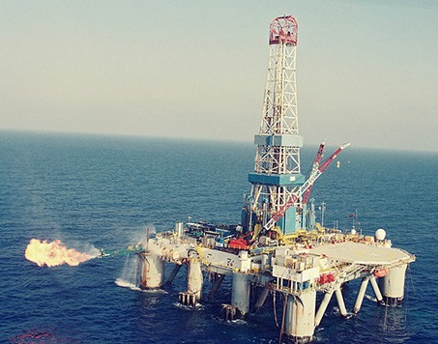
indirect claim on these resources because the land (and in this case the seas that surround it) “rightfully” belongs to the Palestinian populations that are currently “confined” to Gaza and areas in Judea and Samaria. Hezbollah in Lebanon, Houthis in Yemen and Hamas in Gaza would contend that the wealth Israeli companies currently possess should be in the hands of Palestinian Arabs. Passages in Ezekiel indicate that a future war in this region directed against God’s people will have to do with RESOURCES, and not competing religious belief systems. Iran and Turkey are also facing severe economic pressure which will easily provoke angst when compared with Israel. Adding Russia to this group of those who will have a bone to pick with Israeli economic success, frames a conflict scenario

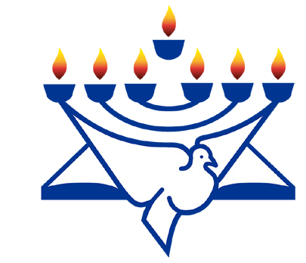Noa natural gas field, offshore Ashkelon (CC BY-SA 3.0, Wikipedia)
CFI News Insights
Christian Friends of Israel
feedback@cfijerusalem.org
www.cfijerusalem.org
foretold almost 3 millennia ago.

Believers should be encouraged that Israel is taking center stage on the world platform and what that means in reference to the infallibility of the Word of God and His perfect will, for not only Israel, but all of us who worship the God of Israel!

Reporting from Jerusalem,
Kim S. Brunson

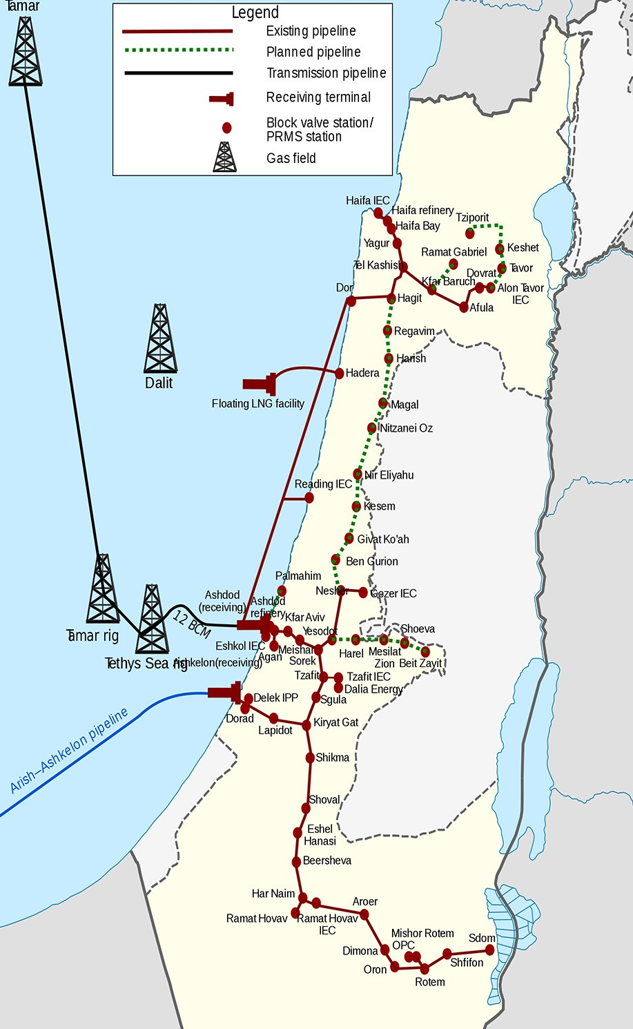
Israeli natural gas lines network map (CC BY-SA 4.0, by Fjmustak, Wikipedia)

