



CFI Projects Monthly Reports for
International
Representatives

Dear CFI International Representative Family,

Thank you for your continued support of the Outreach efforts of Christian Friends of Israel. We continue to strive to encourage those in need and to offer practical assistance during times of struggle. It’s during these times when relationships can be formed which please God and allow us to show Compassion to those who need it the most and have possibly never experienced it before.

During this time of global pandemic, we continue to offer assistance as we are able, and we know each passing day may allow for additional hardships, but we also know the God whom we serve. He is more than able to protect, and provide and heal. We are willing to represent Him to the people of Israel.

Please receive the CFI Outreach electronic updates as a reminder
of the impact each of you have in the lives of so many. We are grateful to represent those of you in the Nations - to those in the Land of Israel.

A friend loves at all times, And a brother is born for adversity.

Proverbs 17:17 (NKJV)

Project Forsake Them Not

Would you like to come along with me today? I will take you to visit some of our precious friends. We haven’t seen each other for almost a year, and we made visitation a priority as soon as the latest lockdown was eased. We, as well as them, are very excited to see each other again, and to exchange news as good old friends do. You know, it is a wonderful quality of friendship – to pick it up, where you dropped
it last, without feeling a distance, and just enjoy every minute of precious time together. The kind of time that refreshes like cold water, on a hot and weary day, and feels so sweet and lovely.

We travelled to Kiryat Gat, in the South of Israel. Nikolay and Anna just celebrated their 58th wedding anniversary. We ring the bell of their apartment and their daughter Mila, who made Aliya (immigrated to Israel) last year, opens the door for us. She welcomes us in and Nikolay comes out to greet us. He is walking slowly with his walker, but with a big smile. Sadly, we can’t exchange hugs; nevertheless the
joy at seeing each other is limitless. Bella, their granddaughter who studies from home now, runs out to greet us too – she has just had her birthday, and wants to share a few sweets with us! Mila makes us delicious coffee with whipped cream, and we settle down for fellowship.
There is a lot of catching up to do, and we are glad we are finally able to meet. After five months in hospital and a rehabilitation centre, Nikolay made it home just on Anna’s 80th birthday – oh, how he was pleading with the doctors to let him go home for such a special occasion! His one leg was unexpectedly amputated because of Diabetes, but he did not give up on learning to walk with proteases again. Anna was always strong and looking after everyone in the family, but Nikolay’s sudden sickness broke her heart and caused deep depression. She doesn’t come out to greet us, and we are not sure if she will join us. But she does! First very quietly, but soon she starts smiling and taking part in our conversation. We speak of the faithfulness of God and about a grateful heart, recalling all the miracles and thanking Him for all the provision. The atmosphere changes, the room fills with life and hope. Anna is talking and laughing – she is herself again! Three hours pass unnoticed, but our hearts are full of joy and gratitude. We agree to meet again soon.
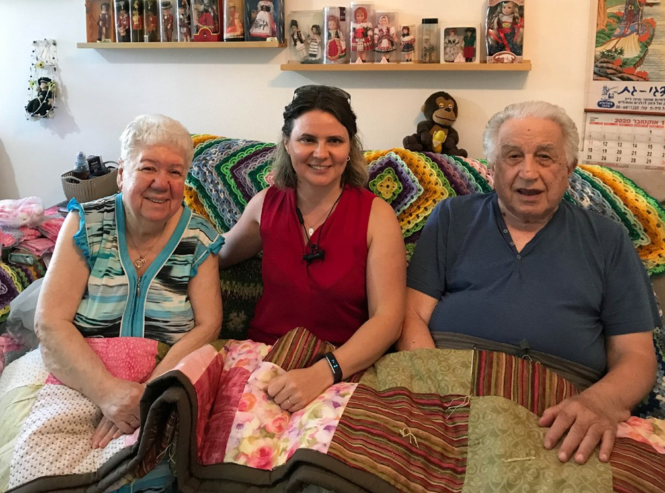
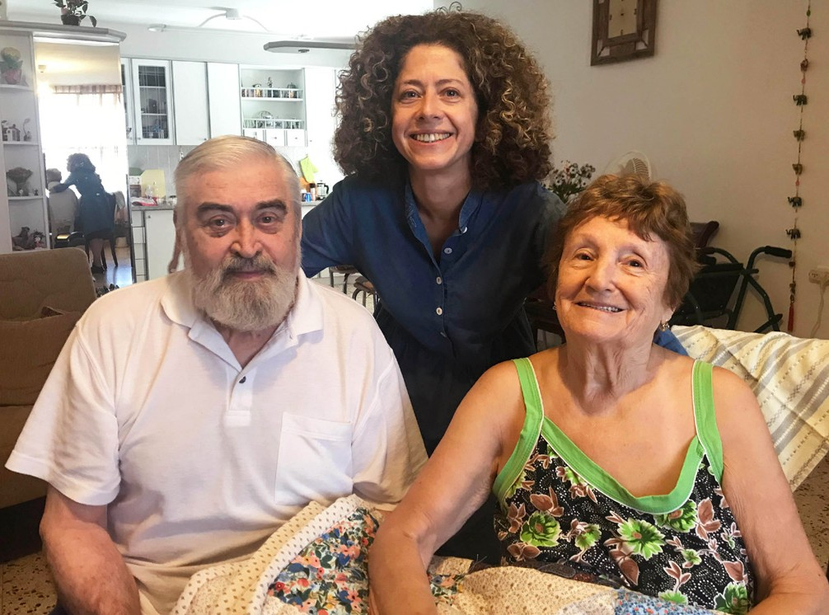

Our second visit is with Shmuel and Batya, our very old friends, just a few days after Shmuel’s 88th birthday. Their apartment is packed with flowers and cards. Batya immediately starts sharing their news – she is usually a talker, while Shmuel peacefully reclines in his soft chair. Now they have seven great grandchildren and one on the way. Batya is a very artistic woman, and she enjoys many different crafts. She has known how to knit from childhood, and everything in her house, clothes, covers and table-cloths, are all made by her. She has also knitted beautiful small clothes for a coming great grand-

daughter and excitedly shows them to us. This time we brought a handmade quilt we just recently received from our friends in America, and Batya is very happy - she so appreciates handmade items,
as she knows the cost of it. She also shows us a beautiful knitted blanket – it was our first gift for Shmuel over 15 years ago! She didn’t only keep it so well all those years, but that blanket encouraged her to learn new knitting techniques! She knitted several dozens of different blankets since, for her entire family and friends. Both, Shmuel and Batya were so happy that day! Nobody apart from their children visited them in past 6 months, and they are hungry for fellowship and good company. Batya, though walking very slowly, walks with us outside the door, and is a little sad to see us leaving. “You cannot even imagine what your visit today meant for us,” she says quietly.
Batya is right, we cannot imagine indeed, but how grateful we are for the privilege to bring joy and hope into the lonely routines of our precious friends. Tired, but happy, we head back to Jerusalem, praising the Lord and praying for those whom we visited.
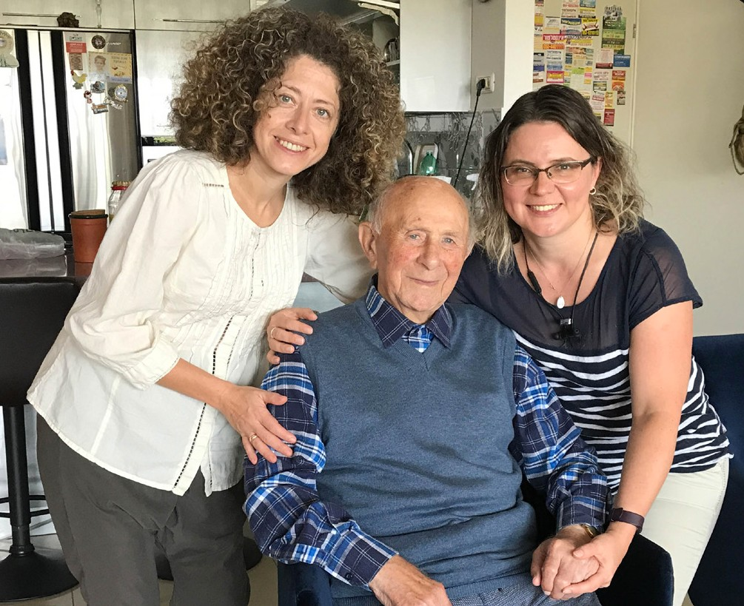
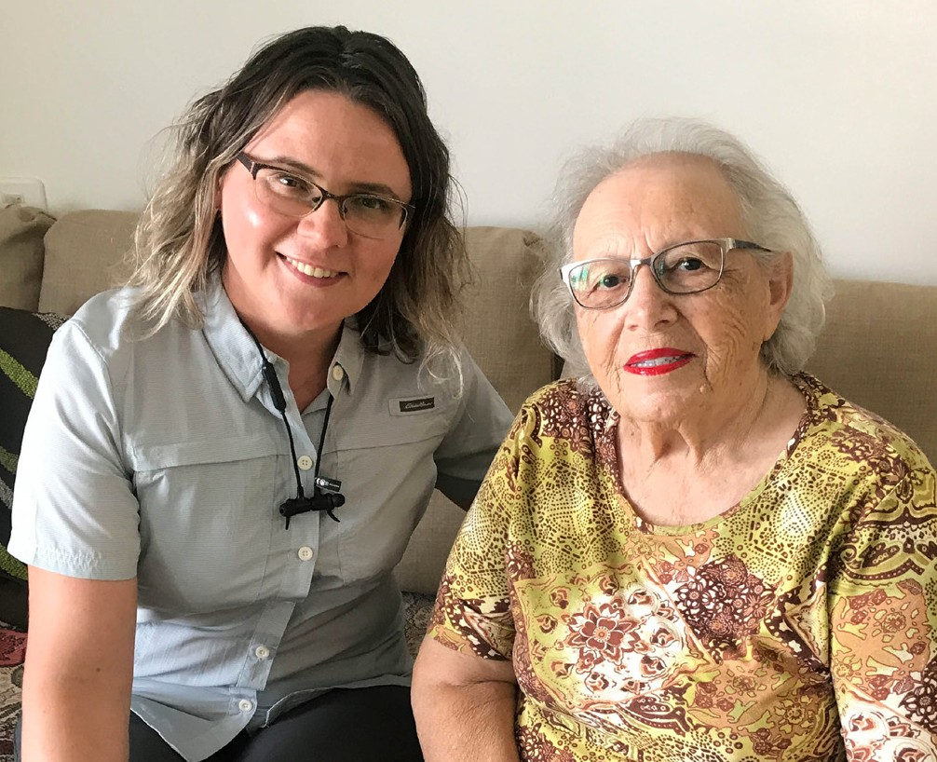

Thank you for joining us today! Thank you so very much for making it possible for us to travel to the different parts of Israel, to bring God’s love and comfort. Thank you for entrusting us to be your feet and your heart. We greatly appreciate your support in these uneasy and urgent times.

“Sing, O heavens! Be joyful, O earth! and break out in singing, O mountains! For the Lord has comforted His people, and will have mercy on His afflicted” (Isaiah 49:13).

Olga Kopilova Project Supervisor

Project Open Gates

Shalom from Jerusalem!

The winter season has started here in Israel. It has been raining already several times. Nature is happy and fresh. The ground has become green. Recently there was a huge rain of blessings here at our CFI distribution center. We received a container full of clothing from our friends and supporters from Colorado, USA. This was an answer to my prayers. Now we are able to receive and bless many new emigrants and other people, who are already calling and asking for an appointment.

We saw God’s hand on the day that the container arrived. While we were unloading the truck the weather was cloudy. When we started to bring a huge amount of boxes into the building, the weather got worse. After the last boxes were inside and we started to eat lunch together it started to rain. God is so Good and Faithful!
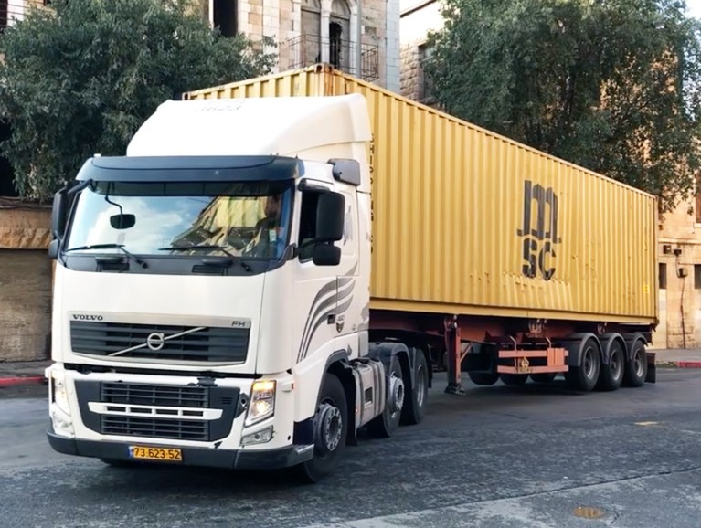
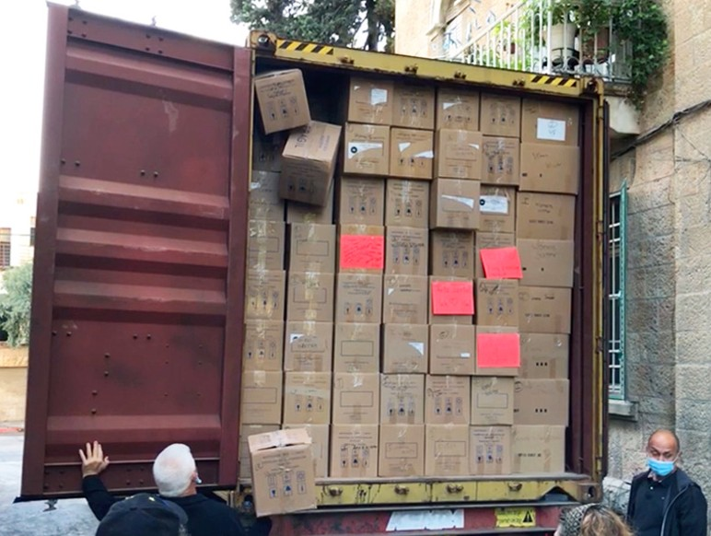

It is a pleasure to see different faces here after the month of the corona lockdown. People still come in one by one. Yesterday I served a couple that made Aliyah from the United States. They were not young anymore. The husband had been a widower for a while after the death of his spouse. He knows Spanish very well and was able and willing to help one lady to make Aliyah. Katya is originally from Costa Rica and her English is not very strong. It happened, that during the process with all the documents, they got married. So, they came to the Land together as a newly married couple.

When Katya saw the Tanach that we usually give to our first time visitors as a present, she was very excited. She took the Spanish-Hebrew version for herself with “a joyful noise” and recommended her husband to take the English-Hebrew one. She found a couple of good looking skirts and other nice items that made her even more happy. The husband was pleased with some shirts.

My life is very busy at the moment. In the morning I serve people and in the afternoon I do sorting and organizing at the DC shop. Next month I will have a helper over here. One sister in the Lord is coming, as an angel from the Lord, to do the work with me. People need clothes, and it is great to give to our Jewish friends some good gifts from the nations. It is a practical way to say: “We care for you.”

Thank you for your prayers for us. May the Lord bless you all!
Tiina Danilevski Project Supervisor

Project Hope For The Future

The Changes we need to envision in a new Era

Fall in Jerusalem starts like a lamb and ends like a lion! With the exception of festival intermittent days, we can truly see how this theory even affects our communities. In August, the last days of summer, many are away on vacation, enjoying leisure’s final days. While on an alternate spectrum, you have the disadvantaged communities. Spending summer in the city; idle time for young people can be stressful for parents. This time of the year becomes especially challenging for our Ethiopian families with many schoolchildren home during the day. Many may ordinarily be attending school, having lunch, and even having breakfast provided at school. Hardship on the family becomes unpredictable with children at home all day, resulting in our clients’ extreme emergent need for financial help.

“Thanksgiving will proceed from them, a sound of celebration. I will multiply them, and they will not be decreased; I will honor them, and they will not be belittled” Jeremiah 30:19 (NIV).

This fall, we had a few families that came under scrutiny, having financial issues. For example, we helped an Ethiopian mother with ten children, eight living in the household. The father of the house, a Rabbi in the community, became very ill and unable to work, and the mother as well deemed unfit to work, created deep need. Hannah presented a few overdue bills, to include fees for education for three of her children! In this unusual circumstance, they reached out to us as an organization prepared to help. We hope to help her older son who suffers from bouts of depression as well. Hannah explained to us he was working at one time with the emergency service as an ambulance driver. Now he is sitting at home refusing to work.
Our ability to assist this family has taken a heavy weight off Hannah’s shoulders! We pray that paying towards the school fees and the food vouchers will allow them to catch up on the other outstanding responsibilities. It may take a few personal visits to speak with her son. Please pray with us and agree, “That this young man will hear words of wisdom and awaken from any oppression of slumber to regain vigor to live life as Abba intended for him to do.”

“A land in which you shall eat bread without scarceness, you shall not lack anything in it; a land whose stones are iron, and out of whose hills you may dig copper” Deuteronomy 8:9 (NKJV).

We vow to keep a watchful eye on the community’s students and support familial ability to create wealth in light of the world’s present situation and economy. Be it with vocational school or with help to stay in college. It is our heartfelt desire to see success in a ‘dire need’ situation and living conditions. We have several requests to help with learning in vocational schools, (i.e. cosmetology, accounting) or help with getting the proper technical requirements for college courses. The long-term and more significant picture will produce lasting results.

Thank you to everyone who shares in our pursuit to be the friends who endure to the end!

Marcia Brunson Project Supervisor

Project Under His Wings

Shalom Dear Friends of Israel,

“For the word of God is living and active, sharper than any two-edged sword” (Hebrews 4:12-13a).

The trauma, which many terror survivors have been suffering is very real, many of them have seen psychiatrists for years but have not made progress. What they receive from their psychiatrists is more and more medications that do not really help them; more medications, more side effects.

Through the revelation given to Shaul (Paul) in Ephesians 6:10-18, God makes known to us that all of us, not only face physical battles but also spiritual ones, fighting not only against flesh and blood, but also against the spiritual forces of evil in the heavenly realms.

From my experience of visiting many Israeli terror survivors who were also IDF solders and security forces, I realize that they are not aware of the spiritual warfare, as they were not taught. As soldiers and security forces they know how to fight physical battles but they do not know how to combat the spiritual forces that try to paralyze them through trauma.

I told these former male and female warriors about the reality of spiritual warfare, and that the weapons we fight the spiritual battle with, are not the weapons of the world, but divine power and the living word of God to demolish strongholds including the stronghold of trauma (2 Corinthians 3:17 & Hebrews 4:12). I said to them that this was my own experience – God set me free from trauma and fear as I mentioned above. I said God can do the same for them; they said they hope so.

Please keep Nir, Shmuel, Anna, Chen, Tal, Lior, Lidor, Shaul, Aviram, Natanel, Denis, Avraham, Shai, and so many others whom Project UHW has visited, that God will help them to remember and apply what I said to them in their lives, to combat the spiritual forces that try to make them invalid through trauma.
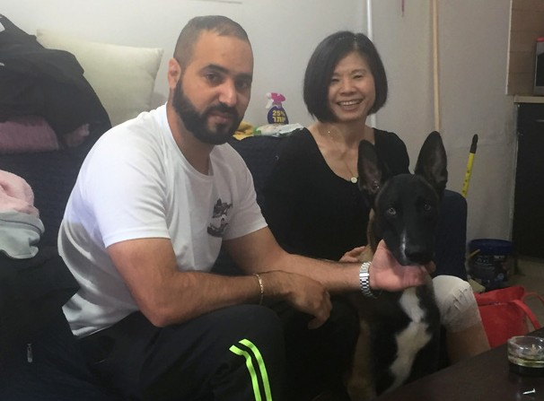
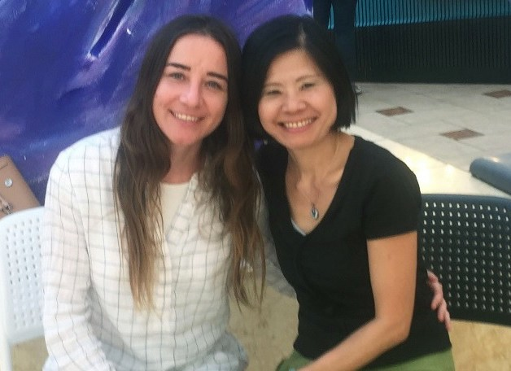
Thank you for your generous support to Project UHW through various ways - finance, prayer and other forms of blessings. Dear friend, God bless you. I pray that in all respects you may prosper and be in good health, just as your soul prospers (3 John 1:2).

Project Communities Under Attack

Dear Friends of Israel,

“When the LORD brought back the captives of Zion…” (Psalm 126:1a).

Shalom. By the same way in which God led Naomi in the Book of Ruth, often times God allows His people go through hardship or persecution, to bring them back to Zion from exile. (Psalm 126:1a & Ruth 1:1-3).

Ziona is one such Israeli rocket victim whom Project CUA visited. Ziona left Israel in her 20’s to reside in France. She met and married her husband Robert and they have three children who were born there.
As Anti-Semitism in Europe, especially in France has risen, it became very dangerous for Jewish people living there. Ziona and her husband came to the realization that there was no future for their youngest son Natanel who is fourteen, so they decided to return to their homeland Israel. Ziona and Robert were deeply moved by the love and support poured out on them from Project CUA of CFI, on behalf our supporters, when they faced the hardships of rocket attacks from Gaza.

Project CUA also visited Suzan and Mayina in November. Suzan and her family have been severely affected by the Covid pandemic. Her son and his wife, plus two young children are living with Susan and her husband, so they have to provide for them. Banks refused to grant them loans, as she has had a huge bank debt and her husband was bankrupt in his business. This family was very grateful to our supporters for standing with them when they have no one they could turn to for help.

Mayina of Ashkelon also made Aliyah to Israel, from Chechnya in the former Soviet Union. She had a fall and broke her arm in May last year while running for shelter, when Tzeva Adom (the Red alert warning siren of incoming rocket attacks) was sounding. She has already had two surgeries on her arm but it is getting worse and she has not been able to move her arm nor sleep well because of pain and trauma.
Her doctor told her to have surgery but they do not have confidence in him. During my visit they asked me if I knew of any good doctor whom I can recommend to her. I said I would ask some friends working in the medical field. Mayina and her granddaughter were very appreciative of this visit and greatly comforted by our love and care.
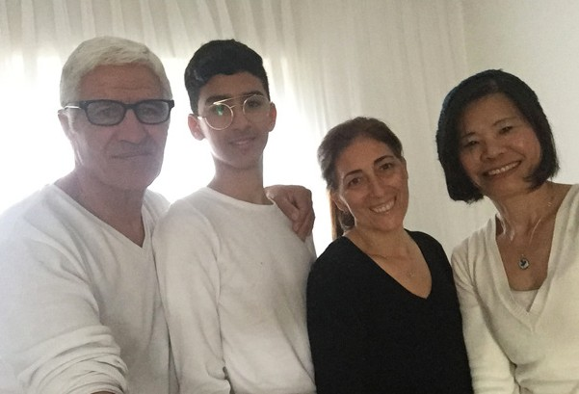
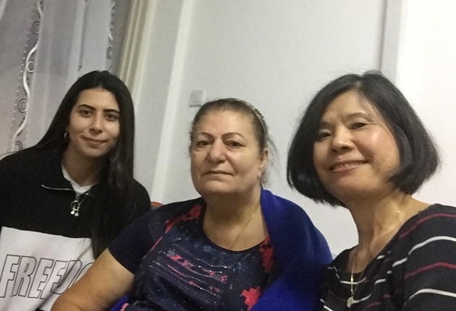

Thank you – our supporters; our work would not be possible without your generous financial support. May God bless you and reward you abundantly.

Project Wall of Prayer

Gathering Together in Unity

“Behold, how good and how pleasant it is for brethren to dwell together in unity!” (Psalms 133:1 KJV)

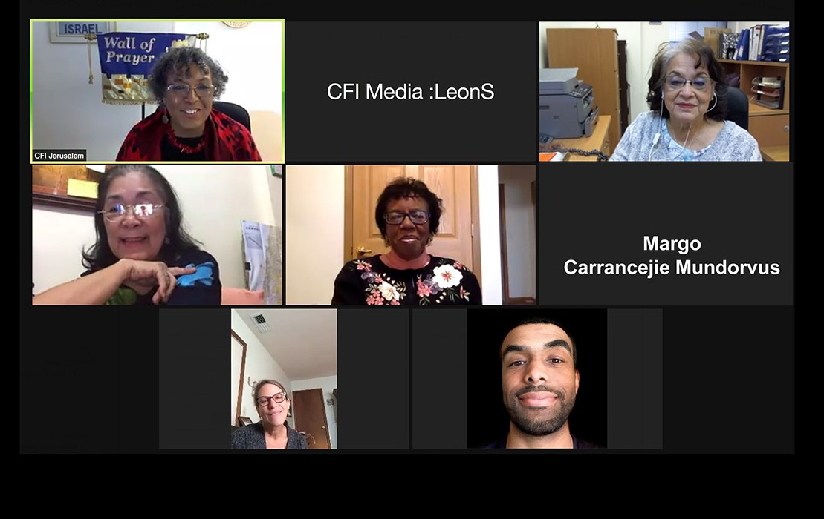This month was a time of “firsts” for the Wall of Prayer. We initiated our first CFI Representatives “Israel Watch” meeting using Zoom video conference software. What a pleasure it was to see representa- tives come together from Australia, Brazil, France, Germany, Japan, Papua New Guinea, Sri Lanka, United Kingdom, and the United States! Because of Covid, there has been no annual conference, where the representatives would normally gather, so everyone was genuinely happy to see one another.
Our first Prayer Team. We are believing God for growth!

Each representative explained how their prayer teams currently operate. With the exception of more remote areas, public gatherings have been curtailed in the majority of these nations. The onset of the Covid pandemic has changed the way most countries can convene for worship. The representatives affirmed that many church services are now online, and prayer has been relegated to individuals at home. Only a few representatives have online corporate prayer meetings. Prayer is certainly not new, but group prayer online has recently emerged as a way of praying together in unity.

We encouraged the representatives to consider hosting online prayer times in their nations if feasible. Even telephone conference call lines can allow people to pray in groups. There is unparalleled power in unified corporate prayer! Our meeting included a time for the representatives to pray aloud for Israel and for us to pray for their CFI work in the nations. We all enjoyed unifying around prayer for Israel and agreed to convene another meeting next month.

As we launched the “Israel Watch” prayer network, people have begun to respond to the call to pray for Israel. When they contact us, we forward those names to the CFI representative of their country. If there is no representative in their country, we include them in the Jerusalem team.

We are pleased that the Jerusalem team convened its “first” two Zoom prayer meetings for those who would unite in praying for Israel. Thus far, we have had participation from Messianic Jews and Christians from as far away as the Philippines. Although we started with a small group, we are believing God for growth. “So let us not lose heart in doing good, for in due time we will reap if we don’t give up” (Galatians 6:9 TLV).

We say “THANK YOU” for the love, prayers and generous support that you have shown to Israel through CFI. May the Lord bless you richly. “The person who blesses others will prosper; he who satisfies others will be satisfied himself” (Proverbs 11:25 CJB).

Project Streams Of Blessings

TOTAL DEPENDANCE

“You will not need to fight this battle. Take your positions; stand still and see the deliverance the Lord will give you” 2 Chron. 20:17.

Within the paradoxical concepts of a Kingdom mindset, doing nothing and staying still are two different approaches. Still spirits know deeply, that no matter what the numbers or the situations are, we can walk and serve with confidence trusting that where our human interventions end, it is the precise moment for the Glory of God to manifest. King Jehoshaphat learned this well. A vast army from Edom was coming against him and instead of being alarmed and trying to win the battle by his own, he decided to inquire of the Lord and proclaimed a fast so all the people of Judah could come together and seek for His deliv- erance. They had the victory with no need to fight but only by lifting hands, crying out and worshipping with a grateful heart. (vs. 21)

We are still in the aftermath of what the world is facing right now. The challenge is great and the needs are many, but the Streams of Blessing project has taken refuge in the guidance and in the Shalom of God to fulfill the mission. We continue helping, feeding, clothing, comforting and more important, we are loving each one of our beneficiaries when we have the opportunity to visit and stand by their side.

We believe that famine will not disrupt God’s plan and purpose for His people. Here in Israel we have seen it as an opportunity to see the hand of God intervening again for His people. Humanly speaking, we cannot do something to change the external situation that overwhelms the lives of many Jewish people, but we can be entities of peace that can transmit love, empathy and solutions, in a world where the daily front page of their lives is to think about fatalism and its consequences that no one can fix except the Hand of God.

One thing we can do as a practical step of faith: Like King Jehoshaphat and the priests, we can raise our hands and pray, that our total dependence comes from heaven, as whatever we do to enlarge the Kingdom of God, will be multiplied for the blessing of many around the world ...and starting here in Zion. Once again we want to thank each of you for helping us to put a smile on the faces of individuals and families here in Israel. Your prayers are important!

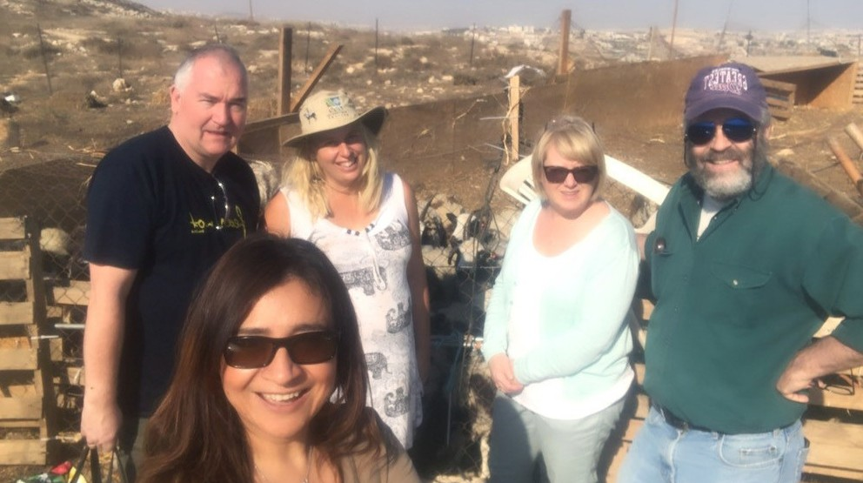
Karen Tohon
Project Supervisor

