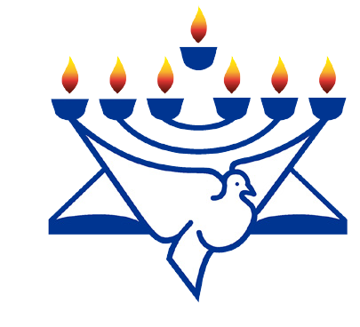
in

Prayer Letter
Watchman’s

Christian Friends of Israel prayer@cfijerusalem.org www.cfijerusalem.org
February 2021 /Jewish Year 5781
A HEART OF FLESH
“Moreover, I will give you a new heart and put a new spirit within you; and I will remove the heart of stone from your flesh and give you a heart of flesh. And I will put My Spirit within you and bring it about that you walk in My statutes, and are careful and follow My ordinances.” (Ezekiel 36:26 TLV)

During Israel’s exile in Babylon, the Lord spoke through the prophet Ezekiel, telling him to speak to the moun- tains, hills, ravines, valleys, desolate ruins, and abandoned cities of Israel. In obedience to God’s prompting while he was a captive in Babylon, the prophet proclaimed that the land of Israel would again be inhabited and the walls rebuilt. Ezekiel declared that God would bring His people back home! Through Ezekiel, the Lord announced that the house of Israel would again be renewed, not for their own sake, but for the sake of His Holy Name. God promised that He would change their stony, rebellious hearts and put His Spirit in them. Their hearts would become tender and pliable – a heart that would truly love the Lord and take pleasure in following His ways.

God sent His word to Israel while they were in a desperate condition of servitude in order to give them hope and to remind them of their future. Although Israel was reaping the results of rebellion against God, He wanted to remind them that He still loved them and would always keep His covenant with them.

Today some portions of Ezekiel’s prophecy are being fulfilled because Israel is indeed a nation that has returned to her own land, and Jews from various parts of the world are painstakingly making the journey home. The words of the prophet from over 2,600 years still echo, “For I will take you from the nations, and gather you from all the lands; and I will bring you into your own land” Ezekiel 36:24 AMP. The Spirit of God is drawing them!

According to the Jewish Virtual Library, out of the 14.7 million Jewish people in the world, 47% reside in Israel. 43% of Israel’s population identify themselves as non-religious. For many, their hearts have yet to be softened by the Spirit of God. We eagerly anticipate the ultimate fulfilment of Ezekiel’s prophecy to come to pass in the Millennial Kingdom.

Until that time, there is a great need for prayer and support for Israel. We celebrate with the 300 Ethiopian Jews who emmigrated to Israel on January 1, 2021, and we pray for 53% of the global Jewish population who yet remain in the diaspora. Our supplication can also be focused on those Israelis whose stony hearts resist the God of their forefathers. Still others marginalize the Jewish believers whose hearts have already been made pliable by the Prince of Peace. They are all part of The Chosen People whom God loves. It is a privilege to pray with them and for them. Will you love the Jewish people enough to continue praying for them?

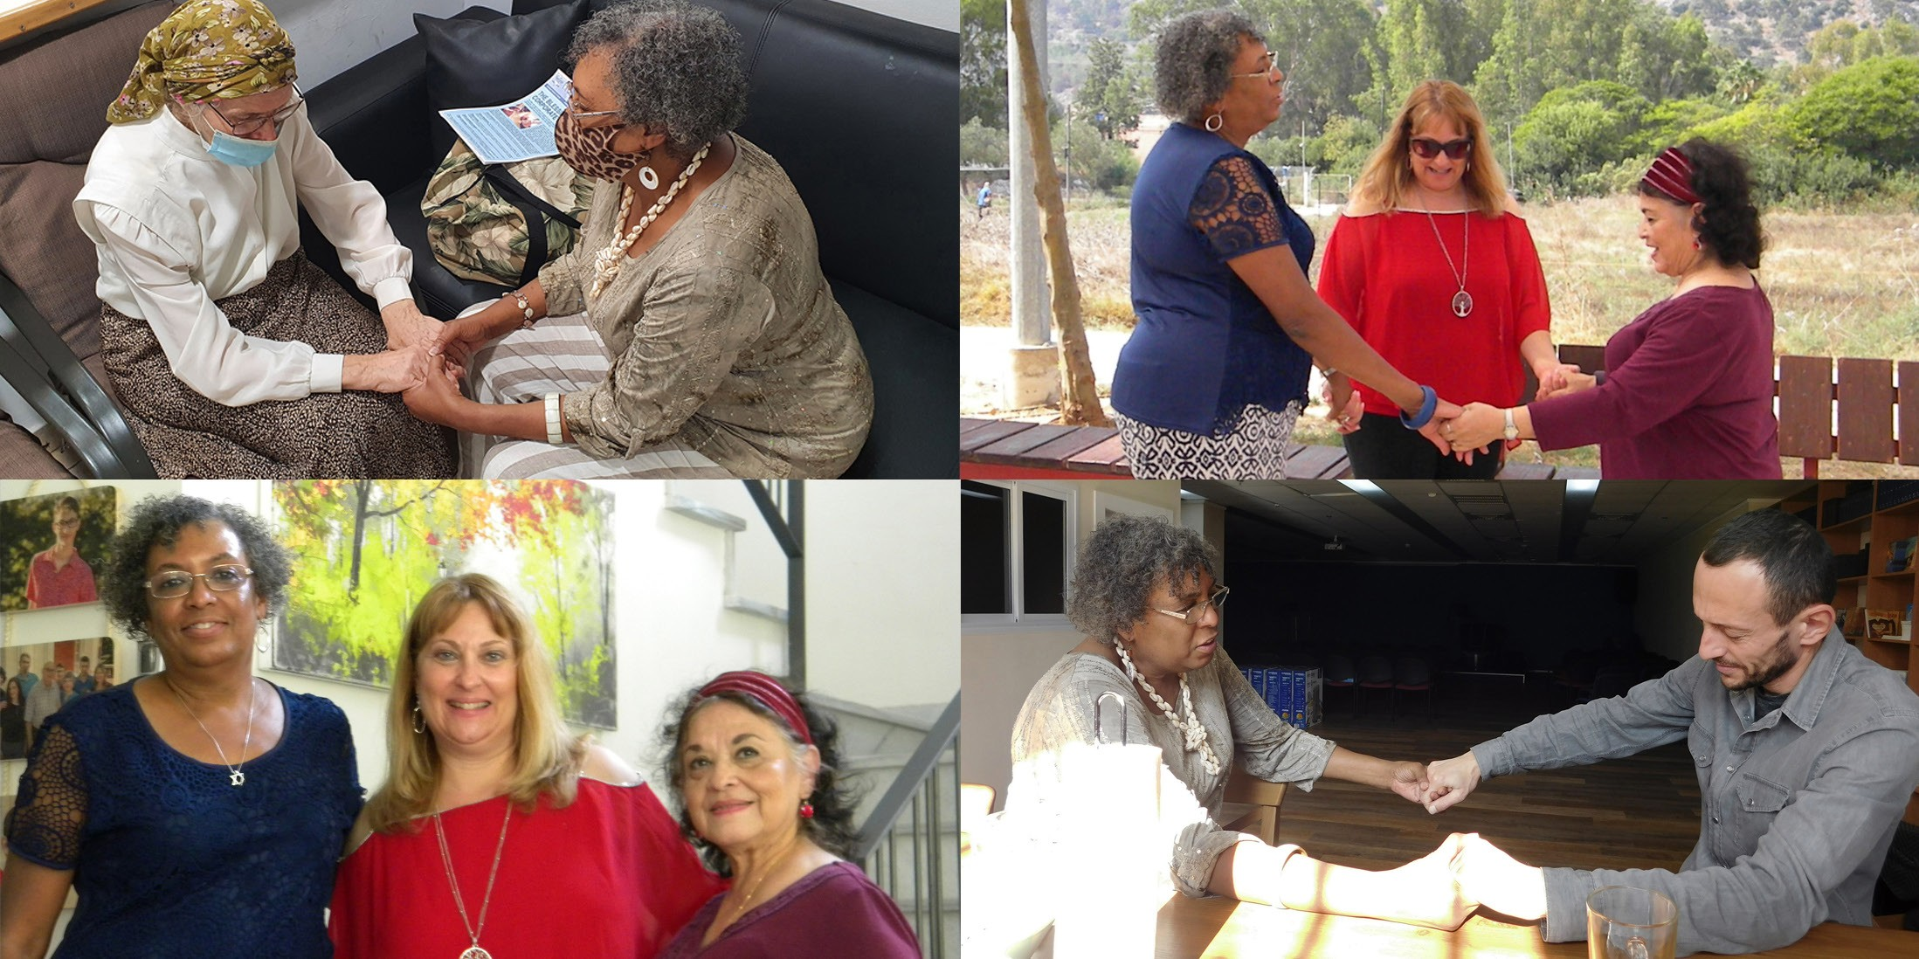

Join us in praying for the Chosen People
- Thank God for his eternal love for Israel. “...Yes, I have loved you with an everlasting love. Therefore, I have drawn you with lovingkindness” (Jeremiah 31:3 TLV). Because He has always kept His covenant with Israel, we can have confidence that God will also keep His promises to us.

- Praise the Lord that despite the enemy’s ongoing attempts to annihilate Israel throughout history, she lives on – because of God’s word. “For to us a child is born, to us a son is given; and the government shall be upon his shoulder... Of the increase of his government and of peace there will be no end, on the throne of David and over his kingdom, to establish it and to uphold it with justice and with righteousness from this time forth and forevermore...” (Isaiah 9:6-7 ESV).

- Declare the Word of God! No matter how resistant or indifferent many may be to following the Lord, He promised that Jewish people would one day have a change of heart. “And I will give them singleness of heart and put a new spirit within them. I will take away their stony, stubborn heart and give them a tender, responsive heart, so they will obey my decrees and regulations. Then they will truly be my people, and I will be their God” (Ezekiel 11:19-20 NLT).

- Intercede on behalf of Jewish believers who are often misunderstood and ostracized. Pray for their encour- agement, protection and provision. Pray that this small remnant continues to follow their Master’s call to be salt and light. “You are the salt of the earth... You are the light of the world. A city set on a hill cannot be hidden” (Matthew 5:13-14 TLV).

Dear Prayer Partners:
Bless the Lord for the opportunity to pray for Israel together! Let’s embrace the Word of God and hold to His promises in these turbulent times – just like Ezekiel did in Babylon. “For God Himself has said, ‘I will never leave you or forsake you’” (Hebrews 13:5 TLV).

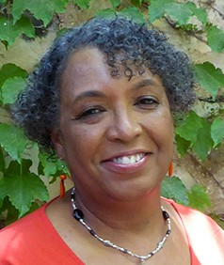
You are invited to join our Israel Watch global prayer network by contacting us at prayer@cfijerusalem.org. If you are already a team member, please send us your picture with your city and country, so we can add your photo to our world map of prayer warriors located in our Jerusalem office.

Blessings to you,

Linda D. McMurray
Wall of Prayer Supervisor

