Prayer Letter
Watchman’s
Christian Friends of Israel prayer@cfijerusalem.org www.cfijerusalem.org
March 2021 /Jewish Year 5781
Little is MUCH
“The Lord said to Gideon, ‘You have too many troops for me to hand the Midianites over to them, or else Israel might elevate themselves over me and say, ‘I saved myself.’” (Judges 7:2 CSB)

The angel of the Lord visited a poor, obscure Israelite man named Gideon. He was secretly beating out wheat in a wine- press to hide it from the Midianites, Israel’s oppressors. He simply needed food for his family. Despite Gideon’s low status in the community and his lack of confidence, God designated him to lead the Israelites to victory over their persecutors. Through several miracles, a dream, and his obedience to divine instructions, Gideon was emboldened by the Spirit of God. Amazingly enough, 32,000 men responded to his clarion call to revolt against the Midianites! When they gathered to prepare for battle, God gave Gideon His war strategy. “For my thoughts are not your thoughts, neither are your ways my ways, declares the Lord” Isaiah 55:8 NIV.

Instead of using the 32,000 who initially answered Gideon’s call for warriors, God designated only 300 of those men to

Gideon learned that where God is concerned, believing and doing go together. But more important still he learnd that one man multiplied by God’s power equals victory no matter what the odds. (CC BY-SA 3.0, Sweet Publishing/FreeBibleimages.org)

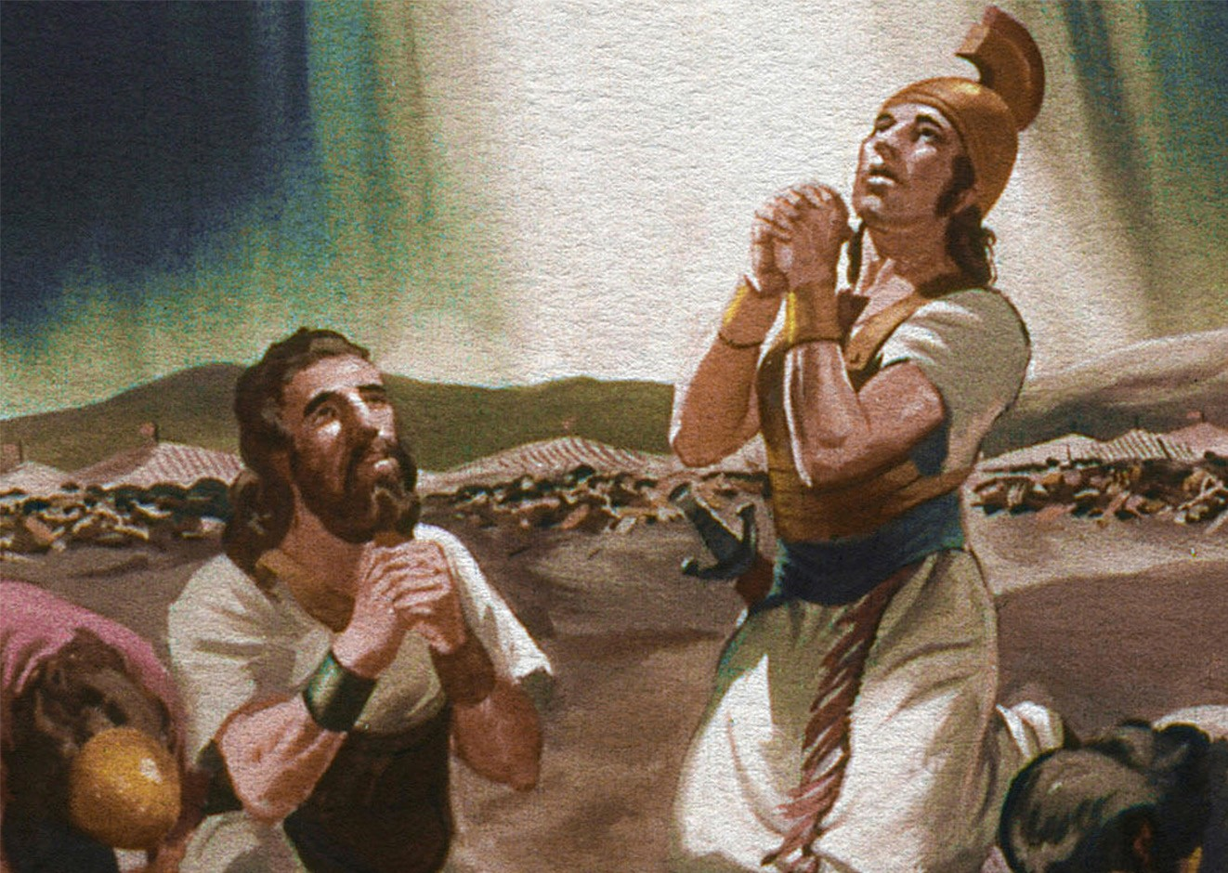launch a surprise attack on the huge encampment of the Midianites. The Lord chose less than 1% of Gideon’s army – only a tiny remnant! At God’s instruction, that small band stealthily surrounded the enemy camp in the middle of the night and burst out upon them with shofar blasts, a sudden explosion of light, and crashing clamor yelling, “For the Lord and for Gideon!” Their enemies were so startled that pandemonium broke out. The Israelites did not have to fight because the Lord caused their oppressors to begin killing one another, with some running away in terror. God does not need a large number to win the victory. Could it be that our human mindset or maybe our pride longs for impressive numbers? Moses said to the children of Israel, “It is not because you are more numerous than all the peoples that Adonai set His love on you and chose you – for you are the least of all peoples” Deuteronomy 7:7 TLV. Please understand, what is little becomes much when God is involved in it!
in

The Lord does not always choose the most prominent people or the ones we deem “most likely to succeed” to accomplish His purposes. In fact, He seems to specialize in doing just the opposite. When the odds of winning are humanly impossible, the victory must be attributed to God, and not man. If the people of God obey His instructions, it does not matter how many people are with them or against them; neither is their ability or inability a factor. As the scripture says, it is, “‘Not by might nor by power, but by my Spirit,’ says the Lord Almighty, and… ‘Who dares despise the day of small things?’” Zechariah 4:6,8 NIV. It was David, the over- looked youngest son of Jesse, whom God chose to be the great King of Israel and through whose lineage the Messiah Jesus came.

Viewing a map of the Middle East, we see that the small nation of Israel is dwarfed by many of the surrounding nations who may or may not genuinely have her best interest at heart. Do not be fooled! The Lord Almighty watches over His beloved Israel. “What then shall we say in view of these things? If God is for us, who can be

