CFI Projects Monthly Reports for
International
Representatives

Dear CFI International Representative Family,

Thank you for your continued support of the Outreach efforts of Christian Friends of Israel. We continue to strive to encourage those in need and to offer practical assistance during times of struggle. It’s during these times when relationships can be formed which please God and allow us to show Compassion to those who need it the most and have possibly never experienced it before.

During this time of global pandemic, we continue to offer assistance as we are able, and we know each passing day may allow for additional hardships, but we also know the God whom we serve. He is more than able to protect, and provide and heal. We are willing to represent Him to the people of Israel.

Please receive the CFI Outreach electronic updates as a reminder
of the impact each of you have in the lives of so many. We are grateful to represent those of you in the Nations - to those in the Land of Israel.

A friend loves at all times, And a brother is born for adversity.

Proverbs 17:17 (NKJV)

Project Forsake Them Not

“And Moses said to the people: “Remember this day in which you went out of Egypt, out of the house of bondage; for by strength of hand the Lord brought you out of this place” (Exodus 13:3a).

The Lord’s command to us to remember is for our own benefit. How often were our hearts lifted up and filled with joy and gratitude when we looked back and saw the deliverance of the Lord. Pesach, or Pass- over, is a joyful season and a time of reflection for the Jewish people. This year, restrictions to celebrate with friends and family were lifted and people embraced the festive celebration of the Pesach Seder, the feast, when the story of Exodus from Egypt is retold again. We remember; therefore we celebrate.

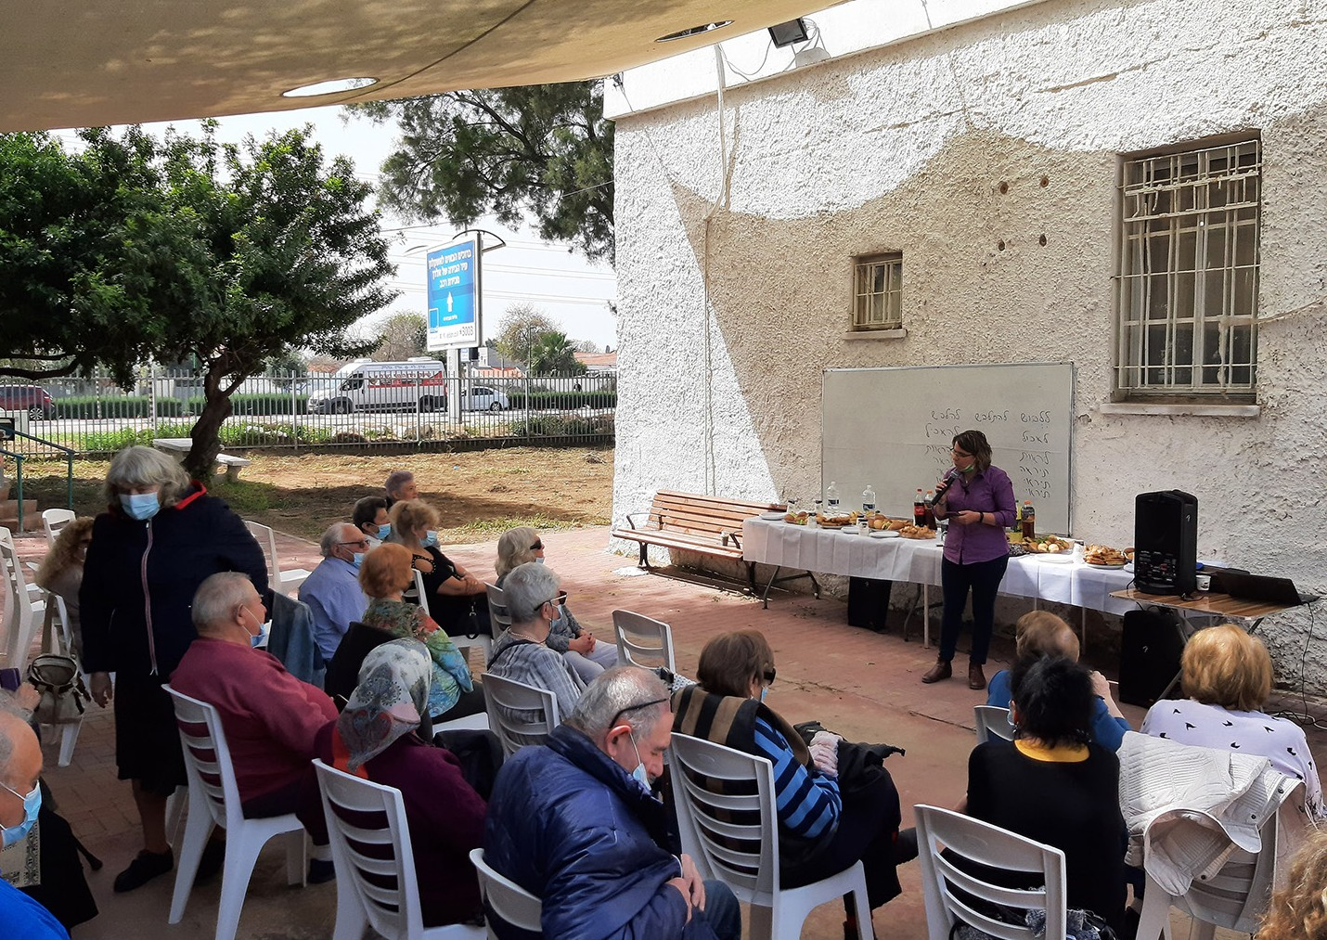
After yearlong restrictions for gatherings and celebrations, life slowly is starting get back to a new norm. Finally, local organisations of the Holocaust Survivors are able to meet together, but still with certain limits. Thus, Ashkelon’s organisation invited us to participate in a Pesach and Holocaust remembrance event, where 50 people were able
to come together in the open air. Both events had one theme in common – the need to remember both the sad and joyful histories. We had a reason for celebration indeed. After lighting six candles
to remember the 6 million innocent Jewish people who perished in the Holocaust, including family members of those present, we also spoke of the
miracle of deliverance and marvellous works of God. We finished the event with the giving of gifts and a wonderful music performance. It was so wonderful to see our precious friends again.

After the event we also visited those who couldn’t come, and delivered their food vouchers and greeting cards. When I came to visit Yakov, who was just released from the hospital, I was very saddened. Yakov turned 92 just a few months ago and we knew him and his wife Vera so well. We were always welcomed to their home as close family members. I will never forget our last visit in the summer, how Yakov played his keyboard and sang songs in Yiddish for us. After a long lockdown, that visit lifted Yakov’s spirit up and brought a lot of joy. Still, Yakov’s condition worsened and I found him on his death bed, surrounded by his wife and caregivers. The atmosphere was heavy and everyone was sighing deeply. Yakov was very weak and his eyes were closed, but when he finally saw me, he brightened up! He was so happy to see me, and asked me about our wellbeing. It was so sweet. Yakov passed away two days later, but we will cherish the memories we were able to have. What a privilege it was indeed to see Yakov and to bring some joy and comfort to his last days.
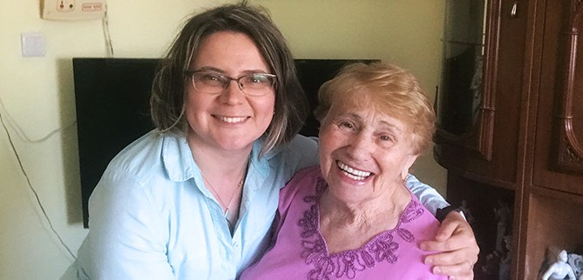
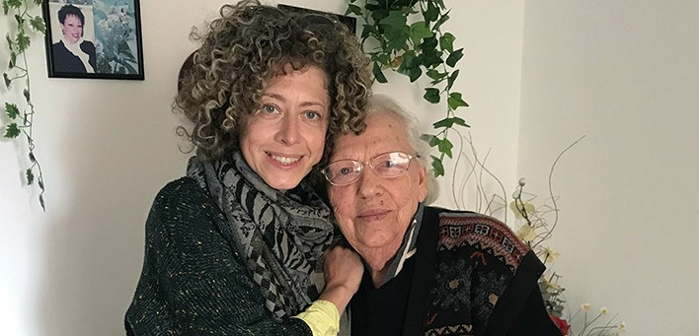

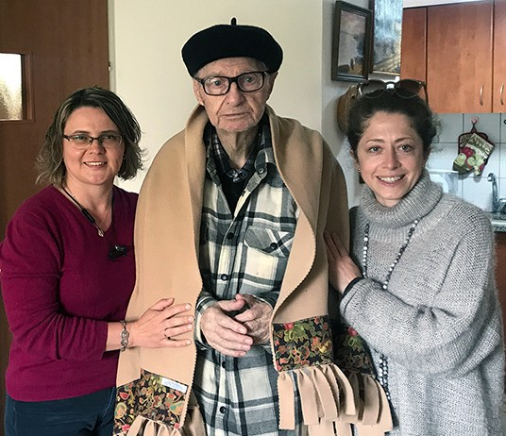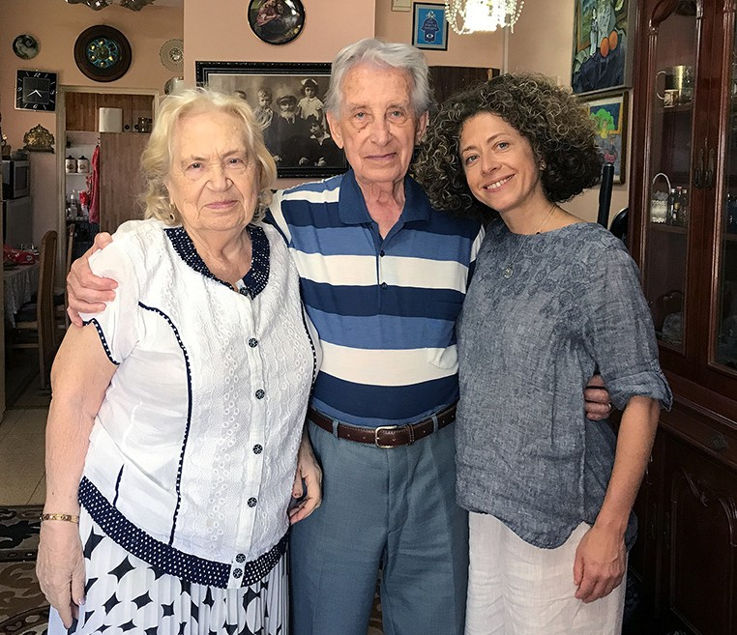

Altogether, we had many special visits with our dear friends, listening to their hearts and needs. One of them was with Klara. Klara is 89 years old and she doesn’t have children or other relatives to look after her, so we truly became her family. She also had a 24-hour caregiver, who mistreated her badly, and Klara spent months in the hospital. Now she has a new caregiver, but is very afraid and struggles to trust. We had a wonderful time speaking of the need for forgiveness and praying together. Klara also had a special need to purchase some essential items from the pharmacy shop, and I was so happy we were able to assist her with those. After I finished my other visits, I purchased everything Klara needed and delivered it to her. There was no limit to her gratitude, as she felt loved and cared for.

All these kind acts and special encounters would not be possible without you!
Thank you so very much for showing kindness to His special treasures through your prayers and financial support. Yeshua prayed to His Father in John 17:21, “that they all may be one”, and we do see and feel your love. We know we are not alone in our effort, and neither are the Holocaust Survivors. As we remember how the Lord delivered His people during the Holocaust, we do rejoice in His salvation, together with those who are still with us!

“Oh, give thanks to the Lord! Call upon His name; make known His deeds among the peoples! Remember His marvelous works which He has done, His wonders, and the judgments of His mouth.”
(1 Chronicles 16:8, 12)

Olga Kopilova Project Supervisor

Project Open Gates

Shalom, dear friends from the nations!
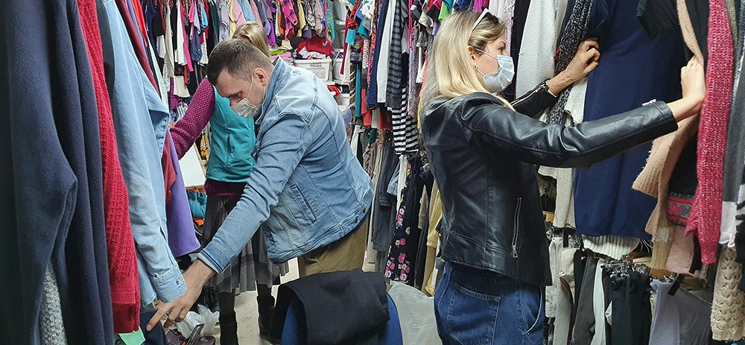

Our CFI distribution center is open and new immigrants are coming in week after week. Yesterday we had one young family from Northern Israel here. Denis and Mariana made Aliyah about three years ago and now are expecting their first child to be born in June. They were in great need of baby clothing. Their friends told them about CFI, and not in vain. We found a lot of good quality things for the baby. Mariana was amazed as she did not expect to get so many beautiful items at once. It is always so special, when a couple is choosing clothes for their first child. You can feel the happiness and excitement in the air, when a husband and a wife are looking at the beautiful little items and imagining their own child in it. Our distribution center has plenty of baby clothing, and our clients can take from that abundance “as much as they can carry”. Mariana told me that she and her husband were worried, because they did not have enough money to buy everything they needed for the baby’s arrival. When they left our building, they were totally released from those “dark clouds”. It was a blessed moment for us all.

Today we had a single mother with a teenager daughter. They were picking out clothes for about an hour and a half. I could see that this family was also in need. They really enjoyed shopping and found good clothes for the coming summer. The mother told me that her daughter has been growing very fast this year and almost everything she wears has become too short. You need a lot of money to buy new clothes here in Israel and so again the distribution center was a great help and blessing to another family.

There are so many different and interesting people that visit us every day. Some of them are musicians. This week we found a suit for a new immigrant who plays in an orchestra. Last week another client, after he had chosen some colorful shirts and other interesting items for himself, sang and played the guitar for us.

Thank you for being part of this ministry.
God bless you and keep you in Yeshua’s name!

Project Bridal Salon

Shalom haverim! Greetings from Jerusalem!

CFI Bridal Salon is serving different clients, and it is always a great joy, when we find a beautiful dress for a bride-to-be. One of them was Aviva, who visited us this week. She is originally from the States, but she made Aliyah years ago and sees herself as Israeli now. It has been difficult for her and her fiancé to plan their wedding. The date is still open. They hope that in June 2021 it will happen.

Aviva is a thin lady. She tried different options and most of them were too big for her. She really wanted to find something at our place because of their financial situation. Once again I understood, how big blessing we can be for those who come in to our Bridal Salon. Even the rental of a wedding dress costs a huge amount of money in Israel. We found a beautiful gown for Aviva. It was a light and pretty dress with some sparkling palettes
on it. She also took a veil and a necklace. Aviva was happy and grateful. Now she is ready for her wedding!

Sometimes we are witnessing sad stories, too. One mother came to seek an evening dress for her daughter’s wedding. She
and her four daughters have been here in our distribution center, so I know this family. Also the bride- to-be came in with her mother and one of the sisters. The mother found a good looking dress and some jewels. The bride to be took a lot of different jewels and hair pieces for herself. She explained that they will celebrate their wedding for 7 days. We also found shoes for her. The sister took some jewels and shoes, too. They were very thankful for all the things we found for them.
Less than a week later the mother and young bride came back. They told me that there would not be any wedding at all. Sometimes this happens here. I did not ask the reason of the cancellation when they returned the items. The girl looked quite joyful indeed. She is still very young and maybe she was not ready yet for such a huge life change. The mother said that it was better to cancel everything now before it was not too late. She believes an unhappy marriage would be a sorrow for everyone involved. I hope we will have this family again in our place in the future. They already know that we will take care of them all, when the four daughters will have their weddings.

Thank you for supporting us! Thank you for praying for the families of Israel!

Project Under His Wings

Shalom Dear Friends of Israel,

“This is my comfort in my affliction, That Your word has revived me” (Psalm 119:50).

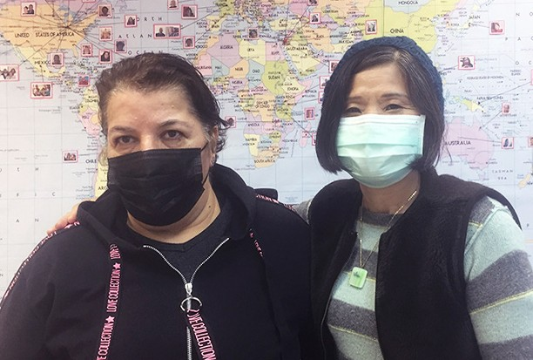
Thanks be to God for allowing me to minister to Ariela who was weighed down and in great distress. Despite the fact that the terror attack has had a great impact on her and her husband, they strive to move on in life
and are working very hard to make their ends meet. But Covid has hit hard on the economies of Israel as well as the whole world. Ariela and her husband have not been able to work and with no salaries to cover their needs their debts started to accumulated. Ariela was greatly comforted and encouraged by the words which God gave me to say to her, and she was reading the Scriptures attentively during the visit. I told her that knowing God is
not about religion but having a living relationship with God who is our Father in Heaven and He cares for us. And she experienced the Peace of God and relief (Psalm 119:50). Please pray that Ariela, as well as other terror survivors visited by Project UHW will learn to feed themselves with the word of God to draw strength and comfort to counter the anxieties and challenges.

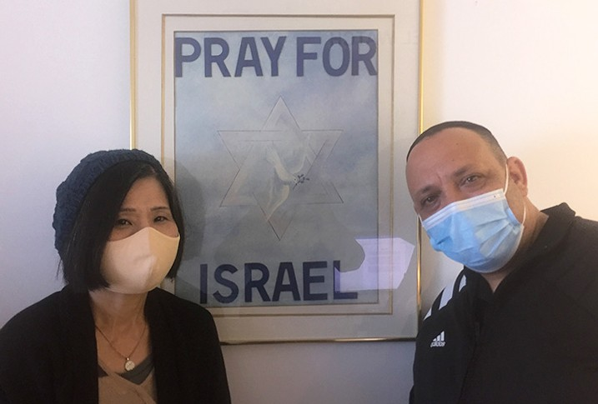
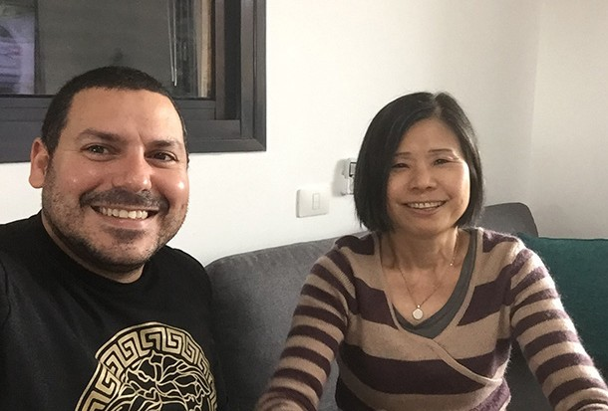
Project UHW also visited Eliyahu and Mordechai. God is good and faithful to both of them. Despite all the hardships they have gone through, caused by terror attacks, God has built Eliyahu a family as well as giving him and his wife two beautiful children. God is also in the process of doing the same for Mordechai. Mordechai and his fiancée have been postponing their wedding due to Covid restrictions. Both of their parents are Moroccan Jews with lots of family members and relatives who would not be happy if being denied the opportunity to attend his wedding. They are waiting for the easing of restriction on numbers, allowed for indoor gathering, to have their big wedding. All the terror survivors are grateful and deeply touched by the love, support and comfort available for them through Project UHW in their times of difficulties.
While rejoicing with them for the goodness and faithfulness of God, Project UHW is very grateful to God for you, our supporters, for your generous financial support which enables this project to do what we do, as mentioned above. May you not only see the good of Jerusalem/Israel but also be blessed by God with the same blessing with which He has been blessing Israel and His chosen people (Psalm 128: 5).

Project Communities Under Attack

Dear Friends of Israel,

“And you will seek Me and find Me, when you search for Me with all your heart“ (Jeremiah 29: 13).

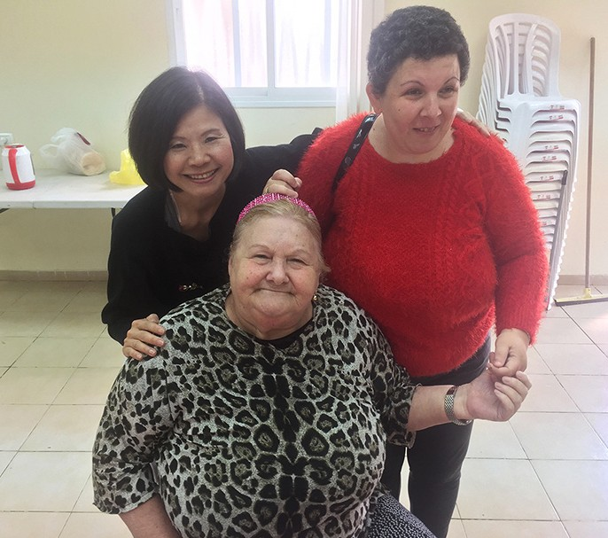
During this last Passover, Project CUA provided food vouchers for 80 civilians affected by the ongoing rocket attacks from Gaza. It was a big surprise to me, when hearing what Ester said to me, in front of her fellow civilians, who were there to receive CUA’s Passover food vouchers. She said Christians know more scriptures on Messiah than we (Jews) do. I do not know how she came to this conclusion to make such statement. I smiled at her and said to her that anyone who is hungry for God’s word and is willing to study the scriptures in the Bible will be like that too. Please pray that God will put a hunger for His word in the hearts of His ancient people – the People of the Book, that will propel them to search for Him and find Him (Jeremiah 29:13).

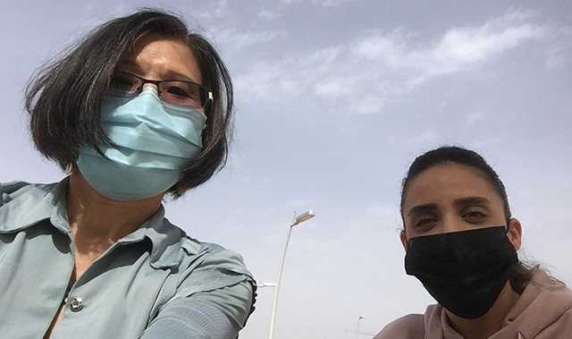
Project CUA also provided help in part payment of a computer for a college student named Tevel. The effect of trauma from the ongoing rocket attacks is very profound. Tevel and several of her family members have been severely traumatized by the ongoing rocket attacks to the point of being unable to function in daily life. Her younger sibling is not able to join the army this upcoming year due to trauma. Growing up in a traditional Jewish home Tevel’s family has been observing many Jewish traditions but God seemed far away from them. It was a very special time
ministering to Tevel, in which she was greatly moved. At the conclusion of this outdoor visit I said to her please read the Word of God daily to know who God is to you. He is your refuge and present help in time of trouble (Psalm 46:1).

Project CUA also ministered to Yehuda and his wife Natalie as well as their children. His wife said Yehu- da literally walked through the valley of the shadow of death of Coronavirus and thankfully God spared his life. But he is still in a serious condition and needs our prayers. Because of being sick with Covid, both Yehuda and his wife have not been able to work for a long time, furthermore having to raise 5 small children, this family has been in a dire financial situation. During the visit, with God in the middle of it, the lives of this family were greatly impacted.

On behalf of the suffering rocket victims thank you so much for playing an important role through your generous support. May The Lord bless you and your family abundantly.

E-X-P-A-N-D-I-N-G THE WALL OF PRAYER

“...pray for one another that you may be healed. The effective, fervent prayer of a righteous man avails much” James 5:16 NKJV.

CFI Jerusalem felt the impact of COVID-19 when it touched some of our staff. Praise God for his faith- fulness; His word was again proven true. Prayer really does change things! The Jerusalem staff rallied together in an all-night prayer vigil to intercede for one of our team members, Norene Fritz, who was hospitalized. Since personal visits were not feasible, we created a prayer chat line to send her scriptures, songs, words of encouragement, and prayers as she rested. She appreciated these acts of love and felt uplifted. Norene is an active and faithful part of several prayer teams emanating from CFI Jerusalem.
During their monthly Zoom prayer meeting, the CFI Reps team interceded for her healing. Various teams across the nations have been lifting each other up in prayer, and God is answering! The other Jerusalem staff who were affected by COVID-19 have already recovered and have returned to the work. At the time of this writing, Norene is rapidly regaining her strength. We look forward to seeing her back in the office.

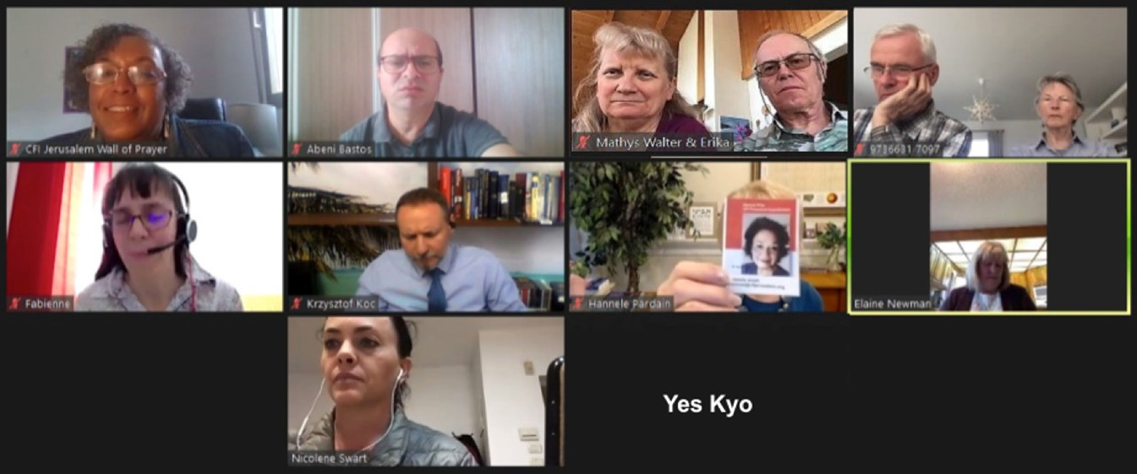
Project Wall of Prayer
CFI Representatives praying for Jerusalem staff member, Norene
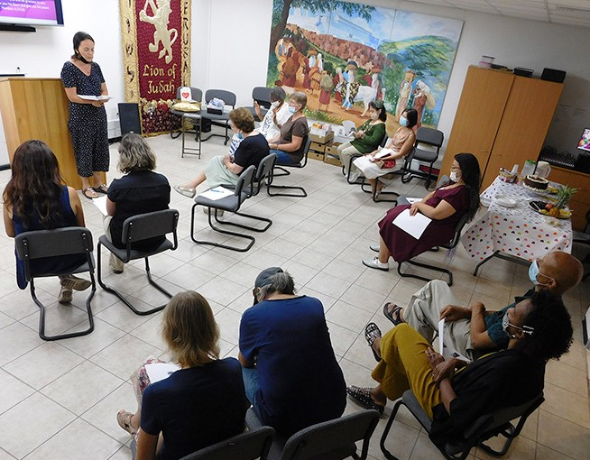
Jerusalem staff praying for CFI Representatives
We are continuing the staff prayer chat line for ongoing requests. As a
result of COVID affecting our office, we now have another prayer outlet at CFI Jerusalem. God can turn seemingly negative situations into positive out- comes. “Now we know that all things work together for good for those who love God, who are called according to His purpose” Romans 8:28 TLV.

Just as you intercede for those of us serving in Jerusalem; we also pray for you who are promoting Israel in your countries. After all, we are part of the same body. “...there are many of us, and in union with the Messiah we comprise one body, with each of us belonging to the others” Romans 12:5 CJB.

We greatly appreciate your ongoing support of the Wall of Prayer because prayer undergirds everything that CFI does. Your encouragement, prayers, and monetary gifts allow us to uphold the people of Israel. We are workers together with Christ (2 Corinthians 6:1). May the God of peace reward you graciously.

Project First Fruits

“Chenaniah, leader of the Levites, was in charge of the singing; he gave instruction in singing because he was skilled” 1 Chronicles 15:22 (AMP).

I was able to make a courtesy visit to Yuval Arts, a school of music and media being stewarded by strong and talented believers in Yad Hashmona. The Davises were able to share with me their vision for pushing students toward excellence in vocal and instrumental music, and the use of social media and graphic arts alongside a strong curriculum of biblical and Hebraic relevance to both tracks of learning. They bravely assumed the mantle of a previous ministry leader during this challenging period and CFI will partner with them on future projects to fortify their assignment in the land. They affect many generations of believers where they are. We were also able to encourage a young worship leader originally from Ukraine. Dmitry is employed in Haifa as an industrial engineer. He leads worship at a small Russian congregation and lives in an apartment adjacent to the church property, where a majority of the member- ship is elderly and are connected with the Aliyah that happened post-Soviet empire. He is very excited about his life in Israel and looks forward to re-establishing a travel/tour service from eastern bloc nations, once COVID restrictions have lifted.

The Nassers currently reside in the wife’s parents’ home in the Old City and are quite young with 2 small children, one being a new-born. They hardly seem old enough to have the responsibility of parenting themselves, but within this rich Arab Christian culture, they are attempting to thrive in the face of sporadic school closings and other inconveniences associated with the pandemic. CFI’s support has been timely.

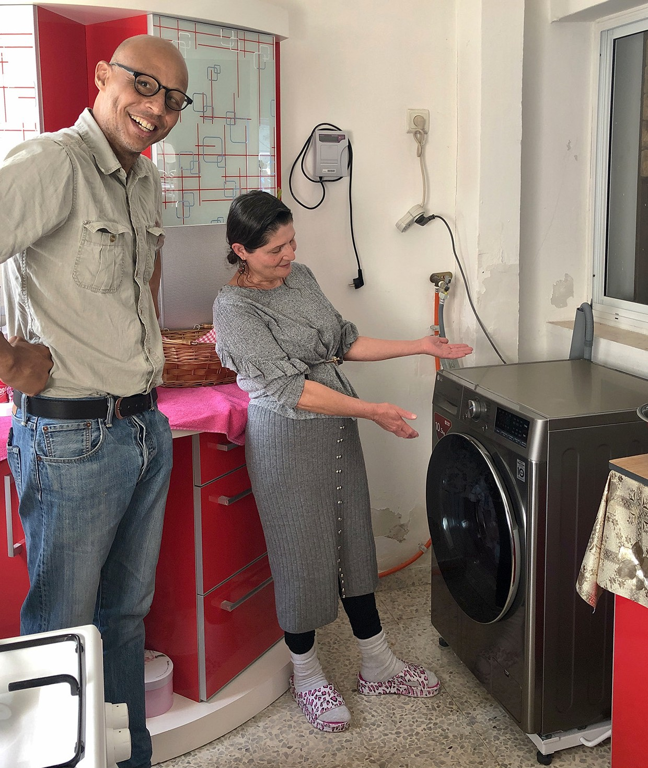
Media cohort Leon Swart accompanied me to Ashkelon where we visited a lady the CFI has provided a new washing machine for. She had been a previous recipient of support from us over 20 years ago, so her daughter reached out to determine if we could repeat the assistance. While we were there, Svetlana shared with us about her journey from war-torn Chechnya and her path to recognizing Yeshua as her Messiah.
She has spoken of a miraculous healing that has taken place in her body and we agreed with her in prayer that her son, who came to Israel 5 years before the rest of family. He experienced a severe mental breakdown during the period of transition and we prayed that would receive a full recovery of health and identity, while in her care. The month ended with Leon and I filming a video from Ashilim that will highlight the First Fruits project. We covered the direction that the project is headed and the momentum that we would like to maintain this year. Please stay tuned to the website for that content.

The LORD upholds all those [of His own] who fall and raises up all those who are bowed down. Psalm 145:14 (AMP)

