CFI Projects Monthly Reports for
International
Representatives

Dear CFI International Representative Family,

Thank you for your continued support of the Outreach efforts of Christian Friends of Israel. We continue to strive to encourage those in need and to offer practical assistance during times of struggle. It’s during these times when relationships can be formed which please God and allow us to show Compassion to those who need it the most and have possibly never experienced it before.

During this time of global pandemic, we continue to offer assistance as we are able, and we know each passing day may allow for additional hardships, but we also know the God whom we serve. He is more than able to protect, and provide and heal. We are willing to represent Him to the people of Israel.

Please receive the CFI Outreach electronic updates as a reminder
of the impact each of you have in the lives of so many. We are grateful to represent those of you in the Nations - to those in the Land of Israel.

A friend loves at all times, And a brother is born for adversity.

Proverbs 17:17 (NKJV)

Project Forsake Them Not

“Let your light so shine before men that they may see your good works and glorify your Father in heaven.” (Matthew 5:16)

Are we all not thankful for the light on bright sunny days that dispels the darkness, bringing warmth to body, soul and spirit. The light is needed when the darkness draws near and the night comes.
No doubt we are living in increasingly dark and challenging times. The corruption and evil of the human heart seems to have no limits. But while there is light, there also is hope.

As a team here in Israel, we have had many opportunities to bring that light and hope to our precious friends on lonely and dark winter days. That was especially evident as we celebrated the Hanukkah mira- cle, reminding us that light always overcomes darkness.

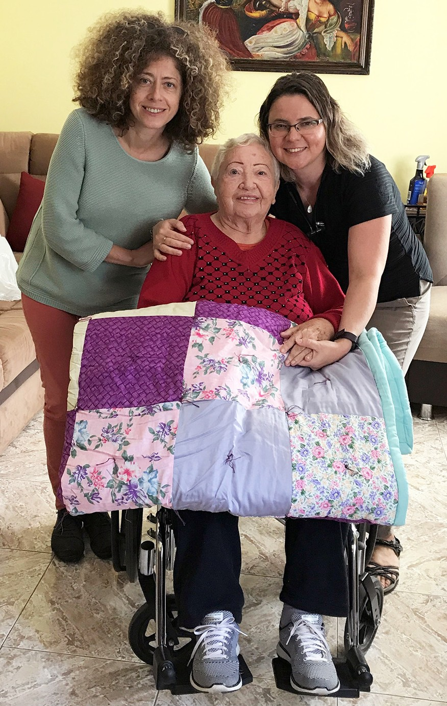
One of the highlights of our visits was the special time with our friend, Tsilya. We celebrated her 90th birthday back in February, just before the lockdown hit the country. What a wonderful time we had then, even dancing together. Tsilya introduced us to her large family and was so happy and proud we came. The bond we share with her is indeed precious. We love her, and she immensely loves us.
We knew this visit would be different, and earnestly prayed for courage, wisdom and comfort. As much as we were looking forward to seeing her, our hearts were broken. The news of Tsilya’s situation was absolutely unexpected and hard to accept. She had suffered a stroke that left her unable to move or speak. Our dearest friend became the prisoner of her own body and now needed round-the-clock special care. Even so, there was no limit to Tsilya’s joy and excitement when she saw us, and there was no limit to our gratitude when we greeted her in her wheelchair, smiling as best she could. She held my hand for the entire visit and even tried to speak. She called our names and though we couldn’t understand her words, it didn’t matter. We were all so happy to be together, to create more memories, to take more pictures and share joy and comfort in her time of need. How grateful we were to bring the beam of God’s light and love to her isolated heart.

We were also thankful to continue our tradition of celebrating Hanukkah with our precious Holocaust survivors in the northern town of Safed. It was a year ago when we were able to meet last, then COVID19 hit and all activities were put on hold. It was so wonderful to see one another again, to talk about the news, to read Bible verses about the Light and hear the testimonies of triumph over evil. We saw how our visit strengthened and encouraged each one to face the challenges ahead. They left to return to their homes with much joy and laughter. We can overcome the darkness, together.

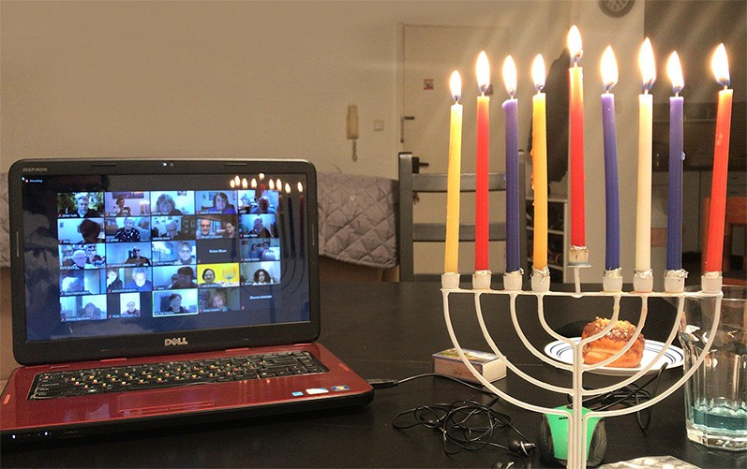
There was another remarkable and joyful event we were able to participate in – a Hanukkah celebration on Zoom – with the leaders of the Association of the Concen- tration Camps and Ghetto Survivors. We exchanged holiday greetings, ate sufganiyot (round jelly doughnuts, traditional Israeli Hanukkah fare), recounted the blessing of the Festival of Light and lit the Hanukkiah together. When all nine candles were lit, the light shone really bright, filling our hearts with gladness and bringing new hope. We will overcome the darkness, together.
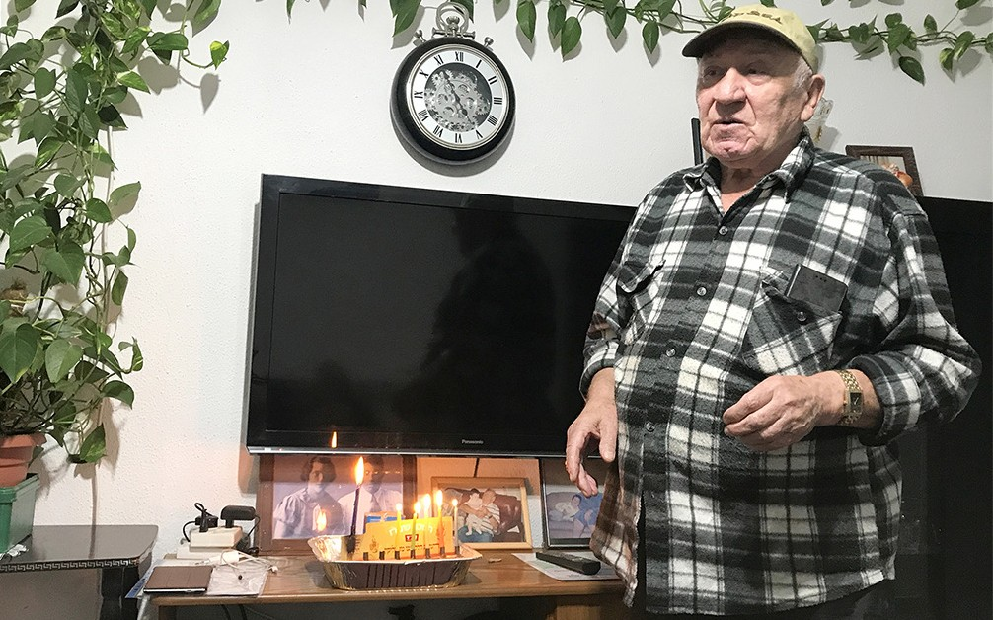

Thank you so very much for helping us bring God’s love and light in this dark season of the year, through smiles, kind words and God’s Word. Thank you for helping us remind these precious friends, that winter will pass and spring will come. Thank you for lifting His special possession, and us, your hands and feet, in your prayers. May God let His light shine brightly through us. We can, and we will, overcome the darkness together.

“Through the tender mercy of our God, with which the Dayspring from on high has visited us; to give light to those who sit in darkness and the shadow of death, to guide our feet into the way of peace.”
(Luke 1:78-79)
Olga Kopilova Project Supervisor

Project Open Gates

Greetings from the CFI distribution center!

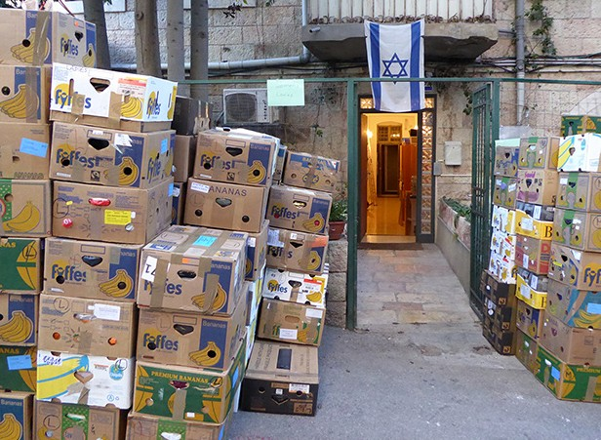
This year in Israel started with another lockdown. We are not allowed to have any visitors at our place at the moment so the appointments have been canceled. It is sad, because there is a need for clothing in many families. People are calling and asking, when they can come. I hope we can start
to serve people in February, if not earlier.
Despite everything we have a lot of things to do at our place. There are still hundreds of boxes to be sorted. I am very thankful for the container that we got in November. We have found a lot of good items for the new immigrants already. Sometimes it feels like Christmas, when you are opening the boxes.

I had an interview with a young immigrant, who visited us just before the lockdown. She is a good example of a quick decision to start a new life in Israel.

Where do you come from? What is your family background?
I come from Brazil. My family traces way back to Germany, Conservative/Reform background.

Were you always aware or your Jewishness? Did it play a big role in your life, when you were growing up?
Yes, and yes.

Did you have any family members in Israel before you came here?
No!

When did you start to think about moving to Israel? What was the main reason for you to make Aliyah?
It was a rather impulsive decision. I finished college, didn’t know exactly what to do next and came for a semester of yeshiva. Covid struck right then and I stayed.

Was is easy or was is very difficult to come to the Land?
It’s always difficult to emigrate to a new country.

How about your family members and relatives? Are they thinking about coming here?
No!

What is the best thing in Israel? What is the worst?
Jerusalem is the best thing in Israel. Managing politics and conflict are the worst.

What are you doing now? What plans do you have for your future in the Land?
I’m just living, working, studying etc. I plan on starting my M.A. degree this year, and who knows what’s next…

What are you afraid of?
Never learning Hebrew!

This lady was in need of warm clothes. Thank God that we were there to be a blessing for her.

Thank you so much for the participation in this good work! Let us pray that the doors of the CFI distribution center can be open again for God’s people, whom He is bringing back to the Promised Land.

Tiina Danilevski Project Supervisor
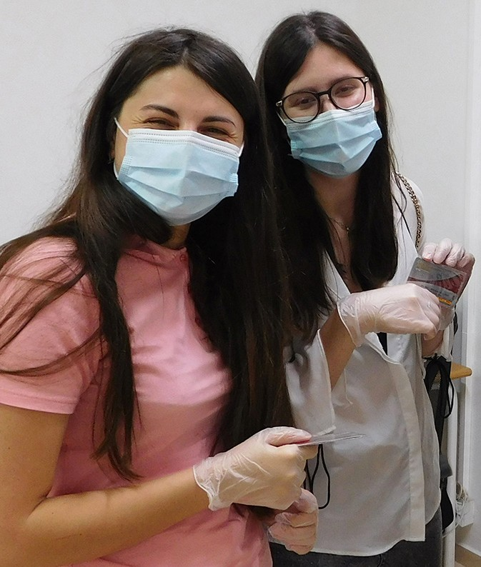

Project Bridal Salon

Shalom from Jerusalem!

Because of the lockdown we can’t have any clients in our Bridal Salon at the moment. I have been doing some organizing, and once again I was surprised at how many beautiful dresses and other items we have over here. One girl is expected right after the lockdown, and I believe that there will be more people coming as soon as the restrictions are over.

I had an interview with one young lady, who found her dress in our Bridal Salon. She was happy to share her experiences with us.
Avital was born in Israel. She grew up in an Israeli town of the northern part of Samaria. There she went to a special school for girls, where they had a lot of lessons about Torah. They also visited many Biblical places, which made the studies very interesting. Her high school was also a religious one. After finishing school Avital served 2.5 years in a commando unit in IDF. Then she spent one year travelling in different countries and started to study. Avital is a massage therapist with a wider education in health care.
Once she was working in a scout camp where her job was to take care of the kitchen cleanliness. In that kitchen she met her future husband. They started to date, and in two years they were married.
It was Avital’s mother, who heard about the CFI Bridal Salon through her work place. Although they had found one dress already, Avital decided to come and have a look. “It was a good experience.” she sais. ”It reminded me of my childhood, when I had an opportunity to try on many beautiful dresses in a special shop in the States.” One of our dresses was ‘the one.’ Avital loved it, and in that dress she was the queen of the wedding. She wants to send many greetings to the Christian friends of Israel. “Thank you! It is so good to know that there are friends in different countries, who are taking care of us. Your place in Jerusalem is very nice. The atmosphere is good and you serve with your heart.”

It is encouraging to hear these words from the mouth of a patriot in Israel.
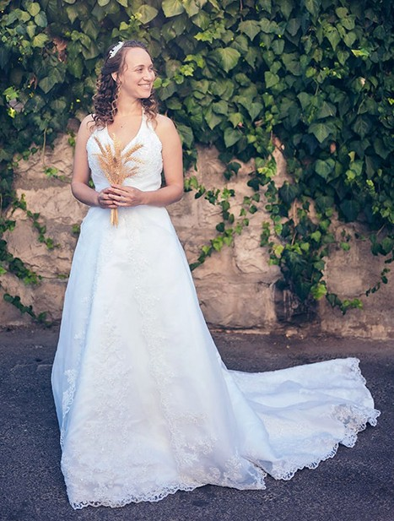
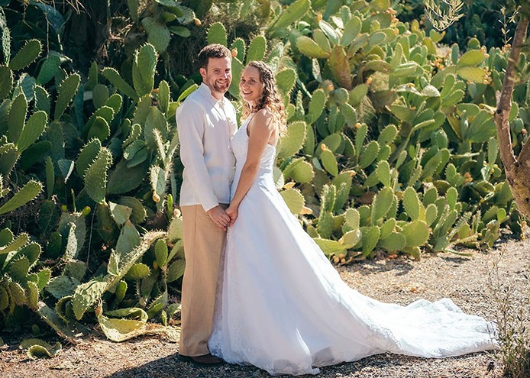

May the Lord use us for His glory in this new year 2021. Thank you for being in the team!
Tiina Danilevski Project Supervisor

Project Hope For The Future

Trusting in the Impossible

“The Lord is my strength and my shield; my heart trusted (*betach) in Him and I am helped” Psalm 28: 7a.

*Trust (in Hebrew ‘betach’) is a word with many meanings such as confidence, security, and hope. This word’s pictographic meaning is as the word. ‘Bet’ is a picture of a tent, abiding, ‘Tet’ is a picture of being wrapped or swaddled like a baby blanket and ‘Chet’ a fence or wall being surrounded and protected with exclusivity.

Personal time working with Rachel Maggolli in the past few years has been extremely rewarding. Rachel is a true advocate for the Ethiopian community. In three years, she has cultivated a vision of “trust” first in the Lord, for all she does to uplift the Ethiopian families. Beginning in 2017, from my observation, WIZO Pardes Kidz had little hope. Many of the projects were lacking sufficient funding while children were still needed more tutorial programs to assist their academic needs. Hope for the Future could only do so much financially, we did pay for one year of tutorial mathematical instruction. We heard the cry for funding, with reports that children were failing. We needed to address the practical side of things, so our vision focused on helping Rachel to plan and develop, more from the inside out. With much patience and time, we got to work, trusting God for funds to come in, (and they did!) This new insight was practically implemented, for the betterment of the organization.

Trust in the Lord! Give a Hand up not just a handout!

Hope for the Future was able to assist Rachel in constructing a vision board for planning. By helping to steer WIZO Pardes Kidz, with tools to stay on course, we enabled the center to develop and see many of the children exceed the expectations of teachers and parents alike. Many of the students were accepted into leadership programs because of their academic growth! Hope for the Future was very instrumental in donating refurbished computers for the present tutorial program. The students moving on to engineer- ing studies needed to be helped by
purchasing laptops for their studies. We anticipate a need for upgraded computers in the near future. The youth was awarded a robotics program in the centre! This will be very timely and crucial in helping the children to bridge academic and learning gaps, as well as prepare them for the future with science, math, and engineering abilities! What awesome things we can do with the help of faith and trust in the Lord.

All at Hope for the Future CFI send our love and say “thank you” for your prayers and donations.

Marcia Brunson Project Supervisor

Project First Fruits

Let each one of us [make it a practice to] please his neighbor for his good, to build him up spiritually. Romans 15:2(Amp)

Based on the ordeals of this previous calendar year for all of us, the transition from 2020 to 2021 has been welcomed. We believe that we will be presented with new challenges and that God will be faithful to have us meet them regarding our ability to serve believers in Israel during this time.

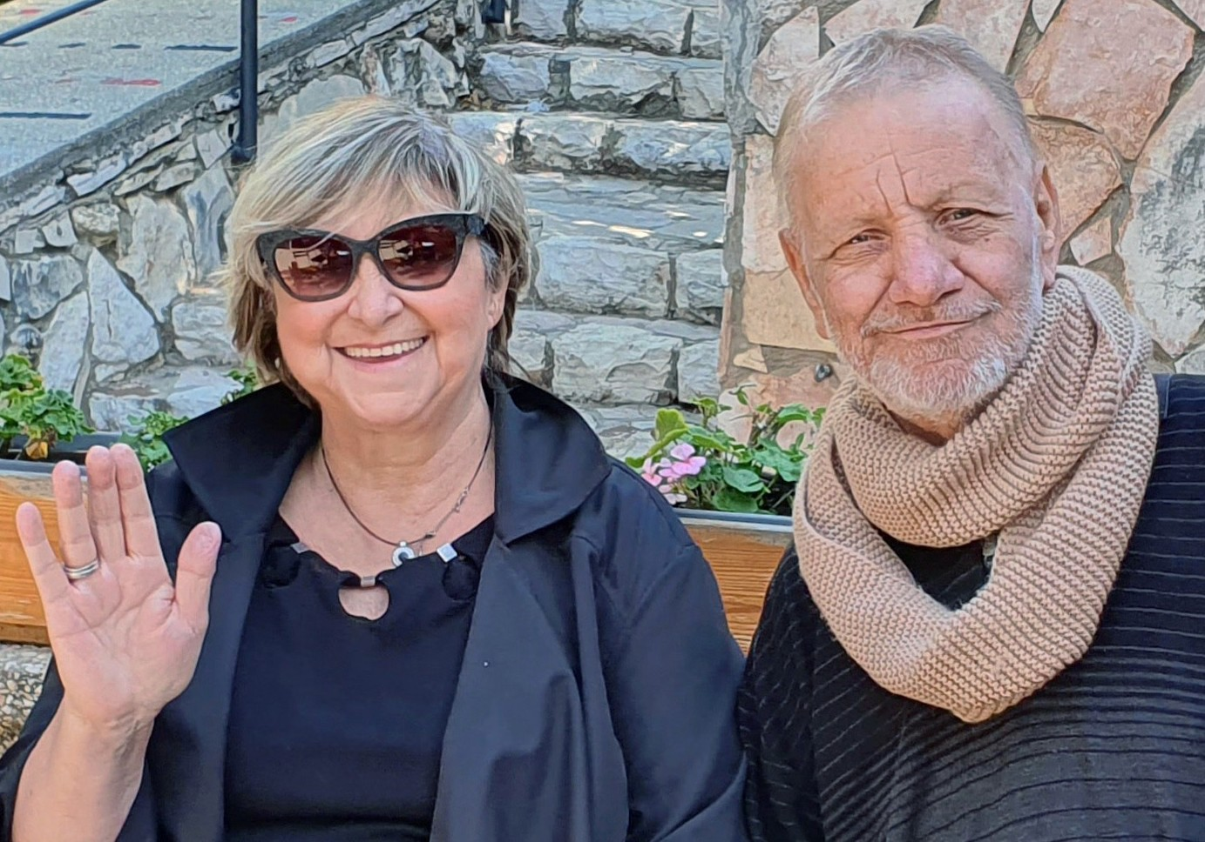
Since my wife Marcia and I were on leave for much of the previous month, other members of the CFI staff were able to participate in our outreach activities for those who had needs in Israel. Accompanying our media photographer Sara to Haifa in our absence to deliver food vouchers to the Winapple family just in time for Hanukkah were the new additions to our team here, Leon and Nicolene Swart. Previously, I had been able to meet the Winapples briefly, but not at their home. As he overcomes
life-threatening illness, Mr. Winapple was able to share his extensive portrait creations inspired by his faith and even minister from scripture and experience to our team, so I am
certain that the visit was as rewarding for them, as our ability to supplement household needs were for the Winapples. Mrs. Winapple was especially touched by our gifts of quilts and a hospitality basket with edibles, as a gesture of covenant.

“But whoever listens to me (Wisdom) will live securely and in confident trust. And will be at ease, without fear or dread of evil.” Proverbs 1:33

While abroad, I was able to secure support for an Armenian and Arab couple who needed some coun- seling to overcome some adverse and traumatic workplace circumstances. This couple has worked and is working in a key ministry in the land, so it was very important to us to keep them encouraged and motivated. Sometimes professional counsel is necessary, even with access to other ministry tools or resources. We believe this will also help their children within the dynamic of their household of faith.

“I would hurry to my refuge [my tranquil shelter far away] From the stormy wind and from the tempest.” Psalm 55:8 (Amp)

After a path fraught with delay and bureaucracy, we were finally able to make good on our pledge to assist the Christian Soldier House in Haifa with materials that were needed to reinforce the roof and upgrade this consequential property in the ability of lone soldiers and/or Arab Christian soldiers to thrive in their faith while serving Israel, despite their community or family opposition. The Christian couple that steward this work are also Arab and Armenian. As diverse as our donor base is, so is our recipient base within the land God has set aside for His blessings and promises!

Kim Brunson Project Supervisor

Project Under His Wings

Shalom Dear Friends of Israel,

“Be pleased, O LORD, to deliver me! O LORD, make haste to help me!” (Psalm 40:13)

At the writing of this UHW project update, Israel is in the third lockdown (or three and a half as one of my Israeli friends said, as it is an extension of the third lockdown), meaning we are working from home, prohibited from leaving more than one kilometer away from our homes, except for essential things such as buying food, medicine or helping those in desperately situations.

While working from home I received a phone call from the mother of the Zino family, asking for prayer (Psalm 40:13). She said their entire household is infected with Covid 19, very likely by one of her sons studying in Yeshiva, with her and one of her daughters’ situations being the worst. She was unable to stand and was feeling very weak. She said she was afraid to go to hospital as the news reported that people became even worse or died after being taken to hospitals. I prayed for her and her family. Knowing they are a family living in poverty, I asked her if they have food at home? She said one neighbor can cook for them but neither this neighbor or themselves have money to buy groceries. Thank you, our supporters, for your generous and sacrificial giving. With the financial help we received from you, Project UHW speedily provided help for this precious needy family, stricken by Covid, to buy food. The family was very grateful and touched by the love from you in their desperate situation. Please pray for healing as well as wisdom for this family that they will knows what to do for recovery from Covid.

News reported that Israel has administered the vaccine to more than 2 million of her citizens – the highest percentage in the world, in the hope of exiting from this pandemic. Prime Minister Benjamin Netanyahu agreed with the pharmaseutical companies to share the data from Israel’s vaccination program for them to improve their vaccines. However, there are voices of concern that Israelis have become the world’s guinea pigs over the Israeli government’s swift mass vaccination to its citizens. There are also citizens who are suspicion about the vaccine.
The Israeli government has come under enormous criticism for its handling of the crisis, with three lockdowns, and inconsistent decisions over opening and closing the economy and education system. Only God knows whether this swift mass vaccination is a wise decision, let us ask God to watch over His people and nation.

Thank you for your ongoing financial support for project Under His Wings. The Lord continue to bless you and keep you in this troubling time (Numbers 6: 24-26).

Maggie Huang Project Supervisor

Project Communities Under Attack

Dear Friends of Israel,

“A friend loves at all times,” (Proverbs 17:17a).

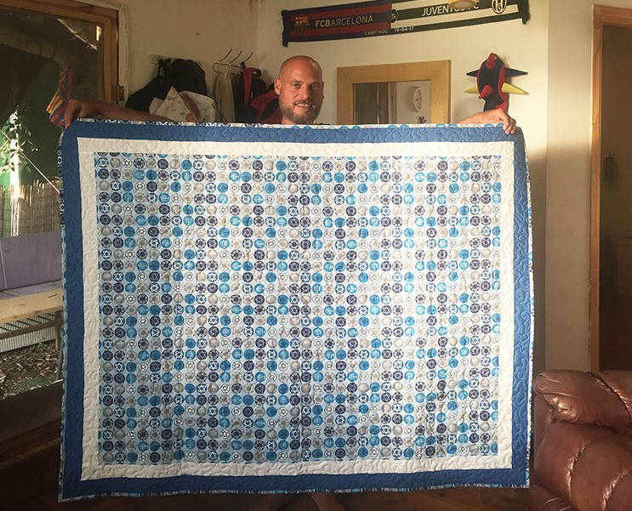
Shalom. Shortly after I went to visit Tal (the young man in the picture), the
Israeli government announced the third lockdown, as the increased infection in Israel, as well as the fear of the spread of the new strains of the Coronavirus, first found in UK and South Africa, were detected in Israel as well.

Tal was traumatized during the second Lebanese War while performing his reservist duty, during which his unit came under fierce attack by Hezbollah fighters, resulting in his commander and several of his comrades being killed or injured. He has been unable to work as he needs continued treatment on his trauma.

Some supporters made quilts for Israelis affected by rocket or terror attacks, and Tal was given one quilt. The visit brought great comfort to Tal, as he knows that he is not alone and is loved by us and our sup- porters (Proverbs 17:17a).

The CUA Project supervisor also provided help to a rocket victim named Mazal as she is in urgent need, and is planning to visit her after the lockdown is lifted. Mazal is a single mom who has been battling cancer for several years, in addition to suffering trauma from the ongoing rocket attacks.

One community leader living in Sderot said the Covid-19 cases are rising rapidly, surpassing even the contagions of the previous waves, and the third lockdown is affecting even more people in Sderot
physically, economically and mentally. This situation, added to the imminent security threat from Hamas and the Islamic groups in Gaza who have not stopped launching rockets on this city, is causing more misery to civilians of Sderot.

Thank you for being an instrument in God’s hand through your support for Project “Communities Under Attack”, helping Tal, Mazal and many others affected by the onging rocket attacks from Gaza. May the Lord command the blessing on you in your storehouse and in all that you undertake (Deuteronomy 28:8).

Maggie Huang Project Supervisor

Project Wall of Prayer

The Community of Prayer Warriors

“They devoted themselves ...to fellowship, to the breaking of bread and to prayer. Everyone was filled with awe… And the Lord added to their number…” (Acts 2:42-43, 47 NIV)

The troubling events that have taken place in our world over the last year have resulted in increased prayer sessions among many Believers; trouble has a way of doing that. This has been an appropriate season to strengthen the Wall of Prayer. In Israel, 2021 began with a third strict lockdown. Although we were unable to meet with Israeli residents, our prayers and words of encouragement for them intensified through phone calls, written letters, and electronic mail.

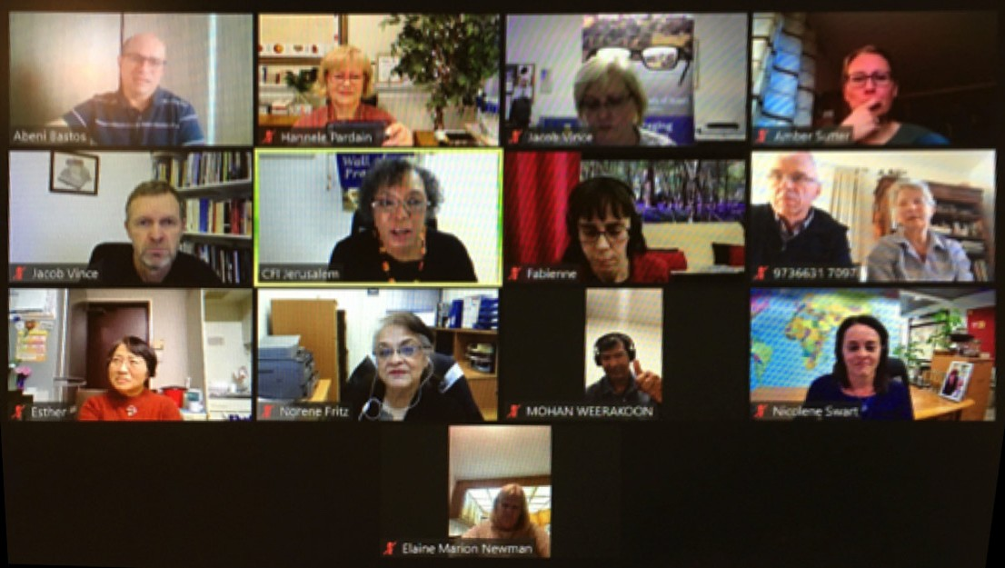
The two monthly Zoom prayer meetings that originate from CFI Jerusalem have also intensified in power and/or number.

Pastor Abeni Bastos, our CFI representative in Brazil, had this to say about our January session with the international reps:

Dear Linda,

Shalom! I prayed in Portuguese and was very happy when I heard Nicolene’s prayer
spoken in English. She was practically repeating the same prayer that I had just prayed in Portuguese! So it was definitely proof that the Holy Spirit is doing something beautiful and special through our prayer meetings. This testimony can certainly be very encouraging for those who feel limited due to the language barrier. For me in particular, it has been wonderful! In fact, it is a blessing and an honor
to pray with this team every month. I believe that this union of nations in prayer can release tremendous blessings for both Israel and our nations. Thank you very much for your initiative in providing us such
a beautiful experience…

Together in Yeshua,
Abeni & Claudia Bastos, CFI Brazil

It is also exciting to witness growth in the other monthly session with our team of prayer warriors from the nations. Initiating online prayer groups does take some effort, but by the leading and power of the Holy Spirit these prayers will reap eternal benefits for the Kingdom of God. If it is feasible, we encourage you to begin or continue supporting group prayer meetings for Israel in your country. “...if any one is a worshiper of God and does his will, God listens to him.” (John 9:31 RSV)

We are very appreciative of the encouragement, prayers, and financial support that you give to Israel through CFI. By undergirding us, you pour strength into us, and we in turn pour into the Israeli residents through our visits, love gifts, and prayers with and for them. Toda Rabah! (“Thank you very much” in Hebrew.) May God reward you abundantly.

Linda McMurray Project Supervisor

Project David’s Shield

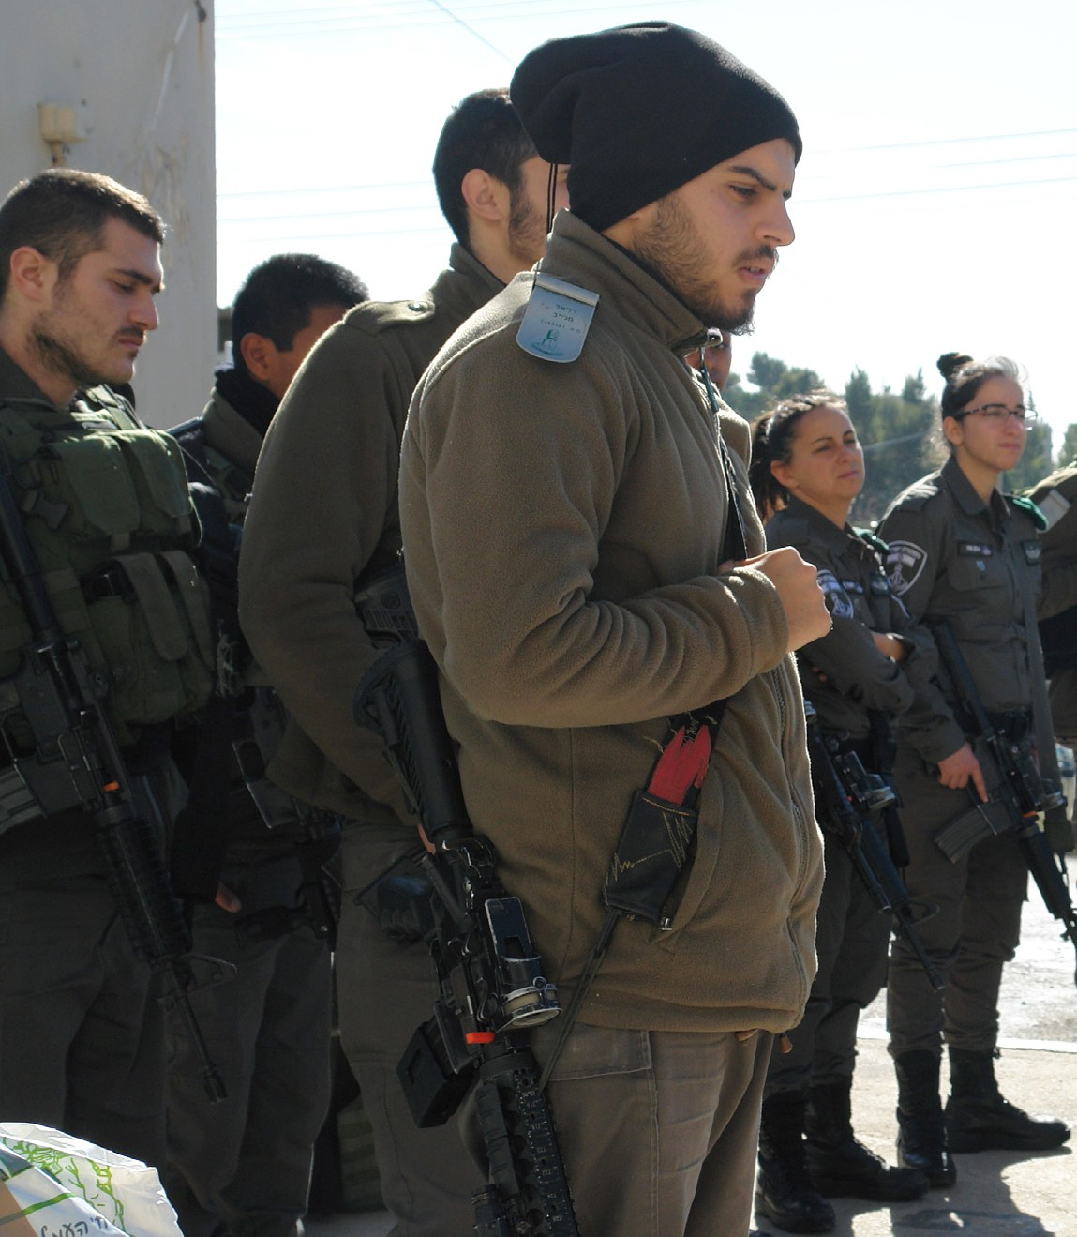
The vision of CFI Jerusalem project David’s Shield is to express solidarity with the vision and mission of the IDF. We stand with the defenders and express our gratitude and encouragement to them. We tell them that they are on the side of God, and His calling on them to be guardians of this land called Israel, is in fact a righteous calling. God has established the Nation, and just as King David, the IDF are up to the task.

During the past year, we strove to advance the CFI vision as much as possible during a time when personal interaction and visits were limited. However, through trusting relationships, we were afforded numerous opportunities to encourage and provide
needed items of comfort and in some cases, tactical equipment.

We are equipped to accomplish that which we are called to do – as are the Israel Defense Forces.

One such encouragement that I shared with many of the defenders came from a supporter in England who writes:

Dear Defenders of the Land,
You are the focus of my greatest admiration and awe. When I think of all of you defending the Land of Israel I feel as if I am looking through the prism of history, seeing great heroes and mighty warriors from ancient days. May you all be like King David’s mighty men! YOUR HERITAGE IS AWESOME! You are walking in the footsteps of warriors from long ago, warriors who did great exploits because they trusted in the Almighty and Honored His Name.
My constant prayer for you all is that you will know the protection of the Almighty and TRUST in HIS POWER to guide you and to give you supernatural abilities to thwart your enemies.
You are all so precious to the Lord - may you be blessed in all you do protecting Israel.

I expect it is difficult to pray sometimes, so I stand in the gap for you.

“Don’t be afraid, for I am with you; don’t be distressed, for I am your God. I give you strength, I give you help, I support you with my victorious right hand. All those who were angry with you will be disgraced, put to shame; those who fought against you will be destroyed, brought to nothing” (Isaiah 41:10-11 CJB).

Thank you for the honor to convey such heartfelt sentiments to the brave defenders of Israel and for the support of Christian friends of Israel from the Nations.
Jim McKenzie Project Supervisor

Project Streams Of Blessings

As Christians who have received from God a love for Israel and the Jewish people, we want to bless them in the Name of the Lord. We invest in the Land of Israel and bring comfort and sup-port to the lives of those who have aligned themselves with the promises of God.

CFI Jerusalem project Streams of Blessings receives many requests to participate with identi-fied, legitimate needs, and one such request has afforded us to support the work of an organiza-tion in Efrat by providing much needed equipment to furnish a youth club.

Youth-at-risk is a problem hardly limited to the State of Israel. What is unique to Israel, is that at-risk behaviors among teenagers is especially exacerbated by the large numbers of new im-migrant families experiencing difficulty acclimating to a new language and society. The Efrat Department of Social Services operates a high school youth club for teens who are experiencing emotional and adaptive difficulties related to problems with family, social peer groups, school performance or substance abuse. The club provides a warm, safe and caring environment where these teens can receive professional guidance, interventions, referral services and other appropriate support.

It is through God’s appointments that we accept invitations to build relationships, and to tear down the erected barriers, which have historically prevented support and expressions of solidar-ity and love to the Jewish People. We know where our help come from - it comes from the Lord!

“If I raise my eyes to the hills, from where will my help come? My help comes from Adonai, the maker of heaven and earth. He will not let your foot slip – your guardian is not asleep. No, the guardian of Israel never slumbers or sleeps” (Psalm 121:1-4 CJB).

Project Streams of Blessing

