August 25, 2021 /Jewish Year 5781

Politics within Nations (even those that do not border) still connected with Israel?

“… and He made from one man every nation of mankind to live on the face of the earth, having determined their appointed times and the boundaries of their lands and territories” Acts 17:26 (Amp).

In the international community, there have been some internal political decisions and occurrences within some nations, that still affect Israel directly or indirectly. In Iran, a new President (Raisi) was set into office after being handpicked by the Ayatollah Khameini, Iran’s ultimate authority. Raisi had a reputation of being the person who gave orders to imprison or execute any enemies of the regime that has been in place since 1979, and reinforces the path of this nation for being anti-Israel and anti-Western based on a strict interpretation of Islam. Ebrahim Raisolsadati, his actual name, facilitated a de facto political purge within Iran in 1988 in his role as a deputy prosecutor in Iran and earned him the distinction of being called the Butcher of Teheran. Besides being the focus

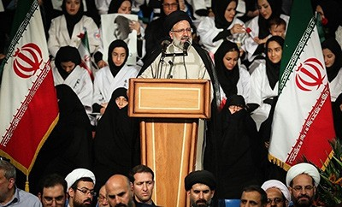
Ebrahim Raisi speaking at a presidential campaign rally in Tehran (by Mahmoud Hosseini, CC BY 4.0, Wikipedia)

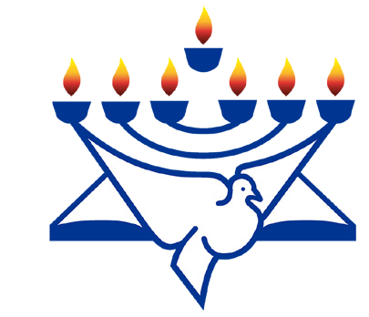of any potential possible renegotiation of the JCPOA (Iranian nuclear deal with the West), a point of contention in Israel had even to do with the E.U.’s participation in the event at all. As guests of honour, was a who’s who list of those seeking Israel’s destruction, Hamas, Hezbollah and Houthi rebel leadership. E. U. leaders skipped the inauguration of the President of Belarus based on political oppression of their population. Giving validity to this leader’s authority may signal to Israel that she will be on her own in dealing with Iran’s nuclear aspirations and the use of proxies to test Israeli resolve.
CFI News Insights
Christian Friends of Israel
feedback@cfijerusalem.org
www.cfijerusalem.org

Another irritant to Israel emanating from Europe happened with the Polish government which passed and signed legislation that blocks property owners within the land, including victims of the Shoah and their descendants from regaining any property that the communist-era regime expropriated. The Polish leadership claimed that this measure was necessary to battle fraud and curb re-privatization that has seen arbitrary evictions. Some of these properties were originally seized by Nazis and then were transferred to communists following the Soviet Union’s liberation of Poland at the end of WW2. This is why Israeli leadership interprets this as another slight from Poland regarding Jews in their land and the Polish role regarding Jews and the Holocaust era. Foreign Minister Lapid sent a clear message to the Poles by delaying the dispatch of new ambassador Yacov Livne to Warsaw temporarily.

“The nations made an uproar, the kingdoms tottered and were moved; He raised His voice, the earth melted” Psalm 46:6 (Amp).

In Afghanistan, after 20 years, the United States and Great Britain pulled out their troop support for the government and military there. In less than a week, the Taliban, also a group who operates and rules by strict Sharia Law and have no tolerance for western or outside influence on their culture, had taken over the nation. It is never good news for Israel for another anti-Israel Islamic regime to be in place in the earth and in years

past, Afghanistan has been a friendly place to harbor and train terrorists and mercenaries who have one thing in common: A hatred for Israel and the West. They have been allowed to carve out a safe haven there, as in some other nations where there are no democratic mechanisms in place and where Judeo-Christian values are frowned upon or despised explicitly.
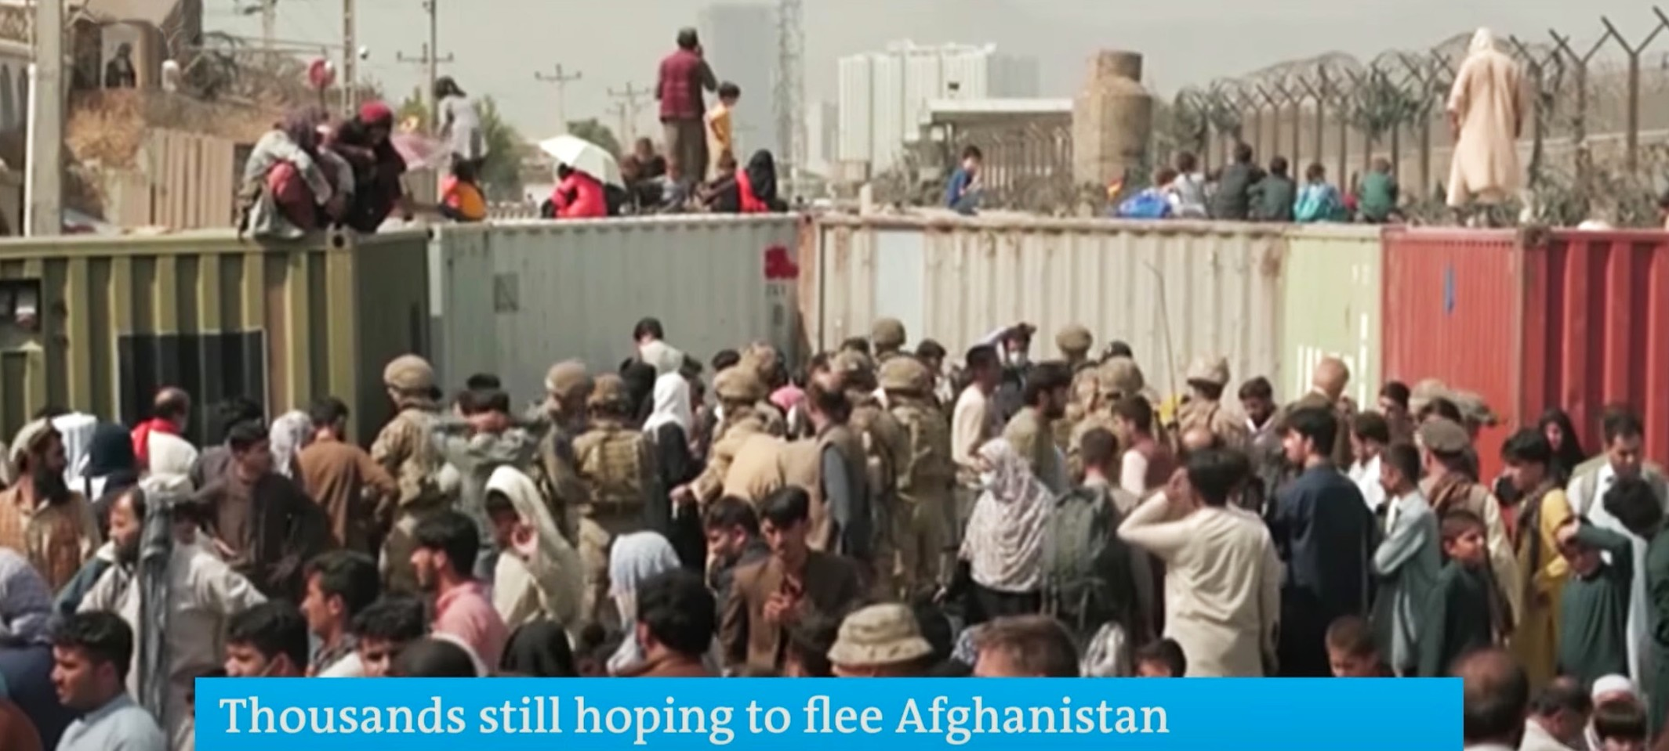
Afghans scramble to flee Taliban at Kabul airport (YouTube)

“The rulers do not know nor do they understand; They walk on in the darkness [of complacent satisfaction]; All the foundations of the earth [the fundamental principles of the administration of justice] are shaken” Psalm 82:5 (AMP).

Those of us who are motivated in our lives by the God of Israel are witnessing upheavals in governments in the Gentile nations of the earth, as He re-gathers His own back to His covenant land. In parallel rhythm, the scriptures indicate the direction nation-states are headed. This includes decisions, alliances, weather patterns and seismic activity which are also indicative of the development of the “olive tree” and the direction she will go as the Lord fully restores her to be head of all nations, not only in position, but in character and with reference to relationship with Him as her King. This has always been His intention. Once Judah goes first concerning this matter, a standard is set for other nations to follow suit, or risk falling by the wayside. As I have mentioned examples of nations that may require more of our attention in prayer, other nations historically hostile to Jews and Israel have gone in the other direction. For example Sunni Muslim Arab nations and previously tepid African states are beginning to understand the value of making decisions favourable to Israel and Jewry, even internal political ones. YHVH’s valley of decision is coming into final shape and please pray that your nation makes a judicious choice and if not, that there is a remnant whom He will preserve, that know His Name, His Sovereignty, His Voice and Character. CFI will agree with prayers of this spirit and intent.

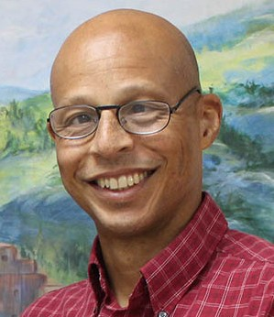
Reporting from Jerusalem,
Kim S. Brunson

