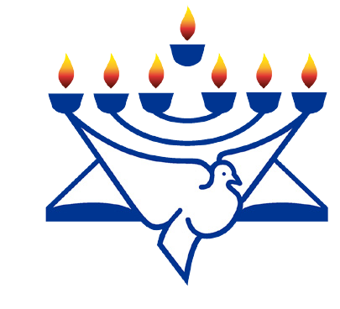
RaisingThe Bar
Christian Friends of Israel
feedback@cfijerusalem.org
www.cfijerusalem.org

November 2020 /Jewish Year 5781
Repentance and Hope

“Now while Ezra was praying, and while he was confessing, weeping, and bowing down before the house of God, a very large assembly of men, women, and children gathered to him from Israel; for the people wept very bitterly. And Shechaniah the son of Jehiel, one of the sons of Elam, spoke up and said to Ezra; “We have trespassed against our God, and have taken pagan wives from the peoples of the land; yet now there is hope in Israel in spite of this.” (Ezra 10:1-2)

“...prayer is not the work of one or two days...”. (Ezra 10:13).
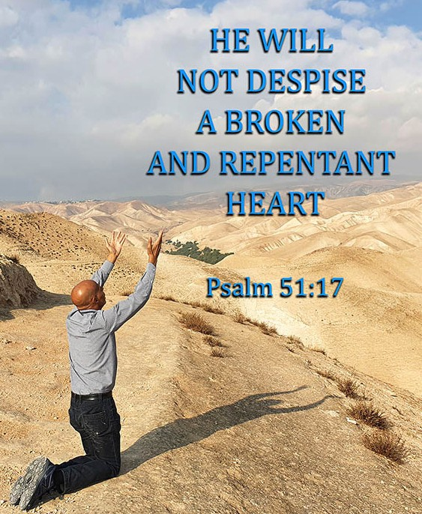
Repent = Bit’shuva Hope = Tikvah

The prophet Ezra always related the spiritual condition of the children of Israel when he was alive. As we look at our world today and the spiritual condition all nations are in, we can see why we have already seen a certain amount of judgment on the earth, plagues and violence throughout the world, not to mention wars and rumors of wars. In addition, we see a few nations aligning themselves with Israel and becoming partners in peace (shalom in Hebrew) when in actuality we have 195 independent and sovereign nations on the planet. We need to pray for more nations to make the right choice and come alongside of Israel. Through repentance towards Israel for centuries of anti-Semitism, many nations can have hope again for their people. So many are suffering under the curse of hatred towards Israel. It was recently reported that a Dutch Protestant Church in the Hague has admitted to failing the Jewish people during the Holocaust. Confession has been made public, and church officials admitted that they “lacked the courage” to stand with the Jewish people. Thank God they have seen their sin and are acknowledging it. Only God can stir the hearts of the nations toward
His Chosen People, and we are witnesses, in our generation, to see a beginning of the softening of hearts and are happy for it; however, there is an abundance of hatred and anti-Semitism is still in the arena of nations. We must do all we can to help eradicate anti-Semitism through teaching others, reporting the truth, and standing with Israel.

To repent is (bit’shuva in Hebrew); part of the word is “shuv” in Hebrew meaning return. We are told to notice that this is the root of teshuvah which is repentance or returning to God. The first is responsibility: We must recognize that we have done wrong. The second is regret: We must have true remorse for doing wrong and for the pain and problems we’ve caused. The third is resolve: We must be committed never to repeat the act regardless of the temptations or situation. This implies that transgression and sin are the natural and inevitable

consequence of man’s straying from God and His laws and that it is man’s destiny and duty to be right with God. In the New Testament, the word translated as ‘repentance’ is the Greek word μετάνοια (metanoia) meaning “after/behind one’s mind,” which is a compound word of the preposition ‘meta’ (after, with) and the verb ‘noeo’ (to perceive, to think, the result of perceiving or observing). Repentance is a stage in Christian salvation where the believer turns away from sin.

To have hope in Hebrew is “tikvah” means to expect or have some sort of expectation. “Hope” is commonly used to mean a wish: its strength is the strength of the person’s desire. But in the Bible hope is the confident expectation of what God has promised and its strength is in His faithfulness. The word for hope in Hebrew (Tikvah), however, is more concrete. ... more like expectation – and it also means cord or rope, which comes from a root word that means to bind or to wait for. To have hope is to want an outcome that makes your life better in some way. Every person needs repentance (sometimes daily). After sorrow of heart and repentance comes, hope steps in to bring light into our lives again. May the nations of the world come into the light of the truth about the Nation of Israel and enlightenment come. Only the Lord will be able to fully teach and explain to everyone just how significant this tiny nation is to God. May those days speedily come.

Let Us Enter the Throne Room of Prayer Together
- Thank God He can cause a stir in His People who may be transgressing His Ways. God can cause a “sorrow of heart” which needs to be realized by the Church especially for her sins towards the Jewish people for centuries. When our spirits are broken because of sin a mighty cleansing can flow from God’s Throne. (Ezra 10:1,2). “But the people are many, and it is a time of much rain, and we are not able to stand without, neither is this a work of one day or two: for we are many that have transgressed in this thing” (Ezra 10:13). It is the season for rain here and in many parts of the world. Pray that even if weather is pouring rain outside, that the faithful servants of God will not be hindered in their prayers for Israel.

- Intercede that people will be stirred in their hearts and rise up to pray. “Rise up; this matter is in your hands. We will support you, so take courage and do it” (Ezra 10:4).

- Beseech the Lord that the Jewish people would begin to gather together as a unified body before God. Often during crisis, large prayer gatherings are held especially at the Western Wall. Pray that Covid 19 will be defeated in order for the large gatherings to continue before God. “And they made proclamation throughout Judah and Jerusalem unto all the children of the captivity, that they should gather them- selves together unto Jerusalem” (Ezra 10:7). Pray for a humbling and confession of sins as a people and nation.

- Pray a prayer of thanksgiving that government leaders will be true to their word to be kinder and more patient with one another during Knesset meetings. This is a real step forward to correct the disunity. It was reported that 70 members of the Knesset signed a pact of mutual respect towards one another at the President’s Residence recently. “A good man brings good things out of the good stored up in him...” (Matthew 12:35).

We’ve learned a lot about prayer and beseeching God from the Book of Ezra. Prayer indeed, is not the work, the labor, the time spent of a few days. It is a lifetime of leaning on the Lord God of Israel and taking before Him all of the concerns, the matters, and reasons to pray before His Throne and boldly coming in, in the Name of Yeshua, to pray for those you love. We love Israel as God commanded us to do. For those who are catching the vision of raising up prayer groups, no matter the size, we pray God will give you wisdom and that you will write and tell us what God is speaking to your heart about praying for Israel. Please write us and encourage us in our vision for more prayer for Israel, and join our newly formed CFI Israel Watch prayer online from Jerusalem.

Also, in the Book of Ezra, is Ezra’s prayer of beseeching God, a beautiful prayer of humble approach to the Lord God and seeking His Face with sincere sorrow of heart. Once church leaders begin to see God’s plans and purposes for Israel, we can begin to thank Him for His Mercy and Grace and wonderful heart towards us. Prayer and repentance are for all today; let us be among those seeking Him daily and in special prayer watches for Israel.

In His Service,
Sharon Sanders
Christian Friends of Israel - Jerusalem

