נהריָּה - Nahariya
July 2022 /Jewish Year 5782

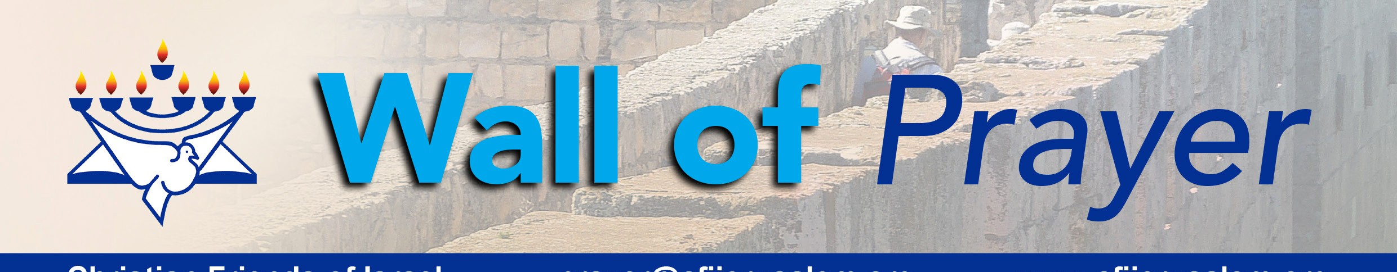
Christian Friends of Israel
prayer@cfijerusalem.org
www.cfijerusalem.org
“You prepare a meal for me in front of my enemies. You pour oil of blessing on my head; you fill my cup to overflowing” (Psalm 23:5, NCV).

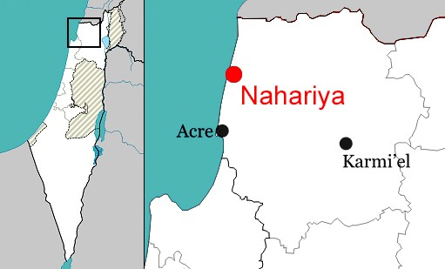Nahariya is Israel’s northernmost coastal city on the Mediterranean Sea shore. Its name is derived from the small Ga’aton River that flows through the city’s main street before pouring into the sea. Nahar (נהר) is the Hebrew word for “river.”

In February 1935, Nahariya was established under British mandate. The first residents were two German Jewish couples escaping Nazi persecution. By the time Israel became a nation in 1948, the city had grown to 1,700 residents. Floods of Jewish refugees from North Africa, the Middle East, and Europe poured into Nahariya in the 1950s, seeking refuge
from the evils of antisemitism. In the 1990s, Nahariya experienced a construction boom as the city absorbed many immigrants from the former Soviet Union and Ethiopia. By 2019, the population had mushroomed to 58,096. As David said in Psalms 23, the Lord prepared a place for His people and poured blessings upon them while their enemies watched. Nahariya was one of the places thousands of Jewish people could call “home.”
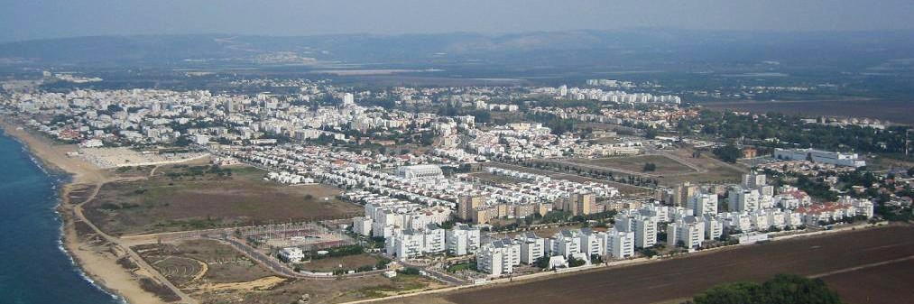
Areal view of Nahariya, direction: towards north-east (CC BY-SA 3.0, Wikipedia)

Nahariya is home to some of Israel’s leading entrepreneurs: the Strauss, Soglowek, and Wertheimer families. Several successful private-sector enterprises originated in this city: the Strauss commercial dairy company, the Soglowek meat processing industry, and Iscar – the high-precision metal works and tool-making giant.

Because of its natural environment, scenic beaches, and excellent conditions for sailing and windsurfing, Nahariya became a popular resort town under British mandate. The beachfront features a public park, a waterfront promenade, public beaches, a marina, hotels, seaside cafes, restaurants, and nightclubs. In 1980, Nahariya hosted world sailing and windsurfing championships.

Sderot Ga’aton (Ga’aton Boulevard) is Nahariya’s main tourist attraction and its central business and entertainment district. It is the city’s main boulevard from the Coastal Highway junction to the Mediterranean. The boulevard is divided by the Ga’aton River, shaded by towering eucalyptus trees, and lined with numerous shops, open-air cafes, and restaurants.

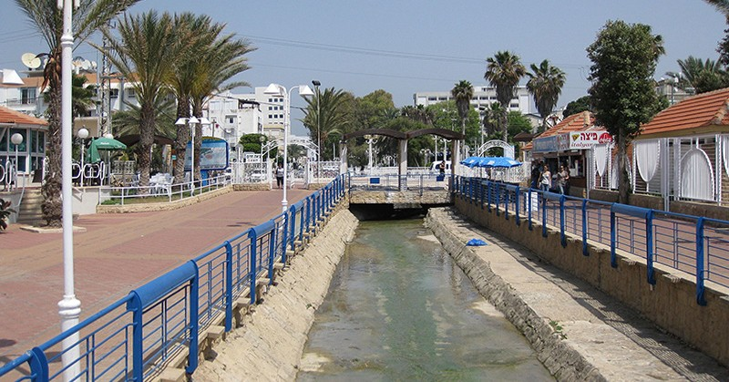
Gaaton river canal flowing through Nahariya (CC BY-SA 3.0, by Deror Avi, Wikimedia)
Unfortunately, Nahariya has had many challenges. Because of its geographic location, 9.6 km (6.0 mi) from Israel’s border with Lebanon, it has been a frequent target of cross-border terrorist attacks. There were numerous mortar strikes from 1970 to 1980 by Palestinian militants. During the 2006 Lebanon War, Nahariya sustained a barrage of several hundreds of Katyusha rockets launched by Hezbollah from Lebanon. The city suffered civilian casualties, five fatalities, and significant damage to the infrastructure. Nahariya’s economy

suffered because two-thirds of the residents had to evacuate, and others spent weeks in bomb shelters. However, God blessed Israel to invent the Iron Dome defense system in 2011. Now, the Iron Dome intercepts most Hezbollah rockets launched from Lebanon into populated areas. The Lord has given Israel resilience because He made a covenant with them. In Genesis 12:3, He said to Abraham, “I will bless those who bless you, but I will curse anyone who curses you, and by you, all the families of the earth will be blessed.”

Recently we traveled to Nahariya to visit a woman who suffered a critical illness that altered her lifestyle. It was a joy to meet her because of her attitude of trust in God’s provision despite living alone in Israel. We assisted her in maintaining her residence in Nahariya; she is looking forward to having family come to live with her soon.

Although Israel is surrounded by countries that may not have her best interest at heart, the Lord continues to
“prepare a table” before Israel in the presence of those who plan to harm her. God’s Word will always stand true!

Praying for Nahariya
- Praise the Lord for His promise of protection to His Chosen People and those grafted into Israel. We can rejoice in the dependability of God’s word! “I am at rest in God alone; my salvation comes from Him. He alone is my rock and my salvation, my stronghold; I will never be shaken” (Psalm 62:1-2, HCSB).

- Please pray that the Israel Defense Force (IDF) will be like David and his men – mighty warriors who trust God for their wisdom, strength, and protection. King David said: “With your help, I can defeat an army. If my God is with me, I can climb over enemy walls” (Psalm 18:29, ERV). “Some trust in chariots and some in horses, But we will remember and trust in the name of the Lord our God” (Psalm 20:7, AMP).

- Petition God to speak to the hearts of those who have “made aliyah” (immigrated) and are trying to adapt to Israeli culture. Please ask the Lord to draw them closer to Him through His Word, giving them peace and hope. May He also speak to those considering making aliyah and those in the process. “‘For I know the plans I have for you’ – this is the Lord’s declaration – ’plans for your welfare, not for disaster, to give you a future and a hope’’’ (Jeremiah 29:11, HCSB).
Dear Prayer Warriors:
These are crucial times. Nations are peering intently at Jerusalem, this place where God said He put His name and presence forever; His eyes and heart are here perpetually (1 Kings 9:3). In response to those who would try to take what belongs to God, please join me in worshipping heartily with the psalmist, “Let God arise, let His enemies be scattered, and let those who hate Him flee before Him. As smoke is driven away, so drive them away…But let the righteous be glad; let them exult before God; Yes, let them rejoice with gladness” (Psalm 68:1-3, NASB 1995). Shalom!

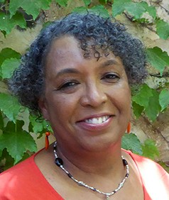
In His Service,

Linda D. McMurray
Wall of Prayer Supervisor

