November 25, 2021 /Jewish Year 5782

Hanukkah in Israel
Ample Oil to Light up our lives in His Land
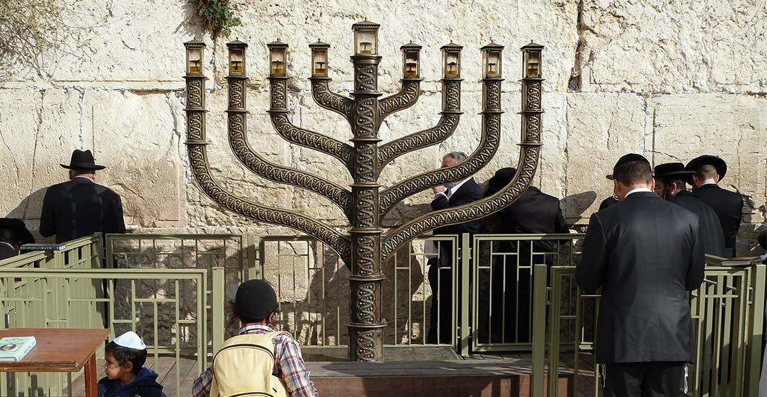
Jerusalem Western Wall with chanukkiyah during Hanukkah festival (CC BY-SA 4.0, Wikipedia)

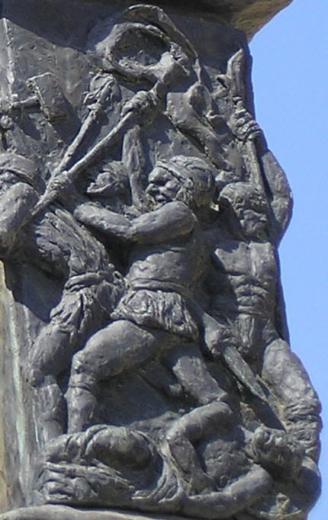
This is a season filled with anticipation and excitement in the land as we are entering the Hanukkah week. I would like to highlight some of the origins of the celebration, its relationship with our own Christian faith. Perhaps there will be some nuggets and lessons that we can draw from the Maccabean revolt period that inspired this annual celebration which will help us remain diligent regarding our relationship with God, with His chosen people, His land and our own roles in this chapter of human history.

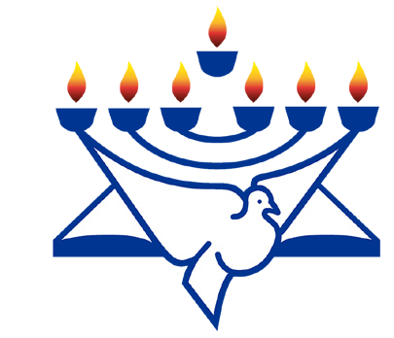
CFI News Insights
Christian Friends of Israel
feedback@cfijerusalem.org
www.cfijerusalem.org

Maccabees on the Knesset Menorah (CC BY-SA 3.0, by Deror Avi, Wikipedia)
During the 2nd century B.C, Judea was ruled by the Seleucid dynastic heir Antiochus Epiphanes which enforced the Hellenization of Jewish custom, even to the suppression of traditional Hebrew religious practice (Mandating the worship of Greek deities). This forced idolatry stirred a righteous indignation within the land led by a priest, then by his sons (the Maccabees) against Hellenized Jews and ultimately their Syrian enablers and was successful in securing the land for those who worship the One True God and Torah adherents. This was deemed a miraculous feat at the time, as these Jews were outnumbered by an army that was supposed to be much more sophisticated than their group. The Talmud records that a second miracle followed: The Rededication of the Temple would require the lighting of the Menorah as would occur with the Lampstand. This could only be done with pure olive oil. There was just one cruse of pure oil available, just enough to keep the menorah lit for one day. In order to replenish the supply and remain

compliant with Mosaic Law, the Maccabees could only produce additional pure oil after eight days: Astonishingly, that one cruse of oil had lasted for all eight days! By that point in time, new oil was ready for use.

“You shall command the Israelites to provide you with clear oil of beaten olives for the light, to make a lamp burn continually [every night]” Exodus 27:20 (AMP).

Therefore, this festival, matches the other feast observances in the land lasting 8 days. The holiday also inspired the Hanukkiah nine-socketed candelabra used during that time instead of the traditional menorah. Interestingly, a 9th “servant” candle stands above or apart from the other 8 and is used to light the candles during the celebratory week. Since Hanukkah was an oil-based miracle, to commemorate it, oily foods are eaten traditionally by Jews here and abroad. Potato pancakes or latkes are partaken of while most I know prefer to eat sufganiyot or bumuelos – deep-fried doughnuts!

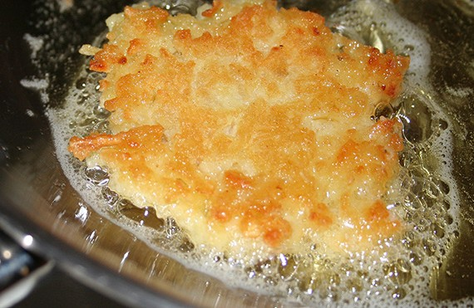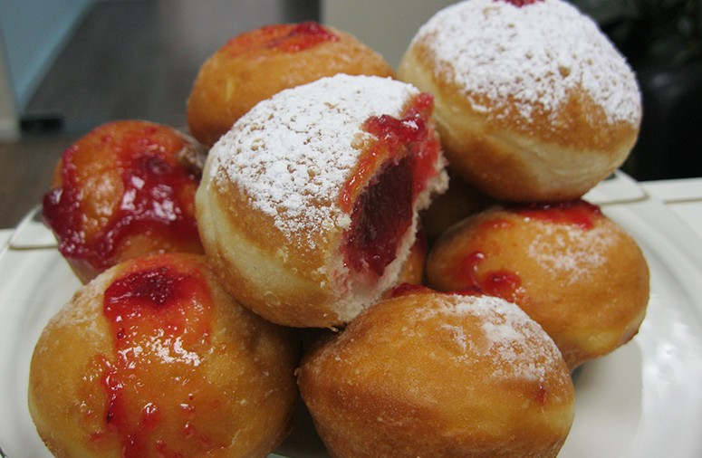

Potato latke frying in hot olive oil.
(CC BY-SA 3.0, by Jonathunder, Wikipedia)
Sufganiyot/doughnuts filled with strawberry jelly.
(CC BY-SA 3.0, by Noam Furer, Wikipedia)

Without the Maccabean period, Yeshua/Jesus would not have had a Temple to be taken to, for His Mosaic dedication after 40 days, and would not have been recognized by Simeon (Luke 2:25-35). This points to the 1st miracle, the military defeat of Antiochus’ forces. I believe the lesson from the 2nd miracle is more applicable to our current state as those of faith. Maintaining enough pure oil to keep our lights burning! The parable of the 5 wise and 5 foolish virgins depicted in Matthew the 25th Chapter points to the perils of having oil run out, thereby not being able to light your wick in time to greet the bridegroom…and missing out on being the Bride!

“Then the kingdom of heaven will be like ten virgins, who took their lamps and went to meet the bridegroom Five of them were foolish [thoughtless, silly, and careless], and five were wise [far-sighted, practical, and sensible]. For when the foolish took their lamps, they did not take any [extra] oil with them, but the wise took flasks of oil along with their lamps. Now while the bridegroom was delayed, they all began to nod off, and they fell asleep. But at midnight there was a shout, ‘Look! The bridegroom [is coming]! Go out to meet him.’ Then all those virgins got up and put their own lamps in order [trimmed the wicks and added oil and lit them]. But the foolish virgins said to the wise, ‘Give us some of your oil, because our lamps are going out.’ But the wise replied, ‘No, otherwise there will not be enough for us and for you, too; go instead to the dealers and buy oil for yourselves.’ But while they were going away to buy oil, the bridegroom came, and those who were ready went in with him to the wedding feast; and the door was shut and locked. Later the others also came, and said, ‘Lord, Lord, open [the door] for us.’ But He replied, ‘I assure you and most solemnly say to you, I do not know you [we have no relationship] Therefore, be on the alert [be prepared and ready], for you do not know the day nor the hour [when the Son of Man will come]” Matt. 25:1-13 (AMP).

As we join with Israelis and Jews in the celebration of Hanukkah and prepare for our own Christmas observances, I implore all of us to reach out to the Servant Candle Himself, Yeshua and ask Him to help us be diligent to keep oil in the lamps of our spirits, that our lights might remain lit and we not be found wanting when the Bridegroom beckons!

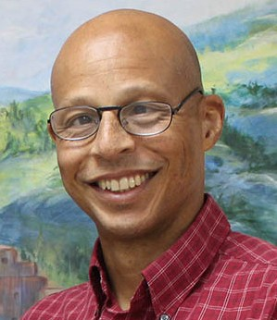
Reporting from Jerusalem,
Kim S. Brunson

